OOPS MINI PROJECT REVIEW

By- Jaya Agarwal

Registration no.-23FE10CAI00187

Section-A

TITLE- JAIPUR TOURIST WEBSITE

SUMMARY:

The project is a **Streamlit website** serving as an interactive guide to Jaipur, India. The website is interactive and designed to provide a dynamic guide to the city, helping users explore Jaipur's culture, legal landscape, tourist attractions, and more.

**Key Features:**

* **Home Page**: Offers an introduction to Jaipur's culture and history, with images of iconic landmarks like Hawa Mahal and Amber Fort.
* **Law Page**: Details regulations in Jaipur, covering traffic rules, building codes, and cultural etiquette. Includes a custom background for visual appeal.
* **Tourism Page**: Provides insights into Jaipur's top tourist attractions and activities, showcasing must-visit sites and experiences.
* **History Page**: Explores Jaipur's historical background, highlighting significant events and the legacy of its royal heritage.
* **Healthcare Page:** Shares information about healthcare services in Jaipur, including hospitals, clinics, and essential health resources for residents and visitors.

**Future Enhancements:**

* Include a chatbot functionality, add comprehensive content to all pages, and integrate real-time updates for user convenience.

TOOLS AND LIBRARIES USED:

1.Python

2.Streamlit library

3.Wikipedia library

REPRESENTATION OF THE PROJECT THROUGH THE BLOCK DIAGRAM

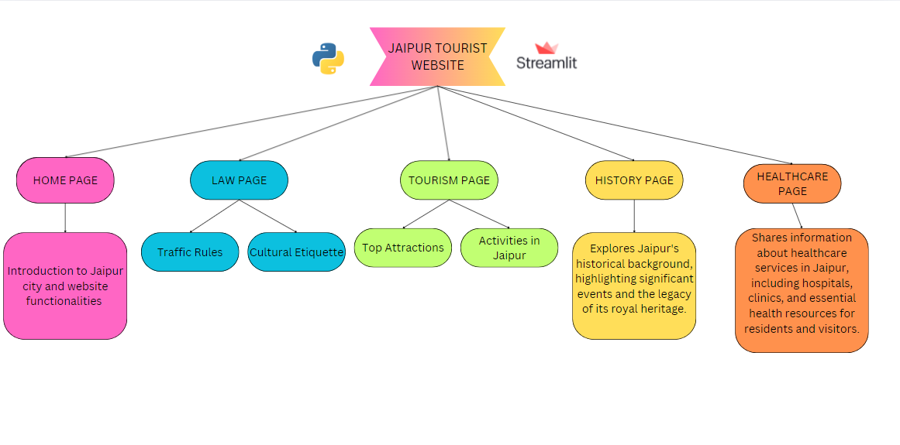

REFERENCES FOR PROJECT DEVELOPMENT:

Streamlit Documentation: Comprehensive guide on building web applications using Streamlit.

<https://docs.streamlit.io/>

Python Official Documentation: Essential reference for Python programming.

<https://www.python.org/doc/>

REFERENCES FOR JAIPUR INFORMATION:

<https://www.tourism.rajasthan.gov.in/>

<https://www.rajasthan.gov.in/><https://www.wikipedia.org>



