**ROR-APP DEPLOYMENT ON AWS ECS**

1. Cloning the Repo

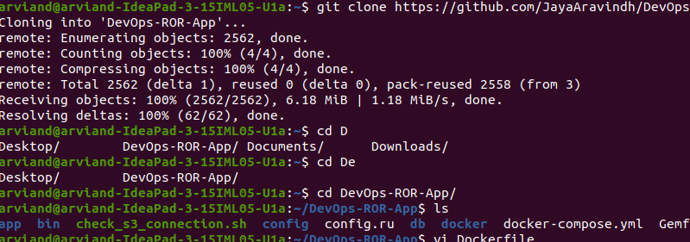

2. Docker Setup

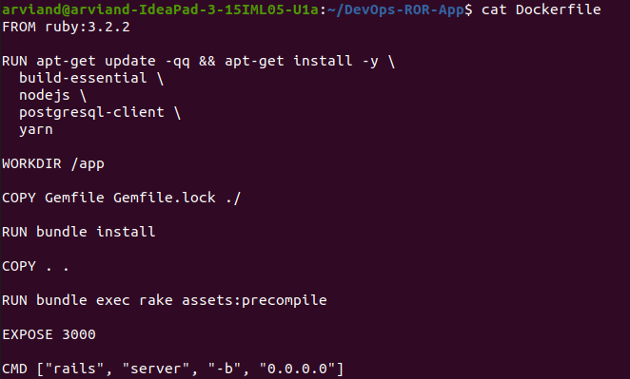

3. Building Docker Image

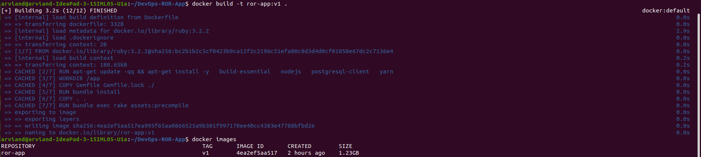

4. AWS Configure

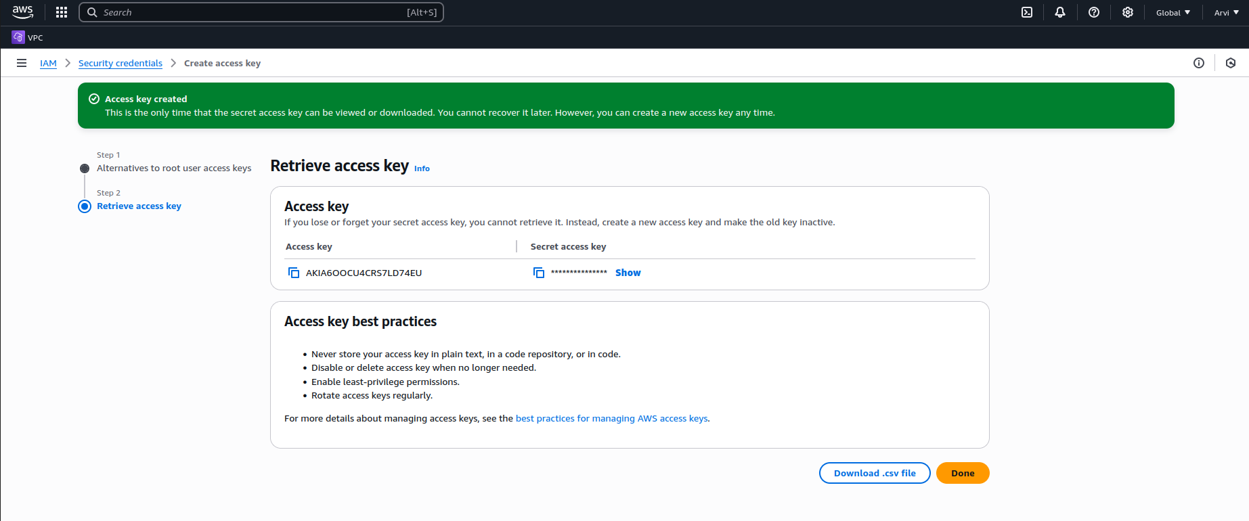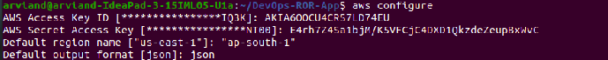

5. AWS environment variables

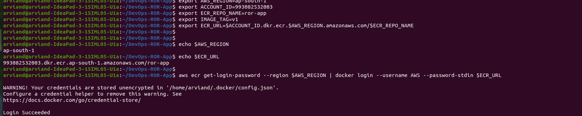

6. Create Repository at AWS ECR and Push the Built Docker image to the Registry.

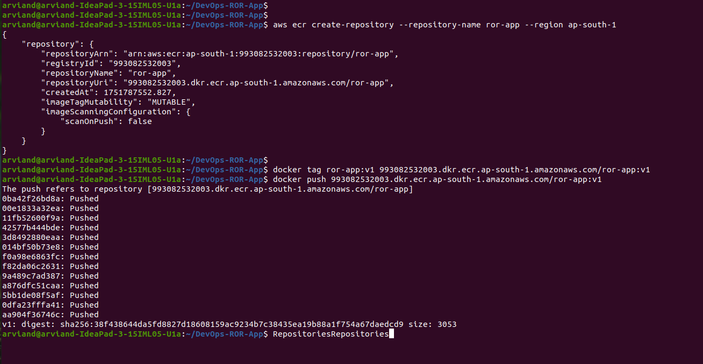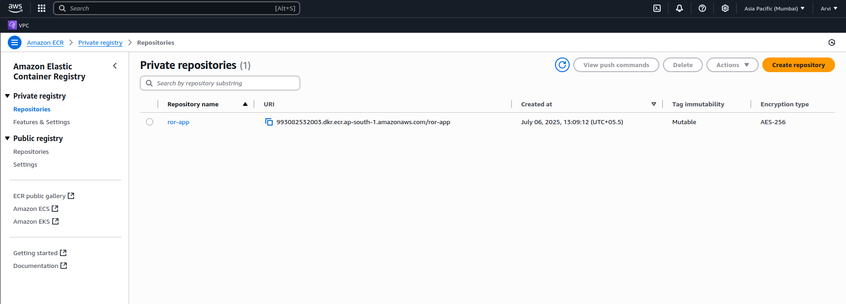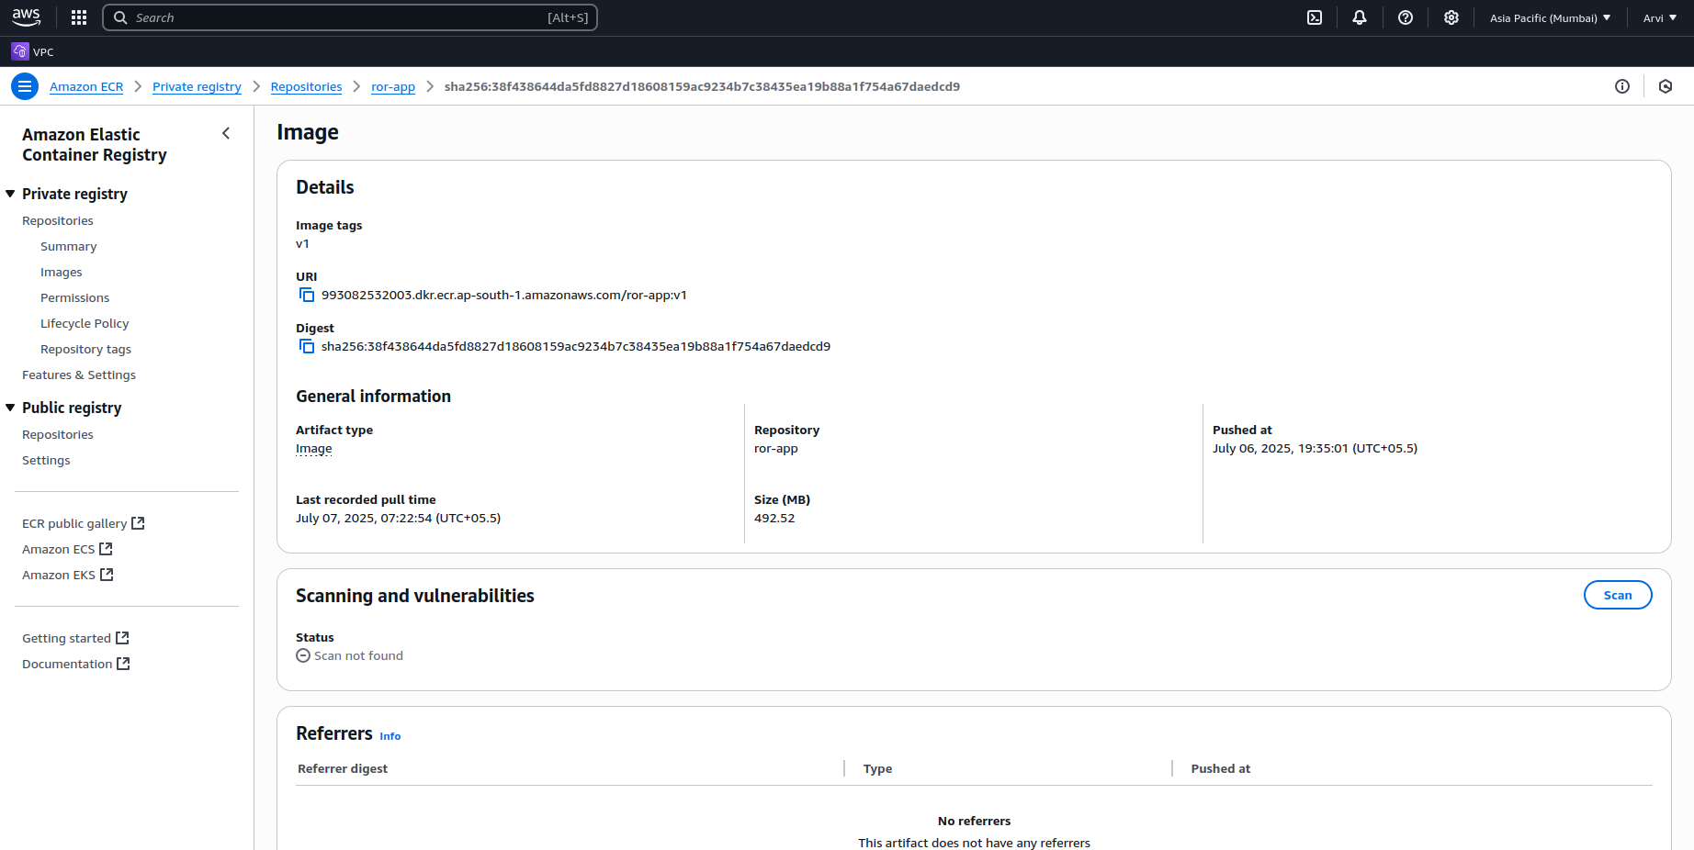

7. Now , Creating Infrastructure using IaC Tool ( Terraform). Terraform Installed on my local machine .

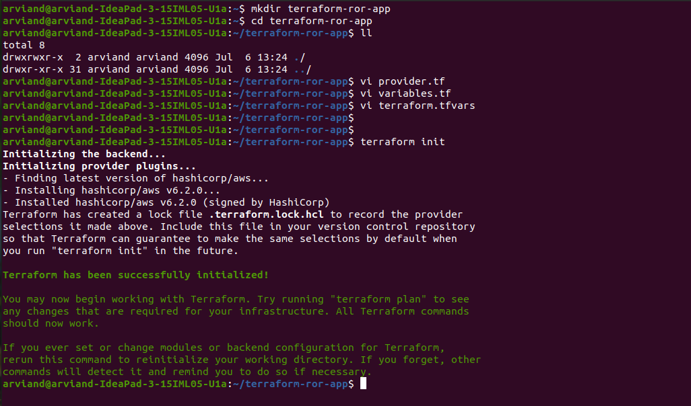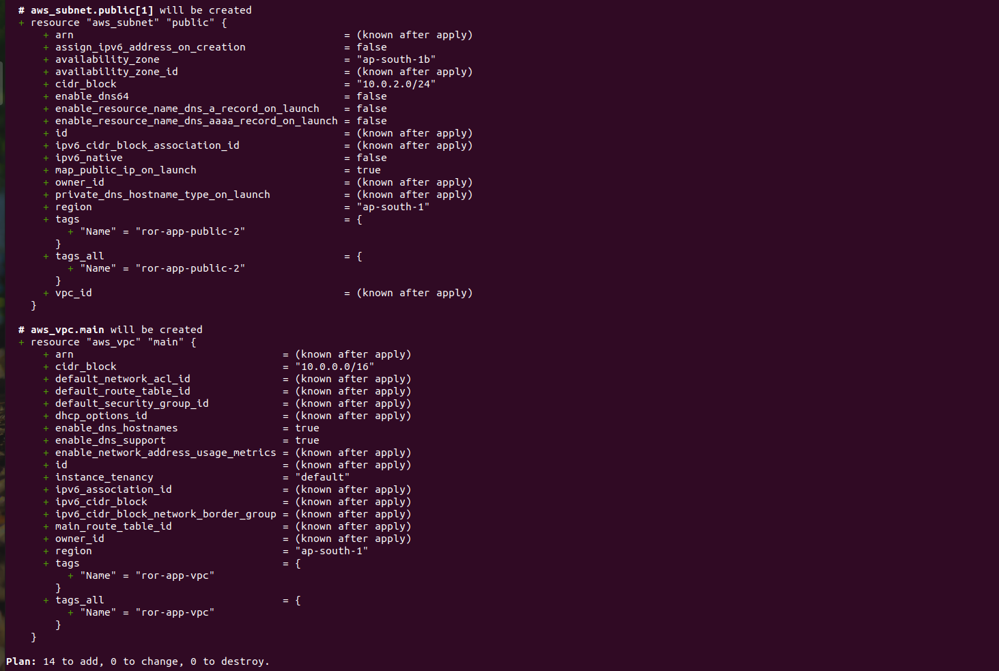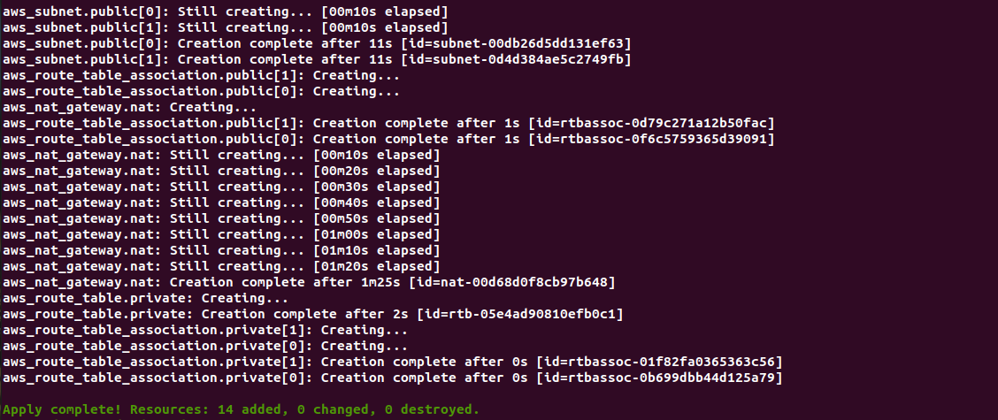

Find the Screenshots Below for the Resources provisioned in AWS Infrastructure.

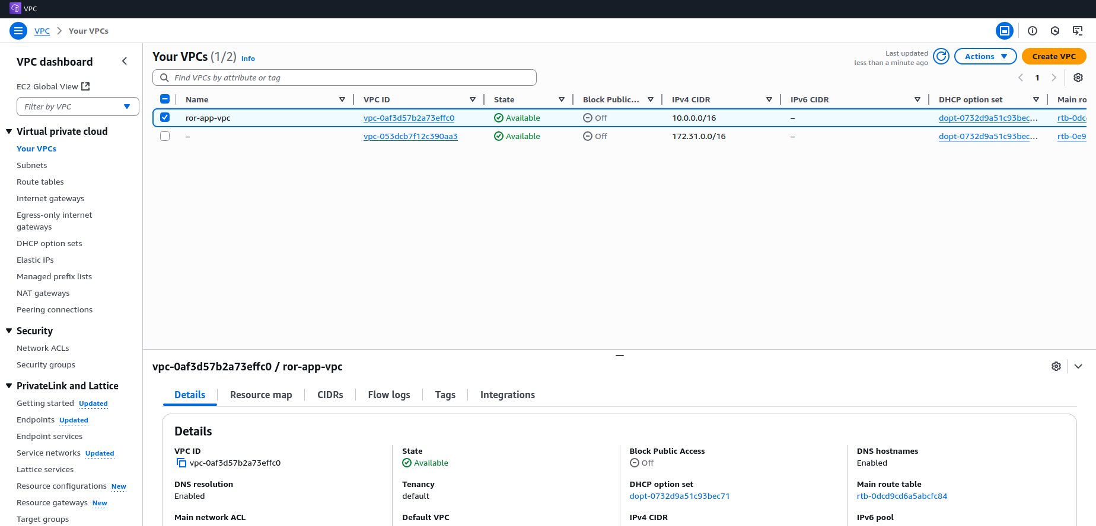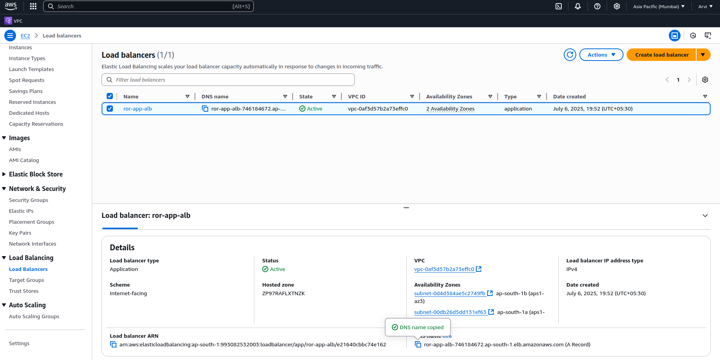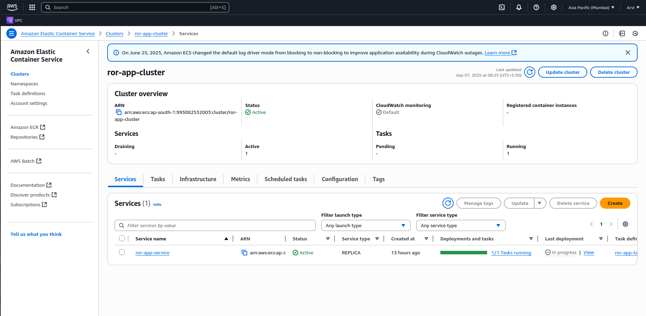

ARCHITECTURE DIAGRAM:

