Statistics: The Science of Decisions Project Instructions

Background Information

In a Stroop task, participants are presented with a list of words, with each word displayed in a color of ink. The participant’s task is to say out loud the *color of the ink* in which the word is printed. The task has two conditions: a congruent words condition, and an incongruent words condition. In the *congruent words* condition, the words being displayed are color words whose names match the colors in which they are printed: for example RED, BLUE. In the *incongruent words* condition, the words displayed are color words whose names do not match the colors in which they are printed: for example PURPLE, ORANGE. In each case, we measure the time it takes to name the ink colors in equally-sized lists. Each participant will go through and record a time from each condition.

Questions For Investigation

As a general note, be sure to keep a record of any resources that you use or refer to in the creation of your project. You will need to report your sources as part of the project submission.

https://en.wikipedia.org/wiki/Stroop_effect

http://www.psytoolkit.org/lessons/stroop.html

https://www.scientificamerican.com/article/seeing-science-exploring-color-perception-with-the-stroop-effect/

<http://www.whatispsychology.biz/about-stroop-effect-definition>

http://smash.psych.nyu.edu/courses/spring10/lhc/materials/lab2directions-c.pdf

http://www.investopedia.com/terms/h/hypothesistesting.asp

http://conversionxl.com/one-tailed-vs-two-tailed-tests/

https://blogs.oracle.com/marketingcloud/the-difference-between-one-tailed-two-tailed-testing

https://cyfar.org/types-statistical-tests

http://onlinestatbook.com/2/summarizing_distributions/variability.html

1. What is our independent variable? Word condition (congruent words and incongruent words)

What is our dependent variable? Time it takes to name the ink colors on words

1. What is an appropriate set of hypotheses for this task?

*Null Hypothesis:* There is no significant population mean difference in participants to name congruent words and incongruent words.

*Alternative hypothesis:* There is a statistically significant difference between the population means. If congruent words are used then the time it takes for participant to name the ink colors are lesser but if incongruent words are used then the time it takes participant to name the ink colors are greater.

d denotes the difference in population mean

d = µincongruent – µcongruent = 0

H0: d = 0

H1: d ≠ 0

What kind of statistical test do you expect to perform?

Paired T test or dependent samples t test.

Justify your choices.

We have two measurements (reaction time on congruent words and reaction time on incongruent words) on the same participant. We are testing twice on the same participant. We have 24 participants in the sample size. We do not know the population standard deviation. As a result, we make an estimate by using the sample.

The paired t test calculates the difference within each before-and-after pair of measurements (reaction time on congruent words and reaction time on incongruent words), determines the mean of the changes, and reports whether this mean of the difference is statistically significant. When we compare the mean difference, we can tell whether there is a difference between the two measurements color reaction times.

Here are the assumptions:

**Assumption 1:** The dependent variable (reaction time to name the ink colors on words) is a continuous/quantitative variable

**Assumption 2:** The independent variable consist of two categories, namely congruent words and incongruent words. The same participants are present in both categories. Each participant are measured on two occasions on the same dependent variable (reaction time to name the ink colors on the words).

**Assumption 3:** There is no significant outliers in the difference between reaction time of the congruent and incongruent words.

**Assumption 4:** The distribution of the differences in the dependent variable (reaction time to name the ink colors on words) between congruent and incongruent words are normally distributed.

Now it’s your chance to try out the Stroop task for yourself. Go to [this link](https://www.google.com/url?q=https://faculty.washington.edu/chudler/java/ready.html&sa=D&ust=1478238786112000&usg=AFQjCNFKUUzEbmzEH7jM0Msv0vj-4Ifa4w), which has a Java-based applet for performing the Stroop task. Record the times that you received on the task (you do not need to submit your times to the site.) Now, download [this dataset](https://www.google.com/url?q=https://drive.google.com/file/d/0B9Yf01UaIbUgQXpYb2NhZ29yX1U/view?usp%3Dsharing&sa=D&ust=1478238786112000&usg=AFQjCNH4bQBRINy9kZXxtj1kcOZeozTBQg) which contains results from a number of participants in the task. Each row of the dataset contains the performance for one participant, with the first number their results on the congruent task and the second number their performance on the incongruent task.

1. Report some descriptive statistics regarding this dataset. Include at least one measure of central tendency and at least one measure of variability.

**Congruent words**

Measures of central tendency:

* 1. Mean – 14.0511
  2. Median – 14.3565

Measure of variability:

* 1. Variance – 12.669
  2. Standard deviation – 3.5594

**Incongruent words**

Measures of central tendency:

1. Mean – 22.0159
2. Median – 21.0175

Measure of variability:

1. Variance – 23.012
2. Standard deviation – 4.7971

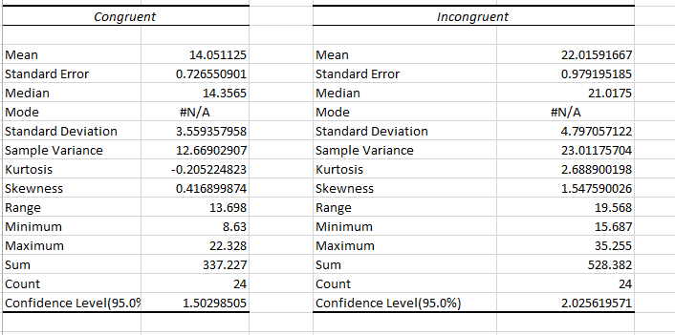

1. Provide one or two visualizations that show the distribution of the sample data. Write one or two sentences noting what you observe about the plot or plots.

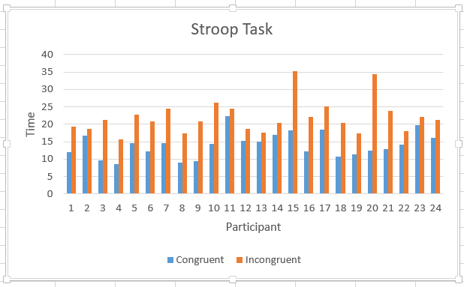

If congruent words are used then the time it takes for the participant to name the ink colors are quicker and if incongruent words are used then the time it takes for the participant to name the ink colors are longer.

1. Now, perform the statistical test and report your results. What is your confidence level and your critical statistic value? Do you reject the null hypothesis or fail to reject it? Come to a conclusion in terms of the experiment task. Did the results match up with your expectations?

I am using 95% confidence level. Critical t value is 2.069. We reject the null hypothesis. The calculated t statistics is -8.021 and it falls in the t critical region. As a result, we reject the null hypothesis. In addition, the p value is 0.0001. The difference is extremely statistically significant. This p value is lesser than the alpha level (0.05). As a result, we can reject the null hypothesis.

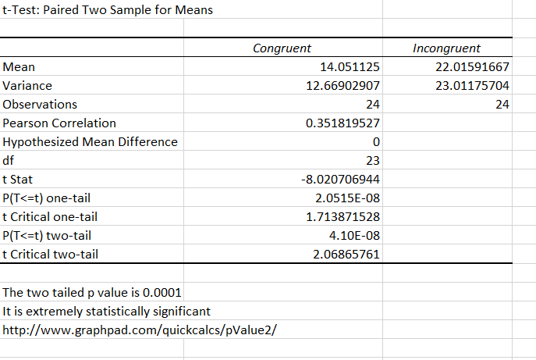

1. Optional: What do you think is responsible for the effects observed?

Speed of Processing: We are so used to processing the word meaning than the color of the ink. It turns out that we can read words faster and more automatically than we can name colors

Selective Attention: Naming colors requires more attention than reading words

Can you think of an alternative or similar task that would result in a similar effect?

Number Stroop effect and emotional Stroop effect

Some research about the problem will be helpful for thinking about these two questions!