Day-7

---1.Rank employees by their total sales

---(Total sales = Total no of orders handled, JOIN employees and orders table)

select e.employee_id,

e.first_name,

e.last_name,

count(o.order_id)as total_orders,

rank() over(order by count(o.order_id) desc) as sales_rank

from employees e

join orders o on e.employee_id = o.employee_id

GROUP BY

e.employee_id, e.first_name, e.last_name;

Output:

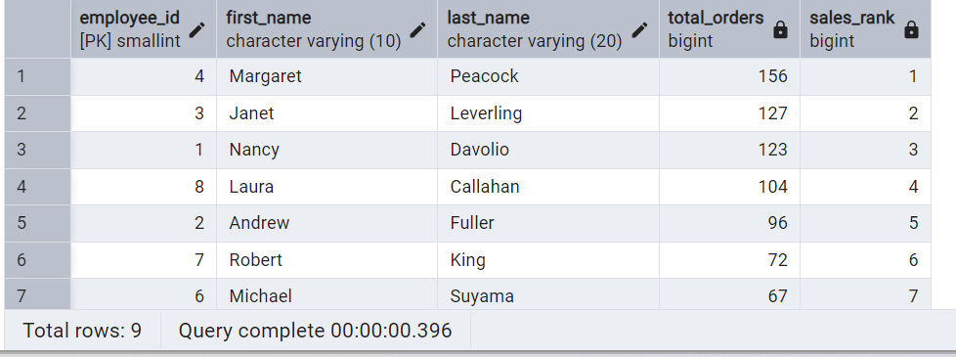

----2.Compare current order's freight with previous and next order for each customer.

--(Display order_id, customer_id, order_date, freight,

---Use lead(freight) and lag(freight).

SELECT

order_id,

customer_id,

order_date,

freight,

LAG(freight) OVER (PARTITION BY customer_id ORDER BY order_date) AS previous_freight,

LEAD(freight) OVER (PARTITION BY customer_id ORDER BY order_date) AS next_freight

FROM

orders;

Output:

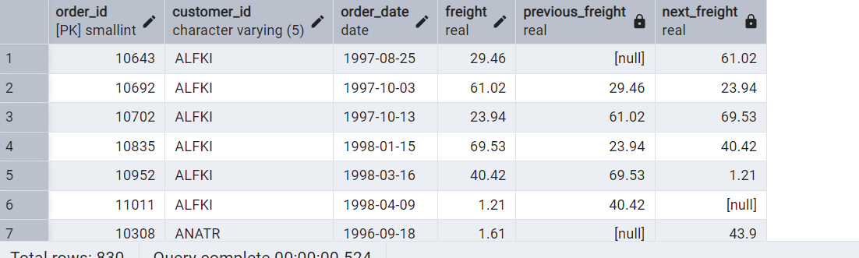

Show products and their price categories, product count in each category, avg price:

         (HINT:

·  Create a CTE which should have price_category definition:

         WHEN unit_price < 20 THEN 'Low Price'

            WHEN unit_price < 50 THEN 'Medium Price'

            ELSE 'High Price'

·  In the main query display: price_category,  product_count in each price_category,  ROUND(AVG(unit_price)::numeric, 2) as avg_price)

WITH price_cte AS (

SELECT

product_name,

unit_price,

CASE

WHEN unit_price < 20 THEN 'Low Price'

WHEN unit_price < 50 THEN 'Medium Price'

ELSE 'High Price'

END AS price_category

FROM

products

)

SELECT

price_category,

COUNT(*) AS product_count,

ROUND(AVG(unit_price)::numeric, 2) AS avg_price

FROM

price_cte

GROUP BY

price_category

ORDER BY

price_category;

output:

