1.Rank employees by their total sales

(Total sales = Total no of orders handled, JOIN employees and orders table)

SELECT e.first_name||''||e.last_name AS Full_name,

count(o.order_id) AS Total_sales,

RANK() OVER(

ORDER BY count(o.order_id) DESC

)As sales_rank

FROM orders o

INNER JOIN

employees e

ON o.employee_id= e.employee_id

GROUP BY

Full_name

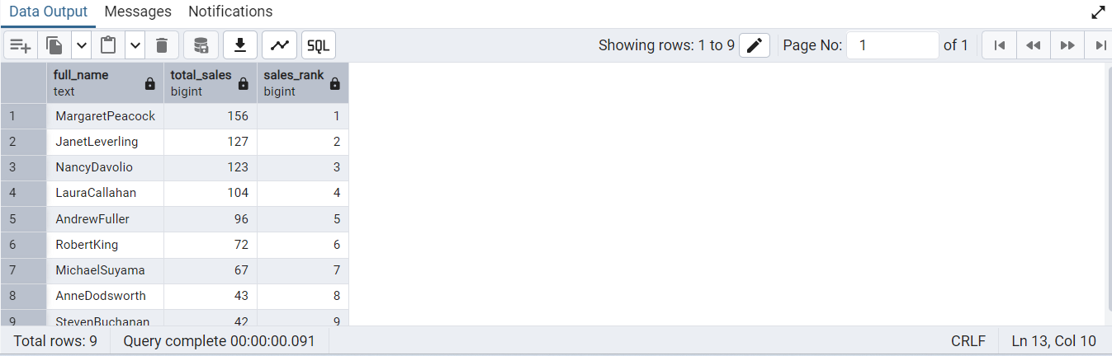

==================================================

2.Compare current order's freight with previous and next order for each customer.

(Display order_id, customer_id, order_date, freight,

Use lead(freight) and lag(freight).

SELECT order_id, customer_id,order_date,freight,

lag(freight) over(partition by customer_id ORDER BY order_date )As previous_freight,

lead(freight) over(partition by customer_id ORDER BY order_date )As next_freight

FROM orders

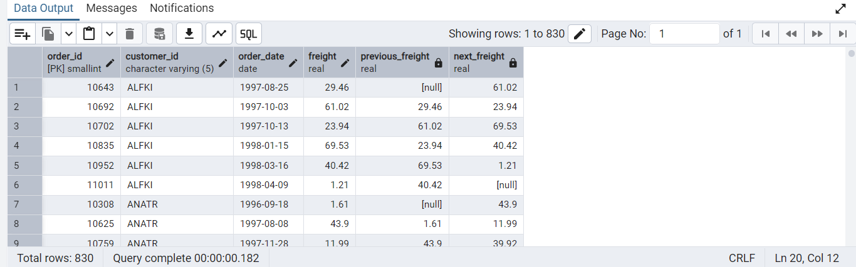

==================================================

3.Show products and their price categories, product count in each category, avg price:

(HINT:

· Create a CTE which should have price_category definition:

WHEN unit_price < 20 THEN 'Low Price'

WHEN unit_price < 50 THEN 'Medium Price'

ELSE 'High Price'

· In the main query display: price_category, product_count in each price_category, ROUND(AVG(unit_price)::numeric, 2) as avg_price)

WITH price_cte AS (

SELECT

product_id,

product_name,

unit_price,

CASE

WHEN unit_price < 20 THEN 'Low Price'

WHEN unit_price < 50 THEN 'Medium Price'

ELSE 'High Price'

END AS price_category

FROM

products

)

SELECT

price_category,

COUNT(*) AS product_count,

ROUND(AVG(unit_price)::numeric, 2) AS avg_price

FROM

price_cte

GROUP BY

price_category

ORDER BY

Price_category;

