–1,1. --Write a function to Calculate the total stock value for a given category:

--(Stock value=ROUND(SUM(unit_price * units_in_stock)::DECIMAL, 2)

--Return data type is DECIMAL(10,2)

CREATE OR REPLACE FUNCTION get_stock_value_by_category(

p_category_id INT

)

RETURNS DECIMAL(10,2)

LANGUAGE plpgsql

AS $$

DECLARE

v_stock_value DECIMAL(10,2);

BEGIN

SELECT ROUND(SUM(unit_price * units_in_stock)::DECIMAL, 2)

INTO v_stock_value

FROM products

WHERE category_id = p_category_id;

RETURN COALESCE(v_stock_value, 0.00);

END;

$$;

SELECT get_stock_value_by_category(7);

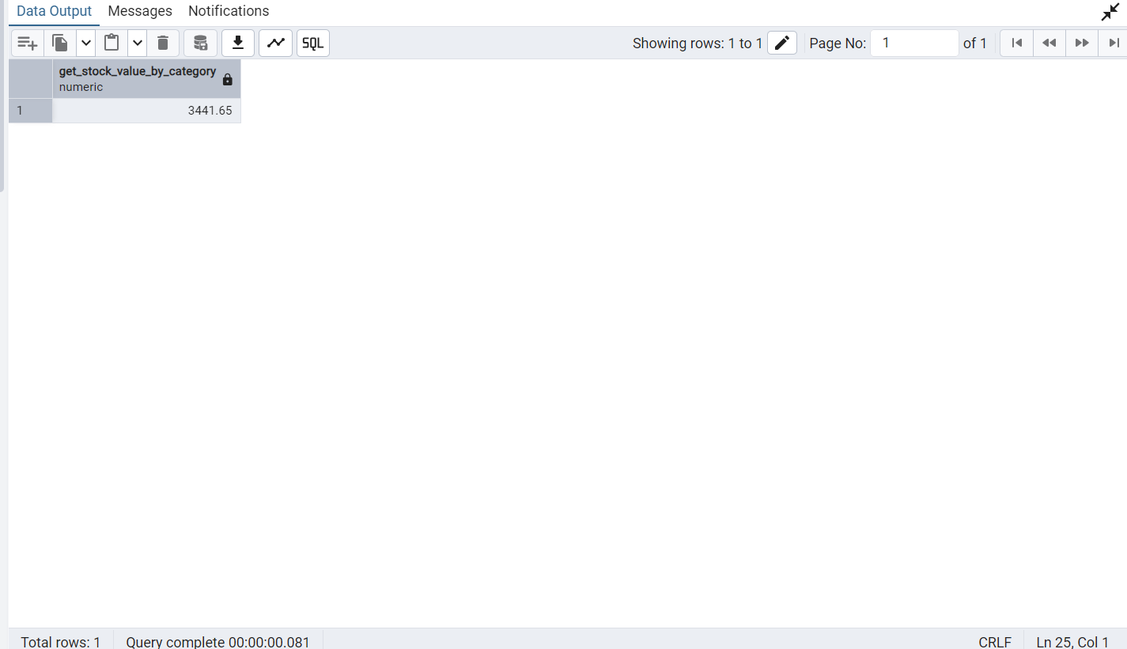

--2. Try writing a cursor query which I executed in the training

--This cursor will iterate through products and adjust prices based on units in stock

CREATE OR REPLACE PROCEDURE update_prices_with_cursor()

LANGUAGE plpgsql

AS $$

DECLARE

product_cursor CURSOR FOR

SELECT product_id,product_name,unit_price,units_in_stock

FROM products

WHERE discontinued =0 ;

product_record RECORD;

v_new_price DECIMAL(10,2);

BEGIN

--open the cursor

OPEN product_cursor;

LOOP

**--fetch the next row**

FETCH product_cursor INTO product_record;

--Exit whn no more rows to fetch

EXIT WHEN NOT FOUND;

**--calculate new price**

IF product_record.units_in_stock < 10 THEN

v_new_price := product_record.unit_price * 1.1;-- 10% increase

ELSE

v_new_price := product_record.unit_price * 0.95;-- 5% increase

END IF;

**--update the product**

UPDATE products

SET unit_price = ROUND (v_new_price,2)

WHERE product_id =product_record.product_id;

**--log the change**

RAISE NOTICE 'updated% price from % to %',

product_record.product_name,

product_record.unit_price,

v_new_price;

END LOOP;

**-- close the cursor**

CLOSE product_cursor;

END;

$$;

**--TO execute:**

CALL update_prices_with_cursor();

