Day-3 SQL Assignment

---1) Update the categoryName From “Beverages” to "Drinks" in the categories table.

update categories

set categoryName='Drinks'

where categoryName='Beverages';

Select * from categories ;

Output:

--2) Insert into shipper new record (give any values) Delete that new record from shippers table.

insert into shippers(shipperID,companyName)

values(99,'fedex');

Output:

delete from shippers

where shipperID=99;

output:

3)      Update categoryID=1 to categoryID=1001. Make sure related products update their categoryID too. Display the both category and products table to show the cascade.

 Delete the categoryID= “3”  from categories. Verify that the corresponding records are deleted automatically from products.

 (HINT: Alter the foreign key on products(categoryID) to add ON UPDATE CASCADE, ON DELETE CASCADE)

alter table products

add constraint fk_categories

foreign key (categoryID)

REFERENCES Categories(CategoryID)

ON update cascade

on delete cascade;

update categories

set CategoryID=1001

where CategoryID=1;

select * from products;

select * from Categories;

Output:

delete from categories

where CategoryID=3;

output:



--4) Delete the customer = “VINET” from customers. Corresponding customers in orders table should be set to null

--(HINT: Alter the foreign key on orders(customerID) to use ON DELETE SET NULL)

alter table orders

add constraint fk_customers

foreign key (customerID)

REFERENCES customers(customerID)

ON DELETE SET NULL;

ALTER TABLE orders

ALTER COLUMN customerID DROP NOT NULL;

ALTER TABLE customers

ALTER COLUMN customerID DROP NOT NULL;

delete from customers

where customerID='VINET';

select * from orders

where customerID='VINET';

select * from customers

where customerID='VINET';

output:

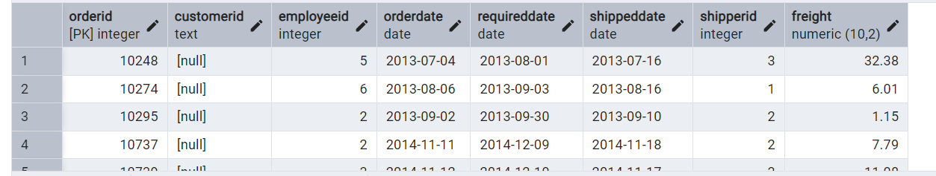

---5)Insert the following data to Products using UPSERT:

--product_id = 100, product_name = Wheat bread, quantityperunit=1,unitprice = 13, discontinued = 0, categoryID=3

product_id = 101, product_name = White bread, quantityperunit=5 boxes,unitprice = 13, discontinued = 0, categoryID=3

product_id = 100, product_name = Wheat bread, quantityperunit=10 boxes,unitprice = 13, discontinued = 0, categoryID=3

insert into products(productID,productName,quantityPerUnit,unitPrice,discontinued,categoryID)

values(100,'Wheat bread',1,13,'false',3)

on conflict(productID)

do update

set productName=excluded.productName,

quantityPerUnit=excluded.quantityPerUnit,

unitPrice=excluded.unitPrice,

discontinued=excluded.discontinued,

categoryID=excluded.categoryID;

ALTER TABLE products

DROP CONSTRAINT fk_categories;

insert into products(productID,productName,quantityPerUnit,unitPrice,discontinued,categoryID)

values(101,'Wheat bread',5,13,'false',3)

on conflict(productID)

do update

set productName=excluded.productName,

quantityPerUnit=excluded.quantityPerUnit,

unitPrice=excluded.unitPrice,

discontinued=excluded.discontinued,

categoryID=excluded.categoryID;

insert into products(productID,productName,quantityPerUnit,unitPrice,discontinued,categoryID)

values(100,'Wheat bread',10,13,'false',3)

on conflict(productID)

do update

set productName=excluded.productName,

quantityPerUnit=excluded.quantityPerUnit,

unitPrice=excluded.unitPrice,

discontinued=excluded.discontinued,

categoryID=excluded.categoryID;

select * from products;

Output:

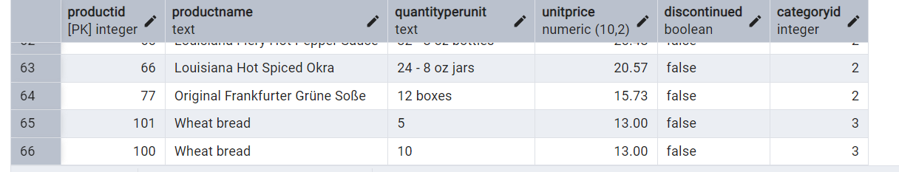

--6)Write a MERGE query:

--Create temp table with name: ‘updated_products’ and insert values as below:

CREATE TABLE updated_products (

productID integer PRIMARY KEY,

productName TEXT NOT NULL,

quantityPerUnit TEXT,

unitPrice NUMERIC(10, 2),

discontinued BOOLEAN,

categoryID INTEGER

);

insert into updated_products

values(100,'Wheat bread',10,20,'true',3),

(101,'White bread','5 boxes',19.99,'false',3),

(102,'Midnight Mango Fizz','24 - 12 oz bottles',19,'false',1),

(103,'Savory Fire Sauce','12 - 550 ml bottles',10,'false',2);

select * from updated_products;

merge into products p

using updated_products up

on p.productid=up.productid

when matched and up.discontinued='false' then

update set

unitprice=up.unitprice,

discontinued=up.discontinued

when matched and up.diccontinued='true' then

delete

when not matched and up.discontinued=0 then

insert into updated_products;

MERGE INTO products p

USING updated_products up

ON p.productid = up.productid

WHEN MATCHED AND up.discontinued = false THEN

UPDATE SET

unitprice = up.unitprice,

discontinued = up.discontinued

WHEN MATCHED AND up.discontinued = true THEN

DELETE

WHEN NOT MATCHED AND up.discontinued = false THEN

INSERT (productid, productname, unitprice,quantityPerUnit, discontinued,categoryid)

VALUES (up.productid, up.productname, up.unitprice, up.quantityPerUnit,up.discontinued, up.categoryid);

select * from products where productid in(100,101,102,103);

output:

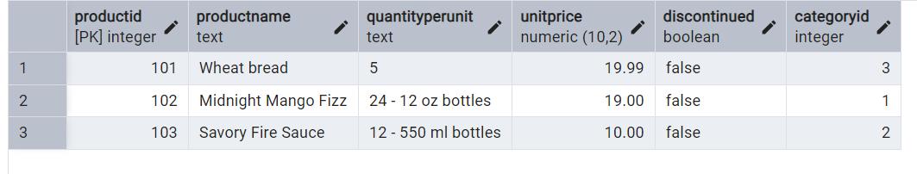

-- 7.List all orders with employee full names. (Inner join)

select * from orders o

INNER JOIN employees e ON o.employee_id = e.employee_id;

Output:

