JAYA DAY 4 -ASSIGNMENT

-- 1. List all customers and the products they ordered with the order date. (Inner join)

-- Tables used: customers, orders, order_details, products

-- Output should have below columns:

-- companyname AS customer,

-- orderid,

-- productname,

-- quantity,

-- orderdate

SELECT * FROM CUSTOMERS

SELECT * FROM ORDERS

SELECT * FROM ORDER_DETAILS

SELECT * FROM PRODUCTS

-------Query to get common columns from multiple tables--------------

SELECT column_name

FROM INFORMATION_SCHEMA.COLUMNS

WHERE table_name IN ( 'products','order_details')

GROUP BY column_name

HAVING COUNT(DISTINCT table_name) > 1;

SELECT c.company_name AS customer,od.quantity,p.product_name,o.order_date,o.order_id

FROM order_details od

INNER JOIN products p ON od.product_id=p.product_id

INNER JOIN orders o ON o.order_id=od.order_id

INNER JOIN customers c ON c.customer_id=o.customer_id

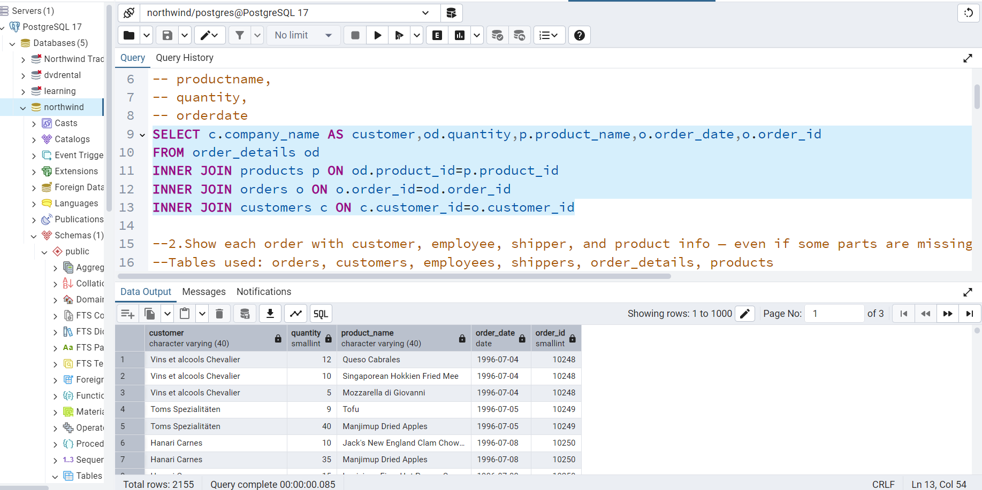

-- 2. Show each order with customer, employee, shipper, and product info — even if some parts are missing. (Left Join)

-- Tables used: orders, customers, employees, shippers, order_details, products

select * from orders

select * from customers

select * from employees

select * from shippers

select * from order_details

-------Query to get common columns from multiple tables--------------

SELECT column_name

FROM INFORMATION_SCHEMA.COLUMNS

WHERE table_name IN ( 'order_details','products')

GROUP BY column_name

HAVING COUNT(DISTINCT table_name) > 1;

SELECT *

FROM orders o

LEFT JOIN customers c ON o.customer_id=c.customer_id

LEFT JOIN employees e ON e.employee_id=o.employee_id

LEFT JOIN order_details od ON od.order_id=o.order_id

LEFT JOIN products p ON od.product_id=p.product_id

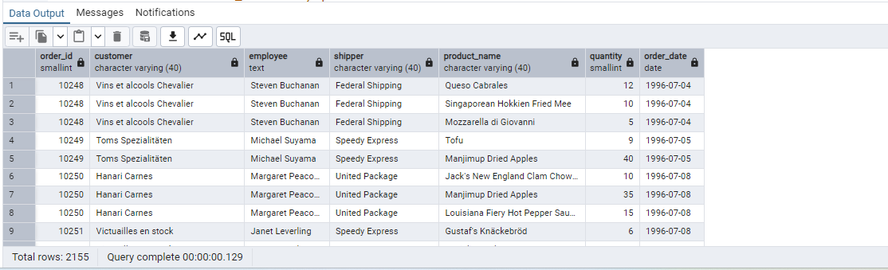

-- 3. Show all order details and products (include all products even if they were never ordered). (Right Join)

-- Tables used: order_details, products

-- Output should have below columns:

-- orderid,

-- productid,

-- quantity,

-- productname

SELECT p.product_id,p.product_name,od.order_id,od.quantity

FROM order_details od

RIGHT JOIN

products p ON od.product_id=p.product_id

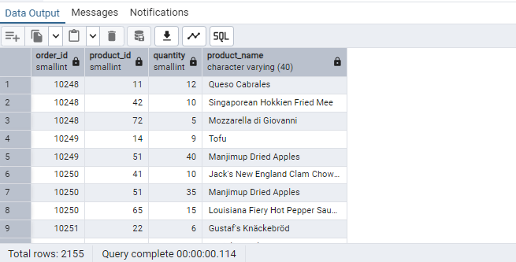

-- 4. List all product categories and their products — including categories that have no products, and products that are not assigned to any category.(Outer Join)

-- Tables used: categories, products

select * from categories

select * from products

SELECT c.category_id , c.category_name ,p.product_id ,p.product_name

FROM products p

FULL OUTER JOIN categories c

ON p.category_id=c.category_id;

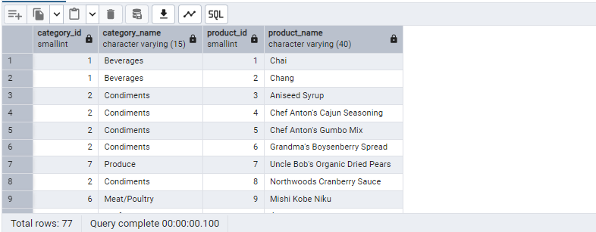

-- 5. Show all possible product and category combinations (Cross join).

------ cross join-----

-- It multiplies the rows of the first table with the rows of the second table.

-- It does not require any condition (like ON or USING).

-------Query to get common columns from multiple tables--------------

SELECT column_name

FROM INFORMATION_SCHEMA.COLUMNS

WHERE table_name IN ( 'categories','products')

GROUP BY column_name

HAVING COUNT(DISTINCT table_name) > 1;

SELECT product_id,product_name,category_name

FROM products

CROSS JOIN categories

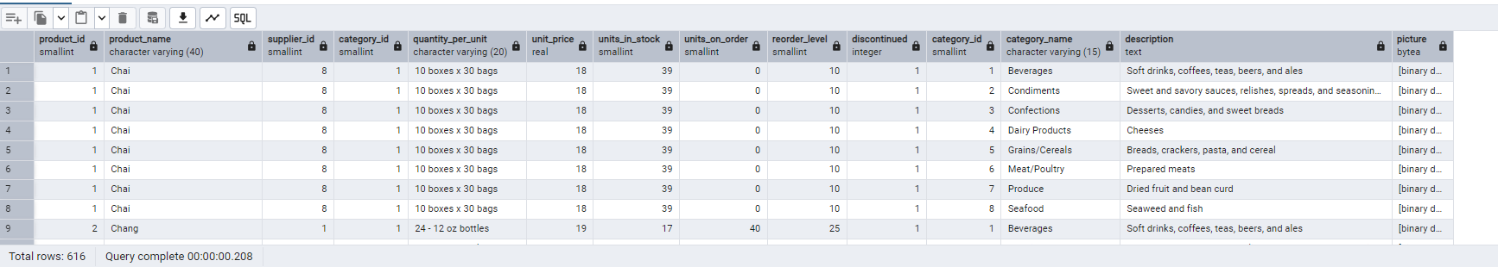

-- 6. Show all employees and their manager(Self join(left join))

select * from employees

SELECT e.first_name||' ' ||e.last_name AS employee,m.first_name||' '||m.last_name AS manager

FROM employees e

LEFT JOIN employees m ON m.employee_id=e.reports_to

ORDER BY manager;

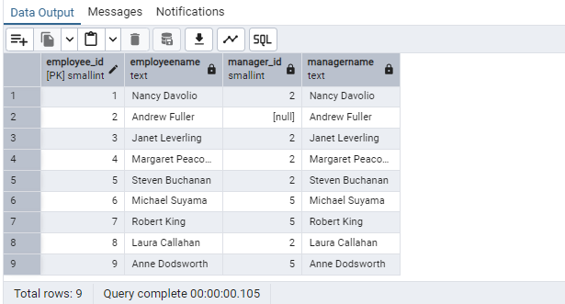

-- 7. List all customers who have not selected a shipping method.

-- Tables used: customers, orders

-- (Left Join, WHERE o.shipvia IS NULL)

SELECT * FROM customers

SELECT * FROM orders

SELECT o.ship_via,c.contact_name,c.company_name

FROM customers c

LEFT JOIN orders o

ON o.customer_id=c.customer_id

WHERE o.ship_via IS NULL

