Day 2 sql Assignment

-- 1) Alter Table:

-- Add a new column linkedin_profile to employees table to store LinkedIn URLs as varchar.

alter table employees

add column linkedin_profile varchar(200)

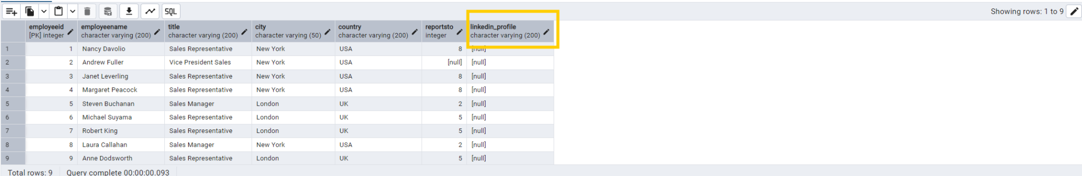

-- Change the linkedin_profile column data type from VARCHAR to TEXT

alter table employees

alter column linkedin_profile type text

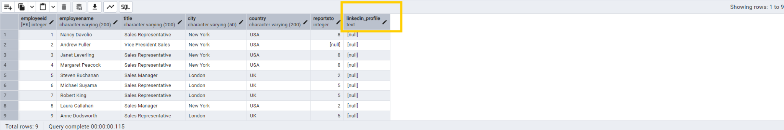

--before set column to not null adding data to linkedin_profile column

UPDATE employees

SET linkedin_profile = employeeid || 'linkedin_profile';

alter table employees

add constraint unique_constraint unique(linkedin_profile)

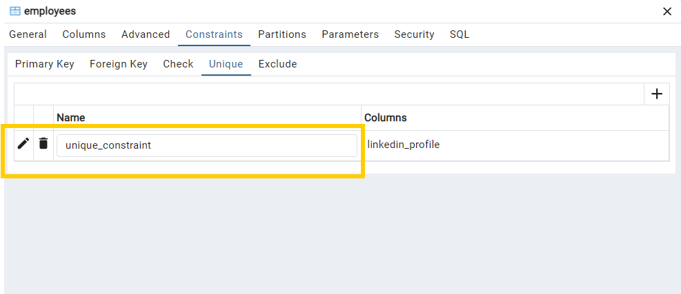

alter table employees

alter column linkedin_profile set not null

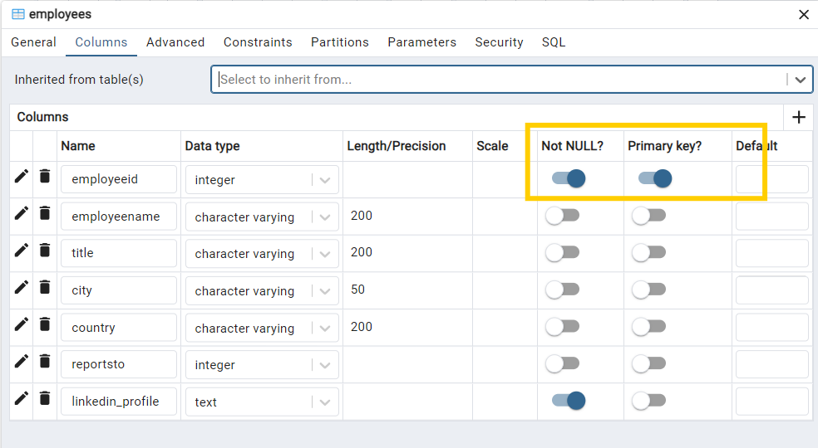

-- Drop column linkedin_profile

alter table employees

drop column linkedin_profile

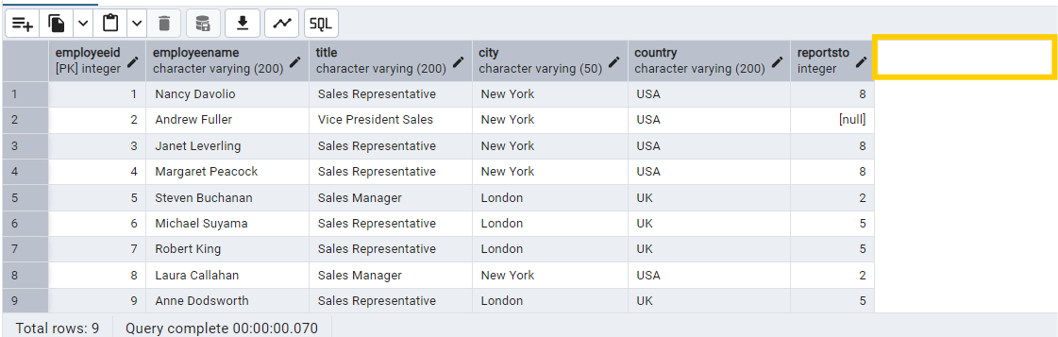

=========================================================

2. Querying (Select)

* Retrieve the employee name and title of all employees

select split_part (employeename,' ',1)as first_name,

split_part(employeename,' ',2)as last_name ,title

from employees;

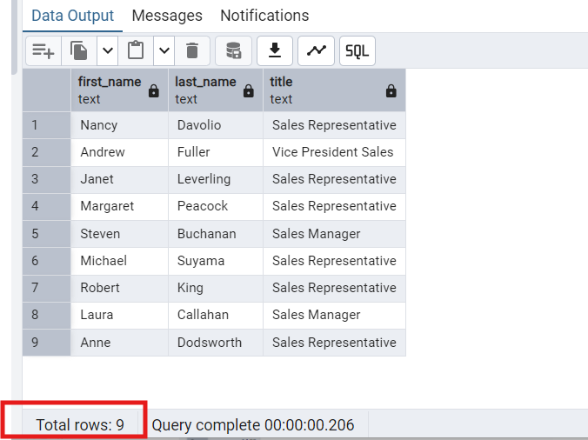

* Find all unique unit prices of products

select distinct (unitprice) from products ;

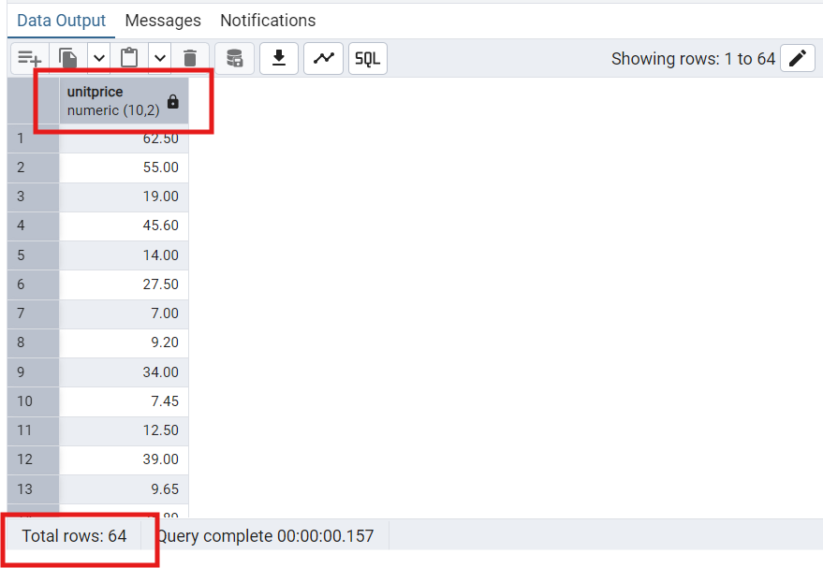

List all customers sorted by company name in ascending order

select *from customers

ORDER BY companyname

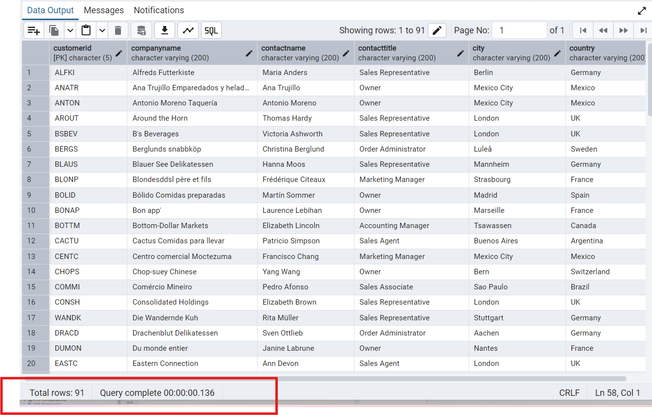

Display product name and unit price, but rename the unit_price column as price_in_usd

select productname, unitprice as price_in_usd

from products;

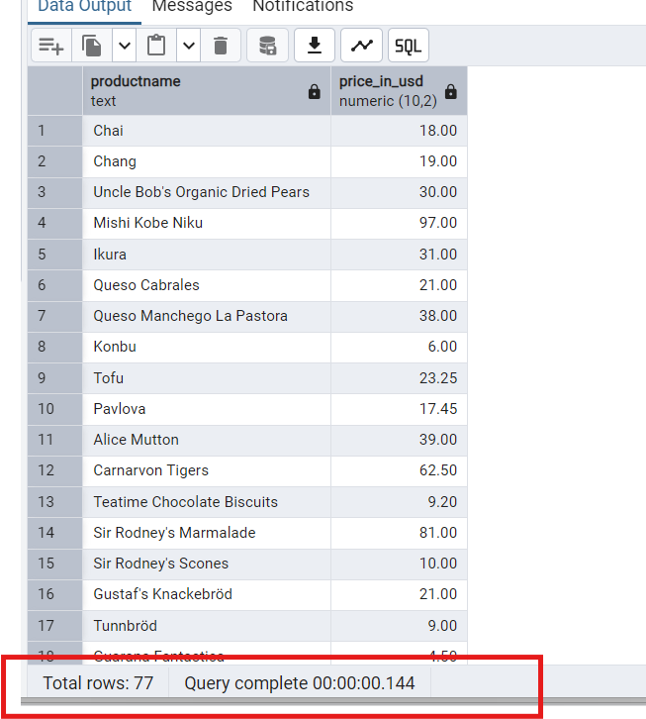

=========================================================

3) Filtering

* Get all customers from Germany.

SELECT * FROM customers

WHERE country='Germany'

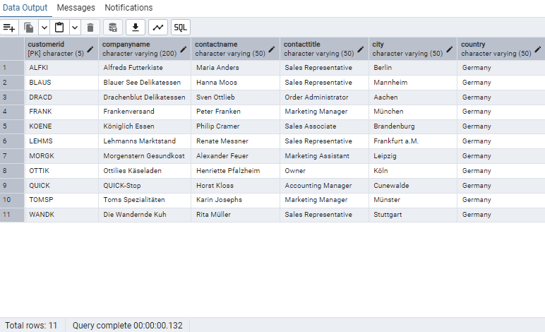

* Find all customers from France or Spain

SELECT * FROM customers

WHERE country ='Germany' OR country='Spain'

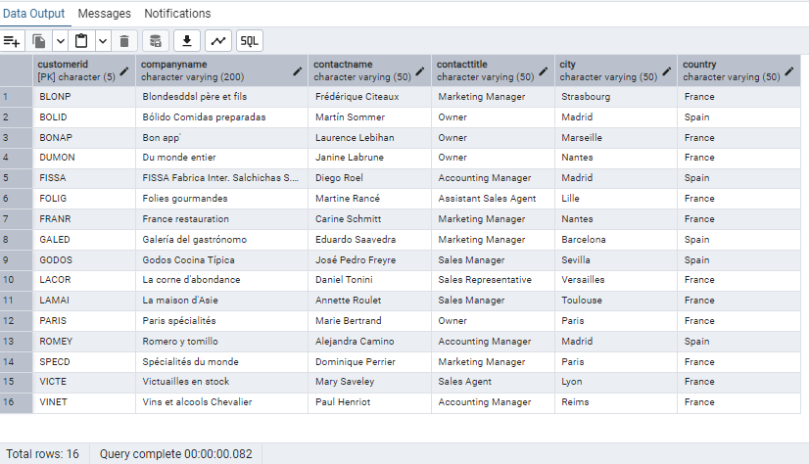

* Retrieve all orders placed in 2014(based on order_date), and either have freight greater than 50 or the shipped date available (i.e., non-NULL) (Hint: EXTRACT(YEAR FROM order_date))

SELECT * FROM orders

WHERE EXTRACT(YEAR FROM orderdate)=2013

AND (freight) >50 OR shippeddate IS NOT NULL

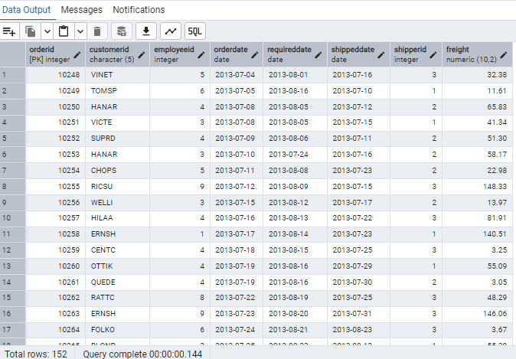

=========================================================

4) Filtering

--Retrieve the product_id, product_name, and unit_price of products where the unit_price is greater than 15

SELECT productid,productname,unitprice

FROM Products

WHERE unitprice>15

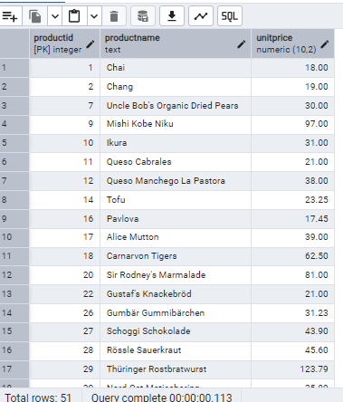

--List all employees who are located in the USA and have the title "Sales Representative".

SELECT * FROM employees

WHERE country='USA' AND title='Sales Representative'

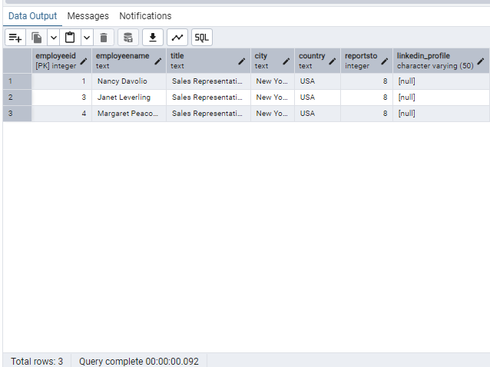

--Retrieve all products that are not discontinued and priced greater than 30.

SELECT * FROM products

WHERE discontinued = 'false' and unitprice > 30

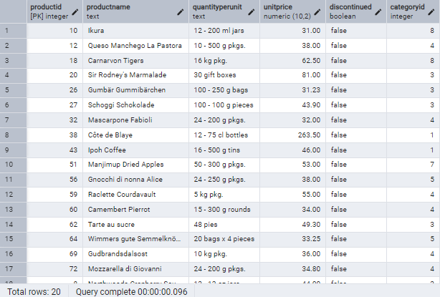

=========================================================

5) LIMIT/FETCH

-- Retrieve the first 10 orders from the orders table.

select * from orders

limit 10;

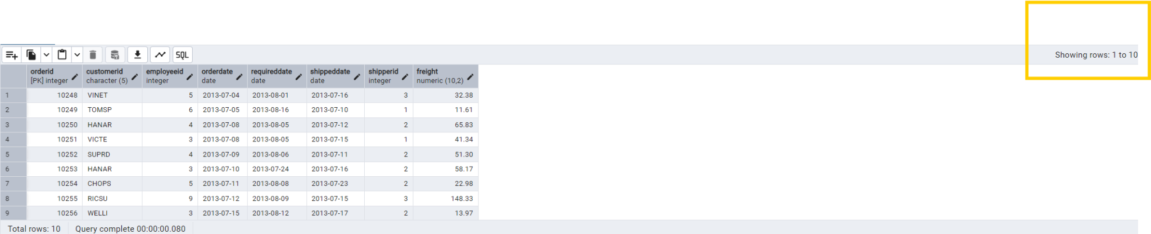

-- Retrieve orders starting from the 11th order, fetching 10 rows (i.e., fetch rows 11-20).

select * from orders

order by orderid

limit 10

offset 10

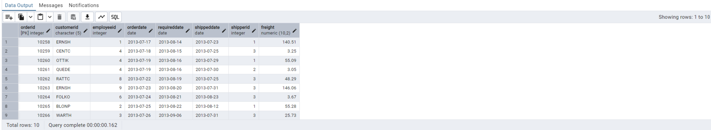

=========================================================

6) Filtering (IN, BETWEEN)

-- List all customers who are either Sales Representative, Owner

select * from customers

where contacttitle = 'Sales Representative' or contacttitle= 'Owner'

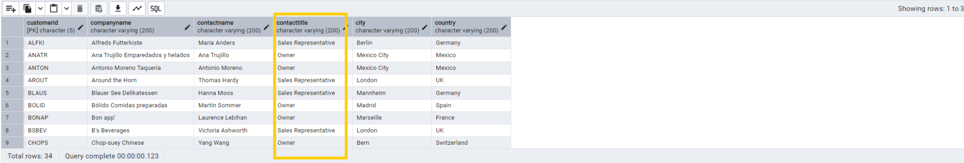

-- Retrieve orders placed between January 1, 2013, and December 31, 2013

select * from orders

where orderdate between '2013-01-01' and '2013-12-31'

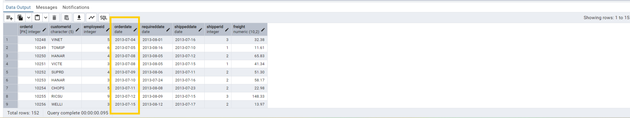

=========================================================

7) Filtering

List all products whose category_id is not 1, 2, or 3.

Find customers whose company name starts with "A".

--List all products whose category_id is not 1, 2, or 3.

SELECT * FROM products

WHERE categoryid NOT IN('1','2','3')

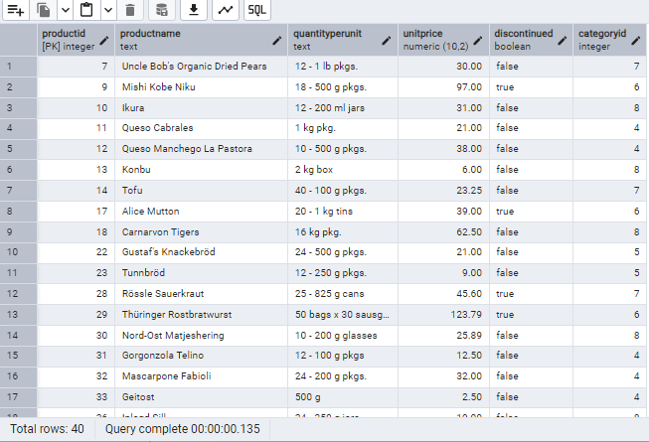

--Find customers whose company name starts with "A".

SELECT * FROM customers

WHERE companyname LIKE 'A%'

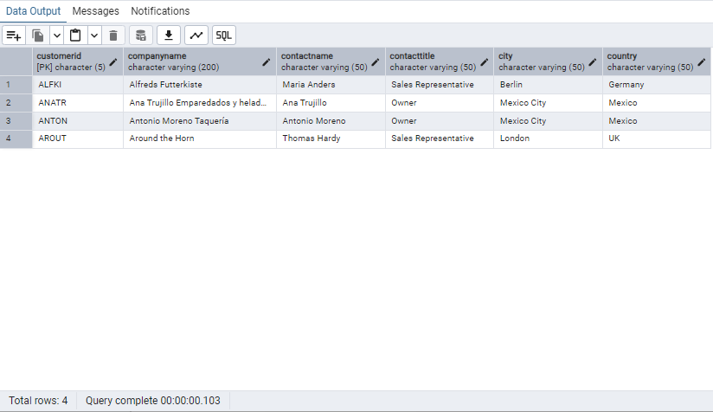

=========================================================

8) INSERT into orders table:

-- Task: Add a new order to the orders table with the following details:

--Order ID: 11078

--Customer ID: ALFKI

--Employee ID: 5

--Order Date: 2025-04-23

--Required Date: 2025-04-30

--Shipped Date: 2025-04-25

--shipperID:2

--Freight: 45.

insert into orders

VALUES (11078, 'ALFKI',5,'2025-04-23','2025-04-30','2025-04-25',2,45)

select * from orders

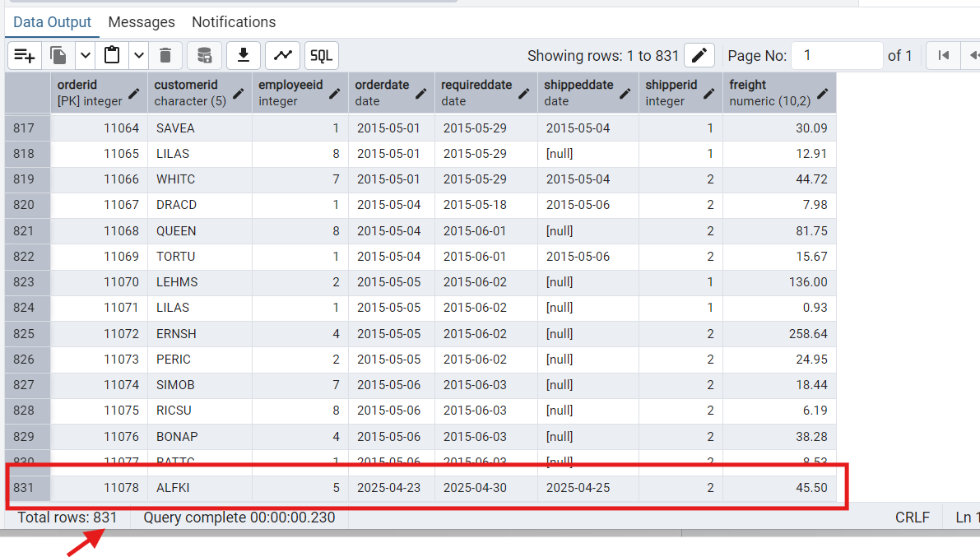

=========================================================

9) Increase(Update) the unit price of all products in category_id =2 by 10%.

(HINT: unit_price =unit_price * 1.10)

UPDATE products

SET unitprice=unitprice*1.10

WHERE categoryid= 2

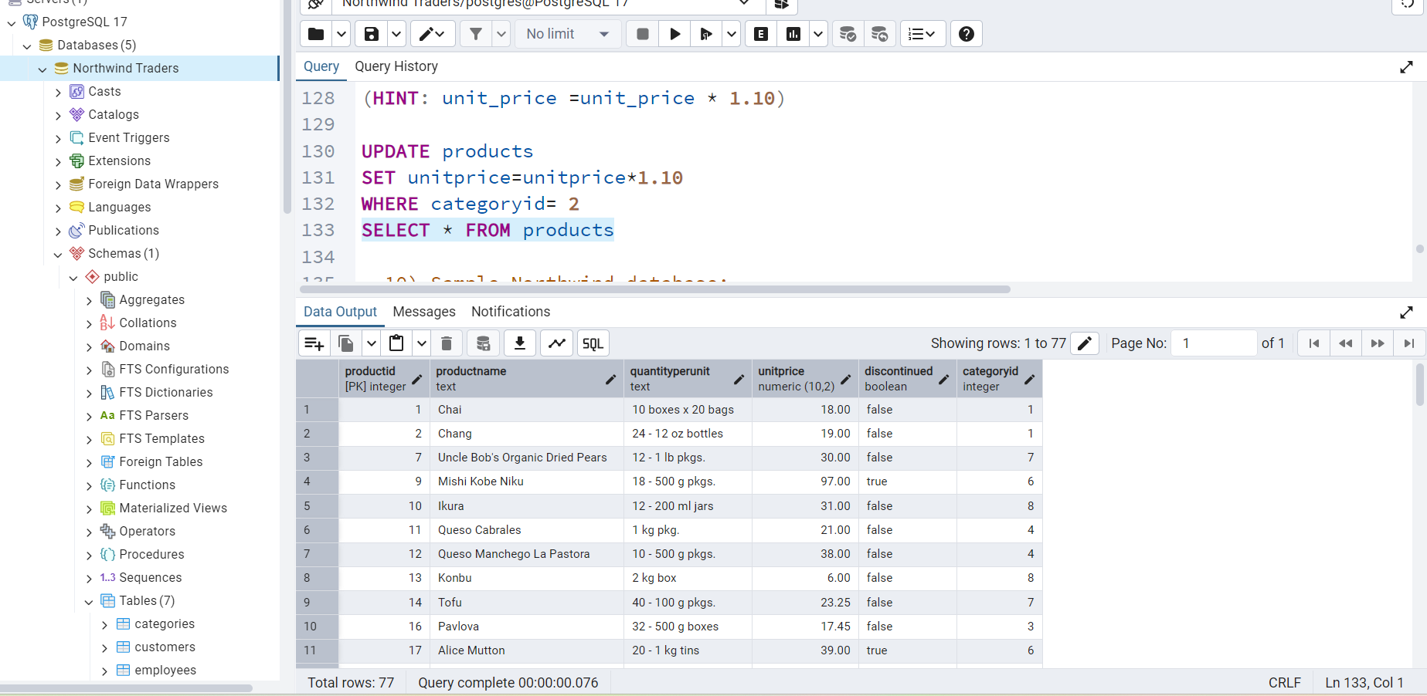

=========================================================

10) Added northwind databases

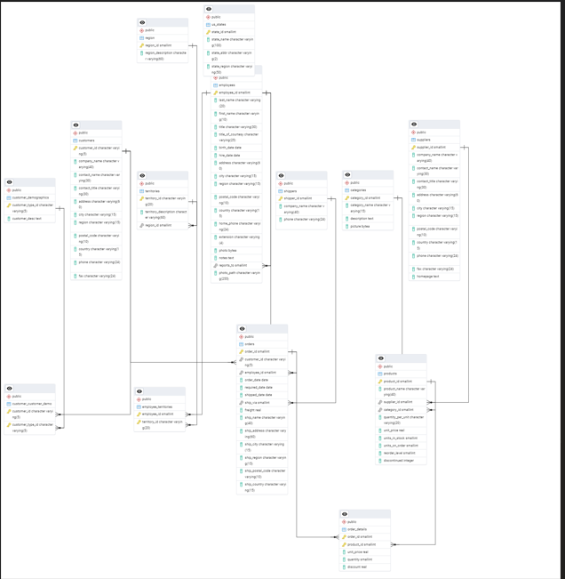

Tables:

