alter table public.products drop constraint categories;

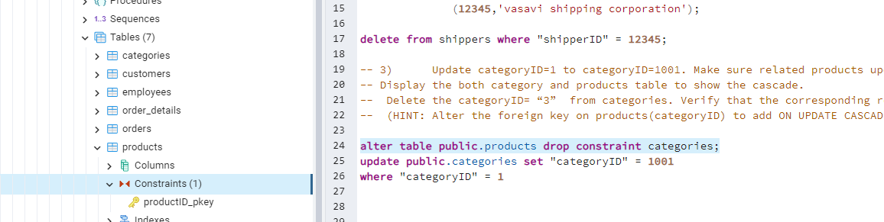

alter table public.products

add constraint fk_categories_categoryID

FOREIGN KEY ("categoryID") REFERENCES categories ("categoryID")

ON UPDATE CASCADE;



alter table public.order_details drop constraint order_details_product_fkey ;

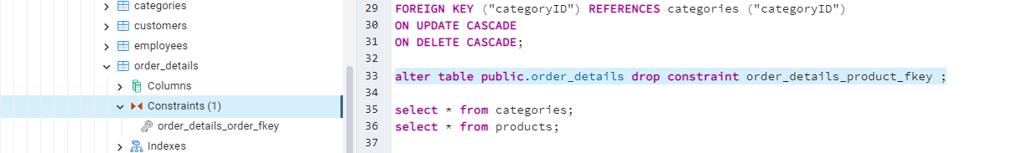

5.

6)      Write a **MERGE query**:

Create **temp table with name:**  ‘updated_products’ and insert values as below:

|  |  |  |  |  |  |
| --- | --- | --- | --- | --- | --- |
| productID | productName | quantityPerUnit | unitPrice | discontinued | categoryID |
| 100 | Wheat bread | 10 | 20 | 1 | 5 |
| 101 | White bread | 5 boxes | 19.99 | 0 | 5 |
| 102 | Midnight Mango Fizz | 24 - 12 oz bottles | 19 | 0 | 1 |
| 103 | Savory Fire Sauce | 12 - 550 ml bottles | 10 | 0 | 2 |

* Update the price and discontinued status for from below table ‘updated_products’ only if there are matching products and updated_products .discontinued =0

* If there are matching products and updated_products .discontinued =1 then delete

* Insert any new products from updated_products that don’t exist in products only if updated_products .discontinued =0.

