Day5

**1.GROUP BY with WHERE - Orders by Year and Quarter**

**Display, order year, quarter, order count, avg freight cost only for those orders where freight cost > 100**

select extract(year from orderDate) as order_year,

extract( quarter from orderDate) as order_quarter,

count(*) as order_count,

avg(freight) as avg_freight

from orders

where freight>100

group by

extract(year from orderdate ),

extract(quarter from orderdate)

ORDER BY

order_year,

order_quarter;

Output:

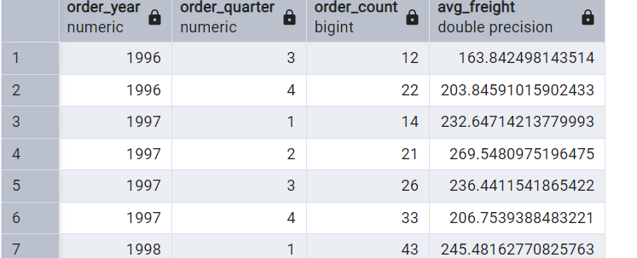

**---2. GROUP BY with HAVING - High Volume Ship Regions**

**--Display, ship region, no of orders in each region, min and max freight cost**

**--Filter regions where no of orders >= 5**

select shipperID,

count(*) as no_of_orders,

min(freight)as min_freight,

max(freight)max_freight

from orders

GROUP BY shipperID

HAVING COUNT(*) >= 5

ORDER BY no_of_orders DESC;

Output:

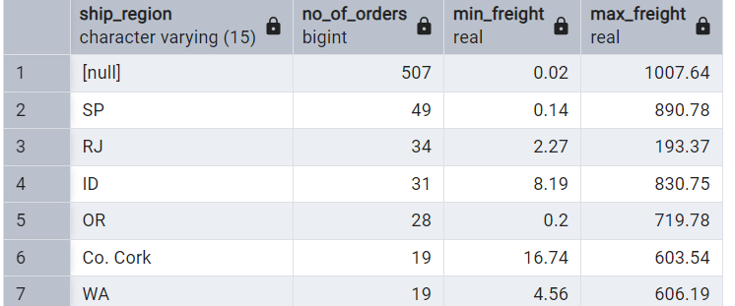

**----3.Get all title designations across employees and customers ( Try UNION & UNION ALL)**

-- Union(without duplicates)

SELECT title

FROM employees

UNION

SELECT contact_title

FROM customers;

Output:

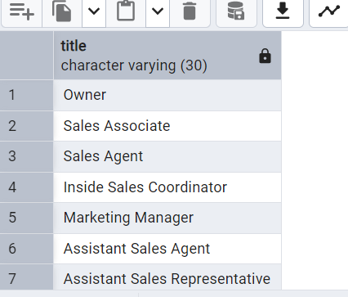

-- Union all(with duplicates)

SELECT title FROM employees

UNION ALL

SELECT contact_title

FROM customers;

Output:

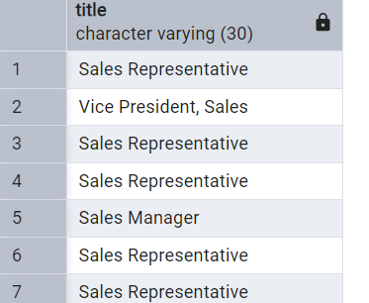

----4.Find categories that have both discontinued and in-stock products

---(Display category_id, instock means units_in_stock > 0, Intersect)

select category_id

from products

where discontinued=1

intersect

select category_id

from products

where units_in_stock>0

output:

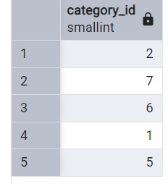

---5.Find orders that have no discounted items (Display the order_id, EXCEPT)

SELECT order_id

FROM orders

EXCEPT

SELECT DISTINCT order_id

FROM order_details

WHERE discount > 0;

Output:

