**🇮🇳 India General Election Results 2024 - Power BI Dashboard**

📅 **Voting Dates:** April 19 – June 1, 2024  
📊 **Result Declared:** June 4, 2024

**📌 Project Overview**

This Power BI project provides a **comprehensive visual analysis** of the **India General Election Results – 2024**, offering deep insights into the voting trends, party performance, and seat distribution across alliances and states. The dashboard enables researchers, political analysts, and the public to interactively explore the electoral data at national, state, and constituency levels.

**🧭 Navigation**

The project includes **six interactive dashboards**:

1. **🧮 Overview Analysis**
   * Total seats won by **NDA**, **I.N.D.I.A.**, and **Other/Independent** parties.
   * Percentage seat share.
   * Party-wise performance breakdown with logos.

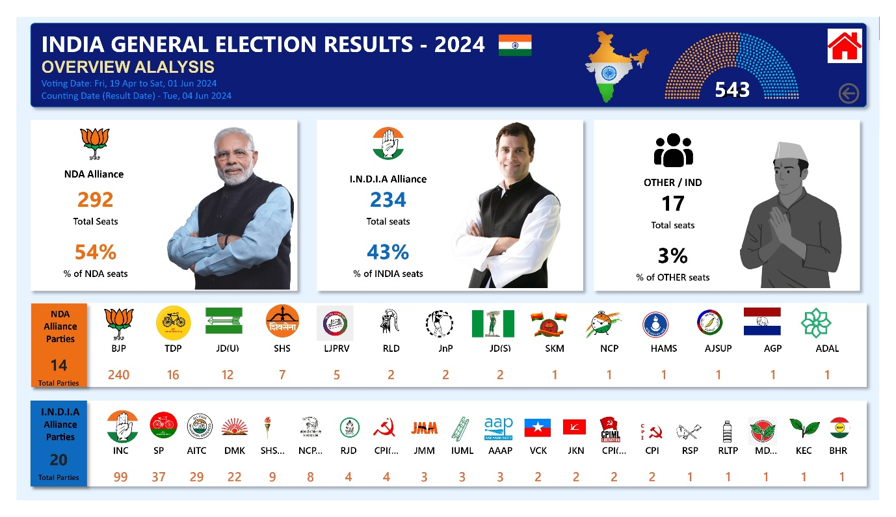

1. **🗺️ State Demographic Analysis**
   * State-wise map showing alliance-wise seat distribution.
   * Winning candidate data by constituency (bubble map).
   * Identification of states with alliance majorities.

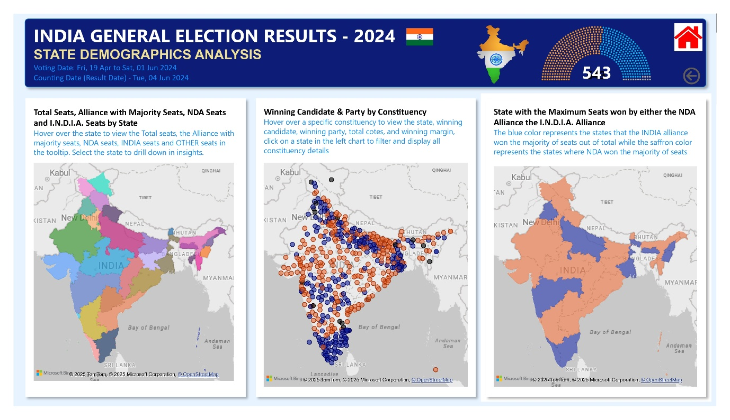

1. **🏛️ Political Landscape by State**
   * State selection filter.
   * Party-wise seat count in selected state.
   * Donut chart showing seat share by party.

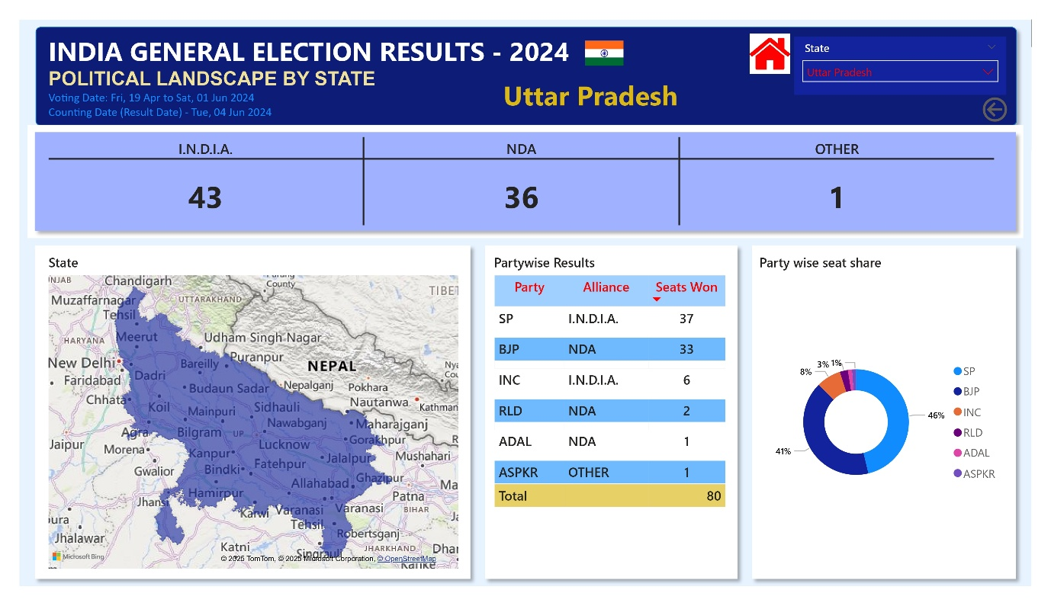

1. **🏙️ Constituency Analysis**
   * Voter turnout, EVM & postal votes.
   * Top 3 candidates with vote share and margins.

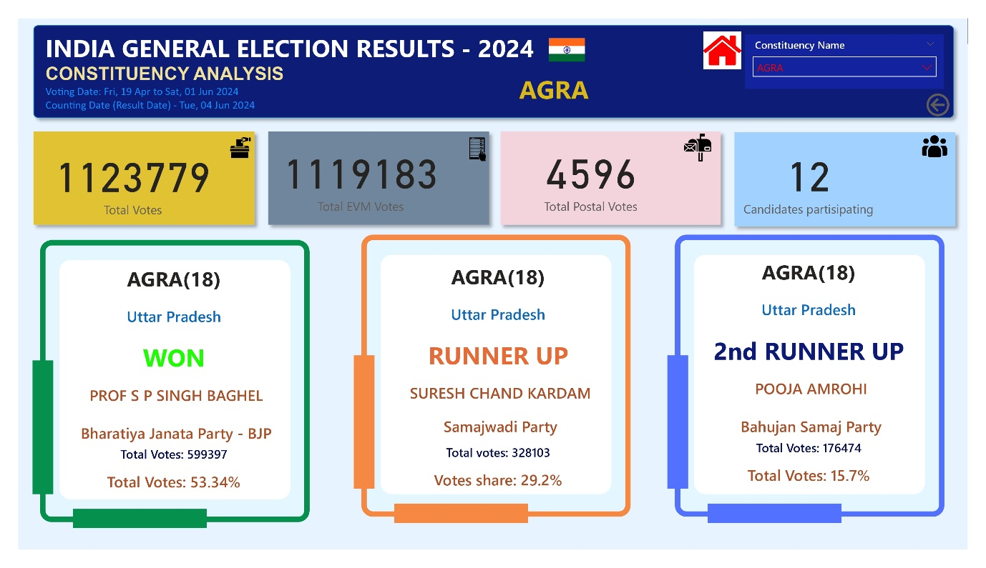

1. **📋 Details Grid**
   * Tabular view of all constituency-level results.
   * Drill-through from other dashboards.
   * Export to Excel option.

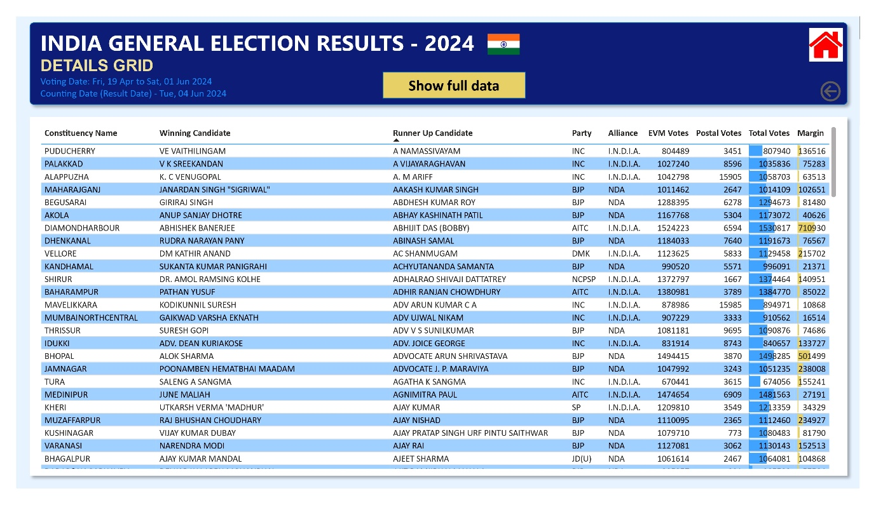

1. **🏠 Landing Page**
   * Central hub for navigation between dashboards.
   * Clean, interactive UI with tooltips and responsive design.

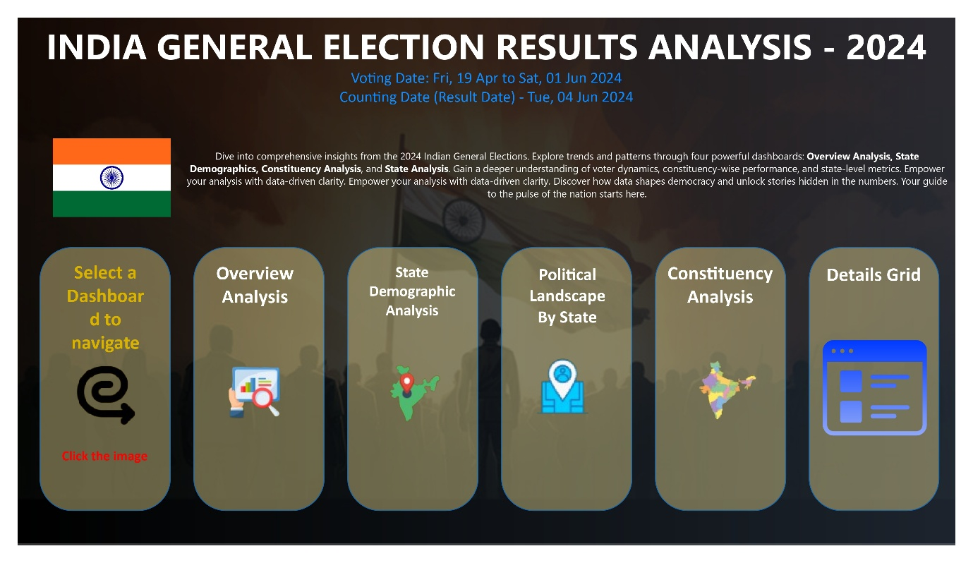

🚨 *Note: Due to size limitations or GitHub restrictions, the .pbix Power BI file may need to be stored in a separate release or cloud link (e.g., Google Drive, OneDrive).*

**🧮 Data Model**

Below is the data model used in the Power BI report. It defines the relationships between different tables including constituency results, party performance, and state-level mappings.

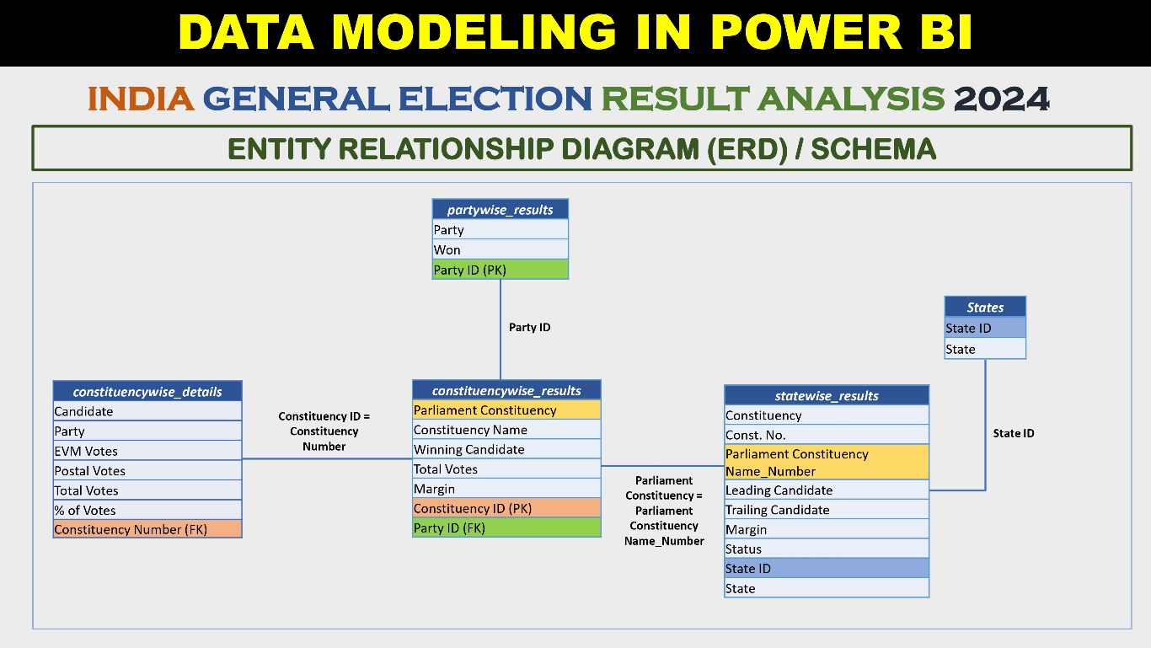

**🛠️ Tech Stack**

* **Power BI Desktop**
* **DAX** for calculated metrics
* **Bookmarks & Drill-throughs** for interactivity
* **Custom visualizations** (maps, donut charts, grids)

**📊 Key KPIs Covered**

* Seats by Alliance (NDA, I.N.D.I.A., Others)
* State-wise party distribution
* Candidate-wise vote margin
* Constituency-level analysis
* Map-based visual insights

**🧠 Insights You Can Derive**

* Which party or alliance dominated a specific state?
* Which candidate had the largest winning margin?
* How did NDA and I.N.D.I.A. perform in key battlegrounds?
* What trends emerge from voter turnout and vote shares?