**COLLEGE MANAGEMENT**

**A PROJECT SUBMITTED BY**

**KAKI SYAMALA SAI JAYA MADHURI**

**(REGD.NO:421206421015)**

**IN THE PARTIAL FULFILLMENT OF REQUIREMENTS FOR THE AWARD OF THE DEGREE OF**

**MASTER OF SCIENCE**

**In**

# COMPUTER SCIENCE

**UNDER THE GUIDANCE OF**

**ASSOCIATE PROF. DR K RAJA KUMAR**



**DEPARTMENT OF INFORMATION TECHNOLOGY AND COMPUTER APPLICATIONS**

**ANDHRA UNIVERSITY**

**VISAKHAPATNAM - 530003**

**(2021-2023)**

**DEPARTMENT OF INFORMATION TECHNOLOGY AND COMPUTER APPLICATIONS**

# ANDHRA UNIVERSITY

# VISAKHAPATNAM-530003



# CERTIFICATE

THIS IS CERTIFY THAT THE PROJECT REPORT ENTITLED **”COLLEGE MANAGEMENT”,** IS THEBONAFIDE WORK CARRIED OUT BY **KAKI SYAMALA SAI JAYA MADHURI** WITH **REGD. NO : 421206421015,** A STUDENT OF MSC IN AU COLLEGE OFENGINEERING (A), ANDHRA UNIVERSITY, VISAKHAPATNAM, DURING THE YEAR 2021-2023, IN PARTIAL FULFILLMENT OF THE REQUIREMENTS FOR THEAWARD OF DEGREE OF MASTER OF SCIENCE.

**ASSOCIATE PROF. DR K RAJA KUMAR PROF. KUNJAM NAGESWARA RAO PROJECT GUIDE HEAD OF THE DEPARTMENT**

**DEPARTMENT OF IT & CA DEPARTMENT OF IT & CA**

**AU COLLEGE OF ENGINEERING (A) AU COLLEGE OF ENGINEERING (A)**

**ANDHRA UNIVERSITY ANDHRA UNIVERSITY**

**VISAKHAPATNAM - 530003 VISAKHAPATNAM- 530003**

# ACKNOWLEDGEMENT

I Would Like To Show My Greatest Appreciation To **ASSOCIATE PROF. DR K RAJA KUMAR,** Enough For His Tremendous Support And Help. Without His Encouragement And Guidance This Project Would Not Have Materialized.

I Would Like To Thank **Prof. K NAGESWARA RAO**, Head Of The Department, Information Technology And Computer Applications, AndhraUniversity College Of Engineering (A), For His Encouragement And Valuable Guidelines In Bringing Shape To The Dissertation.

I Am Sincerely Thankful To **Prof. G. Sasi Bhusana Rao , PRINCIPAL**, For The Valuable Support .

I Would Like To Thank Teaching Staff And Non-Teaching Staff Members of the

Department Of Information Technology And Computer Applications, AndhraUniversity College Of Engineering (A), Visakhapatnam, For Their Constant Support In Successful Completion of My Study .

Finally, I Express My Indebtedness To My Beloved Parents And Friends Without Whose Blessings Encouragement I Would Not Have Completed My Work Fruitfully.

**KAKI SYAMALA SAI JAYA MADHURI**

**( 421206421015 )**

## DECLARATION

I Declare That The Project Report Entitled, Malicious “**COLLEGE MANAGEMENT”** Has Been Done By Me In Partial Fulfillment Of Requirement For The Award Of Degree, Of **“ Master Of Science ”**, During The Academic Year 2019-21 Under The Guide Of **“** **ASSOCIATE PROF. DR K RAJA KUMAR”,** Department Of Information Technology And Computer Applications, AU College Of Engineering (A), AndhraUniversity, Visakhapatnam. I, Here By Declare That This Project Work Has Not Been Submitted To Any Other Universities/Institutions For The Award Of Any Degree.

PLACE : VISAKHAPATNAM KAKI SYAMALA SAI JAYA MADHURI

DATE: (421206421015)

# 

# ABSTRACT

This project is based on COLLEGE MANAGEMENT SYSTEM, a web based application meat for helping institutions. It is a piece of software that helps run the college daily administrative and academic operations smoothly from afar. It manages the records of college and students easily like student details, placement information, various types of events on in the college, it also keeps track records of all the information regarding students those who are placed in the various Organizations.

Achieving this objective is difficult using a manual system like Excel as the information is scattered, can be redundant and collection relevant information may be very time-consuming. All these problems are solved using this project. Admin is the super user of this project. All the record stores in MYSQL database. The proposed software will also reduce the cumbersome paperwork, manual labor as well as communication cost.

Whenever we want, we can easily export the records stored in database to excel. Editing, Viewing, Removing records is easy. Students can access the site to fill their details, surveys and update their details any time through login. Only admin can register and login to the application, he will manage the application further.

.

**Index**

**Contents**

**Chapter - 1 : Introduction**

**1.1 Introduction ……………………………**…**………………...…..1**

**1.2 Problem statement ………………………………………….…1**

**1.3 Motivation ……………………………………………….…….2**

**1.4 Objective ………………………………………………….……2**

**1.5 Scope ………………………………………………...………....2- 3**

**1.6 Existing system …………………………………………….….3**

**1.7 Proposed system ………………………………………….…...3**

**Chapter - 2 :Literature survey ………………………………….…..…....4**

**Chapter - 3 : System Analysis**

* 1. **Requirement Analysis ……………………………………..…5**
  2. **Functional Requirements ……………………………….…...5-6**
  3. **Non-Functional Requirements ……………………………....6**

**Chapter - 4 : System Configuration**

* 1. **Software Requirements …………………………………..…..7**
  2. **Hardware Requirements …………………………………..…7**

**Chapter -5 : System Design**

* 1. **System Architecture …………………………………………..8-9**
  2. **Design ………………………………………………………….9**
  3. **UML Diagrams**
     1. **Use Case Diagram ……………………………..……10-11**
     2. **Activity Diagram …………………………………....11-12**
     3. **Class Diagram ……………………………………... 13**
     4. **ER Diagram ………………………………………... 13-14**
     5. **Sequence Diagram …………………………………..14-15**

**Chapter - 6 : Coding ………………….……………………………….…16-18**

**Chapter - 7 : Screen Shots …………………………………………..….…19-21**

**Chapter - 8 : Implementation ………………………………….….….....22**

**Chapter - 9 : Testing**

**9.1 Types of Testing …………………...………………..………….23**

**9.2 Test cases …………………………………………….…………24-25**

**Chapter - 10 : Conclusion &Future Enhancements ……………………..26**

**Chapter - 11 : Biblography ………………………………………………..27**

**CHAPTER - 1:**

**PROJECT INTRODUCTION**

* 1. **INTRODUCTION -**

The College management system is the ultimate solution to digitize and streamline the day - to - day operations of colleges and universities. From student details management to college details management and placement details to higher education details. The approach of software has several benefits. It has an email Id and password for all the process connected to the college.

The design and implementation of the system is to provide service in institute and colleges. The system is to provide comprehensive student information system and user interface is to replace the current paper records. Students and admin having different user interfaces, admin can access student home page also. Admin should add records of the events and operations of the college, he can edit details any time and can remove the records.

The data stored in the database can be downloaded in the form of excel sheets using a download button. All these will be available for future references too. Searching will become more efficient and faster in comparison to manual searching. Overall, it will reduce the cost and time of the college head in taking care of the college.

* 1. **PROBLEM STATEMENT -**

There is a problem with traditional college management system because it didn’t have a systematic way to store information about students. When the staff or administrator wants to record the details of a student, they must fill out a paper form or manually enter in excel sheets. The data might be lost if there are a lot of problems at the same time.

There is a problem with traditional college management system because it didn’t have a systematic way to store information about students. When the staff or administrator wants to record the details of a student, they must fill out a paper form or manually enter in excel sheets. The data might be lost if there are a lot of problems at the same time.

* 1. **MOTIVATION -**

The motivation behind developing a college management application, is to store details of students, events and operations of college in an efficient way. The software facilitates the administrators to know the present status of the student of the college.

It will generate the reports of all the students of a particular section. Hence, we conclude that the present system (CMS for colleges) would help the user by saving time and effort by reducing the processing time and volume of errors. The efficiency of the work done would be improved and work satisfaction on the part of the users after computerization would on high.

So, the motivation for our project came from that it has been made for that purpose, and for trying hardly to achieve all the previous goals.

* 1. **OBJECTIVE -**
* The main objective of the project is to build a responsive website to manage the different college activities.
* To track student's details and performance.
* To make a virtual community between the members of educational process.
* College management system provides one attractive environment where you can manipulate data and information about students and staff easily.
* The core purpose of designing the application is to manage the task related to the college students/staff and to reduce time to searching of appropriate candidates in college view.
  1. **SCOPE -**

Without a **college management system**, managing and maintaining the details of the student is a tedious job for any organization. Student information will be stored including their background information, educational qualifications and personal details.

This system is designed to be easy for people to use and efficient for a wide range of different tasks. These tasks may include things like registering new students, managing activities, managing placements, and all the other things that make the department of the college work well.

* In computer system the person must fill the various forms & number of copies of the forms can be easily generated at a time.
* In computer system, it is not necessary to create the manifest but we can directly print it, which saves us time.
* To assist the staff in capturing the effort spent on their respective working areas.
* It satisfies the user requirement.
* Be easy to understand by the user and operator.
  1. **EXISTING SYSTEM -**

Some of the drawbacks which force us to plan this whole idea of developing an online college management system, initially college must maintain records of the events and students using excel sheets and they enter details manually, it is hard to use excel. If we want student details, then staff must enter the details of each student.

If we want to store the file uploads then, it will be hard to store using excel and retrieve whenever we want. Update and delete doesn’t work efficiently in excel sheets.

Suppose if some student comes and asks for the profile changes after few days then the staff will open the file and search it manually for the student's name which will take time. In conclusion, this project can avoid these problems effectively and efficiently.

* 1. **PROPOSED SYSTEM -**

This is a web-related application that permits us to approach the entire knowledge regarding the college, students etc. This application is called as college management system. It offers an actual trip of the college campus. Here we would gain the recent knowledge regarding the college.

This general application planned for managing the student and college details. It also allows staff to upload relevant documents about the events and operations done in the college. The administrator would maintain the project by adding new records, updating existing, removing the records and exporting the data in the form of excel sheets.

To solve few problems with manual entry and in excel sheets, this new system has been created, that attempts to operate the whole procedure considering the database integration approach.

**CHAPTER - 2:**

**LITERATURE SURVEY**

Over the years, CMS has gained significant attention in the field of education, and a considerable amount of research has been conducted to explore its potential benefits. According to the literature, the primary objective of CMS is to improve the efficiency of college operations and provide better services to students, teachers, and administrative staff. One of the primary benefits of CMS is that it simplifies complex administrative tasks such as admission, enrolment, attendance, scheduling, and examination management. A study by Ahmed and Omar (2018) revealed that CMS significantly reduces the time and effort required for these activities, thereby enabling administrators to focus on more important tasks such as improving the quality of education. CMS also provides a platform for effective communication between students, teachers, and administrative staff. According to Khan (2019), CMS facilitates online discussion forums, feedback mechanisms, and messaging systems that improve communication between stakeholders, leading to better collaboration and greater transparency. Another significant benefit of CMS is its ability to improve the quality of education. CMS provides teachers with tools for managing courses, creating and sharing course materials, and monitoring student progress.

The system provides guidance to the admin to keep track of each student. The admin has the access to database of the system. In an educational institute, management is crucial thing. So, in order to reduce the efforts of staff we are introducing our system. This system comes on with much functionality like Authenticating user, adding records, updating records, deleting records and downloading records into excel sheets.

This system is a paperless system. Overall reduces the man power and time required. In this section we present reviews of related research papers:

Author ‘**Lalit Joshi**', “A research paper on **college management system**” (2015), International journal of computer applications, referred that the system utilizes user authentication, displaying only information necessary for an individual’s duties. Additionally, each sub-system has authentication allowing authorized users to create or update information in that subsystem.

**College department management system** (2018) proposed by **Ms.A.V.Sinhasane**, **Ms.A.N.Kashid** from international research journal of engineering and technology which is introduced to reduce the stress and efforts of a staff as well as students.

**CHAPTER - 3:**

**SYSTEM ANALYSIS**

**3.1 REQUIREMENT ANALYSIS -**

Requirements analysis is a crucial phase in the software development process where the software requirements are identified, analyzed, documented, and prioritized. This process helps to ensure that the software being developed meets the needs and expectations of its intended users and stakeholders. Requirements analysis typically involves gathering information about the needs and requirements of the users and stakeholders, defining the scope of the software, identifying the functional and non-functional requirements of the software, and documenting the requirements in a detailed and structured manner. The requirements analysis process can include various techniques, such as interviews, surveys, observations, and focus groups, to gather information about the requirements.

* Requirements analysis is the process of identifying and documenting the needs and expectations of the users and stakeholders for a software project.
* It also helps to ensure that the software development team has a clear understanding of what needs to be developed, tested, and delivered.
* This process helps to identify potential issues and risks that may impact the software development process, such as conflicting requirements or missing requirements.

**3.2 FUNCTIONAL REQUIREMENTS -**

Functional Requirement defines a function of a software system and how the system must behave when presented with specific inputs or conditions. These may include calculations, data manipulation and processing and other specific functionality.

In this system following are the functional requirements:

* The system allows authentication and authorization for the users.
* It will help in storing details of college and students.
* We can upload relevant files in the database.
* We can download the data inside the database in the form of excel sheets.
* Admin can able to manage the system like updating functionality.
* Students will be having different UI they can access only few things.
* Admin can access students as well as admin UI.

**3.3 NON-FUNCTIONAL REQUIREMENTS -**

It is a requirement specification that specifies criteria that can be used to judge the operations of a system rather than specific behavior. These requirements are also called quality attributes of a system as these include the majority those metrics that define the standard and quality for the system, some of the parameters coming under this includes Performance, Security etc.

* **Performance**: The system should be able to add, update, delete records quickly and accurately, with minimal delay or lag.
* **Accessibility**: The system should be accessible to users with different levels of physical ability, and be designed with usability best practices in mind.
* **Security**: The system should be secure, with appropriate measures in place to prevent unauthorized access or malicious attacks.
* **Usability**: The system should be intuitive and easy to use, with clear instructions and feedback for users.
* **Availability**: The system should be always available to users, with minimal downtime for maintenance or updates.

**CHAPTER - 4:**

**SYSTEM CONFIGURATION**

**4.1 SOFTWARE REQUIREMENTS -**

These are the requirements which are not directly concerned with the specific function delivery by the system. They specify the criteria that can be used to judge the operation of a system rather than specific behaviors

**The software requirements are:**

Operating system : Windows 7/8/10

Coding Language : JavaScript

Tools : VS Code

Backend : NodeJS

Front End : React

**4.2 HARDWARE REQUIREMENTS -**

In this system following are the hardware requirements:

System : Intel I3 or higher.

Hard Disk : 120 GB.

Monitor : 15’’ LED

Ram : 8 GB or higher

**CHAPTER - 5:**

**SYSTEM DESIGN**

**5.1 SYSTEM ARCHITECTURE -**

System architecture refers to the design and structure of a computer system, including its hardware, software, and other components, as well as their interactions and relationships. A good system architecture is essential for building complex systems that are reliable, scalable, maintainable, and adaptable.

The system architecture for COLLEGE MANAGEMENT SYSTEM could include several components, such as:

**User Interface**

**logout**

**save to database**

**Manipulate Records**

**Authentication**

Fig: System Architecture

**User Interface**: Finally, the user interface module would provide a graphical user interface (GUI) for the user to interact with the system.

**Authentication**: User first authenticated. Whether user is admin or not by credentials like email id and password.

**Manipulate Records**: Admin can manipulate records like adding records, updating, deleting and downloading.

**Data Stored to Database**: After admin changes the data then newly entered data is submitted to database.

**Logout**: After that admin can logout from the application.

**5.2 DESIGN -**

The design of the college management system, to create an accurate, reliable and easy-to-use system, several key design considerations must be taken into account. Firstly, the system architecture should be designed in a scalable and modular way to accommodate the various components of the project.

The user interface is also a critical component of the design, and should be intuitive and easy to use.

**start**

**login**

**Register**

**Admin Home page**

no

yes

**student Home page**

yes

**Manipulate records**

**stop**

Fig: Flow chart for college management system

**5.3 UML DIAGRAMS -**

**5.3.1 USE CASE DIAGRAM -**

A use case diagram is a type of UML diagram that represents the interactions between actors and the system. Actors are external entities

that interact with the system, while use cases are the actions or services that the system provides to the actors. The use case diagram is a dynamic representation of the system, meaning that it shows how the system behaves over time.

The purpose of a use case diagram is to provide a high-level view of the system's functionality and the interactions between actors and the system. Here are some of the key benefits of using a use case diagram:

1. It helps identify the user requirements by identifying the actors and the use cases they need to perform.

2. It helps identify the boundaries of the system by showing which actors are external to the system.

3. It can be used to develop test cases that validate the system's behavior.

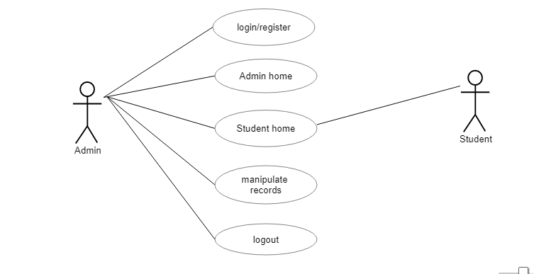

**5.3.2 ACTIVITY DIAGRAM -**

This is the Activity diagram of college management system which shows the flow between the activity of college, students, events, login. The main activity involved in this UML Activity diagram of college management system are as follows:

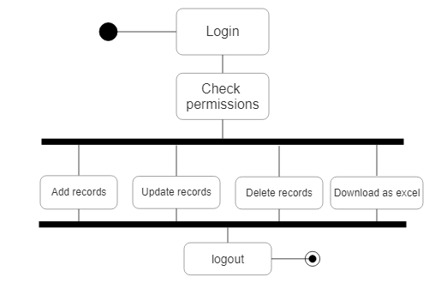

This is the login activity diagram of college management system, which shows the flows of login activity, where admin will be able to login using their E-mail and password. After login user can manage all the operations.

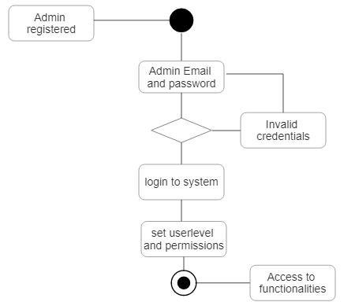

**5.3.3 CLASS DIAGRAM -**

College management system class diagram describes the structure of a college management system classes, their attributes, operations (or methods), and the relationships among objects. The main classes of the college management system are users, activities, collaborative activities, placements etc.

* Users class: Manages all the operations of users.
* Higher Education class: Manages all the operations of Higher education.
* Placement class: Manages all the operations of placements.
* Collaborative Activities class**:** Manages all operations of Collaborative activities etc.

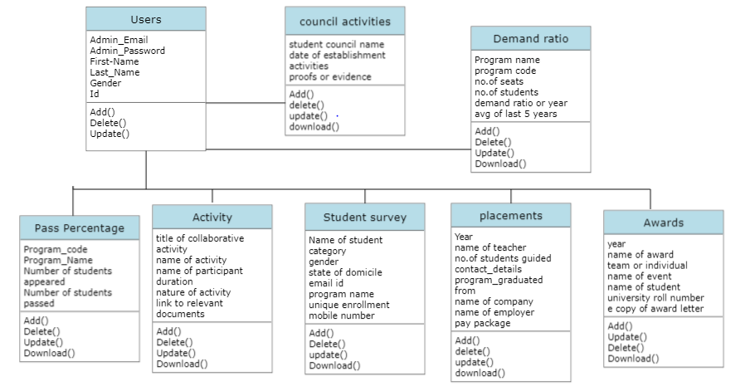

**5.3.4 ER DIAGRAM -**

The ER (Entity Relationship) Diagram represents the model of college management system entity. The entity-relationship diagram of college management system shows all the visual instrument of database tables and the relations between Users, Activity, Placements, Demand ratio etc. It used structure data and to define the relationships between structured data groups of college management system functionality.

The main entities of the college management system are users, activity, demand ratio, placements etc.

College Management System entities and their attributes:

**Users Entity**: Attributes of users are Admin_Id, Admin_password, First_Name, Last_Name etc.

**Activity Entity**: Attributes of activity are Title, Name of activity, Name of participant, Duration, Year of collaboration.

**Demand Ratio**: Attributes of Demand ratio are Program code, program name, number of seats available etc.

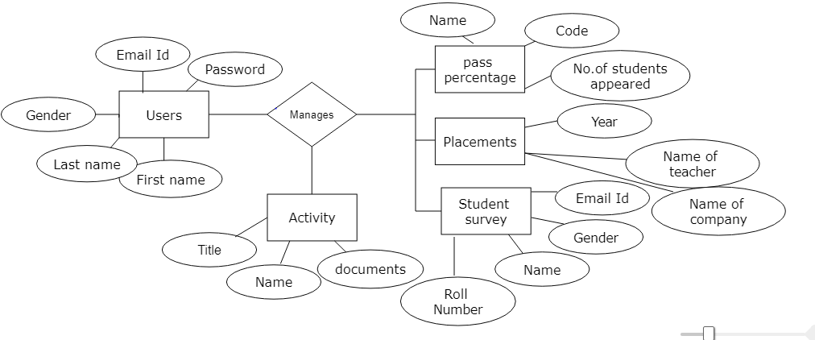

**5.3.5 SEQUENCE DIAGRAM -**

This is a Login sequence diagram of college management system, where admin will be able to login in their account using their credentials. After login user can manage all the operations on college tables and

student tables. The diagram below helps demonstrate how the login page works in a college management system. The various objects in the users, activity, demand ratio etc. Page interacts over the course of the sequence, and user will not be able to access this page.

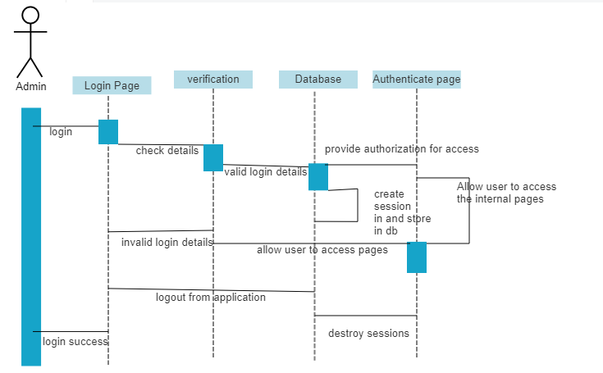

**CHAPTER - 6:**

**CODING**

**BACKEND API’S -**

const app1 = require('./routes/BtechRouter');

const app2 = require('./routes/MtechRouter');

const app3 = require('./routes/MscORMca_Router');

const app4 = require('./routes/PlacementOutgoing_Router');

const app5 = require('./routes/CollaborativeActivities_Router');

const app6 = require('./routes/ValueAddedCourse_Router');

const app7 = require('./routes/DemadRatio_Router');

const app8 = require('./routes/AvgNumberOfDays_Router');

const app9 = require('./routes/Avgpasspercentage_Router');

const app10 = require('./routes/Awards_Router');

const app11 = require('./routes/Per_Students_Undertaking_Router');

const app12 = require('./routes/HigherEducation_Router');

const app13 = require('./routes/StudentComputerRatio_Router');

const app14 = require('./routes/CouncilActivity_Router');

const app15 = require('./routes/StudentSatisfactory_Router');

const app16 = require('./routes/login');

const excel = require('./routes/Excel');

const app = express();

app.use(morgan('dev'));

app.use(express.json());

app.use(cors());

app.use('/btech',app1);

app.use('/mtech',app2);

app.use('/mscormca',app3);

app.use('/placement',app4);

app.use('/activities',app5);

app.use('/',app6);

app.use('/demandratio',app7);

app.use('/avgnumberofdays',app8);

app.use('/avgpasspercentage',app9);

app.use('/awards',app10);

app.use('/internships',app11);

app.use('/highereducation',app12);

app.use('/computerratio',app13);

app.use('/councilactivities',app14);

app.use('/studentsatisfactory',app15);

app.use('/',app16);

app.use('/download',excel);

**Pseudo Code for Creating a server:**

const http = require(‘http’);

Function handleRequest(request, response) {

response.writeHead(200, { ‘Content-Type’: ‘text/plain’});

}

const server = http.createServer(handleRequest);

server.listen(3000, ‘localhost’, () =>{

console.log(‘Server is running on <http://localhost:3000’);>

});

**CHAPTER - 7:**

**SCREEN SHOTS**

**HOME PAGE:** Common home page

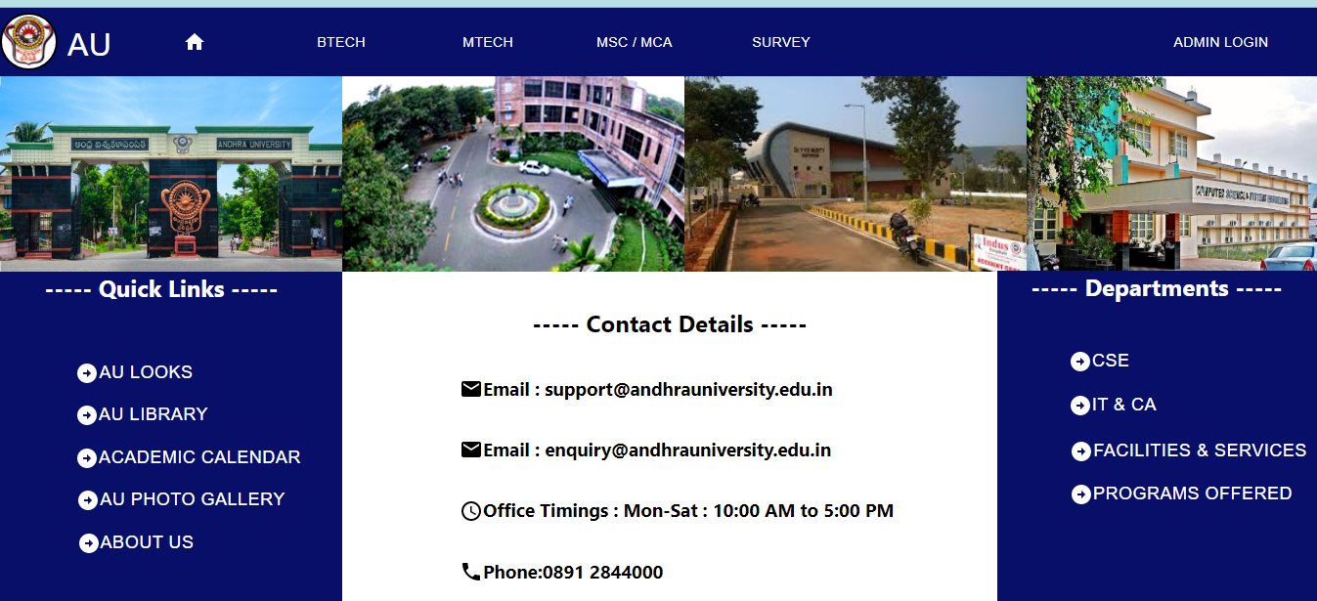

**LOGIN PAGE:** Admin and Students



**REGISTER PAGE:** Admin register page

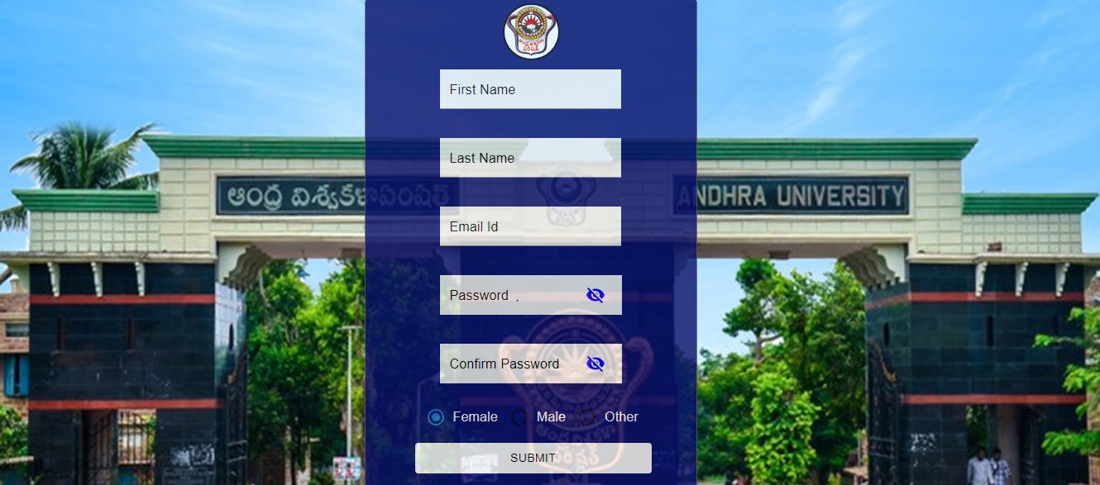

**ADMIN HOME PAGE:**

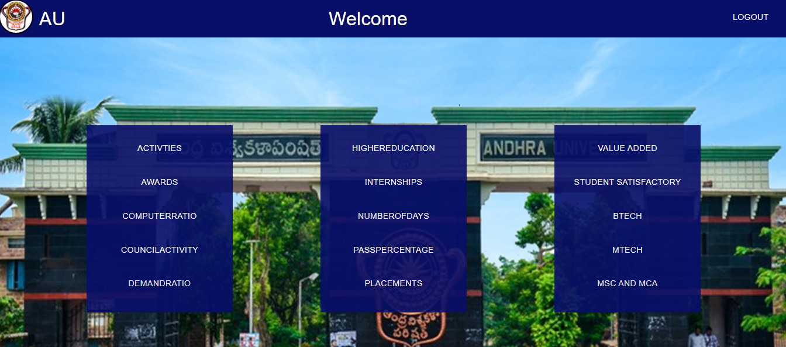

**STUDENT HOME PAGE:**

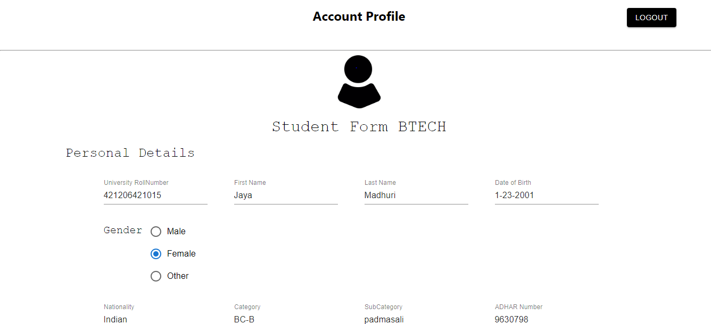

**CHAPTER - 8:**

**IMPLEMENTATION**

This application is developed to achieve a goal that Admin can be able to manage the details of college, student can get his/her required information including view their details, update their details when ever they want. Admin is fully authorized to update, read, delete and insert details of students, events in college, placements details and etc… at any time. This applications helps students to get their information online instead to visit the offices, it becomes easy to view and edit online instead to going to office and ask the management to update their details.

It will save paper work as the things work online through application. It will be very helpful to control and manipulate data and on just one query the required information will be on our screen. Instead to open files one by one and check manually things and wasting time.This application will saving time

Management system is a very important and essential part of any educational institute. The project defines the all management of College System. College management system means it controls all the management tasks and functions. It performs all functions which is require to any educational institute. Admin can view and change all record of the college.

Students can fill their course evaluation forms in the home page as surveys. Students and Admin can use the system through login first they have to authenticate then for admin the home page will be different and for student home page will be different.

Frontend is implemented using ReactJs a Scripting language in Visual Studio Code. Data is taken manually through front-end user interface.

Backend is implemented using NodeJs a framework in Visual Studio Code. Data is stored MySql. User can login and retrieve their data using this.

Middleware is implemented by MySql database, all the data added by the users stored here users can retrieve when they want.

**CHAPTER - 9:**

**TESTING**

Once the project implementation is completed then testing will start. Testing is one of the main phases it is a process of executing a program with the intent of finding in errors and bugs. Debugging is the process of loading the exact cause of an error in removing that cause. Software testing is a critical element of software quality assurance and represents the ultimate review of specifications, design and code generation. These techniques provide systematic guidance for designing tests that : Exercise the internal logic of software components, and exercise the input and output domains of the programs to uncover the errors in program function, behavior and performance.

**9.1 Types of Testing -** There are many types of testing methodologies but we use few of them in this project.

**Black box testing -** we used Black box testing. We give different type of inputs and check the output without any internal code knowledge.

**White box testing** - In this testing, we check all the loops and structure. We give input according to the loops and structure and check the output.

**Unit testing** - In this testing, whenever a module is finished we check it individually, means all the functions are checked individually.

**Interface testing** - we check if all the interactions between these applications are executed properly or not. Errors are handled properly or not. If database returns any error message for any query by application then it be should catch and display these error messages appropriately to users.

**Performance testing** - we test our project on different internet connection speed. In load testing test if user wants to perform so many functionalities at the same time, large input data from users, simultaneous connection to DB, heavy load on specific pages etc.

**9.2 Test cases -**

we have gone for unit testing and integration testing. So, we have initially concentrated on unit testing and for that we spend some time whenever we developed any new functions. This has been done during coding time as well as after the design whenever we use them. After the completion of unit testing, we have moved to integration testing and we completed it in one day.

|  |  |  |  |  |
| --- | --- | --- | --- | --- |
| S.No | Test case description | Expected Result | Actual Result | Status |
| 1 | Enter email and password | Go to Admin/Student home page | Go to home page | pass |
| 2 | register | Go to login page | Go to login page | pass |
| 3 | Save,update,delete,view details | Operation should be performed | successful | pass |
| 4 | See user information | Only admin | successful | pass |
| 5 | logout | Go to main home page | Go to main home page | pass |
| 6 | Records search | Operation should be perform | successful | pass |
| 7 | Download as excel | Excel file should be downloaded | Successful download | pass |
| 8 | Update student details | Update new details | Successful updation | pass |

**Sample Test Data and Result**

|  |  |  |  |
| --- | --- | --- | --- |
| S.No | Test case | Test data | Result |
| 1 | Enter email and password | [Email-421206421015@andhrauniversity.edu.in](mailto:Email-421206421015@andhrauniversity.edu.in)  Password - Auce@123 | Successfully login |
| 2 | Enter email and password | Email - [421206421015@gmail.com](mailto:421206421015@gmail.com)  Password - Auce@123 | Invalid email or password |
| 3 | Register as Admin | First name, Last name, email, password, gender | Successfully registered |
| 4 | Register as Student | Fill form according to their group then automatically account will be created | Successfully registered |

**CHAPTER - 10:**

**CONCLUSION & FUTURE ENHANCEMENTS**

Based on analysis, discussions and a review of previous chapters, the following have been established.

* The College management system application is a desktop application system with two main users Admin and Students. The system is placed on a centralized server accessible by all registered account holders by the administrator into the system( under particular user level ) at all times.
* The System allows its data to be shared, so it’s installed on a centralized server and run from client machines at any department. All the college details are stored in a centralized database.
* The system ensures strong security and confidentiality because of the tools, applications and methodologies that were employed during the design and development stages of the project. Email and password are always required to grant access.

During the development of the project certain functionality that I desired to include in the college management system but wasn’t possible because of time constraints can be considered in future systems. Some of these functionalities are:

1. Result management system
2. Library management system with bar code support
3. Complaint management
4. Seating management
5. Certificate builder and many more…

Future researchers are encouraged to use this as a reference point

**CHAPTER - 11:**

**BIBLOGRAPHY**

**References**

1. **[www.google.com](http://www.google.com)**
2. **[www.wikipedia.com](http://www.wikipedia.com)**
3. **[www.tutorialspoint.com](http://www.tutorialspoint.com) -** learn ReactJs full course
4. **[www.studytonight.com](http://www.studytonight.com) -** MySql Overview
5. **[www.stackoverflow.com](http://www.stackoverflow.com) -** How to use Excel in Nodejs
6. **[www.coursera.com](http://www.coursera.com) -** Course on Server - Side - Development using Nodejs,

Express, Mongodb.