***ANUDIP FOUNDATION***

A Project Report on

**“FASHION RECOMMENDATION SYSTEM”**

By

Batch: ANP-C7344

Student ID: AF0368540

Name: Jaya Mergu

**Under the Guidance of**

Mrs. Rajshri Chandrabhan Thete

FASHION RECOMMENDATION SYSTEM

A Fashion Recommendation System (FRS) utilize algorithms to analyze user preferences, style trends, and contextual data, delivering personalized clothing and accessory suggestions. They streamline the process of discovering new fashion items, helping users explore and discover styles that align with their tastes and preferences.

Top of Form

**Entities:**

* Admin
* User
* Fashion Item
* Occasion
* Weather
* Feedback
* Recommendation

**VARIOUS ENTITIES:**

1. **User**

* UserID(Primary Key)
* UserName
* Email
* Password(Hashed)
* Age
* Gender
* Location
* BodyType
* PreferredStyles
* FavoriteColors

1. **Admin**

* AdminID(Primary Key)
* Email
* PhoneNo
* Permissions

1. **FashionItem**

* ItemID(Primary key)
* ItemName
* ItemType
* Material
* Brand
* Color
* Size
* Seasson
* Occasion

1. **Occasion**

* OccasionID(Primary Key)
* Description

1. **Weather**

* WeatherID
* Temperature
* Humidity
* WeatherType
* Windspeed

1. **Feedback**

* FeedbackID
* RecommendationID
* Rating
* Comment

1. **Recommendation**

* RecommendationID
* FashionItem
* FashionName
* WeatherID
* Occasion
* Brand
* Color

**ENTITY RELATIONSHIP DIAGRAM – FASHION RECOMMENDATION SYSTEM**

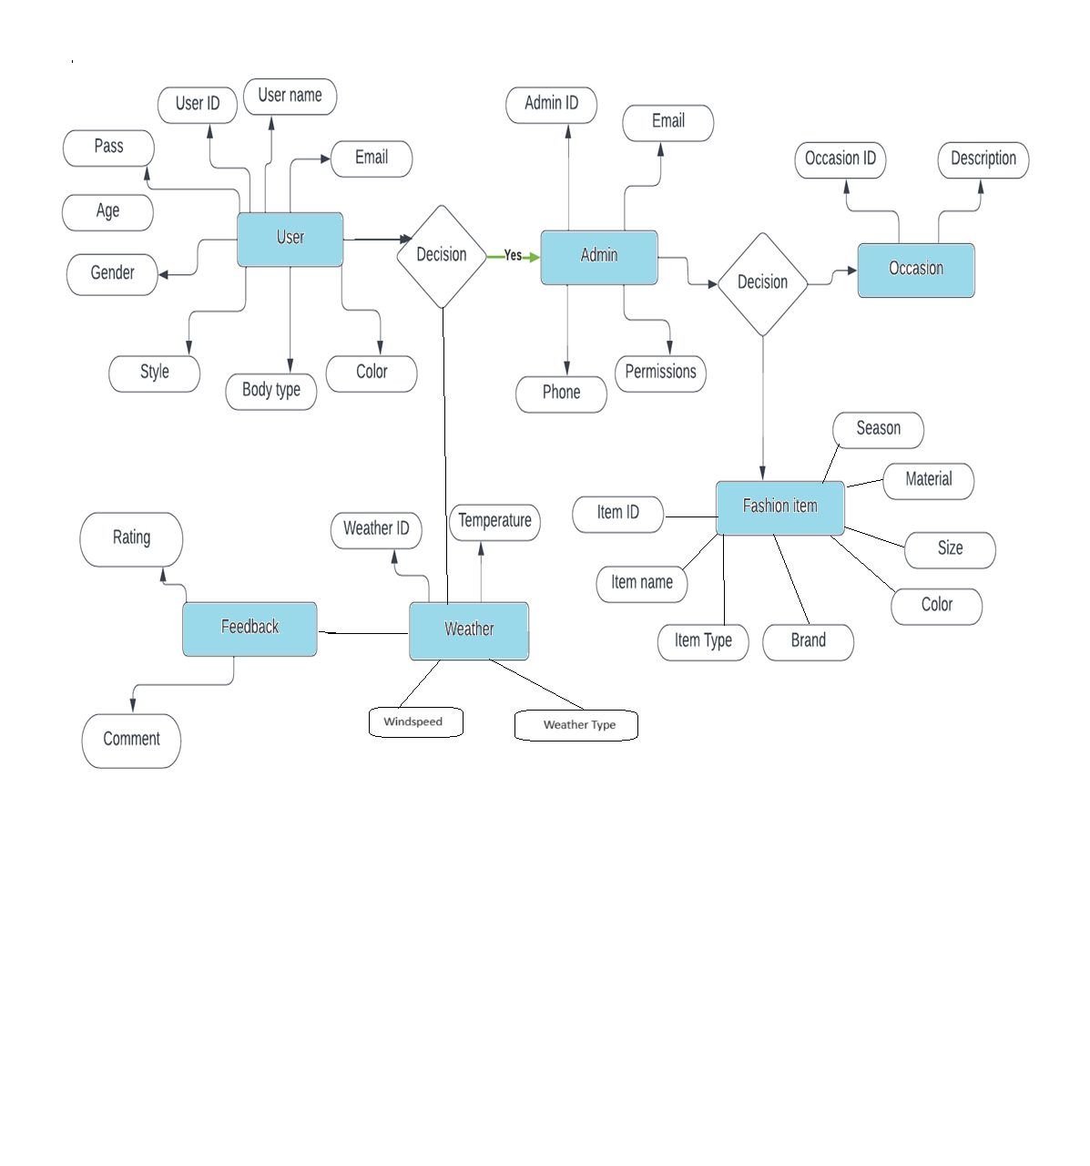

**CLASS DIAGRAM FOR PATIENT MANAGEMENT:**

User ID (Primary Key)

Name,

Password

Email

Age, Body Type

Gender ,Style, Color

Style Preferences

Weather ID (Primary Key)

Temperature

Humidity

Condition

**Weather**

**User**

Occasion ID (Primary Key)

Type

Description

**Occasion**

### 

Recommendation ID (Primary Key)

User ID (Foreign Key)

Weather ID (Foreign Key)

Occasion ID (Foreign Key)

Outfit ID (Foreign Key)

**Recommendation**

Outfit ID (Primary Key)

User ID (Foreign Key)

Weather ID (Foreign Key)

Occasion ID (Foreign Key)

Description

**Outfit**

**CONCLUSION:**

In conclusion, a Fashion recommendation systems deliver personalized clothing and accessory suggestions by analyzing user preferences, style trends, and contextual data. These systems streamline the process of discovering new fashion items, helping users explore and discover styles that align with their tastes and preferences. Through advanced algorithms and data analysis techniques, fashion recommendation systems provide tailored recommendations, empowering users to make informed and confident fashion choices.

.