Database Design for Referal management

## Problem Description

In 2024, a need was identified in Center stones institute to streamline and enhance the process of managing client referrals and follow-ups for crisis counselors. This initiative aims to create a robust web application that facilitates the efficient management of resources, referrals, and follow-ups, ensuring that clients receive timely and appropriate assistance.

The current system involves significant manual effort and lacks integration, leading to inefficiencies and potential delays in providing necessary support to clients. The goal is to develop a comprehensive solution that includes a database for managing referral types, organizations, and follow-up activities, along with a user-friendly web interface for staff to interact with the system.

## Objectives of the Project

1. 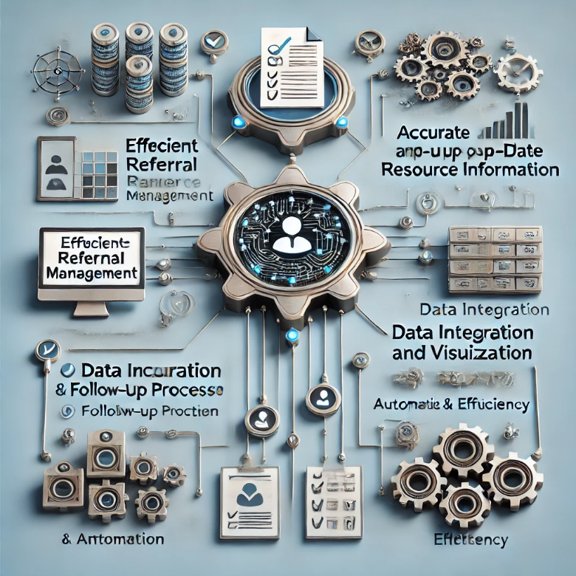**Efficient Referral Management**: Implement a structured system for crisis counselors to log in and access a resources tab. The system will provide options for entering referral details such as referral type, organization name, age group, and zip code. Based on these details, the system will suggest appropriate organizations for referral, ensuring that clients are directed to the most suitable resources.
2. **Accurate and Up-to-Date Resource Information**: Enable staff to regularly update the Organizations table with the latest information about services, contact details, and availability. This ensures that counselors have access to accurate and current data when making referrals.
3. **Comprehensive Follow-Up Process**: Develop a follow-up module where staff can log in to review upcoming follow-ups, including demographic details and referral status. Staff can contact clients using their preferred method (phone, email, text) and record the outcome of the contact in the Follow-Up table. This helps in tracking the progress of referrals and ensuring clients receive the necessary follow-up care.
4. **Data Integration and Visualization**: Create a system that allows for the integration of referral and follow-up data, providing valuable insights through visualizations. Generate reports in various formats (charts, tables, spatial maps) that can be viewed in a browser, aiding in data-driven decision-making and continuous improvement of services.
5. **Automation and Efficiency**: Automate the data collection and storage process, reducing manual effort and minimizing the risk of errors. This will involve setting up automated scripts for data handling, ensuring seamless integration and real-time updates.

The proposed database and web application will enhance the efficiency of managing client referrals and follow-ups, provide accurate resource information, and provide timely and effective assistance for clients in need. The system will also generate valuable data for ongoing improvements, ensuring that our services continue to meet the needs of our clients.

## Scope of Work

In the tasks below, we have summarized each task to accomplish the project goals for developing a comprehensive web application and database system for managing client referrals and follow-ups.

**Task 1: Kick-off Meeting** In the first month of the project contract award, the project team will meet to present, discuss, and finalize the project's scope, tasks, project duration/timeline/milestones, and deliverables.

* **Deliverable 1**: Final scope of work document

**Task 2: Requirement Analysis and Database Design** The project team will work closely to gather detailed requirements for the system. This will include understanding the data to be managed, user roles, workflows, and reporting needs. Based on this analysis, a detailed database schema will be designed.

* **Activities**: Conduct meetings, interviews, and surveys. Analyze current workflows and identify data requirements. Create a comprehensive requirements document.
* **Deliverable 2**: Requirement specification document and ER diagram

**Task 3: Development Environment Setup** Set up the development environment, including the installation of MySQL, web server, and necessary development tools. Version control will be established using GitHub or a similar platform.

* **Activities**: Install and configure MySQL, set up the web server, install necessary development tools (IDEs, libraries, frameworks), set up version control.
* **Deliverable 3**: Development environment ready for use

**Task 4: User Authentication and Authorization** Develop the user authentication module to ensure secure access to the system. Implement role-based access control to manage permissions for different user roles (e.g., counselors, follow-up staff, superusers).

* **Activities**: Design user login and registration forms, implement authentication logic, set up role-based access control, ensure secure password storage and management.
* **Deliverable 4**: User authentication and authorization module

**Task 5: Resource Management Module** Develop the Resource Management module to allow staff to add, update, and delete information about organizations. This module will include forms for entering organization details, services offered, age groups served, and location (zip code). (only for the admin users)

* **Activities**: Design and implement forms for resource management, develop CRUD (Create, Read, Update, Delete) operations for organizations, ensure data validation and integrity.
* **Deliverable 5**: Resource Management module

**Task 6: Referral System** Create the Referral System module where counselors can log in to enter referral details such as referral type, organization name, age group, and zip code. The system will provide

* **Activities**: Design the referral input form, implement logic for suggesting organizations based on referral details, ensure data is stored securely and efficiently.
* **Deliverable 6**: Referral System module

**Task 7: Case Management and Follow-Up Module** Develop the Case Management and Follow-Up module to track each referral with a unique Case_ID and Patient_ID. Implement functionalities for follow-up staff to review upcoming follow-ups, contact clients, record outcomes, and update follow-up statuses.

* **Activities**: Design forms and interfaces for case management and follow-up, implement logic for tracking referrals and follow-up activities, ensure accurate and timely data updates.
* **Deliverable 7**: Case Management and Follow-Up module

­­­­­

**Task 8: Data Integration and Visualization** Create a data integration and visualization system that generates reports and visualizations of referral and follow-up data. Develop features to export data in various formats (e.g., charts, tables, spatial maps) that can be viewed in a browser.

* **Activities**: Design and implement data visualization dashboards, integrate data from various modules, develop export functionalities for different data formats.
* **Deliverable 8**: Data visualization dashboard

**Task 9: Testing and Quality Assurance** Conduct thorough testing of the system, including unit testing, integration testing, and user acceptance testing (UAT). Ensure the system meets all requirements and performs efficiently.

* **Activities**: Develop test plans and test cases, perform unit testing for individual modules, conduct integration testing to ensure modules work together, perform UAT with end-users, document and fix any issues found during testing.
* **Deliverable 9**: Test reports and a fully tested system

**Task 10: Deployment and Post-Deployment Support** Deploy the system to a live server and ensure it is fully operational. Provide post-deployment support to address any issues and ensure smooth operation.

* **Activities**: Set up the production environment, migrate data from development to production, perform final system checks, provide support for any issues encountered after deployment.
* **Deliverable 10**: Deployed system and post-deployment support plan

**Task 11: Application Maintenance and Updates** Provide ongoing maintenance and updates to the application, ensuring it remains functional, secure, and up to date with any new requirements or changes in the organization.

* **Activities**: Monitor system performance, apply security patches and updates, implement new features or changes as needed, provide regular maintenance and support.
* **Deliverable 11**: Regular updates and maintenance logs for the application

By following these tasks, the project will achieve its goal of developing a robust and efficient system for managing client referrals and follow-ups, enhancing the support provided to clients and improving overall operational efficiency.

## Additional Benefits/Potential for Implementation

The successful completion of this database system project will provide numerous benefits, enhancing the efficiency and effectiveness of managing client referrals and follow-ups. The project deliverables will directly benefit the organization through multiple facets, including:

1. **Enhanced Data Accuracy and Reliability**
   * Centralized and regularly updated database ensures the availability of accurate and current information about organizations and services.
   * Reduced errors in data entry and management through validation and automated updates.
2. **Comprehensive Follow-Up Tracking**
   * Systematic follow-up module allows for consistent tracking of client interactions and outcomes.
   * Ensures clients receive necessary follow-up care, improving overall service quality.
3. **Data-Driven Decision Making**
   * Visualization dashboards provide valuable insights through charts, tables, and spatial maps.
   * Facilitates data-driven decision-making and continuous improvement of services.
4. **Increased Accessibility and Usability**
   * User-friendly web interface accessible from any device with internet connectivity.
   * Role-based access control ensures appropriate access to different functionalities based on user roles.
5. **Cost and Time Savings**
   * Automation of referral and follow-up processes reduces the time and resources required for manual tasks.
   * Improved efficiency leads to cost savings in managing client services.
6. **Enhanced Client Satisfaction**
   * Timely and accurate referrals ensure clients receive the most suitable services.
   * Systematic follow-ups improve client engagement and satisfaction with the services provided.
7. **Scalability and Flexibility**
   * The system can be easily scaled to accommodate increasing data and user needs.
   * Flexibility to integrate additional features and modules as the organization’s requirements evolve.
8. **Security and Compliance**
   * Secure authentication and data management practices ensure the protection of sensitive client information.
   * Compliance with data protection regulations and standards.
9. **Comprehensive Reporting and Analytics**
   * Ability to generate detailed reports for monitoring and evaluating the effectiveness of referral and follow-up processes.
   * Supports continuous monitoring and enhancement of organizational strategies and practices.
10. **Promotion of Best Practices**
    * Establishes a standardized approach to managing client referrals and follow-ups.
    * Promotes the adoption of best practices across the organization.

By leveraging these benefits, the organization will significantly enhance its capability to manage client referrals and follow-ups, ultimately leading to better client outcomes and operational efficiency.

## Research Team

The development team from the University of Memphis (UOFM), led by Dr. Sabyasachee Mishra and supported by experienced graduate students, will conduct the project. All team members bring significant expertise and value to the project, contributing to design, development, data integration, testing, and deployment. Each team member has a proven track record in delivering high-quality software solutions and adds substantial value to the project.

Dr. Sabyasachee Mishra, the project lead, has over a decade of experience. His expertise will ensure the project meets its technical and functional requirements. Dr. Sabyasachee Mishra leadership will guide the team through all phases of the project, from initial planning to final deployment.

**Graduate Students** from UOFM will support various aspects of the project:

* A specialist in database design and management will oversee the creation and maintenance of the MySQL database, ensuring data integrity and optimal performance.
* A full-stack development expert will work on the integration of front-end and back-end systems, developing seamless user interfaces and robust server-side logic.
* An individual with experience in data visualization and analytics will develop the data integration and visualization modules, providing valuable insights through interactive dashboards.
* A focus on testing and quality assurance will implement comprehensive testing strategies to ensure the system meets all functional and non-functional requirements.

The team's combined experience and expertise will ensure the successful completion of the project, delivering a robust and efficient database system for managing client referrals and follow-ups. The involvement of graduate students will also provide valuable hands-on experience and contribute to their academic and professional growth.

## Quality of Facility and Equipment

Facilities and equipment available at the University of Memphis (UOFM) will be utilized for this project. A comprehensive list of software and tools, including database management systems (MySQL, PostgreSQL), web development frameworks (React.js, Node.js, Django), data visualization tools (D3.js), and programming languages (Python, JavaScript, SQL), will be available for use in the project.

The development team is well-versed in using these tools and has extensive experience in designing and implementing database systems and web applications. Additionally, the team has access to high-performance computing resources, secure servers for data storage, and advanced development environments that will facilitate efficient and effective project execution.

The available facilities and equipment will ensure that the project can be carried out with the highest standards of quality and efficiency, leveraging the latest technologies and best practices in database management and web development.

## Project Schedule for Database Systems Project (6 Months)

The project schedule for developing the comprehensive database system for managing client referrals and follow-ups is planned over a period of 6 months, with detailed weekly tasks to ensure timely completion. Below is the weekly schedule for the project:

#### Month 1: Planning and Design

**Week 1-2: Kick-off Meeting and Requirement Analysis**

* Conduct kick-off meeting
* Finalize project scope, methodology, and deliverables.
* Gather detailed requirements.
* Create requirement specification document.

**Week 3-4: Database Design**

* Design ER diagram and database schema
* Review and finalize database design.
* Deliverable: Requirement specification document and ER diagram

#### Month 2: Development Environment Setup and Initial Development

**Week 5-6: Development Environment Setup**

* Set up MySQL database.
* Install and configure development tools and version control.
* Deliverable: Development environment ready for use

**Week 7-8: User Authentication and Authorization**

* Develop user login and registration forms.
* Implement authentication logic.
* Set up role-based access control.
* Deliverable: User authentication and authorization module

#### Month 3: Resource Management and Referral System

**Week 9-10: Resource Management Module**

* Design and implement forms for resource management.
* Develop CRUD operations for organizations.
* Ensure data validation and integrity.
* Deliverable: Resource Management module

**Week 11-12: Referral System**

* Design referral input form
* Implement logic for suggesting organizations based on referral details.
* Ensure secure and efficient data storage.
* Deliverable: Referral System module

#### Month 4: Case Management and Follow-Up Module

**Week 13-14: Case Management Module**

* Design forms and interfaces for case management
* Implement tracking logic for referrals.
* Assign unique Case_ID and Patient_ID
* Deliverable: Case Management module

**Week 15-16: Follow-Up Module**

* Design follow-up forms and interfaces
* Implement functionalities for contact logging and outcome recording.
* Ensure accurate and timely data updates.
* Deliverable: Follow-Up module

#### Month 5: Data Integration, Visualization, and Testing

**Week 17-18: Data Integration and Visualization**

* Develop data visualization dashboards.
* Integrate data from various modules.
* Implement export functionalities for different formats.
* Deliverable: Data visualization dashboard

**Week 19-20: Testing and Quality Assurance**

* Develop test plans and test cases.
* Perform unit testing, integration testing, and user acceptance testing (UAT)
* Document and fix issues found during testing.
* Deliverable: Test reports and a fully tested system

#### Month 6: Deployment, Support

**Week 21-22: Deployment**

* Set up the production environment.
* Migrate data from development to production.
* Perform final system checks.
* Deliverable: Deployed system

**Week 23-24: Post-Deployment Support**

* Monitor system for any issues.
* Provide support for initial user feedback.
* Implement quick fixes and optimizations as needed.
* Deliverable: Post-deployment support plan

# Project Schedule

|  |  |  |  |  |  |  |  |  |  |  |  |  |  |  |  |  |  |  |  |  |  |  |  |  |  |
| --- | --- | --- | --- | --- | --- | --- | --- | --- | --- | --- | --- | --- | --- | --- | --- | --- | --- | --- | --- | --- | --- | --- | --- | --- | --- |
| Tasks | Description | Weeks | | | | | | | | | | | | | | | | | | | | | | | |
| 1 | 2 | 3 | 4 | 5 | 6 | 7 | 8 | 9 | 10 | 11 | 12 | 13 | 14 | 15 | 16 | 17 | 18 | 19 | 20 | 21 | 22 | 23 | 24 |
| Task 1 | **Requirement Analysis and Database Design** |  |  |  |  |  |  |  |  |  |  |  |  |  |  |  |  |  |  |  |  |  |  |  |  |
| Task 2 | **Development Environment Setup** |  |  |  |  |  |  |  |  |  |  |  |  |  |  |  |  |  |  |  |  |  |  |  |  |
| Task 3 | **User Authentication and Authorization** |  |  |  |  |  |  |  |  |  |  |  |  |  |  |  |  |  |  |  |  |  |  |  |  |
| Task 4 | **Resource Management Module** |  |  |  |  |  |  |  |  |  |  |  |  |  |  |  |  |  |  |  |  |  |  |  |  |
| Task 5 | **Referral System** |  |  |  |  |  |  |  |  |  |  |  |  |  |  |  |  |  |  |  |  |  |  |  |  |
| Task 6 | **Case Management and Follow-Up Module** |  |  |  |  |  |  |  |  |  |  |  |  |  |  |  |  |  |  |  |  |  |  |  |  |
| Task 7 | **Data Integration and Visualization** |  |  |  |  |  |  |  |  |  |  |  |  |  |  |  |  |  |  |  |  |  |  |  |  |
| Task 8 | **Testing and Quality Assurance** |  |  |  |  |  |  |  |  |  |  |  |  |  |  |  |  |  |  |  |  |  |  |  |  |
| Task 9 | **Deployment and Post-Deployment Support** |  |  |  |  |  |  |  |  |  |  |  |  |  |  |  |  |  |  |  |  |  |  |  |  |