**ARGOCD**

Install argocd in k8s cluster

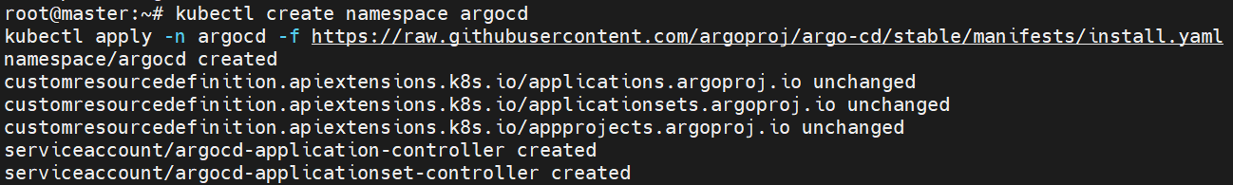

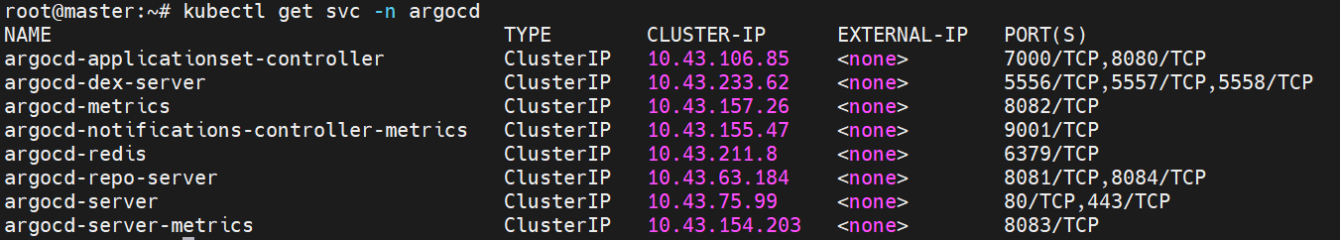

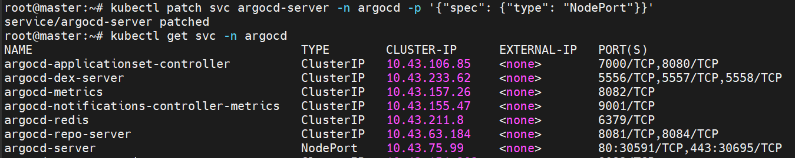

Copy local IP address and give it in chrome and also port number

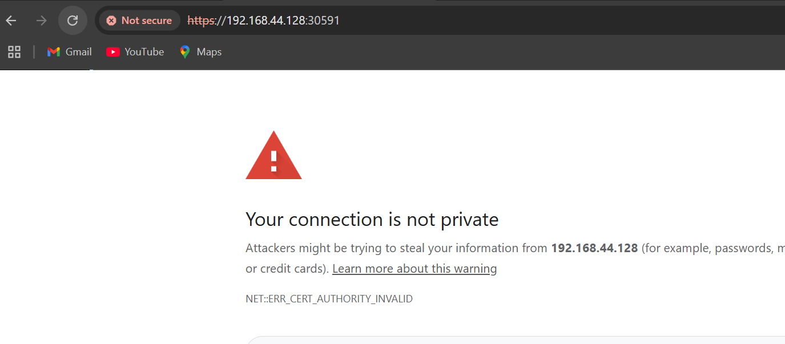

Go inside the pod and give the command

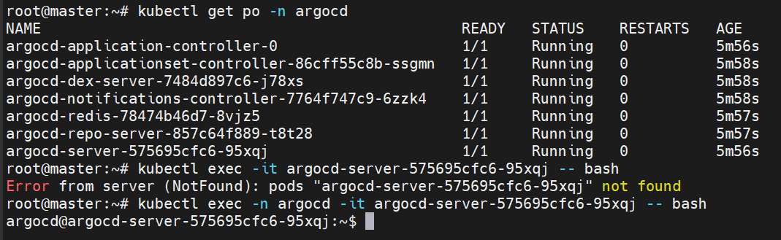

Get the password

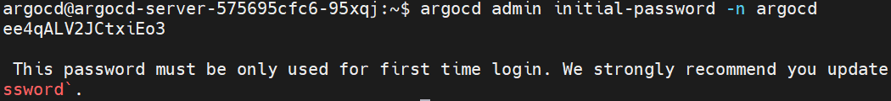

This is the front page

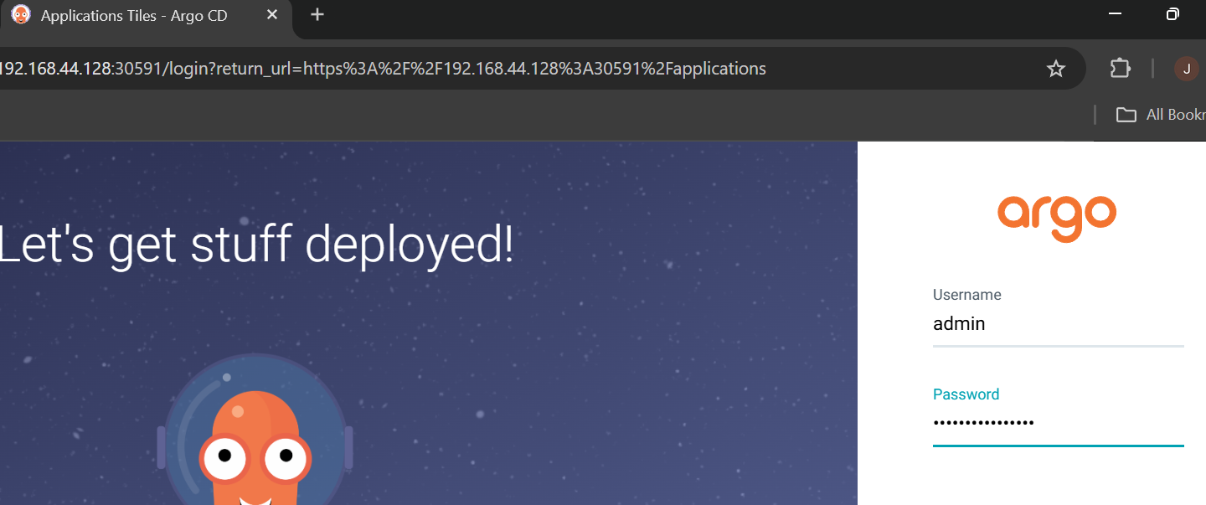

Now create a deployment YAML file in github

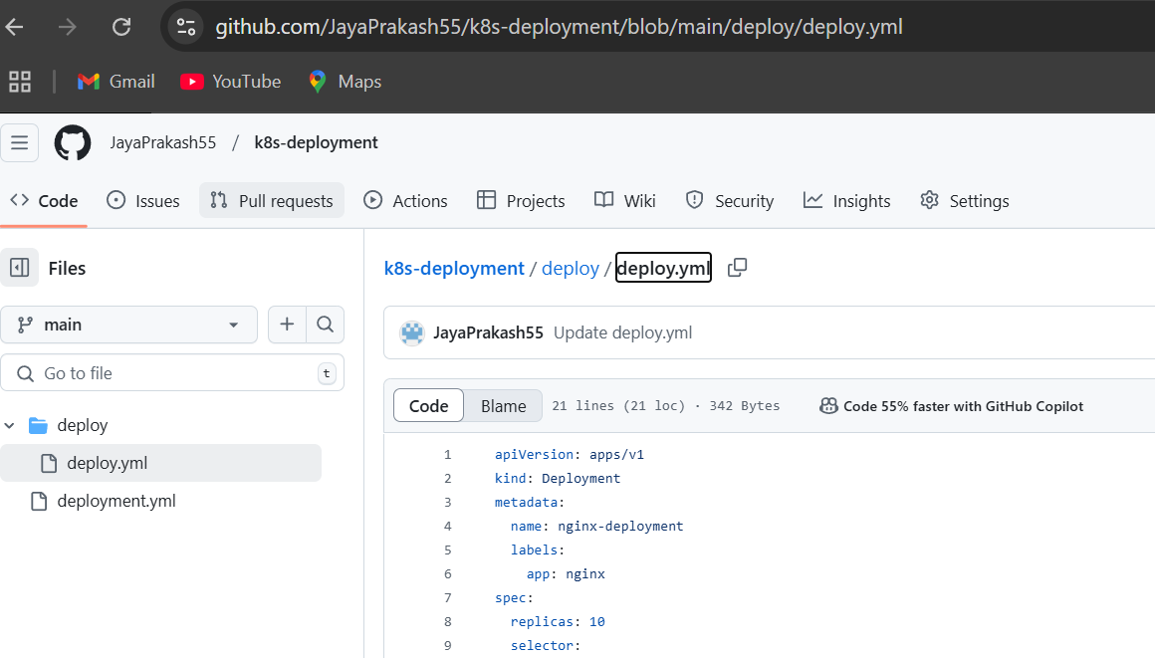

Click on create new app and start giving information for project

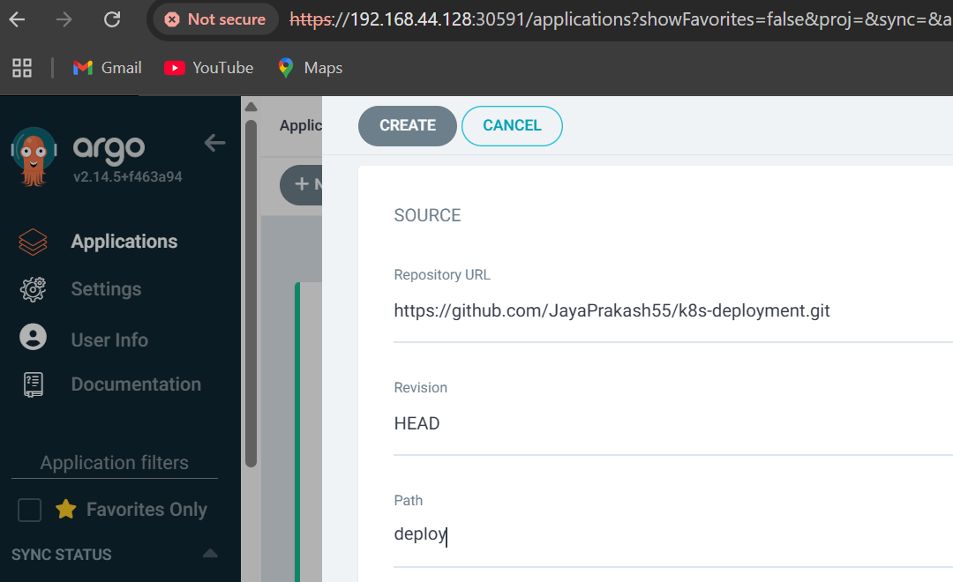

Now the project is created in argocd , the YAML file is in github

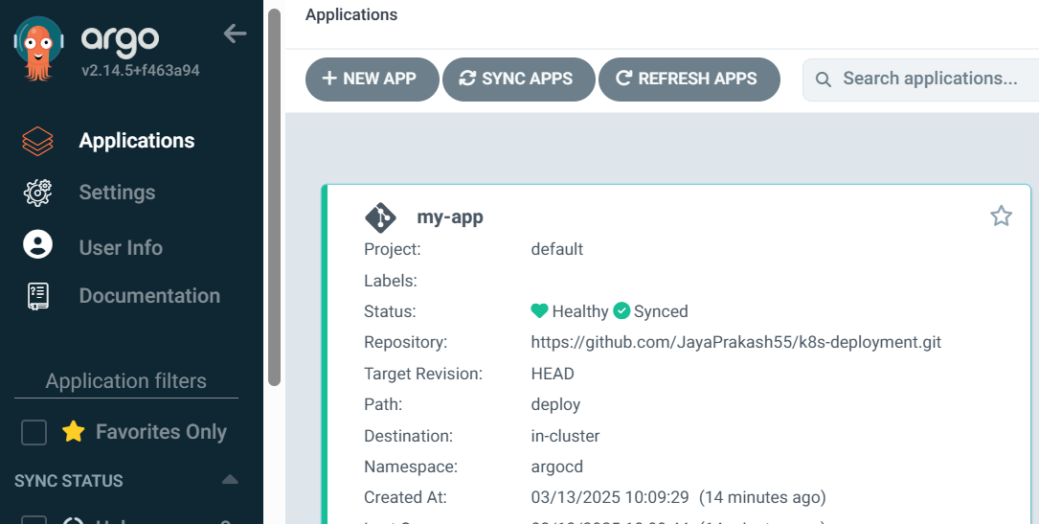

So the pods is created in local k8s cluster,

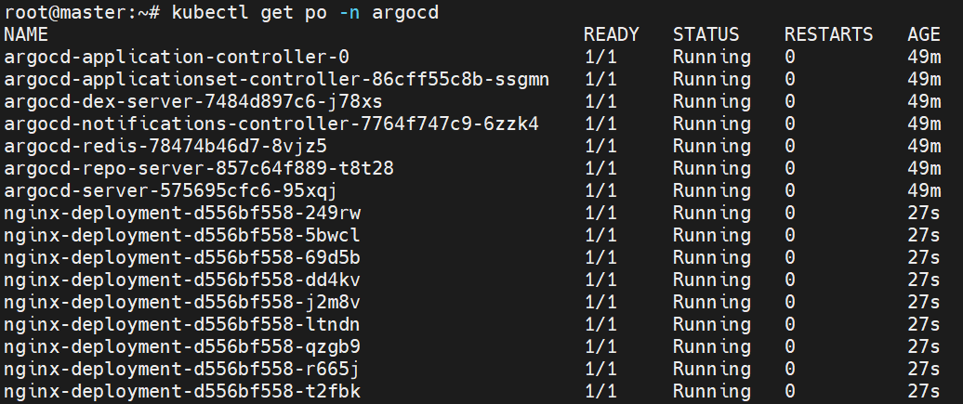

NOTE: IF WE MAKE ANY CHANGES IN GITHUB IT WILL BE REFLECTED IN K8S CLUSTER

BEFORE THAT CHECK WHETHER IT IS AUTO SYNC OR MANUAL SYNC , IF IT IS MANUAL SYNC THEN SYNC IT BY YOURSELF