WEEK-2

Name: G_Jaya_Praveen

Roll number:228w1a1286

>iris

Sepal.Length Sepal.Width Petal.Length Petal.Width Species

1 5.1 3.5 1.4 0.2 setosa

2 4.9 3.0 1.4 0.2 setosa

3 4.7 3.2 1.3 0.2 setosa

4 4.6 3.1 1.5 0.2 setosa

5 5.0 3.6 1.4 0.2 setosa

6 5.4 3.9 1.7 0.4 setosa

7 4.6 3.4 1.4 0.3 setosa

8 5.0 3.4 1.5 0.2 setosa

9 4.4 2.9 1.4 0.2 setosa

10 4.9 3.1 1.5 0.1 setosa

11 5.4 3.7 1.5 0.2 setosa

12 4.8 3.4 1.6 0.2 setosa

13 4.8 3.0 1.4 0.1 setosa

14 4.3 3.0 1.1 0.1 setosa

15 5.8 4.0 1.2 0.2 setosa

16 5.7 4.4 1.5 0.4 setosa

17 5.4 3.9 1.3 0.4 setosa

18 5.1 3.5 1.4 0.3 setosa

19 5.7 3.8 1.7 0.3 setosa

20 5.1 3.8 1.5 0.3 setosa

21 5.4 3.4 1.7 0.2 setosa

22 5.1 3.7 1.5 0.4 setosa

23 4.6 3.6 1.0 0.2 setosa

24 5.1 3.3 1.7 0.5 setosa

25 4.8 3.4 1.9 0.2 setosa

26 5.0 3.0 1.6 0.2 setosa

27 5.0 3.4 1.6 0.4 setosa

28 5.2 3.5 1.5 0.2 setosa

29 5.2 3.4 1.4 0.2 setosa

30 4.7 3.2 1.6 0.2 setosa

31 4.8 3.1 1.6 0.2 setosa

32 5.4 3.4 1.5 0.4 setosa

33 5.2 4.1 1.5 0.1 setosa

34 5.5 4.2 1.4 0.2 setosa

35 4.9 3.1 1.5 0.2 setosa

36 5.0 3.2 1.2 0.2 setosa

37 5.5 3.5 1.3 0.2 setosa

38 4.9 3.6 1.4 0.1 setosa

39 4.4 3.0 1.3 0.2 setosa

40 5.1 3.4 1.5 0.2 setosa

41 5.0 3.5 1.3 0.3 setosa

42 4.5 2.3 1.3 0.3 setosa

43 4.4 3.2 1.3 0.2 setosa

44 5.0 3.5 1.6 0.6 setosa

45 5.1 3.8 1.9 0.4 setosa

46 4.8 3.0 1.4 0.3 setosa

47 5.1 3.8 1.6 0.2 setosa

48 4.6 3.2 1.4 0.2 setosa

49 5.3 3.7 1.5 0.2 setosa

50 5.0 3.3 1.4 0.2 setosa

51 7.0 3.2 4.7 1.4 versicolor

52 6.4 3.2 4.5 1.5 versicolor

53 6.9 3.1 4.9 1.5 versicolor

54 5.5 2.3 4.0 1.3 versicolor

55 6.5 2.8 4.6 1.5 versicolor

56 5.7 2.8 4.5 1.3 versicolor

57 6.3 3.3 4.7 1.6 versicolor

58 4.9 2.4 3.3 1.0 versicolor

59 6.6 2.9 4.6 1.3 versicolor

60 5.2 2.7 3.9 1.4 versicolor

61 5.0 2.0 3.5 1.0 versicolor

|  |  |  |  |  |  |
| --- | --- | --- | --- | --- | --- |
| 62 | 5.9 | 3.0 | 4.2 | 1.5 | versicolor |
| 63 | 6.0 | 2.2 | 4.0 | 1.0 | versicolor |
| 64 | 6.1 | 2.9 | 4.7 | 1.4 | versicolor |
| 65 | 5.6 | 2.9 | 3.6 | 1.3 | versicolor |
| 66 | 6.7 | 3.1 | 4.4 | 1.4 | versicolor |
| 67 | 5.6 | 3.0 | 4.5 | 1.5 | versicolor |
| 68 | 5.8 | 2.7 | 4.1 | 1.0 | versicolor |
| 69 | 6.2 | 2.2 | 4.5 | 1.5 | versicolor |
| 70 | 5.6 | 2.5 | 3.9 | 1.1 | versicolor |
| 71 | 5.9 | 3.2 | 4.8 | 1.8 | versicolor |
| 72 | 6.1 | 2.8 | 4.0 | 1.3 | versicolor |
| 73 | 6.3 | 2.5 | 4.9 | 1.5 | versicolor |
| 74 | 6.1 | 2.8 | 4.7 | 1.2 | versicolor |
| 75 | 6.4 | 2.9 | 4.3 | 1.3 | versicolor |
| 76 | 6.6 | 3.0 | 4.4 | 1.4 | versicolor |
| 77 | 6.8 | 2.8 | 4.8 | 1.4 | versicolor |
| 78 | 6.7 | 3.0 | 5.0 | 1.7 | versicolor |
| 79 | 6.0 | 2.9 | 4.5 | 1.5 | versicolor |
| 80 | 5.7 | 2.6 | 3.5 | 1.0 | versicolor |
| 81 | 5.5 | 2.4 | 3.8 | 1.1 | versicolor |
| 82 | 5.5 | 2.4 | 3.7 | 1.0 | versicolor |
| 83 | 5.8 | 2.7 | 3.9 | 1.2 | versicolor |
| 84 | 6.0 | 2.7 | 5.1 | 1.6 | versicolor |
| 85 | 5.4 | 3.0 | 4.5 | 1.5 | versicolor |
| 86 | 6.0 | 3.4 | 4.5 | 1.6 | versicolor |
| 87 | 6.7 | 3.1 | 4.7 | 1.5 | versicolor |
| 88 | 6.3 | 2.3 | 4.4 | 1.3 | versicolor |
| 89 | 5.6 | 3.0 | 4.1 | 1.3 | versicolor |
| 90 | 5.5 | 2.5 | 4.0 | 1.3 | versicolor |
| 91 | 5.5 | 2.6 | 4.4 | 1.2 | versicolor |
| 92 | 6.1 | 3.0 | 4.6 | 1.4 | versicolor |
| 93 | 5.8 | 2.6 | 4.0 | 1.2 | versicolor |
| 94 | 5.0 | 2.3 | 3.3 | 1.0 | versicolor |
| 95 | 5.6 | 2.7 | 4.2 | 1.3 | versicolor |
| 96 | 5.7 | 3.0 | 4.2 | 1.2 | versicolor |
| 97 | 5.7 | 2.9 | 4.2 | 1.3 | versicolor |
| 98 | 6.2 | 2.9 | 4.3 | 1.3 | versicolor |
| 99 | 5.1 | 2.5 | 3.0 | 1.1 | versicolor |
| 100 | 5.7 | 2.8 | 4.1 | 1.3 | versicolor |
| 101 | 6.3 | 3.3 | 6.0 | 2.5 | virginica |
| 102 | 5.8 | 2.7 | 5.1 | 1.9 | virginica |
| 103 | 7.1 | 3.0 | 5.9 | 2.1 | virginica |
| 104 | 6.3 | 2.9 | 5.6 | 1.8 | virginica |
| 105 | 6.5 | 3.0 | 5.8 | 2.2 | virginica |
| 106 | 7.6 | 3.0 | 6.6 | 2.1 | virginica |
| 107 | 4.9 | 2.5 | 4.5 | 1.7 | virginica |
| 108 | 7.3 | 2.9 | 6.3 | 1.8 | virginica |
| 109 | 6.7 | 2.5 | 5.8 | 1.8 | virginica |
| 110 | 7.2 | 3.6 | 6.1 | 2.5 | virginica |
| 111 | 6.5 | 3.2 | 5.1 | 2.0 | virginica |
| 112 | 6.4 | 2.7 | 5.3 | 1.9 | virginica |
| 113 | 6.8 | 3.0 | 5.5 | 2.1 | virginica |
| 114 | 5.7 | 2.5 | 5.0 | 2.0 | virginica |
| 115 | 5.8 | 2.8 | 5.1 | 2.4 | virginica |
| 116 | 6.4 | 3.2 | 5.3 | 2.3 | virginica |
| 117 | 6.5 | 3.0 | 5.5 | 1.8 | virginica |
| 118 | 7.7 | 3.8 | 6.7 | 2.2 | virginica |
| 119 | 7.7 | 2.6 | 6.9 | 2.3 | virginica |
| 120 | 6.0 | 2.2 | 5.0 | 1.5 | virginica |
| 121 | 6.9 | 3.2 | 5.7 | 2.3 | virginica |
| 122 | 5.6 | 2.8 | 4.9 | 2.0 | virginica |
| 123 | 7.7 | 2.8 | 6.7 | 2.0 | virginica |
| 124 | 6.3 | 2.7 | 4.9 | 1.8 | virginica |
| 125 | 6.7 | 3.3 | 5.7 | 2.1 | virginica |
| 126 | 7.2 | 3.2 | 6.0 | 1.8 | virginica |
| 127 | 6.2 | 2.8 | 4.8 | 1.8 | virginica |
| 128 | 6.1 | 3.0 | 4.9 | 1.8 | virginica |
| 129 | 6.4 | 2.8 | 5.6 | 2.1 | virginica |
| 130 | 7.2 | 3.0 | 5.8 | 1.6 | virginica |

|  |  |  |  |  |  |
| --- | --- | --- | --- | --- | --- |
| 131 | 7.4 | 2.8 | 6.1 | 1.9 | virginica |
| 132 | 7.9 | 3.8 | 6.4 | 2.0 | virginica |
| 133 | 6.4 | 2.8 | 5.6 | 2.2 | virginica |
| 134 | 6.3 | 2.8 | 5.1 | 1.5 | virginica |
| 135 | 6.1 | 2.6 | 5.6 | 1.4 | virginica |
| 136 | 7.7 | 3.0 | 6.1 | 2.3 | virginica |
| 137 | 6.3 | 3.4 | 5.6 | 2.4 | virginica |
| 138 | 6.4 | 3.1 | 5.5 | 1.8 | virginica |
| 139 | 6.0 | 3.0 | 4.8 | 1.8 | virginica |
| 140 | 6.9 | 3.1 | 5.4 | 2.1 | virginica |
| 141 | 6.7 | 3.1 | 5.6 | 2.4 | virginica |
| 142 | 6.9 | 3.1 | 5.1 | 2.3 | virginica |
| 143 | 5.8 | 2.7 | 5.1 | 1.9 | virginica |
| 144 | 6.8 | 3.2 | 5.9 | 2.3 | virginica |
| 145 | 6.7 | 3.3 | 5.7 | 2.5 | virginica |
| 146 | 6.7 | 3.0 | 5.2 | 2.3 | virginica |
| 147 | 6.3 | 2.5 | 5.0 | 1.9 | virginica |
| 148 | 6.5 | 3.0 | 5.2 | 2.0 | virginica |
| 149 | 6.2 | 3.4 | 5.4 | 2.3 | virginica |
| 150 | 5.9 | 3.0 | 5.1 | 1.8 | virginica |

* summary(iris)

Sepal.Length Sepal.Width Petal.Length Petal.Width Species

Min. :4.300 Min. :2.000 Min. :1.000 Min. :0.100 setosa

:50

1st Qu.:5.100 1st Qu.:2.800 1st Qu.:1.600 1st Qu.:0.300

versicolor:50

Median :5.800 Median :3.000 Median :4.350 Median :1.300 virginica

:50

|  |  |  |  |  |  |  |  |
| --- | --- | --- | --- | --- | --- | --- | --- |
| Mean | :5.843 | Mean | :3.057 | Mean | :3.758 | Mean | :1.199 |
| 3rd Qu.:6.400 | | 3rd Qu.:3.300 | | 3rd Qu.:5.100 | | 3rd Qu.:1.800 | |
| Max. :7.900 | | Max. :4.400 | | Max. :6.900 | | Max. :2.500 | |

* head(iris)

Sepal.Length Sepal.Width Petal.Length Petal.Width Species

|  |  |  |  |  |
| --- | --- | --- | --- | --- |
| 1 | 5.1 | 3.5 | 1.4 | 0.2 setosa |
| 2 | 4.9 | 3.0 | 1.4 | 0.2 setosa |
| 3 | 4.7 | 3.2 | 1.3 | 0.2 setosa |
| 4 | 4.6 | 3.1 | 1.5 | 0.2 setosa |
| 5 | 5.0 | 3.6 | 1.4 | 0.2 setosa |
| 6 | 5.4 | 3.9 | 1.7 | 0.4 setosa |
| * tail(iris)   Sepal.Length Sepal.Width Petal.Length Petal.Width Species | | | | |
| 145 | 6.7 | 3.3 | 5.7 | 2.5 virginica |
| 146 | 6.7 | 3.0 | 5.2 | 2.3 virginica |
| 147 | 6.3 | 2.5 | 5.0 | 1.9 virginica |
| 148 | 6.5 | 3.0 | 5.2 | 2.0 virginica |
| 149 | 6.2 | 3.4 | 5.4 | 2.3 virginica |
| 150 | 5.9 | 3.0 | 5.1 | 1.8 virginica |

* hist(iris$Sepal.Length, main="Histogram of Sepal Length", xlab="Sepal Length")

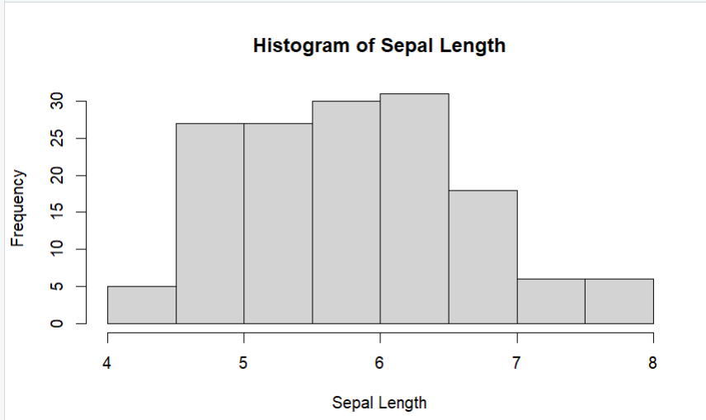

* hist(iris$Sepal.Width, main="Histogram of Sepal Width", xlab="Sepal Width")

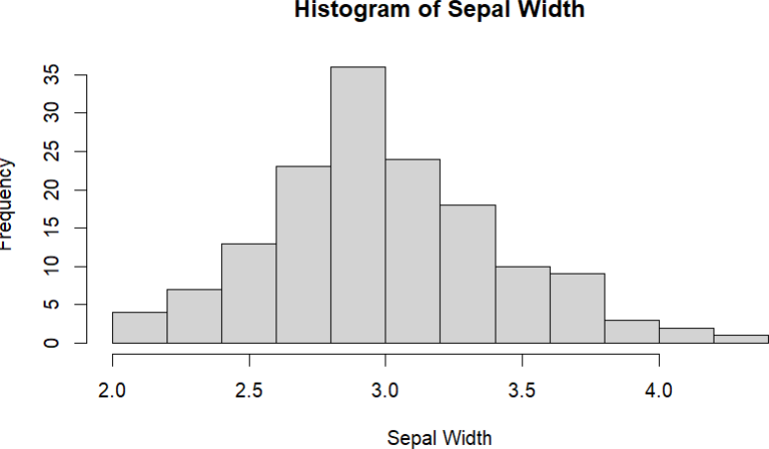

* hist(iris$Petal.Length, main="Histogram of Petal length", xlab="Petal length")

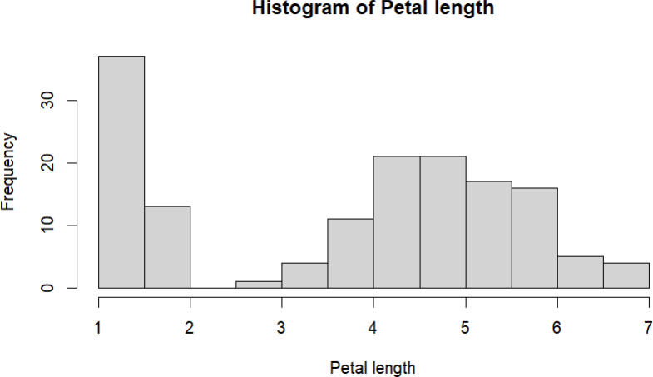

* hist(iris$Petal.Width, main="Histogram of Petal Width", xlab="Petal Width")

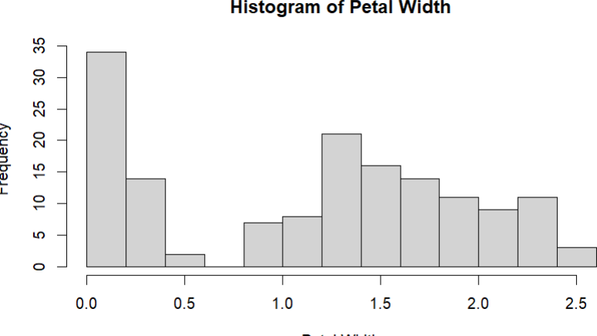

* boxplot(Petal.Width ~ Species, data=iris, main="Boxplot of Petal Width by Species", xlab="Species", ylab="Petal Width")

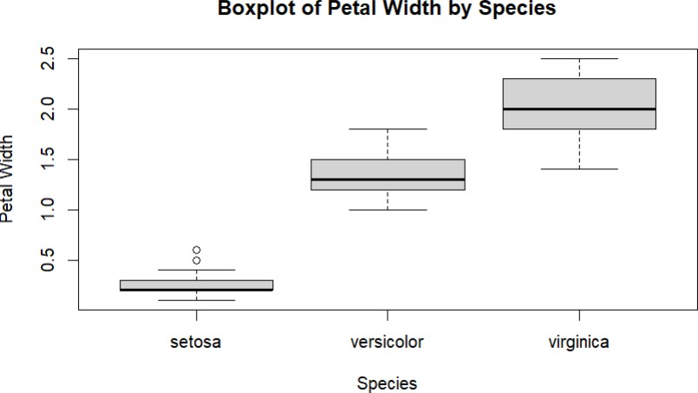

* plot(iris$Sepal.Length, iris$Sepal.Width, main="Scatter plot of Sepal Length vs. Sepa

xlab="Sepal Length", ylab="Sepal Width")

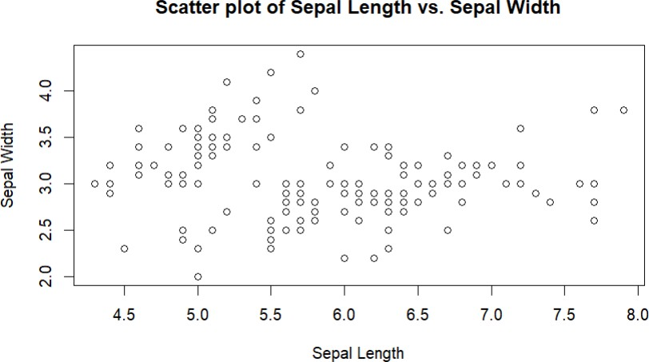

t_test_result <- t.test(Sepal.Length ~ Species, data=subset(iris, Species

%in% c("setosa", "versicolor")))

* print(t_test_result)

Welch Two Sample t-test data: Sepal.Length by Species

t = -10.521, df = 86.538, p-value < 2.2e-16

alternative hypothesis: true difference in means between group setosa and group versicolor is not equal to 0

95 percent confidence interval:

-1.1057074 -0.7542926

sample estimates:

mean in group setosa mean in group versicolor

5.006 5.936