A Resource Efficient Transfer Learning Framework For Real Time Driver Distraction Detection
Author Name1* and Author Name2
Department of Computer Science and Engineering, Institution Name, City, Country
*Corresponding author: email@example.com
Abstract
Driver distraction detection is an important component of intelligent transportation systems, but deep vision models are often too large for microcontroller-class hardware. This work presents a compact TinyML framework for classifying driver behavior into ten State Farm driver-distraction classes using teacher-student knowledge distillation. Four teacher candidates, namely MobileNetV3-Small, EfficientNet-B0, ResNet50, and ConvNeXt, are used to generate softened class-probability targets. A small depthwise-separable convolutional student is then trained with a hybrid objective combining hard-label cross entropy and response-based distillation through Kullback-Leibler divergence. The final student models use 96 x 96 RGB input, INT8 quantization, approximately 5,930 trainable parameters, and a 204,800-byte tensor arena during embedded inference. Hardware profiling was performed on ESP32, ESP32-S3/M5Stack CoreS3, and Raspberry Pi Pico/RP2040 targets. The results show that the proposed approach can reduce the deployable model to about 22.7 KB while preserving useful driver-state discrimination for resource-constrained deployment.
Keywords: Driver distraction detection; TinyML; Knowledge distillation; Embedded AI; TensorFlow Lite Micro; State Farm dataset

1 Introduction
Visual driver monitoring is increasingly used to detect unsafe behaviours such as texting, phone use, drinking, reaching behind, operating the radio, and talking to passengers. Cloud-based classification can provide high accuracy, but it introduces latency, privacy concerns, connectivity dependence, and deployment cost. For in-vehicle applications, the inference pipeline should operate directly on local hardware with predictable memory use and low response time.
Recent studies on embedded driver-state recognition have shown that lightweight architectures can approach the performance of larger deep networks when the model design is carefully matched to the target platform [1]. Other works have explored hybrid convolution-attention networks for efficient driver-distraction classification [2], lightweight YOLO variants for real-time driver behaviour detection [3], and transfer-learning pipelines for the State Farm dataset [4]. These studies motivate a practical research question: how small can a multi-class distracted-driving model become while still remaining useful on microcontroller-class hardware?
The main challenge is not only model file size. In embedded inference, the tensor arena required by TensorFlow Lite Micro can dominate memory consumption because it stores intermediate activations and operator workspaces. During early hardware profiling, a 224 x 224 x 3 model used a model array of 179,868 bytes but required several megabytes of runtime tensor memory. This motivated a redesign toward a 96 x 96 RGB INT8 student with a much smaller activation footprint.
2 Related Work
Tiny deep learning for driver-state recognition focuses on reducing parameters, memory, and latency while preserving class separability. The TinyDL benchmark paper evaluates multiple compact architectures for embedded driver-state detection and reports that carefully designed small networks can offer real-time performance on constrained platforms [1]. The USH model introduces a lightweight hybrid design that mixes convolution and attention mechanisms to balance accuracy and computational efficiency [2]. FAN-YOLO approaches the problem as behaviour detection and redesigns YOLO feature aggregation for low-latency operation [3]. Transfer-learning work on driver distraction detection demonstrates the value of pre-trained vision backbones and staged fine-tuning for improving generalization on the State Farm classes [4].
The present work differs by focusing on a deployable microcontroller student model. Instead of placing a large teacher directly on the hardware target, the teacher is used offline to guide a smaller student. This separates representation quality from deployment cost: the teacher supplies richer class-distribution information during training, while the student performs the final hardware inference.
3 Proposed Method
3.1 Dataset and Class Definition
The framework uses the State Farm Distracted Driver Detection dataset, which contains ten classes: safe driving, texting right, talking on the phone right, texting left, talking on the phone left, operating the radio, drinking, reaching behind, hair and makeup, and talking to passenger. A driver-wise split is used so that the same subject does not appear in both training and validation sets. This avoids inflated results caused by person-specific visual leakage.
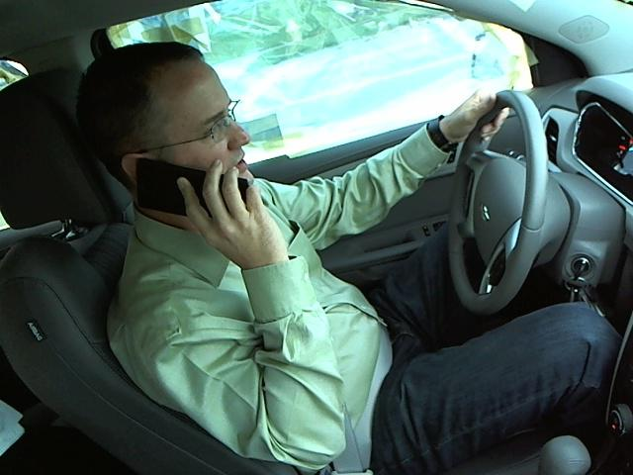  img_9617.jpg | 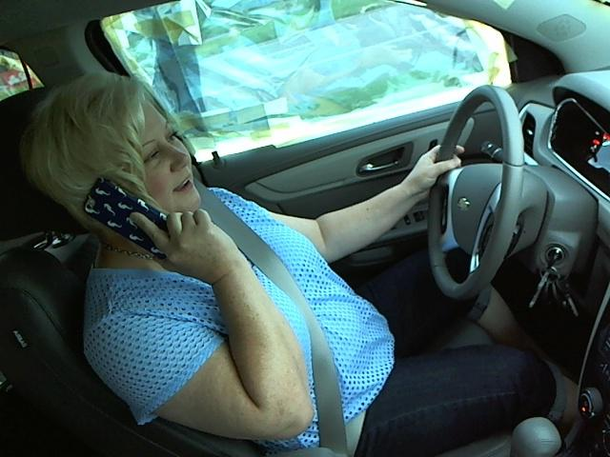  img_9662.jpg | 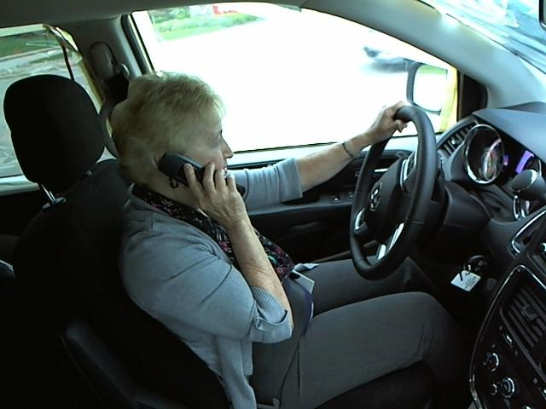  img_9719.jpg
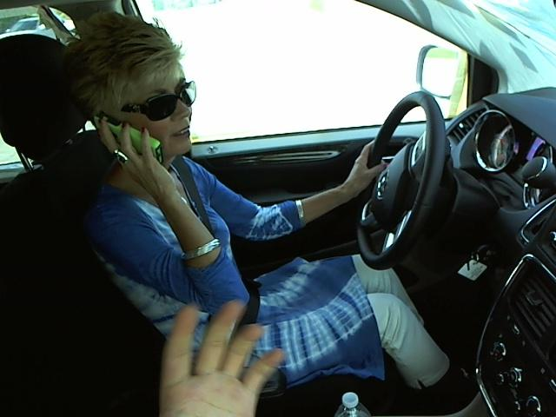  img_9779.jpg | 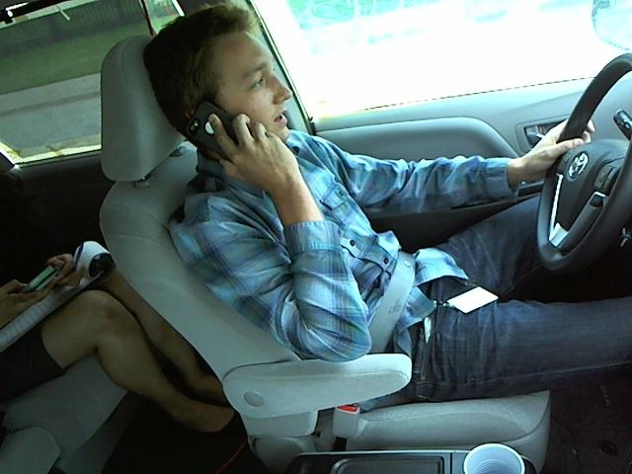  img_9843.jpg | 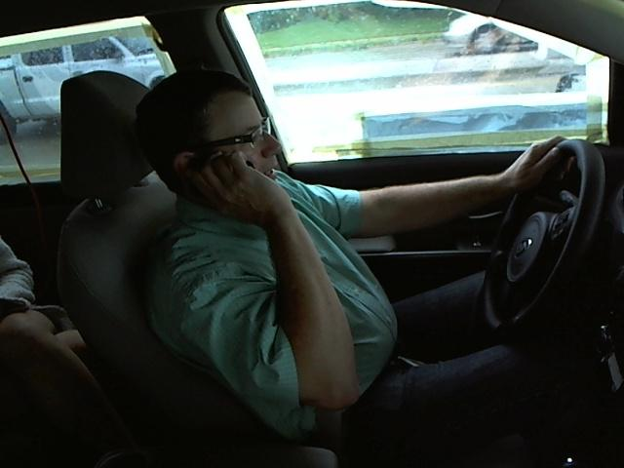  img_9869.jpg
Fig. 1 Sample driver-state images used for qualitative inspection.
3.2 Teacher Models
Four teacher candidates were prepared as TensorFlow Lite models. These teachers provide soft probability targets for each training image. The stored parameter count is inferred from file size and datatype, and is reported as an approximate deployment-scale indicator.
Teacher | Stored model size | Approx. stored parameters | Role
ConvNeXt | 179,868 bytes | 43,828 | Compact teacher candidate
MobileNetV3-Small | 3,091,264 bytes | 1,523,096 | Lightweight mobile teacher
EfficientNet-B0 | 8,071,972 bytes | 3,999,372 | Balanced CNN teacher
ResNet50 | 23,928,320 bytes | 23,501,984 | High-capacity CNN teacher

Table 1 Teacher candidates used for offline distillation.
3.3 Student Architecture
The student is a small depthwise-separable CNN. It begins with a 3 x 3 convolution, followed by max pooling and repeated depthwise convolution, pointwise 1 x 1 convolution, and pooling blocks. Global average pooling and dropout are used before the final dense classification layer. ReLU activation is used inside the feature extractor, and the final layer emits logits for the ten classes.
Component | Configuration
Input | 96 x 96 x 3 RGB
Initial layer | Conv2D width=10, kernel 3 x 3, ReLU
Main blocks | DepthwiseConv2D + 1 x 1 Conv2D with 20, 30, and 40 filters
Final block | DepthwiseConv2D + 1 x 1 Conv2D with 50 filters
Classifier | GlobalAveragePooling2D, Dropout 0.2, Dense(10) logits
Quantized deployment | INT8 TensorFlow Lite Micro
Trainable parameters | Approximately 5,930

Table 2 Student architecture used for embedded deployment.
3.4 Knowledge Distillation Objective
Response-based knowledge distillation is used. For every training image, the teacher produces a probability distribution over the ten classes. These soft targets contain inter-class similarity information, such as the relationship between phone-use and texting classes. The student is optimized with a weighted sum of hard-label cross entropy and softened teacher-student KL divergence:
L = alpha CE(y, z_s) + (1 - alpha) T^2 KL(softmax(z_t/T) || softmax(z_s/T))
The training configuration uses temperature T = 4.0 and alpha = 0.45. Teacher probabilities are cached as NumPy arrays after the first pass, which prevents repeated teacher inference and makes student retraining faster.
4 Hardware Deployment
The embedded inference firmware stores the quantized student model in flash and allocates the tensor arena in available RAM. The input image is resized on-device from the stored sample image representation to the model input shape. A green output indicator represents distraction, while a red output indicator represents safe driving or model failure. The implementation targets TensorFlow Lite Micro through PlatformIO.
Target hardware | SRAM / PSRAM profile | Deployable model | Tensor arena | Input
ESP32 DevKit V1 | No PSRAM; internal SRAM only | 96 RGB INT8 student | 204,800 bytes | 96 x 96 x 3
ESP32-S3 / M5Stack CoreS3 | Internal SRAM plus PSRAM-capable variants | 96 RGB INT8 student | 204,800 bytes | 96 x 96 x 3
Raspberry Pi Pico / RP2040 | 264 KB SRAM | 96 RGB INT8 student | 204,800 bytes | 96 x 96 x 3

Table 3 Hardware deployment configuration.
5 Results and Discussion
All four teacher-derived students use the same compact deployment architecture and therefore have the same hardware memory profile. Differences arise from the teacher distributions used during distillation. The ResNet50 teacher produced the strongest student validation accuracy in the current driver-wise experiment, while MobileNetV3 showed useful behaviour on selected single-image tests. Single-image tests are useful for debugging but should not be interpreted as full accuracy.
Distillation teacher | Student size | Input | Tensor arena | Driver-wise accuracy | Macro F1
ConvNeXt | 22,728 bytes | 96 x 96 x 3 | 204,800 bytes | 44.90% | 43.48%
EfficientNet-B0 | 22,728 bytes | 96 x 96 x 3 | 204,800 bytes | 52.28% | 50.30%
MobileNetV3-Small | 22,728 bytes | 96 x 96 x 3 | 204,800 bytes | 54.92% | 54.38%
ResNet50 | 22,728 bytes | 96 x 96 x 3 | 204,800 bytes | 59.28% | 58.71%

Table 4 Student validation performance under driver-wise splitting.
Hardware | Model input | Tensor arena | Representative latency | FPS
ESP32 DevKit V1 | 96 x 96 x 3 | 204,800 bytes | about 2.42 s | 0.41
ESP32-S3 / M5Stack CoreS3 | 96 x 96 x 3 | 204,800 bytes | about 2.42 s | 0.41
Raspberry Pi Pico / RP2040 | 96 x 96 x 3 | 204,800 bytes | about 43.4 ms | 23.04

Table 5 Hardware latency summary for the deployed student profile.
6 Conclusion
This work demonstrates a complete teacher-student pipeline for compressing driver-distraction recognition into a microcontroller-ready model. The framework replaces direct deployment of high-capacity vision models with offline distillation, INT8 quantization, and a depthwise-separable student architecture. The resulting student requires only about 22.7 KB of model storage and a 204,800-byte tensor arena, making it feasible for selected microcontroller hardware. Future work should improve accuracy through stronger driver-wise teacher training, balanced augmentation, temporal smoothing across frames, and evaluation on larger labelled test sets.
References
[1] S. Essahraui, A. Elhanashi, Q. Zheng, N. Almutairi, and S. Saponara, "Tiny deep learning models for real-time and efficient embedded driver state detection," Journal of Real-Time Image Processing, vol. 23, no. 39, 2026.
[2] H. Wang and Y. Li, "USH: an efficient real-time distracted driving detection model," Journal of Real-Time Image Processing, vol. 22, no. 164, 2025.
[3] X. Gan, L. Huang, Y. Yuan, and Y. Deng, "FAN-YOLO: Real-time driver behavior detection based on full-layer aggregation network of YOLO," Journal of Real-Time Image Processing, vol. 22, no. 139, 2025.
[4] Y. Singh, A. Roy, and R. N. Rao, "Research on Transfer Learning-Based Framework for Real-Time Driver Distraction Detection on Edge Devices," IEEE Access, 2026.
[5] Kaggle, "State Farm Distracted Driver Detection," dataset containing ten driver behaviour classes.

