React app

1.create project:

npx create-react-app app_name

2.create routing:

npm install react-router-dom

3.install bootstrap:

npm install bootstrap

4.install json-server

npm install -g json-server

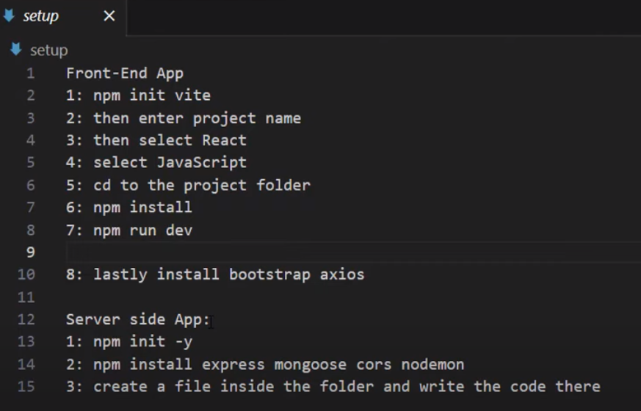

nodejs:

download--

https://snapcraft.io/node

nvm:download--

https://github.com/nvm-sh/nvm

to create project(it creats basic structured project)

set up everything you need to run a React application.

=>node create-react-app project-name

to execute the React application :

=>npm start

What is React?

React, sometimes referred to as a frontend JavaScript framework, is a JavaScript library created by Facebook.

React is a tool for building UI components.

React app