**PHASE 5: MACHINE LEARNING MODEL DEPLOYMENT WITH IBM CLOUD WATSON STUDIO**

**INTRODUCTION:**

In this phase 5 file, we are going to see about the output and some links about this project. In the previous phase 4 file of machine learning model deployment with ibm cloud watson studio, we saw the actual model and python code of the machine learning model and the deployment of the model in the ibm cloud.

**DATABASE DB2 CONNECTIONS:**

This below image represents the connection of DB2 database to ibm cloud machine learning model code. Where the machine learning model has been stored in this module and the intermediate tool is that database cloud object.

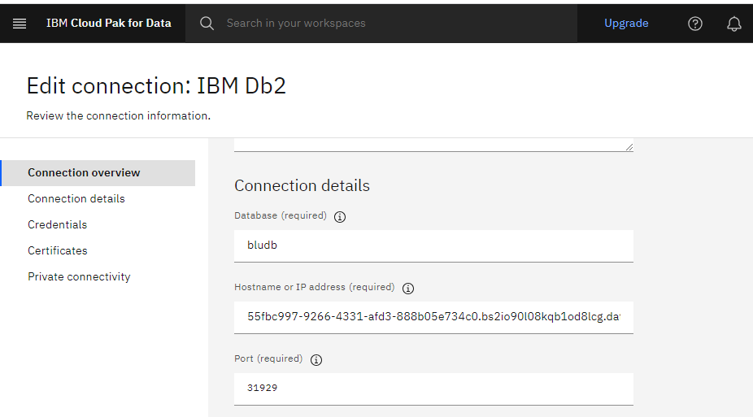

**MACHINE LEARNING MODEL:**

Here in this machine learning model deployment with ibm cloud watson studio, we have done an proper machine learning model known as decision tree model.

Decision Tree is a Supervised learning techniquethat can be used for both classification and Regression problems, but mostly it is preferred for solving Classification problems. It is a tree-structured classifier, whereinternal nodes represent the features of a dataset, branches represent the decision rules and each leaf node represents the outcome.

**OUTPUT FOR DECISION TREE:**

The below picture is the representation for the decision tree in machine learning which was deployed in the ibm cloud watson studio using jupiter notebook.

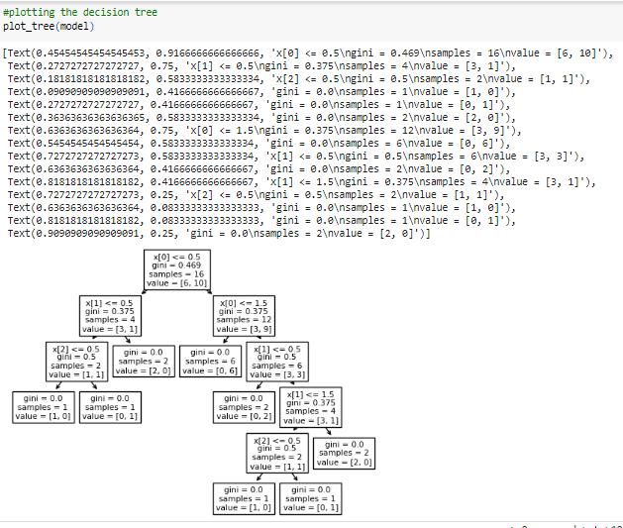

**ACCURACY OF DECISION TREE MODEL:**

The below picture is the representation for checking the accuracy of the machine learning model. Whereas the model says 1 as output the accuracy is strong and if the model says 0, it has less accuracy in the model.

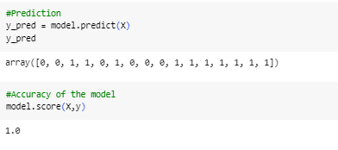

**CONCLUSION:**

In this phase 5 we saw about the connection from the database db2 credentials and some output of the decision tree machine learning model deployed in the ibm cloud watson studio. These deployment of machine learning model was successfully done using the ibm cloud tools and watson machine learning tool.