**PHASE 4: MACHINE LEARNING MODEL DEPLOYMENT USING IBM CLOUD WATSON STUDIO**

**INTRODUCTION:**

Using IBM Watson Machine Learning, you can deploy models, scripts, and functions, manage your deployments, and prepare your assets to put into production to generate predictions and insights.

This graphic illustrates a typical process for a machine learning model. After you build and train a machine learning model, use Watson Machine Learning to deploy the model, manage the input data, and put your machine learning assets to use.

**FLOW DIAGRAM:**

This is the data flow diagram for the machine learning model deployment using cloud watson studio. At first the data have to chosen from the any data set. Further we proceed to the data base connectivity through the DB2.

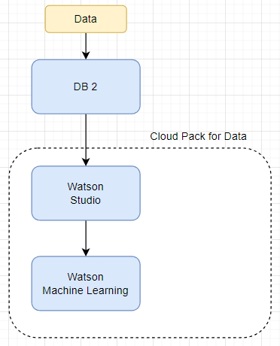

Then we connect the data base to the watson studio for the deployment process of machine learning model using watson studio. All creation of the model and deployment are done in the ibm cloud data pak for data environment. The machine learning model code can be edited through the jupiter notebook tool which was present in the ibm cloud catalog.

**DATA:**

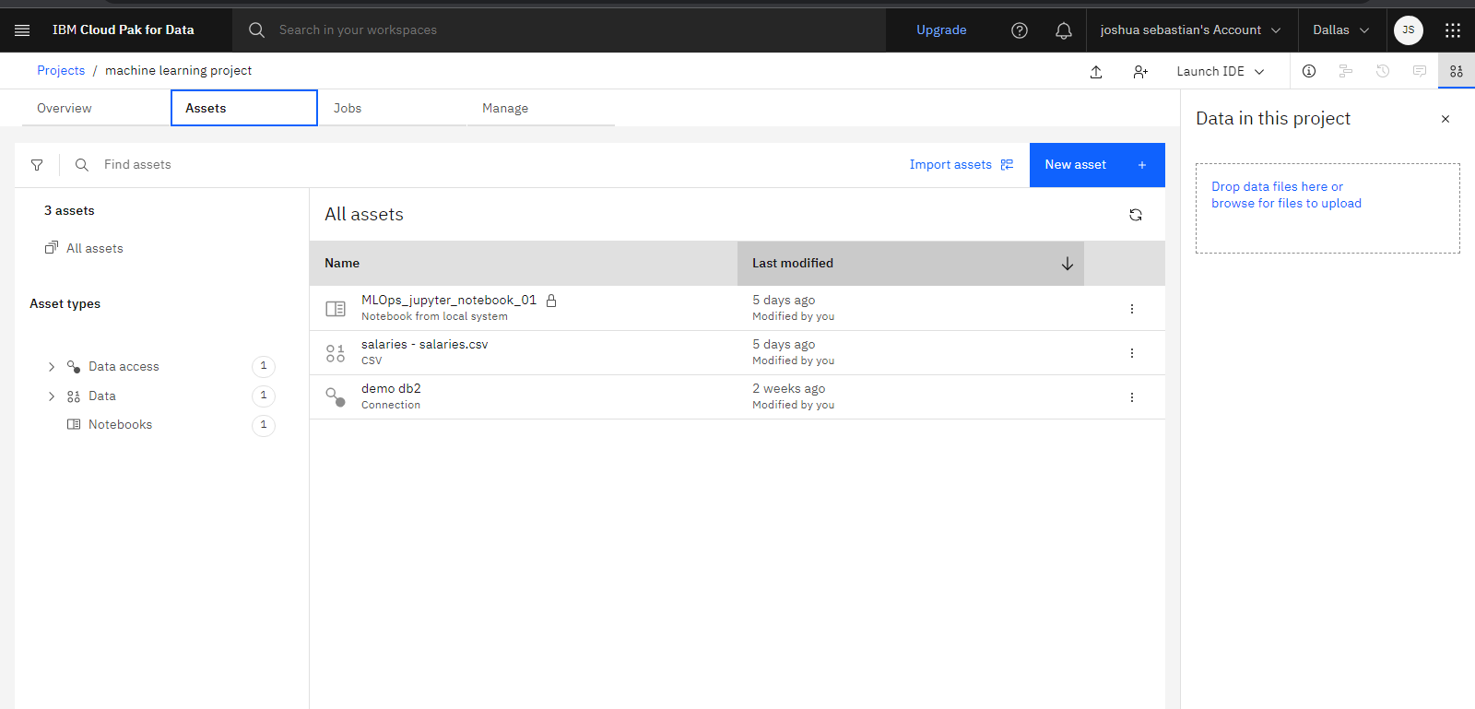

These are the data assets used in the ibm cloud for building the machine learning model for deployment in ibm cloud watson studio.

**MACHINE LEARNING MODEL CODE EXPLANATION:**

At first we have to connect the jupiter notebook to the ibm cloud, and then setting up the watson machine learning tool to the cloud.

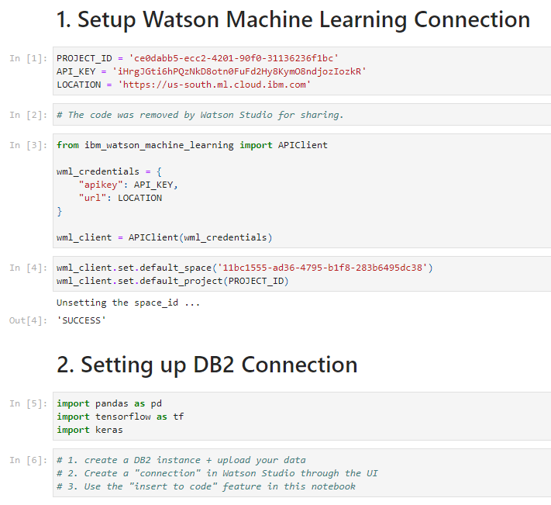

Then after we have to connect the machine learning model to the DB2 database using the python code. All the instructions of code are been written using the python code.

After getting the connection from the db2, prepare the data using the python code.

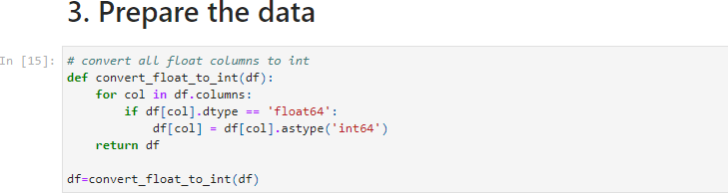

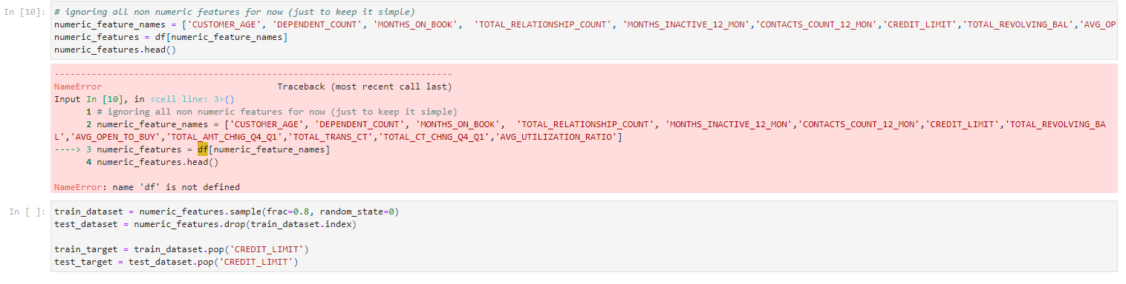

After we prepare the data for execution, do the actual machine learning model using the python code.

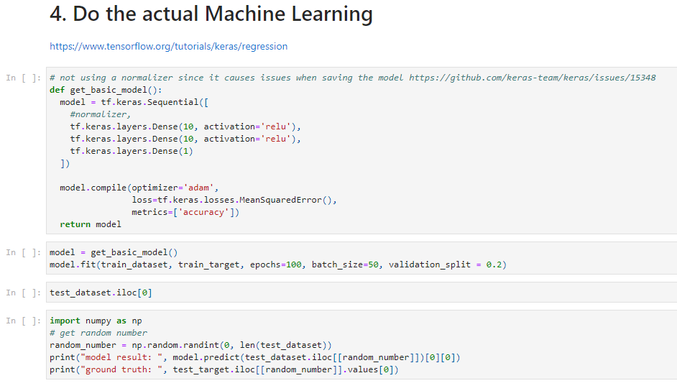

Once the machine learning model had been done using python code check for the error. If any debug it. Then store the model in the cloud.

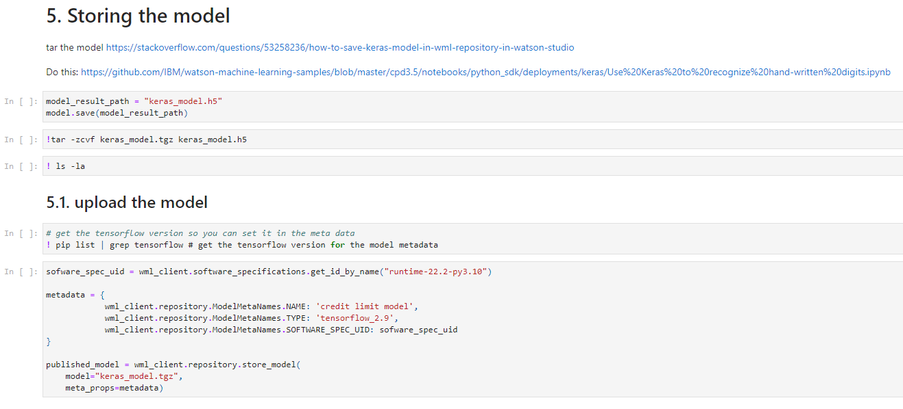

Upload the machine learning model in the ibm cloud deployment service that had been offered by ibm. Get the basic information of the machine learning model programmatically. And then test the machine learning model using the python code.

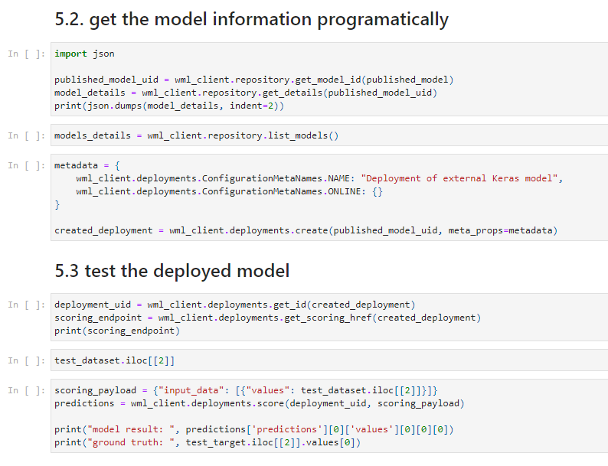

**CONCLUSION:**

In this module of phase 4, we have made the machine learning model which was developed using the python code. In the next phase 5, we have made the output for the respective machine learning model.