**DEPARTMENT OF COMPUTER SCIENCE**

**ONLINE GRADUATE TRACER**

**SYSTEM**

A Capstone Project

Presented to

the Faculty of the Department of Computer Science

University of San Carlos

In Partial Fulfillment

of the Requirements for the Degree of

Bachelor of Science in Information and Communications Technology

By

Cabalan, Rael

Irog-irog, Christian Jay

Lawsin, John Stephen

Rosauro, John Dale

Polinar, Stephanie

Faculty Adviser

February 21,2015

**Acknowledgement**

First and foremost, we would like to thank the Almighty God for always guiding and helping us especially for the entire four years of our college life. We would also like to give our gratitude to our parents who have been so supportive and understanding whenever we are busy and for acknowledging all of our hardships and efforts in making this project possible.

We are very grateful to our client, consultant, and chair of the Department of Computer Science- Miss Mary Jane Sabellano for sparing us with her time and insights despite being a very busy person.

We would like to say thank you to Ms. Stephanie Polinar our capstone adviser for helping us and sharing with us her knowledge about our capstone project. Thank you so much for all the time and patience the she has given to us. Thank you for always being there whenever we needed help and feel like giving up.

And we would also like to show our appreciation for all our classmates and friends that helped us and further encouraged us to do our best. Thank you for sharing with us your knowledge and time.

And last but not the least, we would like to give our gratitude to our panelists- Ms. Mary Jane Sabellano, Mr. Jerson Sabellano and Ms. Antonette Cantara.

And because of all of you, we’ve made it here today. Again, thank you everyone and may God bless all of you.

**Abstract**

The University of San Carlos, Department of Computer Science has been producing competent graduates in the industry. Tracing and monitoring graduates has never been an easy task for the department. It requires more information from the graduates to trace the graduates. It is important for the department to have a system that keeps track of their graduates for the department to have enough information about the graduates of Department of Computer Science. This is the reason why the project Computer Science Department Online Graduate Tracer System is very useful for the department. It is not only useful for the teachers and faculty of CS Department but also to the graduates of CS Department. The Online Graduate Tracer will help the CS Department tracer the graduates easily and get the information they need about the graduates, it eliminates the inconvenience of using Google docs as the research instrument from the previous study. Through this system, the faculty of the department can get important information needed, like employment rate, work experiences, school background, and program outcomes of the graduates. With the results of the evaluation that the developers have conducted, the overall average rate of the system is 4.13% out of 5.00%which lead to the conclusion that for the users, this Online Graduate Tracer System is very acceptable.

**TABLE OF CONTENTS**

Acknowledgement..............................................................................i

Abstract..............................................................................................ii

TABLE OF CONTENTS.....................................................................iii

LIST OF TABLES...............................................................................v

LIST OF FIGURES.............................................................................vi

CHAPTER 1.......................................................................................1

INTRODUCTION................................................................................1

* 1. Background of the Project.............................................................
  2. Project Objectives ....................................................................

1.2.1 General Objectives................................................................

1.2.2 Specific Objectives.................................................................

* 1. Significance of the Study.............................................................
  2. Scope and Limitations of the Project ...........................................

CHAPTER 2.........................................................................................

REVIEW OF THE RELATED LITERATURE........................................

CHAPTER 3...........................................................................................

PROJECT METHODOLOGY.........................................................................

CHAPTER 4...........................................................................................

4.1 Requirement Specification.................................................................................

4.1.1 Business Flow................................................................................

4.1.2 System Interfaces...........................................................................

4.1.3 User Interfaces....................................................................................

4.1.4 Hardware Interfaces.....................................................................

4.1.5 Software Interfaces....................................................................

4.1.6 Communication Interfaces............................................................

4.1.7 User Characteristics......................................................................

4.1.8 Constraints.....................................................................................

4.1.9 Specific Requirements…………………………………………………

4.1.10 Component Diagram…………………………………………………

4.1.11 High Level Case………………………………………………………….

4.1.12 Entity Relation Diagram ………………………………………………

4.1.13 Testing and Evaluation ……………………………………………….

CHAPTER 5 ……………………………………………………………………

RESULTS AND ANALYSIS ………………………………………………….

5.1 Statistical Treatment of Data …………………………………………….

5.2 Interpretation of Data …………………………………………………….

5.3 Tabular Graphical Representation of Results ………………………..

CHAPTER 6 ………………………………………………………………….

CONCLUSION AND RECOMMENDATION………………………………

DEFINITION OF TERMS ………………………………………………….

REFERENCES………………………………………………………………

PROJECT COST/BUDGET ………………………………………………

USER’S MANUAL ………………………………………………………………..

CURRICULUM VITAE …………………………………………………………...

**List of Tables**

Table 4.1 ……………………………………………………………………

Table 4.2.5.1.1 ……………………………………………………………………

Table 4.2.5.1.2 ……………………………………………………………………

Table 4.2.5.2.1 ……………………………………………………………………

Table 4.2.5.2.2 ……………………………………………………………………

Table 4.2.5.2.3 ……………………………………………………………………

Table 4.2.5.2.4 ……………………………………………………………………

Table 4.2.5.2.5 ……………………………………………………………………

Table 4.2.5.2.6 ……………………………………………………………………

Table 4.2.5.3.1 ……………………………………………………………………

Table 4.2.5.4.1 ……………………………………………………………………

Table 4.3.1 ……………………………………………………………………….

Table 4.3.2 ……………………………………………………………………….

Table 4.3.3 ……………………………………………………………………….

Table 5.1 …………………………………………………………………………..

Table 5.2 …………………………………………………………………………..

Table 5.3 …………………………………………………………………………..

Table 5.4 …………………………………………………………………………..

Table 5.5 …………………………………………………………………………..

Table 5.6…………………………………………………………………………..

Table 5.7 …………………………………………………………………………..

**List of Figures**

Figure 3.1 …………………………………………………………………………..

Figure 4.1 …………………………………………………………………………..

Figure 4.2 …………………………………………………………………………..

Figure 4.3 …………………………………………………………………………..

Figure 4.4 …………………………………………………………………………..

Figure 4.5 …………………………………………………………………………..

Figure 4.6 …………………………………………………………………………..

Figure 4.7 …………………………………………………………………………..

Figure 4.8 …………………………………………………………………………..

Figure 4.9 …………………………………………………………………………..

Figure 4.10 …………………………………………………………………………..

Figure 4.11 …………………………………………………………………………..

Figure 4.12 …………………………………………………………………………..

Figure 4.13 …………………………………………………………………………..

Figure 4.14 …………………………………………………………………………..

Figure 4.15 …………………………………………………………………………..

Figure 4.16 …………………………………………………………………………..

Figure 4.17 …………………………………………………………………………..

Figure 4.18 …………………………………………………………………………..

Figure 4.19 …………………………………………………………………………..

Figure 4.20 …………………………………………………………………………..

Figure 5.1 …………………………………………………………………………..

Figure 5.2 …………………………………………………………………………..

Figure 5.3 …………………………………………………………………………..

Figure 5.4 …………………………………………………………………………..

Figure 5.5 …………………………………………………………………………..

Figure 5.6 …………………………………………………………………………..

Figure 5.7 …………………………………………………………………………..

Figure 5.8 …………………………………………………………………………..

Figure 5.9 …………………………………………………………………………..

**CHAPTER 1**

**INTRODUCTION**

This chapter will show the purpose of the study, why this study was made. The background of the project, what the project is all about. Objectives of the project, what the project intends to do. Significance of the study. who will be the beneficiaries of the study. Scope and limitation of the project, what the project covers and its limitations.

**Rationale of the study**

The University of San Carlos has been producing professionals that graduated from different courses. These professionals are ready to compete for jobs and career. Some of them are employed to the jobs that fit to their fields of expertise. Some of them are employed to jobs that are not related to their chosen fields of expertise.

The number of graduates produced by the University of San Carlos is one of the factors of difficulty in tracing graduates and their careers. The University’s, many departments, makes tracing graduates too hard because of the different courses taken.

This is the reason why Graduate Tracer System was conceptualized. This project will support the graduate tracer study. The Graduate Tracer System will be able to trace graduates from a specific department if they are employed or unemployed, and if employed the project will trace whether their jobs fit to their course graduated. The data gathered by the system helps the department know if the changes that need to be made in their curriculum and to know the percentage of unemployed and/or job mismatch.

**Project Objectives**

**General Objective**

This study aims to develop a Graduate Tracer System for the Department of Computer Science of University of San Carlos.

**Specific Objective**

1. Determine the requirements and the relevant information needed in tracing graduates
2. Develop an Online Graduate Tracer System.
3. Test and Evaluate the System

**Significance of the Study**

The study on Graduate Tracer System of Computer Science Department University of San Carlos will be beneficial to the following:

To the **Computer Science Department**, it will able to keep track alumni where he\she currently works and also where he\she previous worked. And what is his\her work right now and his\her previous works before he\she got his\her present job. It will also able to track by programs what program is the highest percentage of employed and unemployed or their jobs mismatch on their field of expertise. The department will take actions whether they have to improve the curriculum on the said programs for the benefits of the upcoming students.

To the **Alumni**, that they can track their own record in case of urgent use. The system will also able to help all past and present students looking for help in finding a job or even an internship.

To the **University**, that they will benefit, and make use of the information and analysis of the present study on Graduate Tracer System by making it as their reference of their research.

**Scope and Limitation**

The scope of the project is to show whether or not the graduates specific works assigned are related to their field of study, to figure out the length of waiting time before the graduate get employed, and to indicate possible deficit in a given educational program.

Gather data from graduates using survey that is built in to the system for the graduates convenience. The graduates will answer the survey questionnaire prior to the questions demanded by the Department. The data will be analyzed and processed to generate information like, employment rate, relevance of their jobs to their course graduated, and others. The analyzed information will be used to generate reports that will help the admin get information easily.

The Graduate Tracer System can send emails to the users who answered the questionnaire, content of the email could be notification from the admin or reminder from the admin about the system update. The system can also generate and analyze reports from information given by the alumni, the reports will be presented through graphs and charts.

The admin (Computer Science Department), can view results and responses from the alumni’s answered from, admin can also print reports from the information given by the alumni’s responses, and can add, edit, delete items in the questionnaire.

In the alumni side, the alumni can only answer and update profile, they cannot see and generate reports. In the system side, the system can only trace graduates from a specific department, Computer Science Department.

**Chapter 2**

**Review of Related Literature**

This chapter shows the related literature and research studies after comprehensive and complete research of the researchers. This will also present the theoretical background and conceptual framework to have a knowledge about the study.

Graduate Tracer study is a system that is used by many organizations in an Academe to track and keep record of the students who graduated from the academe. With the use of a Graduate Tracer, an Academe will be able to assess the quality of the education and effectiveness of the curriculum given to the students by knowing their employment status, and job positions for the Academe to know if there are changes to be made in the curriculum given to the students.

A study by Chinyama and Zembere (1996) of the University of Malawi, show the results of the graduates of the University of Malawi who graduated from 1987 to 1995, shows that the opportunities of securing a job by a graduate had declined over the years and the waiting time of the graduates to find a job increased. The study also shows that most of the graduates had change jobs more than once and most of the graduates are employed in the Education sector.

A study conducted by Macatangay (2013) in Lyceum of the Philippines University, Batangas. The findings were greater percentage of the graduates work along their field of specializations while others are working not related to their completed course, mastery in the subject matter being taught and relating the subjects to other fields and other life situation were on the top three very relevant factors to employment based on the respondents’ responses. Salaries, benefits and career challenge are some reason changing their job. They are looking for companies where they can apply their knowledge and skills. In terms of competencies and skills learned in school, communication skills and information technology skills ranked first, followed by critical thinking skills, problem solving skills and human relation skills.

Related study made by Laguador and Dotong (2013) a Computer Engineering student in the same University, Lyceum of the Philippines University, Batangas shows that, College of Engineering must strengthen their services and focus on the quality of instruction with the support of research community extension. Annual update of the status of their graduates and ask for possible curriculum enhancement program they could offer to College. Understanding and appreciation of natural subjects must be strengthened by the faculty members in order to apply knowledge in scientific research and developments.

Another related study made in Lyceum of the Philippine University by Celis, Festijo and Cueto shows that majority of the respondents are gainfully employed and landed a job from one to two years after graduation. Most of them are contractual basis. Benefits and salary plays a big role in staying or changing jobs. Human relation skills and communication skills are considered to be the most important competencies learned by students from the University. Updates regularly once a year the status of their graduates and ask for possible curriculum enhancement and suggestion on what changes to be done in the curriculum.

Another study by Gines (2014), conducted in the Philippine Normal University, the study shows that having provided very adequate skills such as knowledge and technical, communications, human relations, leadership, research, problem solving and other competencies were the major factors on top of area of specialization considered for job acquisition. The graduates level of satisfaction with the University’s services is generally high.

Verona (2011) conducted a study of employment status of graduates in Polytechnic University of the Philippines Quezon City, the study reveals that majority of the respondents are regularly employed and works in the service industry. Most of the respondents stayed in their first job in 1-6 months. Salaries and benefits is the majority answer by respondents for their reason in changing their job. Majority of the respondents found their first job after college in 1-6 months. Most of the respondents agree that their present job is related to their course. Communication skills are the most useful competencies acquired in college.

Related study by De Ocampo, Bagano, and Tan (2012), the study shows that the useful competencies learned in the University were communication skills, human relation skills, critical thinking skills, entrepreneurial skills and problem solving skills. The result also indicated that male graduates have greater chances of earning higher initial salary than female graduates. Majority of the employed graduates specify salaries and benefits, career challenge and relevance to the course.

**Chapter 3**

**Project Methodology**

This chapter discusses about the steps involve in making the project. This project used Rapid Application Development software development model. Rapid Application Development emphasizes more on the development than the planning task. Rapid Application Development approaches emphasize the necessity of adapting requirements in reaction to knowledge gained in the progresses of the project.

In Figure 3.1, The Rapid Application Development Model with four phases.

The first phase is Requirements and Planning, second is the System Design,

third is the Development phase, and the last is the Cutover phase.











**Figure 3.1 RAD Model**

**3.1 Phase 1: Requirements Planning**

The outline system area model and scope of the proposed system are developed in this task. The functionality of the system is expressed in terms of the business processes and the data that the system will support.

**3.2 Phase 2: System Design**

After planning the department’s system, the developer then makes design for their proposed sytem. An ERD was designed for the clients to fully grasp the process of the system. The normalized table was presented to the clients to show the relationship between all the accounts and the database. If the process is approved by the department, the developer can now design the User Interface of the system according to the department’s preference.

**3.3 Phase 3: Development**

After approving the proposed process flow and the design by the department’s representative, the developers can now develop the proposed system.

**3.4 Phase 4: Cutover**

The developers prepare existing data for the proposed system and train users to operate the new application. The developers also provide support to resolve any problems that arise immediately after the application becomes operational.

**CHAPTER 4**

**Software Development**

This chapter discusses about the business process of the system, system flow, requirements, specifications, and design specifications.

**4.1 Requirement Specification**

**4.1.1 Business Process**

The Business Process is through Online Survey so that the graduates can have access anywhere. The graduates will use their accounts given from the administrator to log in. After log in, they will be redirected to the homepage. They have to answer the survey and give all information needed. In every three years the will receive a notification for information update. Refer to Figure 4.1.

**Figure 4.1 Business Process Flow Chart – Admin**

The admin needs to log in the system, and will be redirected to the homepage. The admin can manage surveys, they can add, view, edit, delete surveys and questions. View the response from the Online Survey answered by the graduates. View the list of graduates and their background information. Given the data from the graduates’ responses, it will be processed to information and Admins can view reports. Refer to Figure 4.2.





**Figure 4.2 Business Process Flow Chart- Admin**

**4.2 Requirements and Specifications**

This part discusses about the different requirements and specification in developing the system.

**4.2.1 User Interface**

In Figure 4.3, The graduates and admin will log in the system using their username and password.

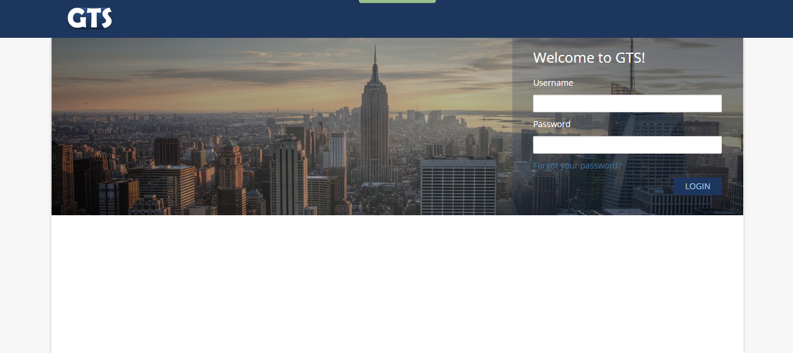

**Figure 4.3 Login Page - Admin**

In figure after log in, the Admin will be redirected to the homepage of Administrator’s page.

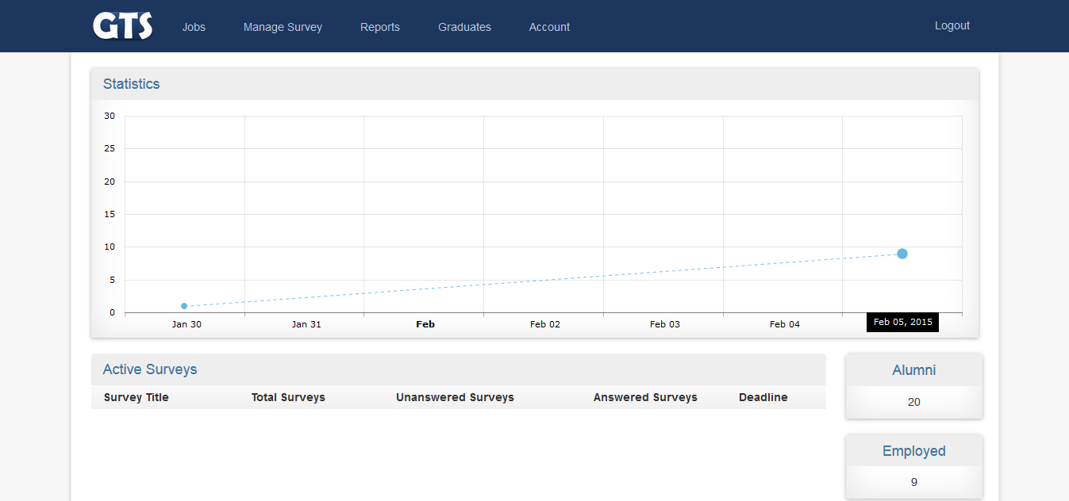

**Figure** **4.4 Home Page - Admin**

This page lets the admin add surveys that will be sent to the graduates. In every survey, there are questions with choices added in the survey.

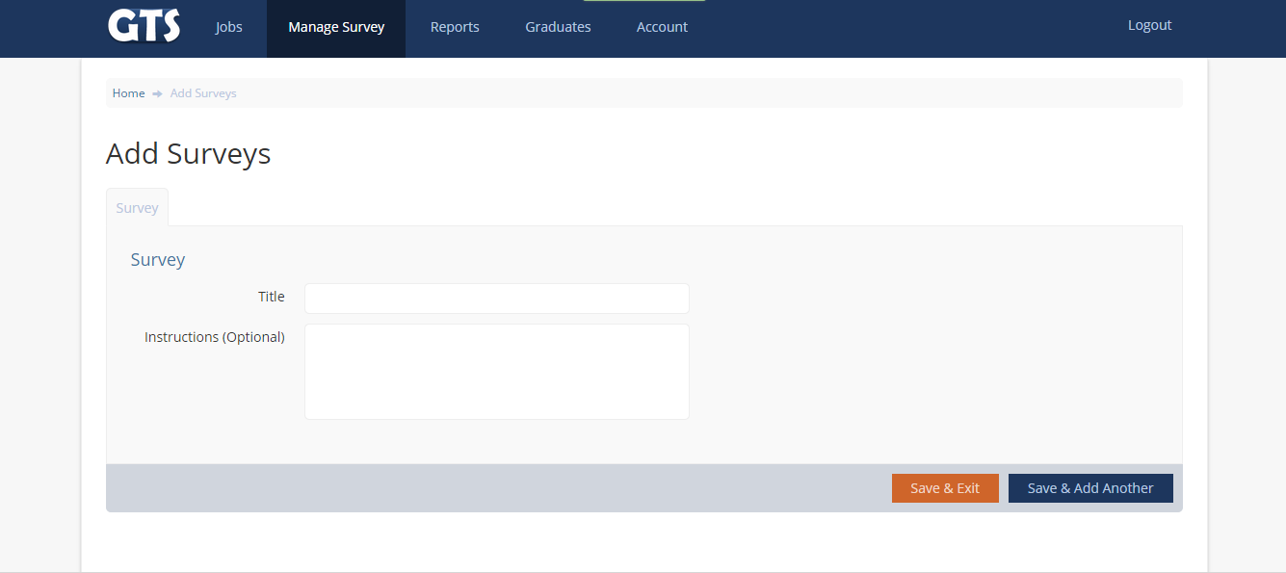**Figure 4.5 Add Surveys - Admin**

This page shows the list of surveys created by admin, in this page admin can manage the surveys. Admin can send the survey to the graduates, view surveys,

add questions to the surveys, edit surveys, search surveys print surveys, and delete surveys.

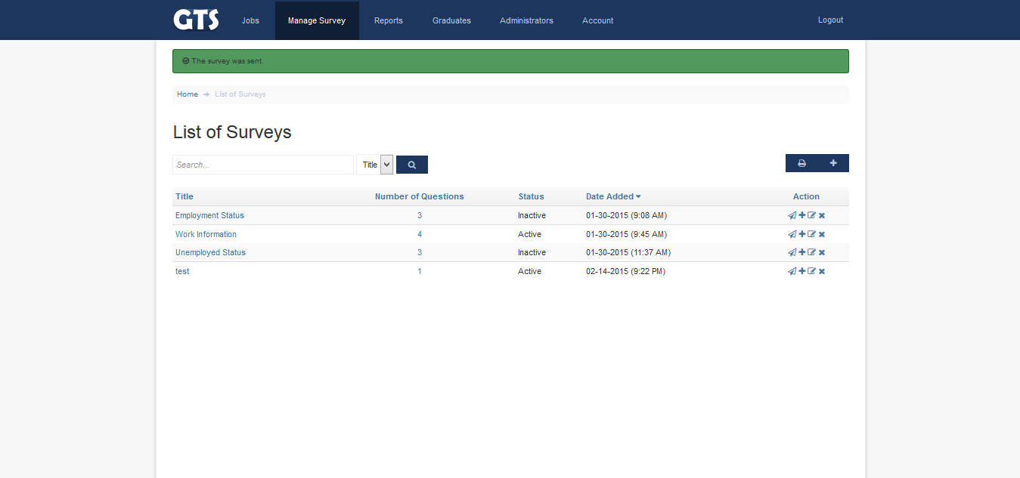

**Figure 4.6 List of Survey - Admin**

Admin can add questions and choices in this page. Admin can choose what type of questions to make and number of choices in every question.

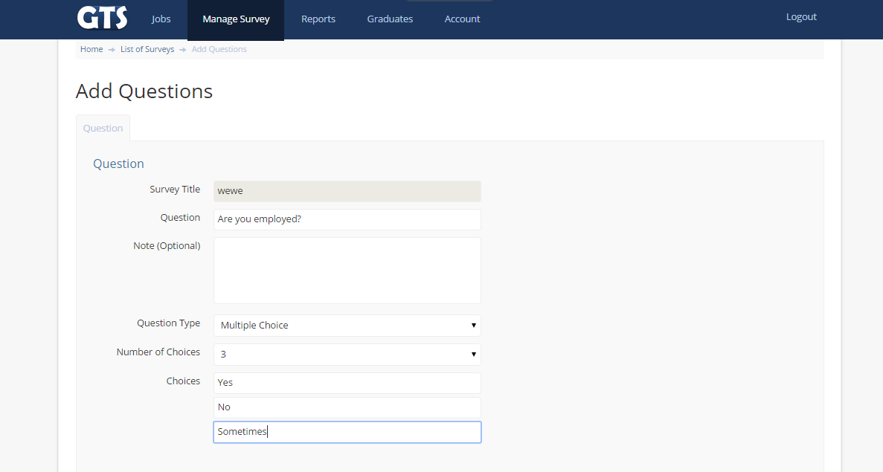**Figure 4.7 Add Questions - Admin**

If the Admin wants to make changes in the survey, admin can edit the survey in this page.

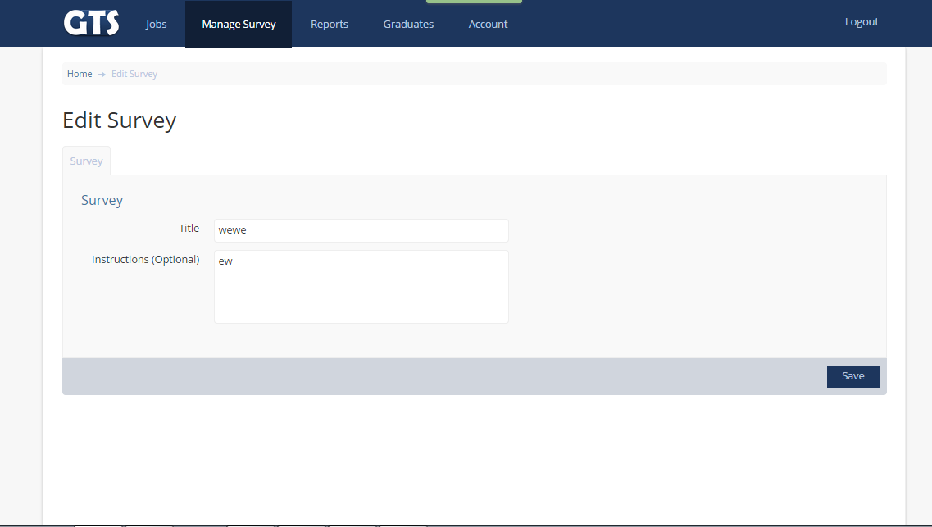

**Figure 4.8 Edit Survey - Admin**

In this page, the Admin can make changes in a specific question of a survey.

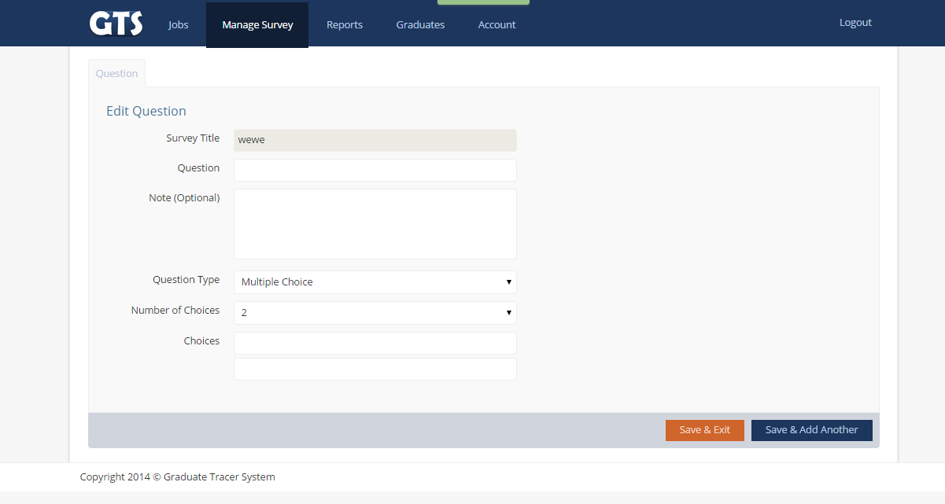

**Figure 4.9 Edit Question – Admin**

List of Graduates shown in this page, Admin can view details of each graduates, can print the list, and can make changes in the account of graduates.

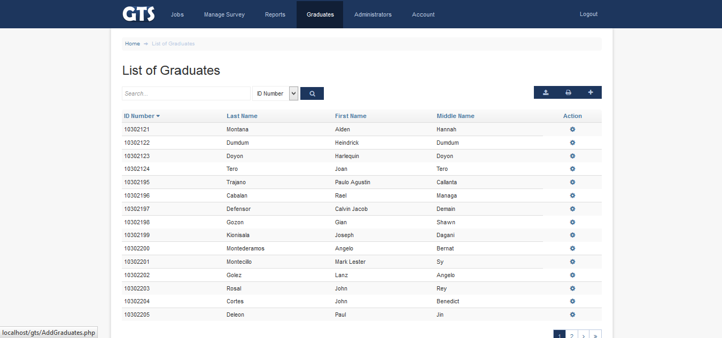

**Figure 4.10 Lists of Graduate - Admin**

This page let the Admin view the details of a graduate, its account information and personal information.

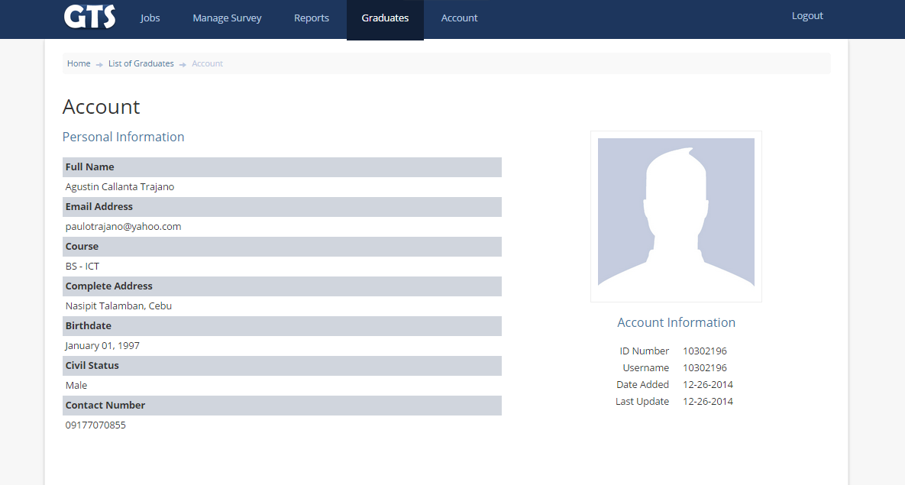

**Figure 4.11 View Graduates - Admin**

Admin can view the account of Graduates in this page, but can’t change the personal information.

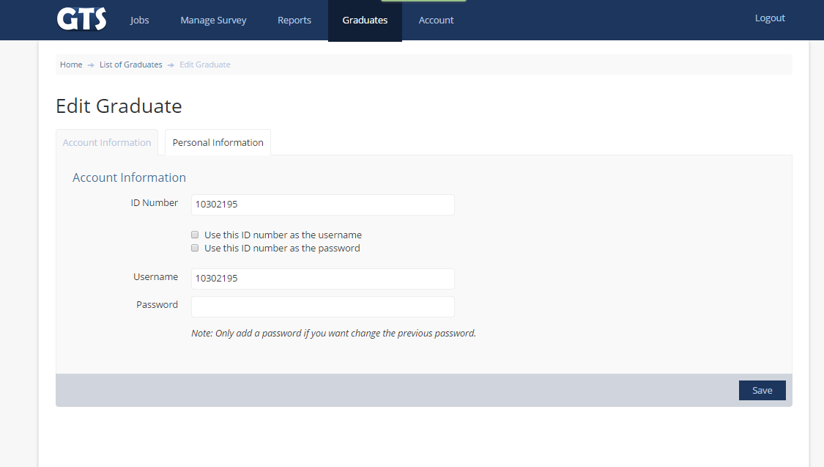

**Figure 4.12 Edit Graduate - Admin**

This page is where the graduates will log in using their username and password.



**Figure 4.13 Login Page - Graduates**

After successful log in, the graduates will be redirected to graduates’ homepage.

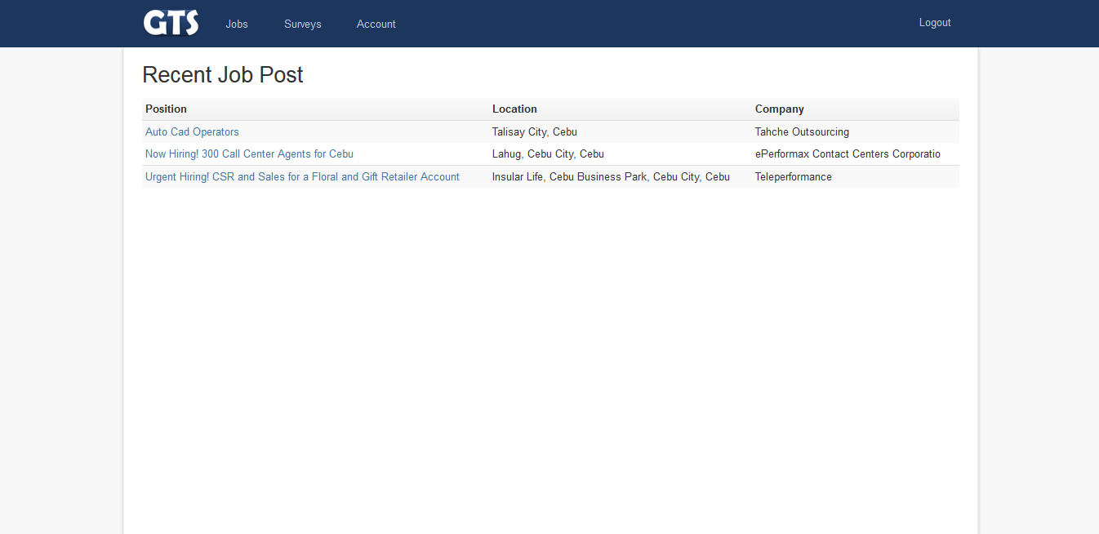

**Figure 4.14 Home Page - Graduates**

Graduates can view surveys sent from admin in this page, it shows the number of questions, status, date sent, and graduates can also print survey.

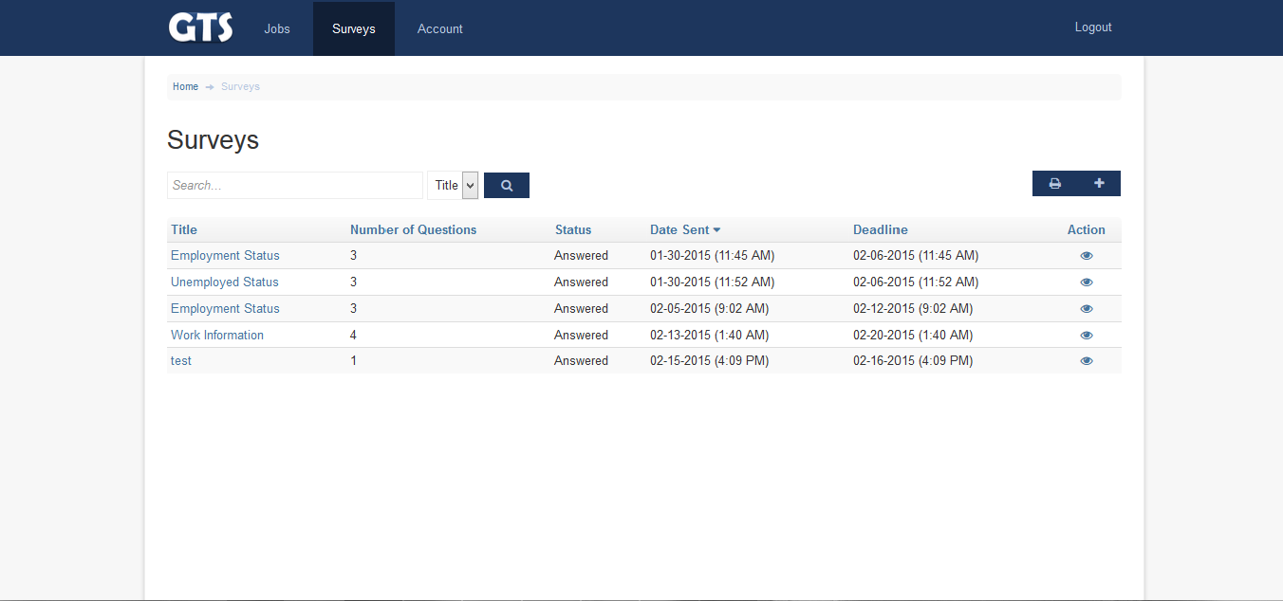

**Figure 4.15 View Surveys – Graduates**

In this page, Graduates can answer the survey and submit after answering survey.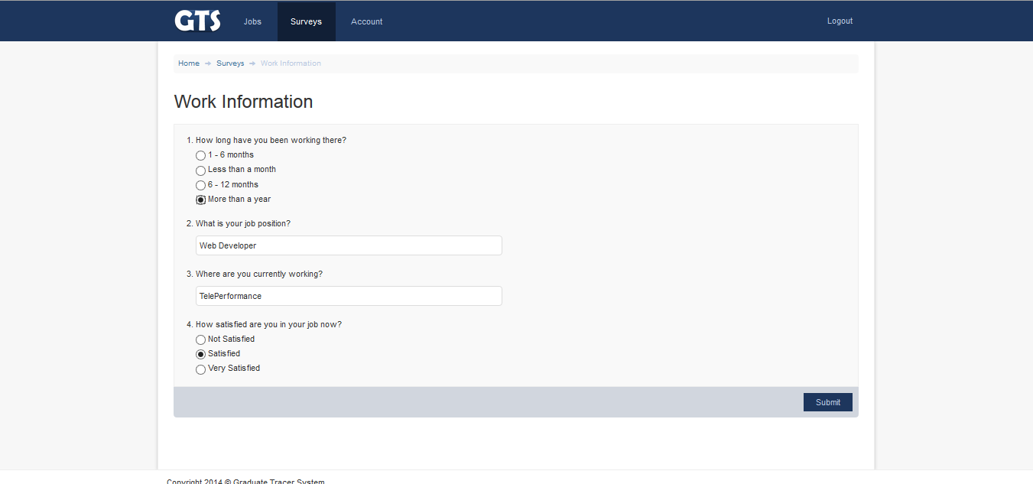

**Figure 4.16 Answer Survey - Graduates**

After answering the survey, the Graduates can view their answers in this page.

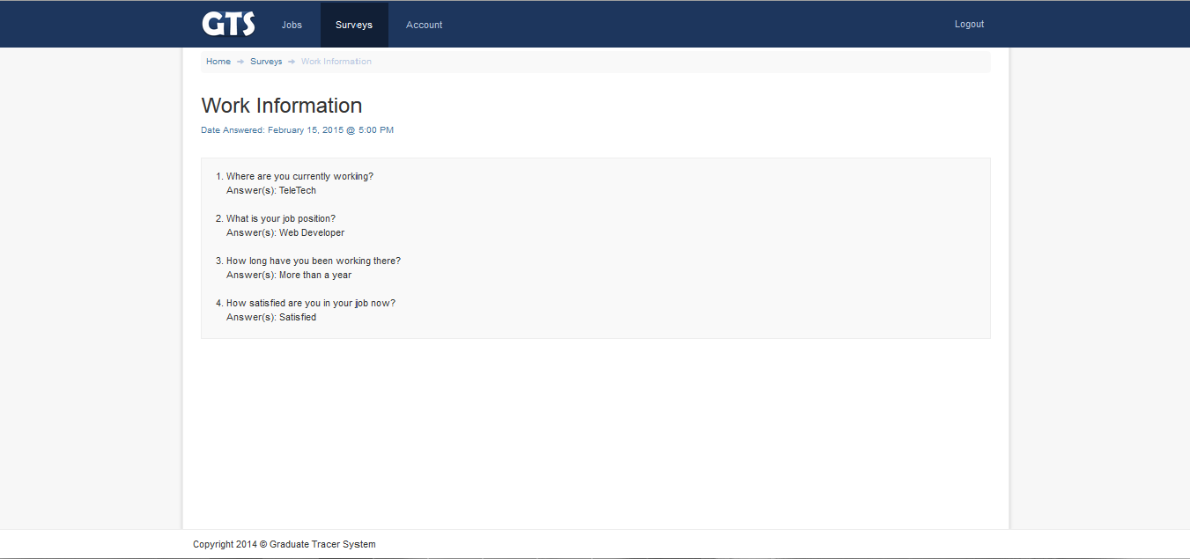

**Figure 4.17 View Answers - Graduates**

**4.2.2 Software Interface**

**Table 4.1 Software Interface**

|  |  |  |  |
| --- | --- | --- | --- |
| **Name** | **Version** | **Source** | **Purpose** |
| PHP | 5.6.4 | www.php.net | Used for development |
| Apache | 2.4.10 | www.apache.org | Use to enable PHP hosting. |
| XAMPP | 5.6.3 | www.apachefriends.org/index.html | Provides support for creating and manipulating databases in MySQL |
| MySQL | 5.7 | www.mysql.com | Used for database |
| Sublime Text 2 | 2.0.2 | http://www.sublimetext.com/2 | Used for coding. |
| Microsoft Word | 15.0.4551.1011 | www.office.microsoftword.com/en-us/word | Word processor used for documentation. |

For the Software Interfaces, PHP is the most important in the development. XAMPP is the main web server used. Apache is then used for the web server application. MySQL is used to handle and manipulate the database, which was used for data storage of the system. Sublime Text 2 is software used for coding programming languages that makes user to code with convenience. Last is the Microsoft Word, main software application used for the documentation of the system.

**4.2.3 User Characteristics**

There are three users in this system, and each should have basic knowledge on how to use computers. All of the users will be dealing on surveys.

The first user is the administrator. The administrator should know about using the system and should know each components of the system. The administrator can login to the system’s administrator-side to manage all the reports. The administrator can see all the graduates with their response to the survey given to them and can view all reports generated from the system. Only the administrator has the access to reports.

The other user is the second admin or the low-level-admin. This user can promulgate the same job of the main administrator but doesnt have the power to add another admiin.

The alumnus, the graduates should also have knowledge about computer and computer applications. The user can answer surveys, review their answers, and update their information.

**4.2.4 Constraints**

The system requires stable internet connection. The system runs best at Google Chrome, but in Internet Explorer, some features are not supported.

**4.2.5 Specific Requirements**

**4.2.5.1 Functional Requirement**

|  |  |  |  |
| --- | --- | --- | --- |
| Requirement ID | Description | Priority | Approved/Confirmed By |
| REQ-0001 | The window should load easily in the web browser | 1 | Stephanie Polinar |
| REQ-0002 | The initial window must contain empty fields allocated for username and password. The password field must be a “secret field”, so that it will not display what the user inputted. | 1 | Stephanie Polinar |

**Table 4.2.5.1.1 Login**

**Table 4.2.5.1.2 Data Entry**

|  |  |  |  |
| --- | --- | --- | --- |
| Requirement ID | Description | Priority | Approved/Confirmed By |
| REQ-0003 | All information created by the admin and client must be stored in the database. | 1 | Stephanie Polinar |
| REQ-0004 | All updated made by the admin and client must be saved in the database. | 1 | Stephanie Polinar |

**4.2.5.2 Performance Requirements**

|  |  |  |  |
| --- | --- | --- | --- |
| Requirement ID | Description | Priority | Approved/Confirmed By |
| REQ-0005 | The system shall display the jobs that the admin created. | 1 | Stephanie Polinar |
| REQ-0006 | The administrator can view, edit, delete the selected job title. | 1 | Stephanie Polinar |
| REQ-0007 | The administrator can search the job created. | 1 | Stephanie Polinar |

**Table 4.2.5.2.1 List of Jobs**

**Table 4.2.5.2.2 List of Surveys**

|  |  |  |  |
| --- | --- | --- | --- |
| Requirement ID | Description | Priority | Approved/Confirmed By |
| REQ-0008 | The system shall display the survey that the admin created. | 1 | Stephanie Polinar |
| REQ-0009 | The administrator can send survey, add questions, edit and delete questions. | 1 | Stephanie Polinar |
| REQ-00010 | The administrator can view the new survey created. | 1 | Stephanie Polinar |

**Table 4.2.5.2.3 List of Graduates**

|  |  |  |  |
| --- | --- | --- | --- |
| Requirement ID | Description | Priority | Approved/Confirmed By |
| REQ-00011 | The system shall display the graduates that the admin created. | 1 | Stephanie Polinar |
| REQ-00012 | The administrator can view and edit graduates except work information. | 1 | Stephanie Polinar |
| REQ-00013 | The administrator can search the graduates. | 1 | Stephanie Polinar |

**Table 4.2.5.2.4 List of Administrators**

|  |  |  |  |
| --- | --- | --- | --- |
| Requirement ID | Description | Priority | Approved/Confirmed By |
| REQ-00014 | The system shall display the list of administrators that is created. | 1 | Stephanie Polinar |

**Table 4.2.5.2.5 Reports**

|  |  |  |  |
| --- | --- | --- | --- |
| Requirement ID | Description | Priority | Approved/Confirmed By |
| REQ-00015 | The administrator can view reports | 1 | Stephanie Polinar |
| REQ-00016 | By clicking “Reports” menu, a dropdown box will appear. | 1 | Stephanie Polinar |
| REQ-00017 | By clicking “Survey Results” link, the system will  automatically redirect you to another page. | 1 | Stephanie Polinar |
| REQ-00018 | The “Survey Results” page contains graphical representation of data that show the results of the survey per question. | 1 | Stephanie Polinar |
| REQ-00019 | By clicking “Employment Status” link, the system will automatically redirect you to another page. | 1 | Stephanie Polinar |
| REQ-00020 | The “Employment Status” page contains graphical representation of data that show the employment status of the graduates whether they are employed or unemployed. | 1 | Stephanie Polinar |

**Table 4.2.5.2.6 Account**

|  |  |  |  |
| --- | --- | --- | --- |
| Requirement ID | Description | Priority | Approved/Confirmed By |
| REQ-00021 | The administrator views his own account information. | 1 | Stephanie Polinar |
| REQ-00022 | By clicking “Account” menu, the system will automatically redirect you to another page. The page contains your account and personal information. | 1 | Stephanie Polinar |
| REQ-00023 | By clicking “Edit Profile” button, the system will  automatically redirect you to another page. | 1 | Stephanie Polinar |
| REQ-00024 | From “Edit Profile” page, fill out the necessary information needed about the account and personal information to be edited, then click “Save” button. | 1 | Stephanie Polinar |

**4.2.5.3 Security  
   
 Table 4.2.5.3.1 Security**

|  |  |  |  |
| --- | --- | --- | --- |
| Requirement ID | Description | Priority | Approved/Confirmed By |
| REQ-0010 | All users can change their password for their accounts and is protected by an md5 encryption. | 1 | Stephanie Polinar |
| REQ-0011 | The Survey information can only be view by the Administrator. | 1 | Stephanie Polinar |

**4.2.5.4 Reliability  
  
 Table 4.2.5.4.1**

|  |  |  |  |
| --- | --- | --- | --- |
| Requirement ID | Description | Priority | Approved/Confirmed By |
| REQ-0012 | The survey has expiration. | 1 | Stephanie Polinar |

**4.2 Design Specification**

**4.2.1 Component Diagram (a UML Diagram) In figure 4.18.**

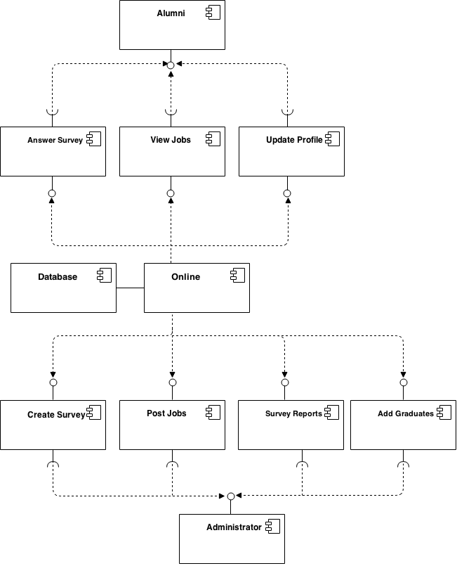

**Figure 4.18 Component Diagram**

**4.2.2. High Level Case (a UML Diagram)** 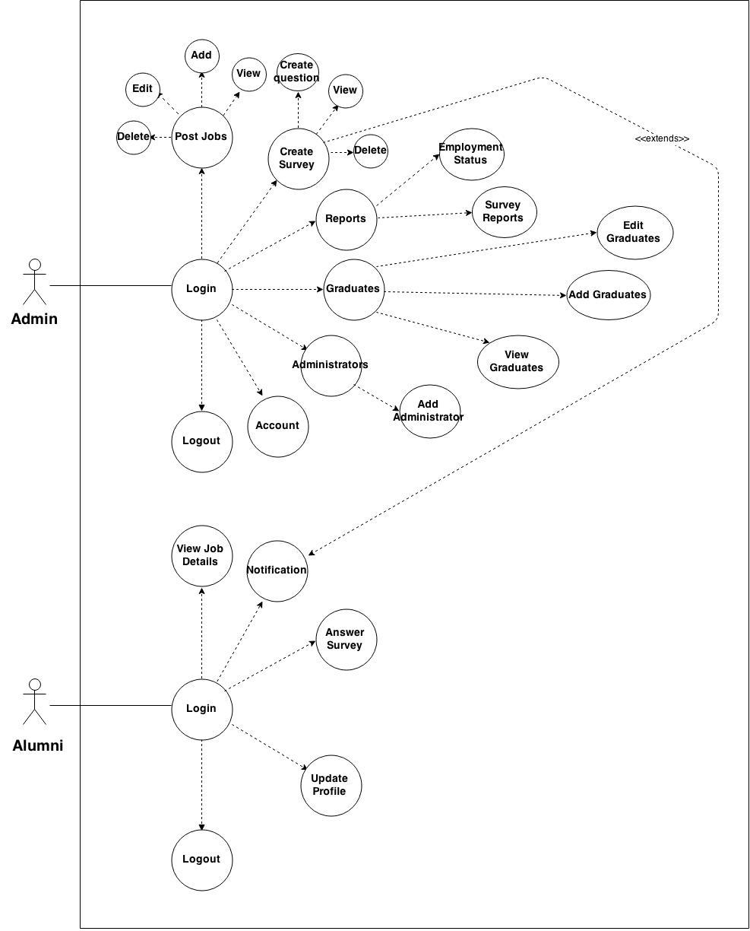**Figure 4.19 High Level Case**

**4.2.3 Entity Relationship Diagram**



**Figure 4.20 Entity Relation Diagram**

## **4.3 Testing and Evaluation**

This table shows the tabular and graphical representation of data from the user's evaluation. The modules being tested and evaluated was given scores that corresponds the criteria that will help developers determine the actual passing rate.

**Table 4.3.1 Tabular Representation Results (Administrator)**

|  |  |  |  |  |
| --- | --- | --- | --- | --- |
| USER (Administrator) | INPUT | EXPECTED OUTPUT | ACTUAL OUTPUT | STATUS |
| LOG-IN PAGE | | | | |
| 1. Case Sensitivity | Admin | Log-in Success | Log-in Success | Pass |
| 1. Input Password | Password | Log-in Success | Log-in Success | Pass |
| Password | Error | Username/ password is incorrect | Pass |
| ADD JOBS | | | | |
| 3. No Empty Field | *blank fields | Fill the missing field | Fill the missing field | Pass |
| ADD SURVEYS | | | | |
| 4. No Empty Field | *blank field | Fill the missing field | Fill the missing field | Pass |
| ADD GRADUATES | | | | |
| 6. No Empty Field | *blank field | Fill the missing field | Fill the missing field | Pass |
| ADD ADMINISTRATOR | | | | |
| 7. No Empty Field | *blank field | Fill the missing field | Fill the missing field | Pass |
| VIEW LIST OF JOBS | | | | |
| 8. Button Functionalities | Click | Buttons should function | Displays functions | Pass |
| VIEW LIST OF SURVEYS | | | | |
| 9. Button Functionalities | Click | Buttons should function | Displays functions | Pass |
| VIEW LIST OF GRADUATES | | | | |
| 10. Button Functionalities | Click | Buttons should function | Displays functions | Pass |
| VIEW LIST OF ADMINISTRATOR | | | | |
| 11. Button Functionalities | Click | Buttons should function | Displays functions | Pass |
| UPLOAD GRADUATE INFORMATION | | | | |
| 12. Upload list of graduate in .CSV format | Choose file and upload | Upload the file | Upload the file | Pass |
| MANAGE SELECTED SURVEYS | | | | |
| 13. View survey | Click | See all survey | See all survey details | Pass |
| MANAGE SELECTED SURVEYS | | | | |
| 14. Edit Survey | Click | Edit Survey | Edit survey details | Pass |
| MANAGE SELECTED SURVEYS | | | | |
| 15. Send Survey | Click | Notify Confirmation | Send Survey | Pass |
| 16. Delete Survey | Click | Delete Survey | Delete Entire Survey details | Pass |
| 17. Add Question | Click | Questions Settings | Add Question | Pass |
| REPORTS | | | | |
| 18. Survey Results | Click according to survey title | Displays survey questionnaire and reports | Display report | Pass |
| 19. Employment Status | Click | Displays graduates employment status | Display report | Pass |
| LOGOUT | | | | |
| 20. Logout | Click | Logout current user | Logout current user | Pass |

**Table 4.3.2 Tabular Representation Results (Administrator)**

|  |  |  |  |  |
| --- | --- | --- | --- | --- |
| USER (Administrator) | INPUT | EXPECTED OUTPUT | ACTUAL OUTPUT | STATUS |
| LOG-IN PAGE | | | | |
| 1. Case Sensitivity | Admin | Log-in Success | Log-in Success | Pass |
| 2. Input Password | Password | Log-in Success | Log-in Success | Pass |
| Password | Error | Username/ password is incorrect | Pass |
| ADD JOBS | | | | |
| 3. No Empty Field | *blank fields | Fill the missing field | Fill the missing field | Pass |
| ADD SURVEYS | | | | |
| 4. No Empty Field | *blank field | Fill the missing field | Fill the missing field | Pass |
| ADD GRADUATES | | | | |
| 6. No Empty Field | *blank field | Fill the missing field | Fill the missing field | Pass |
| VIEW LIST OF JOBS | | | | |
| 8. Button Functionalities | Click | Buttons should function | Displays functions | Pass |
| VIEW LIST OF SURVEYS | | | | |
| 9. Button Functionalities | Click | Buttons should function | Displays functions | Pass |
| VIEW LIST OF GRADUATES | | | | |
| 10. Button Functionalities | Click | Buttons should function | Displays functions | Pass |
| VIEW LIST OF ADMINISTRATOR | | | | |
| 11. Button Functionalities | Click | Buttons should function | Displays functions | Pass |
| UPLOAD GRADUATE INFORMATION | | | | |
| 12. Upload list of graduate in .CSV format | Choose file and upload | Upload the file | Upload the file | Pass |
| MANAGE SELECTED SURVEYS | | | | |
| 13. View survey | Click | See all survey | See all survey details | Pass |
| MANAGE SELECTED SURVEYS | | | | |
| 14. Edit Survey | Click | Edit Survey | Edit survey details | Pass |
| MANAGE SELECTED SURVEYS | | | | |
| 15. Send Survey | Click | Notify Confirmation | Send Survey | Pass |
| 16. Delete Survey | Click | Delete Survey | Delete Entire Survey details | Pass |
| 17. Add Question | Click | Questions Settings | Add Question | Pass |
| REPORTS | | | | |
| 18. Survey Results | Click according to survey title | Displays survey questionnaire and reports | Display report | Pass |
| 19. Employment Status | Click | Displays graduates employment status | Display report | Pass |
| LOGOUT | | | | |
| 20. Logout | Click | Logout current user | Logout current user | Pass |

**Table 4.3.3 Tabular Presentation Results (Alumni)**

|  |  |  |  |  |
| --- | --- | --- | --- | --- |
| USER (Client) | INPUT | EXPECTED OUTPUT | ACTUAL OUTPUT | STATUS |
| LOG-IN PAGE | | | | |
| 1. Case Sensitivity | Client | Log-in Success | Log-in Success | Pass |
| 1. Input Password | Password | Log-in Success | Redirect to Home Page | Pass |
| Password | Error | Username/pasword incorrect | Pass |
| VIEW JOBS | | | | |
| 3. View job title | Click | See job details | See job details | Pass |
| VIEW LIST OF SURVEYS | | | | |
| 4. Button functionalities | Click | List of Survey | Display survey | Pass |
| VIEW ACCOUNT INFORMATION | | | | |
| 5.Button | Click | Profile Account | Profile Account | Pass |
| 6. Edit Account | Click | Blank fields | Blank fields | Pass |
| 7. Save and Exit | Click | Redirect to Home Page | Redirect to Home Pag | Pass |
| LOGOUT | | | | |
| 8. Logout | Click | Logout current user | Logout current user | Pass |

**Chapter 5**

**Results and Analysis**

This chapter presents the analysis of the data result after the system was developed. To identify whether the expected output of the system was met, a Software Quality Evaluation questionnaire was given to the respondents and answered. Presented below are the combined results of the evaluations done by the client, it is shown in a tabular and graphical representation.

**5.1 Statistical Treatment of Data**

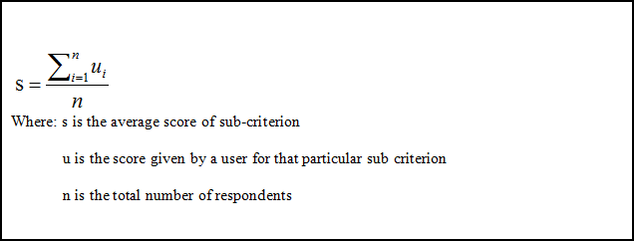

**Figure 5.1 Overall computation formula of the system**

The developers need to use the formula to continue the average score per sub-criteria. In which, the formula is used to compute the average score of the user’s evaluation per sub-criteria by getting the score given a sub-criteria and the total number of respondents.

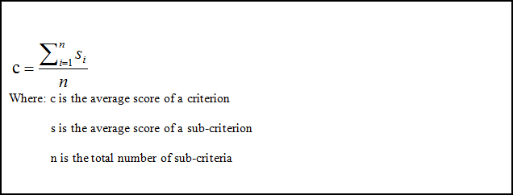 **Figure 5.2 Average computation formula for criteria**

To compute the average score per criteria, the developers need to use this formula. Wherein the formula is used to compute the average score of the user’s evaluation per criteria by gathering the average score of a sub-criteria and the total number of sub-criteria.

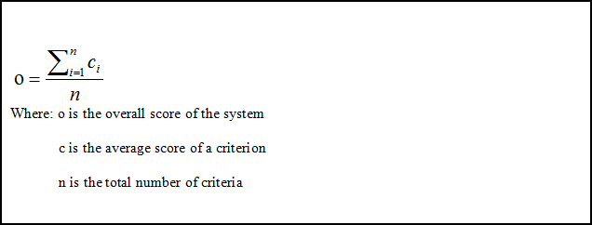**Figure 5.3 Overall computation formula of the system**

To compute the overall score of the system, the developers need to use this formula. This formula is used to compute the overall score of the system by getting the average score of the criterion and the total number of criteria.

**5.2 Interpretation of Data**

**Table 5.1 Numerical Scale Interpretation**

|  |  |
| --- | --- |
| **Average Scale** | **Interpretation** |
| 4.51 - 5.0 | Highly acceptable |
| 3.51-4.50 | Very Acceptable |
| 2.51-3.50 | Acceptable |
| 1.51-2.50 | Moderately Acceptable |
| 1.00-1.50 | Not Acceptable |

The interpretation and the results of the evaluation are based from Numerical Scale Interpretation of the evaluation component the scale ranges from Highly Acceptable, to Not Acceptable.

**5.3 Tabular Graphical Representation of Results**

The functionality scored an average of 4.2 which is interpreted with Very Acceptable rating. Accuracy scored 4.1 and Security scored 4.3 both are Very Acceptable. Base on the scale interpretation. Users are satisfied with the functionalities, they think that the system satisfied its objectives and purpose.

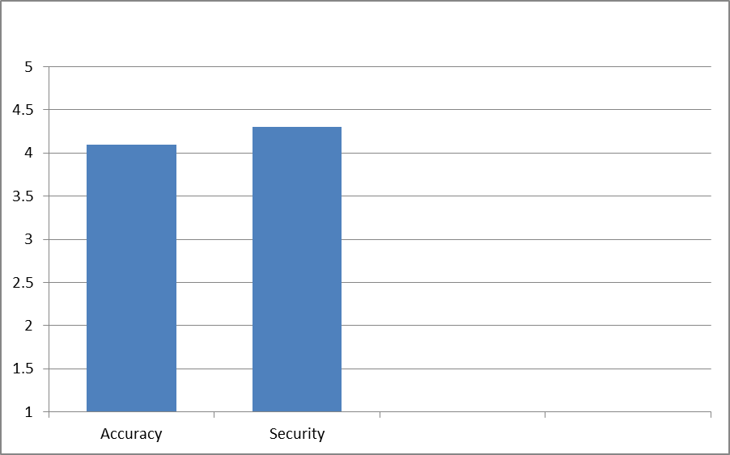

**Figure 5.4 Functionality**

**Table 5.2 Software Quality Evaluation result: Functionality**

|  |  |  |
| --- | --- | --- |
| **Criteria** | User | Total |
| Accuracy | 4.1 | 4.1 |
| Security | 4.3 | 4.3 |
| **Average** |  | 4.2 |

In the Reliability, Table 5.3 and in Figure 5.5 showed the result of data validity and recoverability of the system. The data validity of the system scored 4.2 and recoverability scored 4.0 which is both Very Acceptable based on the scale of interpretation.

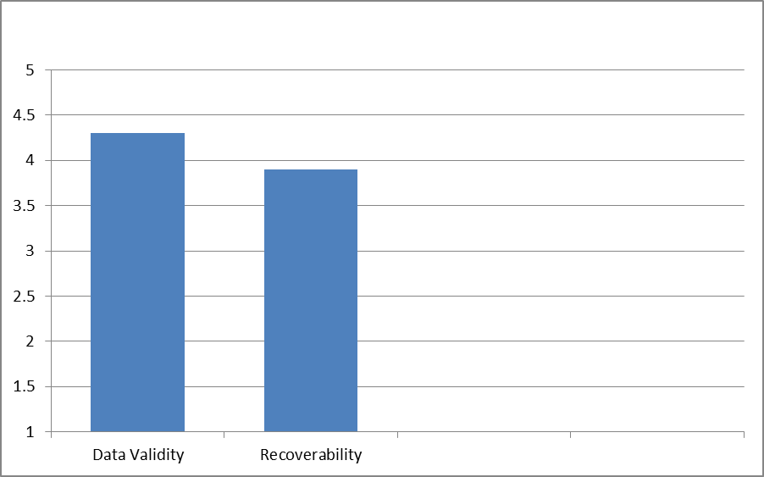

**Figure 5.5 Reliability**

**Table 5.3 Software Quality Evaluation result: Reliability**

|  |  |  |
| --- | --- | --- |
| **Criteria** | User | Total |
| Data Validity | 4.3 | 4.3 |
| Recoverability | 3.9 | 3.9 |
| **Average** |  | 4.1 |

In Usability, Table 5.4 and in Figure 5.6 showed the result of understandability with average of 4.2, learnability with average of 4.0, operability with average of 4.2, and attractiveness with average of 3.8. All results are Very Acceptable in the scale of interpretation.

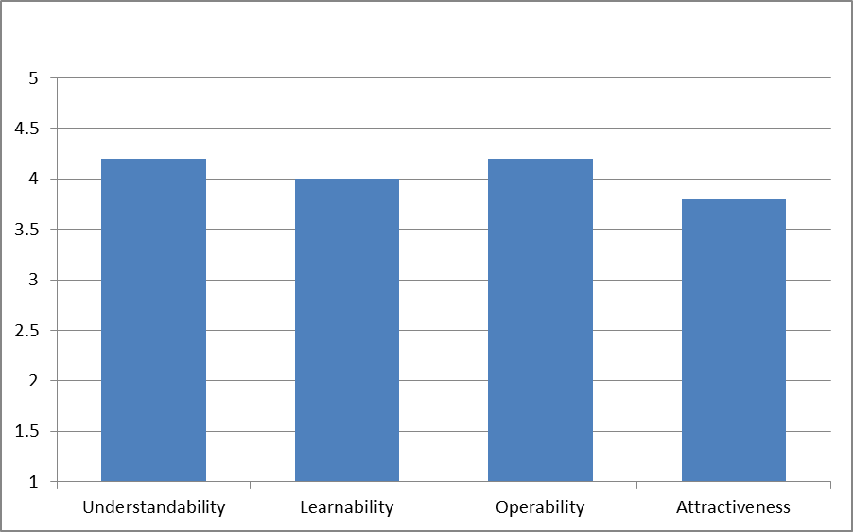**Figure 5.6 Usability**

**Table 5.4 Software Quality Evaluation result: Usability**

|  |  |  |
| --- | --- | --- |
| **Criteria** | User | Total |
| Understandability | 4.2 | 4.2 |
| Learnability | 4.0 | 4.0 |
| Operability | 4.2 | 4.2 |
| Attractiveness | 3.8 | 3.8 |
| **Average** |  | 4.0 |

In the Efficiency, Table 5.5 and in Figure 5.7 showed the result of ease of start-up with average of 4.2, resource utilization with average of 4.2, and time behavior with average of 4.3. All the results are Very Acceptable according to the scale of interpretation.

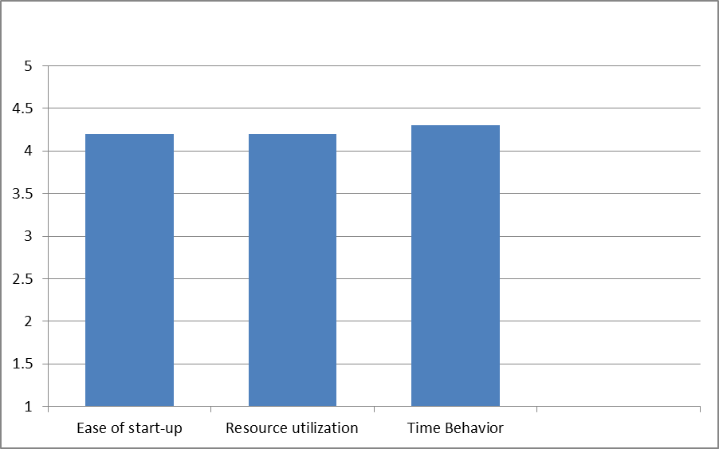

**Figure 5.7 Efficiency**

**Table 5.5 Software Quality Evaluation result: Efficiency**

|  |  |  |
| --- | --- | --- |
| **Criteria** | User | Total |
| Ease of Start-up | 4.3 | 4.3 |
| Resource Utilization | 4.3 | 4.3 |
| Time Behavior | 4.2 | 4.2 |
| **Average** |  | 4.2 |

In Maintainability, Table 5.6 and in Figure 5.8 showed the result of instalability with average of 3.93 and testability with average of 4.13. All the results are Very Acceptable according to the scale of interpretation.

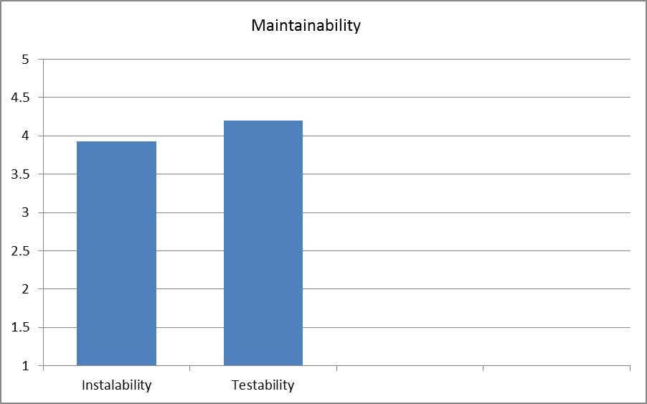

**Figure 5.8 Maintainability**

**Table 5.6 Software Quality Evaluation result: Maintainability**

|  |  |  |
| --- | --- | --- |
| **Criteria** | User | Total |
| Instalability | 3.93 | 3.93 |
| Testability | 4.13 | 4.13 |
| **Average** |  | 4.03 |

In the Support and Manuals, Table 5.7 and in Figure 5.9 showed the result of understandability with average of 4.03 and visual reference with average of 4. All the results are Very Acceptable according to the scale of interpretation.

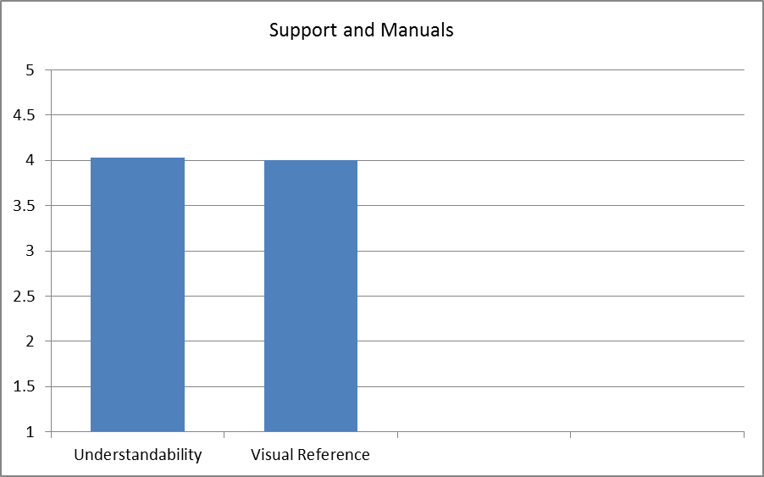

**Figure 5.9 Support and Manuals**

**Table 5.7 Software Quality Evaluation result: Support and Manuals**

|  |  |  |
| --- | --- | --- |
| **Criteria** | User | Total |
| Understandability | 4.03 | 4.03 |
| Visual Reference | 4 | 4 |
| **Average** |  | 4.02 |

**CHAPTER 6 CONCLUSIONS AND RECOMMENDATIONS**

**Conclusion and Recommendation**

This chapter shows the conclusion of the results gathered from the evaluation of the system. It also shows the recommendation regarding the system implemented.

**Conclusion**

After they gathered useful information and analyzed the flow of the system, the developers had then create a function that will track the records of the alumni through survey online

Therefore, the system made by the developers was successful and it was implemented. The developers were able to achieve their main goal and that is to track the alumni and generate reports.

**Recommendation**

Regarding of what the system result, this system must be more reliable to the users. Also the system must have a function that will import files through excel in a CSV file that will allow an easy upload by the admin. Also Breakdown of graduates through course and employment status for an easy tracking of records.

**Definition of terms**

Terms are operationally and conceptually defined here for better understanding of the readers.

**PHP**

-an open source server-side scripting designed for Web development produce dynamic Web pages. It is one of the first developed server side scripting languages to be embedded into an HTML document rather than calling an external file to process data.

**HTML**

-HyperText Markup Language (HTML) is the main markup language for displaying web pages and other information that can be displayed in a web browser.

**Methodology**

-A guideline system for solving a problem, with specific components such as phases, tasks, methods, techniques and tools.

**Admin**

-refers to the administrator of the system, the one who has the authority to modify the system.

**Dashboard**

-refers as the home page after logging in to the system

**References**

Laguador, J. M. & Dotong, C. I. (2013).Tracer Study of the BS Computer Engineering Graduates of Lyceum of the Philippines of Batangas, Batangas City. Vol. 3

Macatangay, L. (2013). Tracer Study of BSCS Graduates of Lyceum of the Philippines University from 2004-2009. Lyceum of the Philippines University, Batangas City. Vol.4 No.5.

De Ocampo, M. B., Bagano, A. J. & Tan, A. L. (2012). Culture of Entrepreneurship versus Employment.2012 Fifth Taiwan-Philippines Academic Conference.

Verona L. J. (2011). A Tracer Study of the Employment Status of Polytechnic University of the Philippines Quezon City AY 2004-2005. Quezon City, Phillipines.

Zembere S. N. & Chinyama M. P. M. (1996). The University of Malawi Graduate Tracer Study. University of Malawi - The Polytechnic, P/Bag 303, Chichri,Blantyre 3 Malawi

Gines A. (2014). Tracer Study of Philippine Normal University Graduates. Philippine Normal University, Taft Avenue cor. Ayala Blvd, Manila Philippines. Vol.4 No. 3.

Celis M. I., Festijo, B. & Cueto, A. (2013). Graduate’s Employability: A TracerStudy

For Bachelor of Science in Hotel and Restaurant Management.

Lyceum of the Philippines University, Batangas City. Vol. 1

Shongwe, Mzwandile & Ocholla, Dennis N(2011).A tracer study of LIS Graduates

at the University of Zululand.

Lutwama,Edith & Kigongo-bukenya, I.M.N(2004). A tracer study of the East

African School of Library and Information Science

Dr. Dolores B. Dumas and Judy B. Dumlao(July 2011). Graduate Tracer Study of

the Bachelor of Elementary Education

**Project Cost/ Budget**

The estimated total project cost is the summary of the approximate investment of a particular project from the time it was started until the release of this copy. The estimated total project cost amounted to ₱ 988.00 which includes the supplies and equipment, transportation fee, and hosting fee. A detail of the total project cost is shown in the tables below.

|  |  |  |  |
| --- | --- | --- | --- |
| **Supplies and Equipment** | **Price per unit** | **No. of units** | **Total price(Php/**₱) |
| Globe Broadband (load) | ₱60 | 5 | ₱320 |
| Bond Paper | ₱150 | 1 | ₱150 |
| Envelope | ₱6 | 3 | ₱18.00 |
| Clearbook | ₱80 | 1 | ₱80.00 |
| Plastic Envelope | ₱5 | 5 | ₱25.00 |
| Total: | | | ₱593.00 |

The Purchase of Supplies and Equipment totals ₱593.00 since we bought, bond paper for printing, envelope and plastic envelope for our documents, clearbook for our compilation and Globe Broadband for our internet.

|  |  |  |  |
| --- | --- | --- | --- |
| **Transportation Fee** | **Destination** | **Transporation Price** | **Cost** |
| Client Interview | USC-TC | ₱10.00 | ₱100.00 |
| Meeting of the developers | USC-TC | ₱8.00 | ₱100.00 |
| Total: | |  | ₱200.00 |

The total amount of transportation fee is ₱200.00. The transportation fee is based on developing the needs of this project.

**USER MANUALS**

**ADMIN MANUAL**

1. Login Page

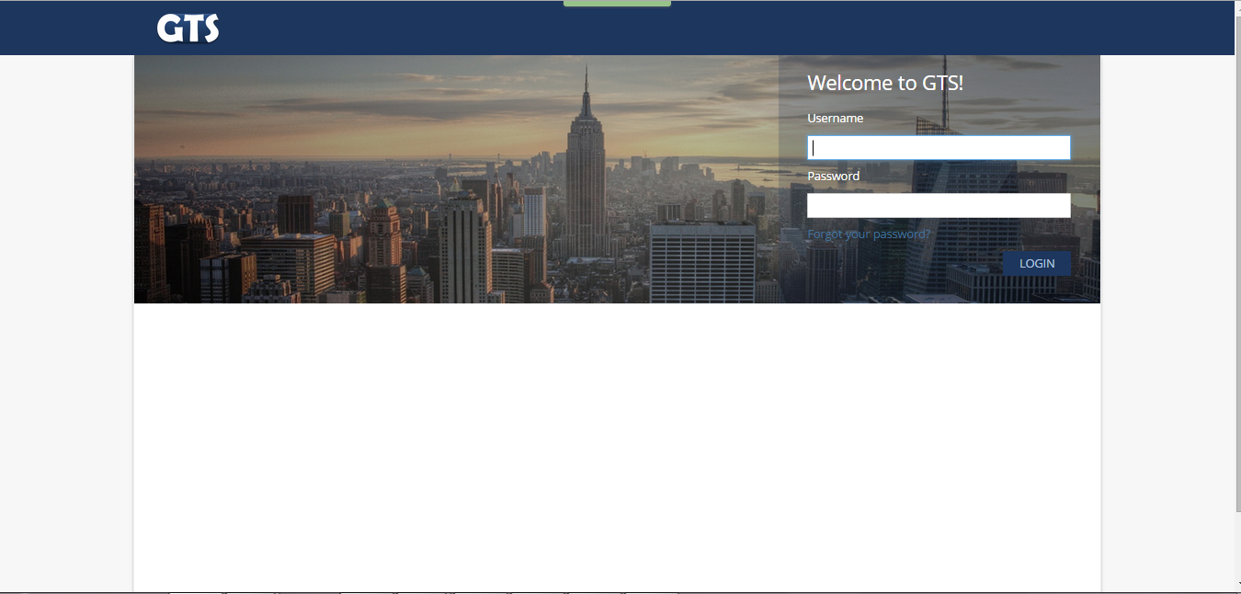

1. Home Page (Dashboard Admin)

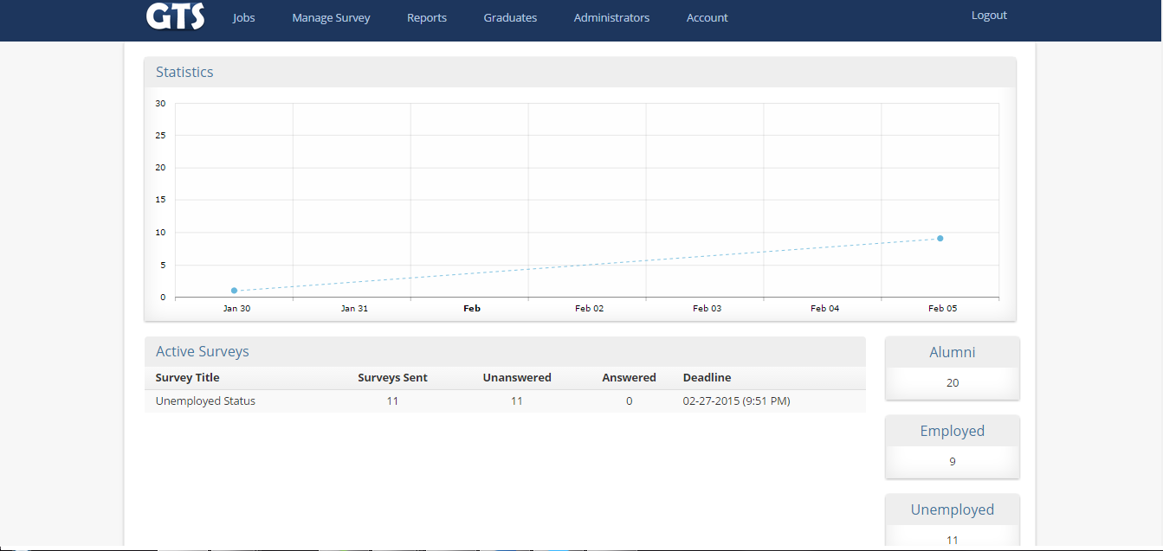

1. Add Jobs (Admin)

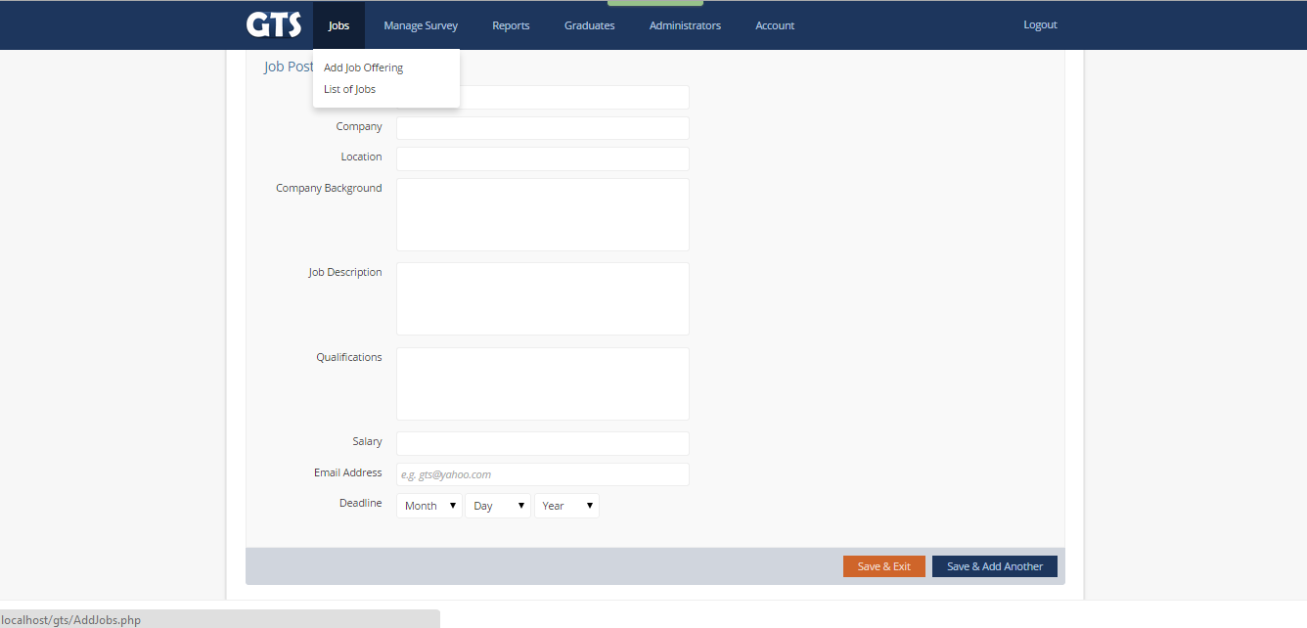



4. View Jobs (Admin)

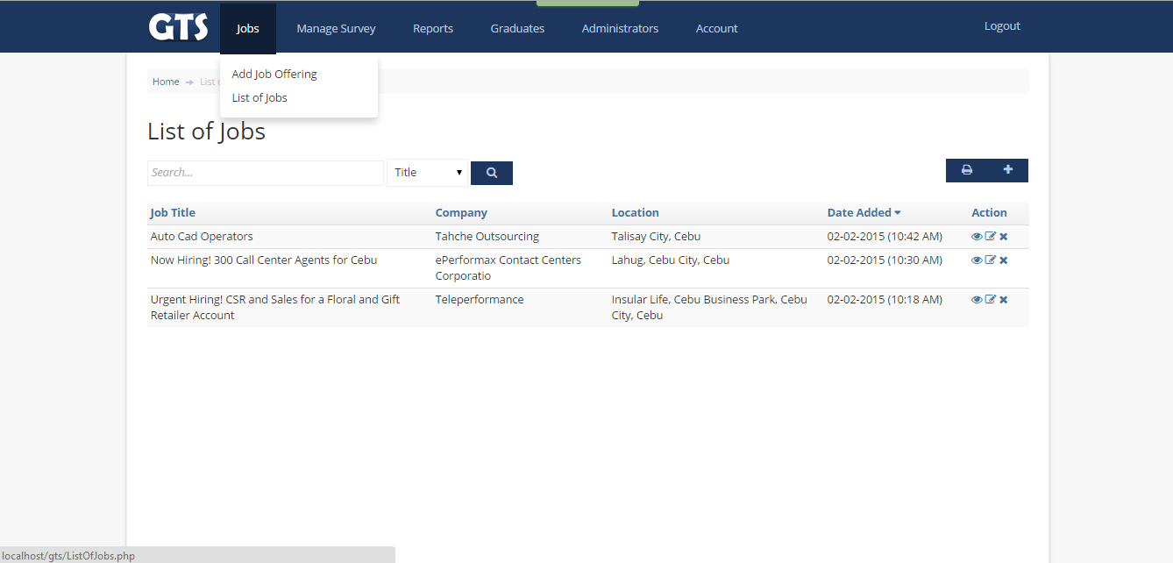  
  
  
  
5. Add Surveys (Admin)  
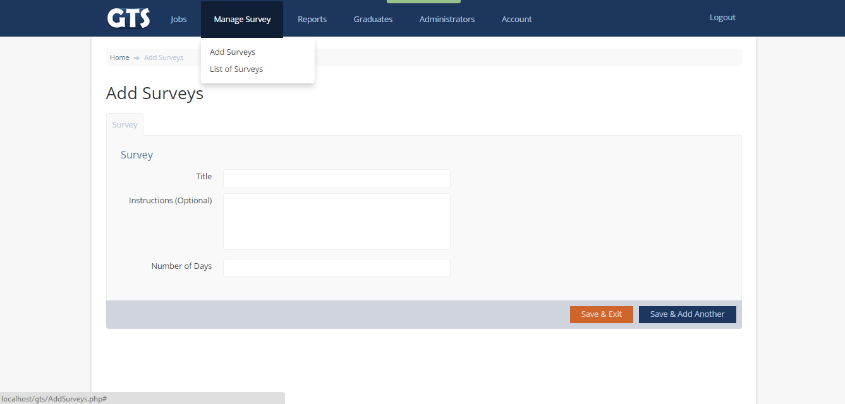

6. List Surveys (Admin)  
  
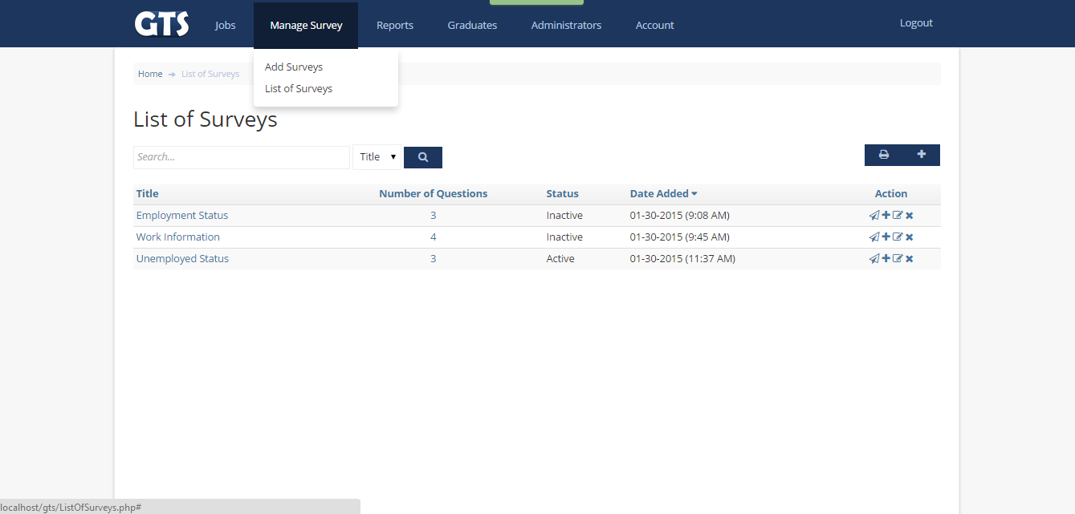

7. Reports(Admin)  
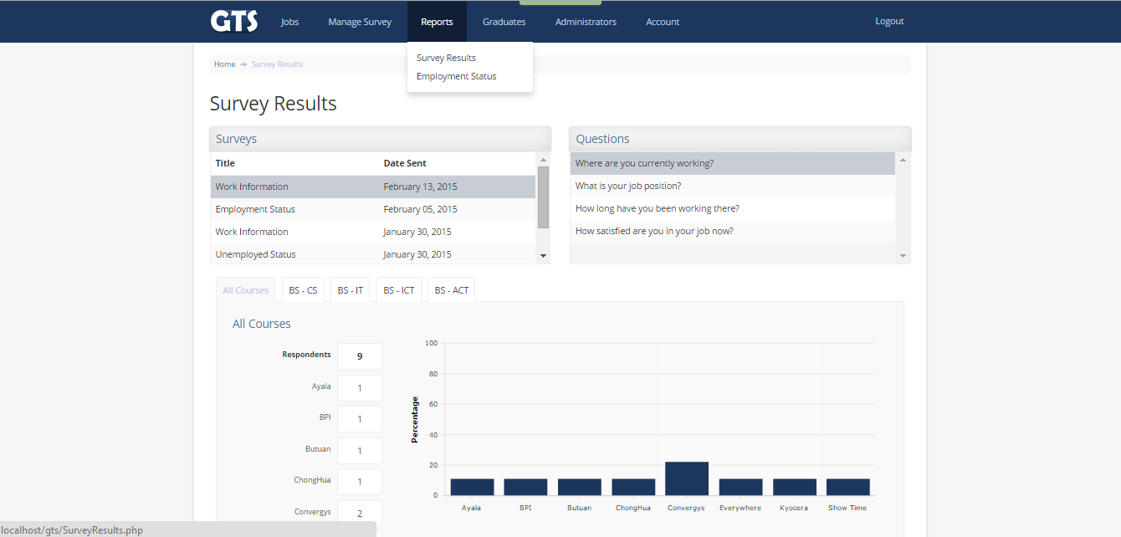  


7. Reports(Admin)  
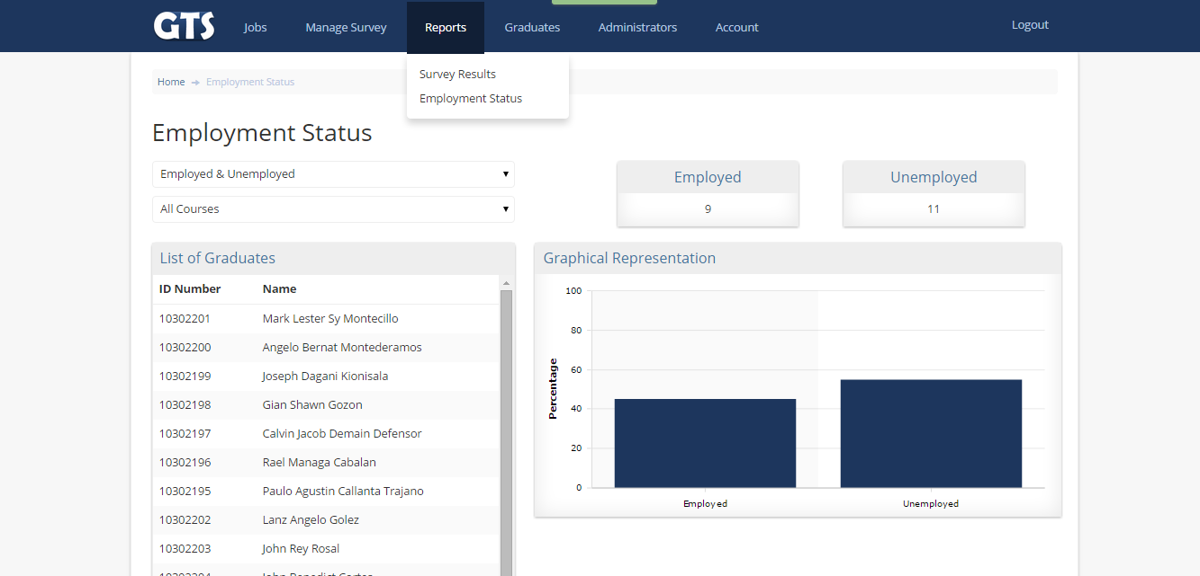  
  
  


7. List of Graduates(Admin)

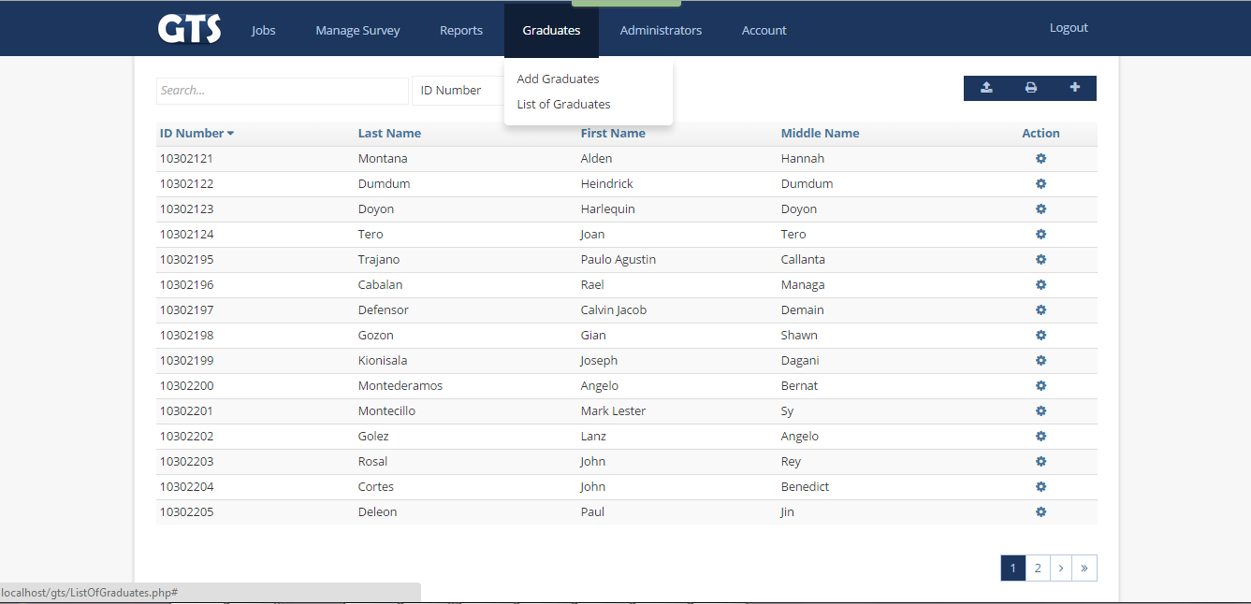  
  
  
  
  


7. Administrators(Admin)

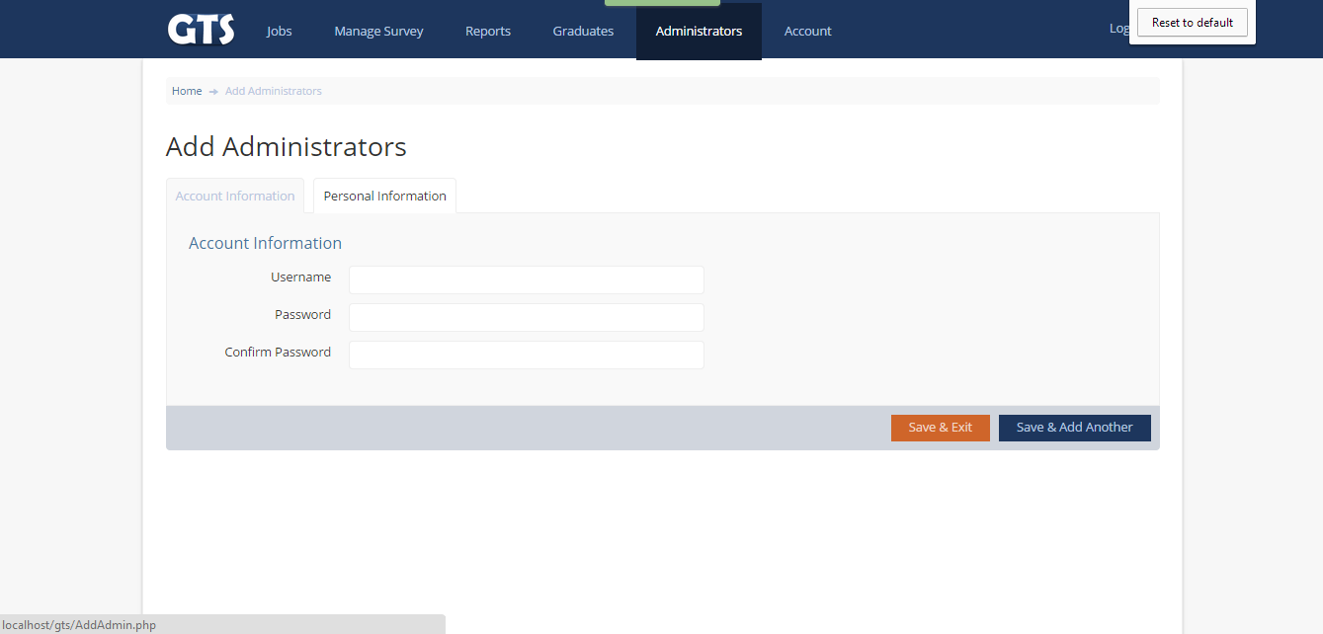

**Technical Manual**

1. **Installation and Configuration**

**For local Accessing:**

1. Run Xampp -> Start Apache Module -> Start MySQL Module.

2. Open Browser -> localhost/phpmyadmin->Create “gts” database

3.Extract file to htdocs with a filename of gts folder

4. Import sql file to gts database. If successful --------> Open Internet browser.

5. Type “localhost/gts“

**For Live-Accessing:**

1. Find a website hosting source.
2. We use [www.freewebhost.com](http://www.freewebhost.com) as our host in uploading it to live
3. Just open any browser and clear cached and history for better acces.
4. Type our url which is “http://gtsusc.site40.net/gts/index.php
5. **Software and Hardware Requirements**
6. Windows XP, Vista, 7 and 8
7. Web Browsers: Internet Explorer, Mozilla Firefox or Google Chrome (recommended)

**CURRICULUM VITAE**

RAEL CABALAN 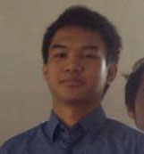

Nasipit Talamban, Cebu City

09206213925 [raelcabalan@gmail.com](mailto:raelcabalan@gmail.com)

**Relevant Skills**

* Knowledge in Microsoft Office Applications such as MS Word, Excel and Powerpoint
* Interpersonal communication skills
* Verbal communication skills
* Detail Oriented
* Flexible and willing to try new things and interested in improving efficiency on assigned tasks
* Able to set-up computer system without aide
* Hardware and Software installation
* Familiar with HTML, CSS, Bootstrap
* Internet Savvy

**Education**

* Urios College Grade School, 2000-2006

Elementary School Graduate

* Agusan National High School, 2006-2007

Father Saturnino Urios University, 2007-2010

High School Graduate

* University of San Carlos - Talamban Campus

Bacherlor of Science in Information and Communication Technology, 2010

**Seminar and Training Experiences:**

* 9th & 10th PSITE ICT STUDENTS CONGRESS 2013 & 2014

9th of March 2013, 7th of March 2014

Cebu Institute of Technology University

University of San Carlos - Main

* Intern at Live2sell, Inc as an IT Specialists

June - Oct 2014

A.S. Fortuna, Mandaue City

CURRICULUM VITAE

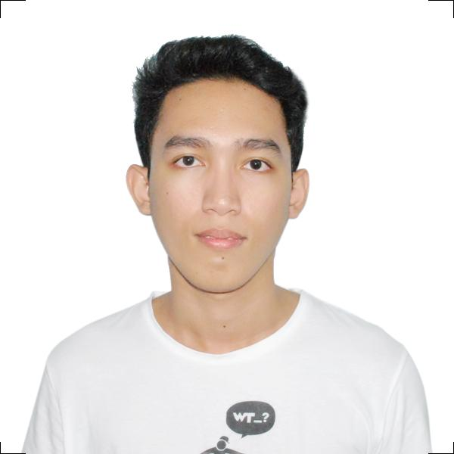

JOHN STEPHEN LAWSIN

Bag-ong dan, Yati, Lilo-an

0916499015, jlawsin2013@gmail.com

**Relevant Skills**

* Knowledge in Microsoft Office Applications such as MS Word, Excel and Powerpoint
* Interpersonal communication skills
* Verbal communication skills
* Detail Oriented
* Flexible and willing to try new things and interested in improving efficiency on assigned tasks
* Able to set-up computer system without aide
* Hardware and Software installation
* Familiar with HTML, CSS, Bootstrap

**Education**

* Monterey School of Learning ,2001-2007
* University of San Jose Recoletos - Basak Campus ,2007-2008

La Consolacion College - Lilo-an, 2008-2011

* University of San Carlos - Talamban Campus

Bacherlor of Science in Information and Communication Technology, 2011

**Seminar and Training Experiences:**

* 10th PSITE ICT STUDENTS CONGRESS 2014

7th of March 2014

University of San Carlos - Main

* Intern at Wishbone Digital Group as an Web Developer

June - Oct 2014

Ayala Business Park, Cebu

CURRICULUM VITAE

CHRISTIAN JAY IROG-IROG 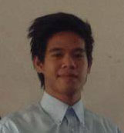

Nasipit, Talamban

09423951663, christianjayirogirog@yahoo.com

**Relevant Skills**

* Knowledge in Microsoft Office Applications such as MS Word, Excel and Powerpoint
* Interpersonal communication skills
* Verbal communication skills
* Detail Oriented
* Flexible and willing to try new things and interested in improving efficiency on assigned tasks
* Able to set-up a computer system
* Hardware and Software installation
* Familiar with HTML, CSS, Bootstrap
* Capable in creating and editing image and presentation using Adobe Photoshop, InDesign and CorelDraw

**Education**

* Tubigon Central Elementary School ,2001-2007

Elementary School Graduate

* Holy Cross Academy ,2007-2011

High School Graduate

* University of San Carlos - Talamban Campus

Bacherlor of Science in Information and Communication Technology, 2011

**Seminar and Training Experiences:**

* 10th PSITE ICT STUDENTS CONGRESS 2014

7th of March 2014

University of San Carlos - Main

* Intern at Wishbone Digital Group as an Web Developer

June - Oct 2014

Ayala Business Park, Cebu

CURRICULUM VITAE

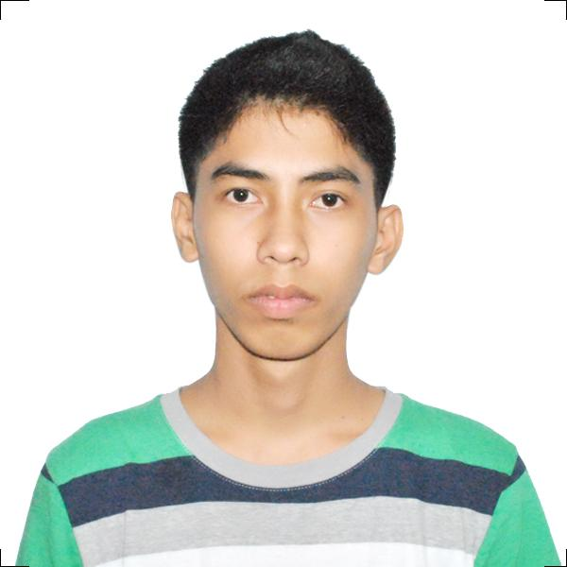

JOHN DALE ROSAURO

Poblacion, lilo-an ,cebu

09998742782, jhndlrsr123@gmail.com

**Relevant Skills**

* Knowledge in Microsoft Office Applications such as MS Word, Excel and Powerpoint
* Interpersonal communication skills
* Verbal communication skills
* Detail Oriented
* Flexible and willing to try new things and interested in improving efficiency on assigned tasks
* Able to set-up computer system with aide
* Hardware and Software installation
* Familiar with HTML, CSS, Bootstrap

**Education**

* Liloan Central Elementary School,2001-2007

Elementary School Graduate

* Compostela National High School,2007-2008

High School Graduate

* University of San Carlos - Talamban Campus

Bacherlor of Science in Information and Communication Technology, 2011

**Seminar and Training Experiences:**

* 10th PSITE ICT STUDENTS CONGRESS 2014

7th of March 2014

University of San Carlos - Main

* Intern at Wishbone Digital Group as an Web Developer

June - Oct 2014

Cebu Business Park, Cebu