

- PROJECT SUMMARY
Title of the project : EDP HaTSPoTSCC (Electricity Decarbonization Program:
Harnessing The Sun's Power Through Sustainable
Community Cooperation) Phase 2
Project Locale : Brgy Alegria, Tuburan, Cebu
No. of Training Hours : 40 hours
No of Beneficiaries : 8 Female, 10 Male, and 2 All Genders
Total Project Cost :
Implementing Curricular Program/s : (example: BSED, BIT, BSIE)
Implementing Partner/s :
Extension Agenda :

 | 1- LAMESA |  | 3- LIKOP |  | 5- LAMBO |  | 7- LAMDAG |  | 9- LAMBIGIT
 | 2- LIMPYO |  | 4- LISTA |  | 6- LAGSIK |  | 8- LIHOK |  | 10- LOKAL

- PROJECT EVALUATION OF THE PREVIOUS PHASE

- Give a brief description of the project.
- Paragraph 1: What are the objectives of the previous phase? What are the actual accomplishments? Discuss facilitating and limiting factors.
- Paragraph 2. Discuss the post-training survey result including important comments and suggestions of the beneficiaries. If you have conducted a focus group discussion, write about it here. If you use any other forms of training and project evaluation, discuss the result here.
- Paragraph 3: What are the challenges encountered in the implementation of the project? How did your team overcome them? What lessons have you learned to improve the implementation of the next project phase?

- RATIONALE (pls use the subheadings to make it easier for the evaluator to do the rating)

- Statement of Need
- What is the problem or need of your target community/beneficiaries? Why is this problem important? Why is the proposal of a phase 2 community extension project important?

- Relevance of Need
- How does the need/problem relate to VMGO of CTU? to ESD Goals? to the program goals & objectives?

- Beneficiary Profile
- Paragraph 1: How many target project beneficiaries did you have at the start of the previous project phase? How many remained at the end of the project implementation? Discuss facilitating and limiting factors.
- Paragraph 2: Who are the present beneficiaries? Give a detailed profile. Why are they chosen to proceed in the next phase? Discuss extensively.
- Proposed Solution
Guide questions: (Answer in paragraph form)
- Do you have a solution to the problem?
- Did you discuss with the beneficiaries the proposed solution to their problem? Did you agree that the proposed solution will address the statement of need?
- Who did you consult? Who have you talked to - especially the beneficiaries – about the problem/need, and how do you propose to solve/address it?
- Why do you think it will work? Did it work before?

- GOALS/OBJECTIVES/INTENDED OUTCOMES (please pay attention to the sequence.)

ESD Goal:
 | 1-No Poverty |  | 7-Affordable and Clean Energy |  | 13-Climate Action
 | 2-Zero Hunger |  | 8-Decent Work and Economic Growth |  | 14-Life Below Water
 | 3- Good Health and Well-Being |  | 9-Industry, Innovation, and Infrastructure |  | 15-Life on Land
 | 4-Quality Education |  | 10-Reduced Inequalities |  | 16-Peace, Justice & Strong Institutions
 | 5-Gender Equality |  | 11-Sustainable Cities and Communities | / | 17-Partnerships for the Goals
 | 6-Clean Water and Sanitation |  | 12-Responsible Consumption and Production

Intended Outcome: Example: An economically sustainable organization of weavers
Project Goals:
- There will be increased productivity.
Objective:
100% of the weavers will have increased competencies in production-related skills.
- The weavers will become a community organization with legal identity with established linkages with government and other resource organizations.
Objective:
The weavers are organized and registered with relevant government agencies.
- The social enterprise will become profitable.
Objective:
The social enterprise will have an ROI of at least 5%.

- IMPLEMENTATION PLAN
- Extension Delivery Mode
(Discuss in detail how you will deliver the extension services considering the current situation of your campus and your extension locality. This part will understandably vary across projects as this will depend on the existing resources of your campus and your beneficiaries. Check the link below for the various extension delivery modes that might be of help.
The New Extensionist Learning Kit
https://www.g-fras.org/en/knowledge/new-extensionist-learning-kit-nelk.html

- Implementation Plan
Objective | Activities | Person Responsible | May  202_ | June  202_ | July  202_ | Aug  202_ | Sept  202_ | Oct  202_ | Nov  202_ | Status | Remarks
Objective 1
The business enterprise will have an ROI of at least 5%. | Participation in Trade Fair | Ms. Rachel Geraldizo |  | x |  | x
The business enterprise will have an ROI of at least 5%. | Ecommerce | Mr. Limuel | x | x | x | x | x
The business enterprise will have an ROI of at least 5%. | Product Dev't for value adding | Ms. Mildred Martinez | x | x | x | x | x
Objective 2
The weavers are organized and registered with relevant government agencies. | Meeting no.1 | Dr. Jima Bejagan | x
 | MeetingNo. 2 Formulation | Ms. Rainera Lucero |  | x
 | Meeting No. 3 Election of Officer | Dr. Jorelyn Concepcion |  |  | x
Objective 3
100 % of the weavers will have increased competencies in production-related skills | Training on Contemporary Weaving | Dr. Jorelyn Concepcion | x
 | Training Fabric Design | Dr. Jorelyn Concepcion |  | x

Note: If you have many planned activities, use as many pages as you needed. This should be in portrait orientation.
- MONITORING & EVALUATION PLAN
Objectives | Success Indicators | Baseline Data | Method of Data Gathering | Frequency | Actual Accomplishments | Means of Verification | Remarks
The business enterprise will have an ROI of at least 5%. | % of ROI as reflected in the FS | Record of income and expenses in the last ___ years | Documentation review/Cost-Benefit Analysis | annual |  | Audited FS
The weavers are organized and registered with relevant government agencies. | - Officers elected  - Registration in a government agency | Previous organizational structure | Documentation Review | once |  | Certificate of registration  List of Officers
100 % of the weavers will have increased competencies in production-related skills | - % increase in production-related competencies  - % increase in output | Record of the number of meters woven by each weaver / X number of hours in the previous ___ year/s | Documentation review | monthly |  | Current productivity level per weaver

Note: This should be in portrait orientation.

- ORGANIZATIONAL CAPABILITY (in paragraph form)
- Explain why your extension team is the best group to implement this project.
- What expertise do you bring to the project?
- Describe your partner organizations/groups. Explain how you complement each other and why you have selected them as partners.
- Explain who will do what.

- THE COMMUNITY EXTENSION TEAM (This section will show why you have selected the specific persons who will work on this project)

NAME | GENDER |  |  | ROLE | RESPONSIBILITY
NAME | Male | Female | All Gender  (Please specify) | ROLE | RESPONSIBILITY
- Fitzgerald Consuelo |  |  |  | Extension Coordinator
- Cyrus Miñoza |  |  |  | Chronicler
- Olivia Alivio |  |  |  | FP-ESD
- Abby Monacillo |  |  |  | FP-M & E
- Quinn Rivero |  |  |  | FP-Community Organizing
- David Birondo |  |  |  | FP-Research
- Millie Fortuna |  |  |  | FP-Entrepreneurship
- Jake Cabeleño |  |  |  | Training Specialist
- Rowan Camoro |  |  |  | Training Specialist
- Rebecca Perkins |  |  |  | Community Project Gender Advocate
- BSIE students |  |  |  | Demonstrator
TOTAL

Reminders:
- Clearly describe the role of each team member in the planning, implementation, evaluation of your proposed project.
- Do not forget to include your students in the team.

- SUSTAINABILITY PLAN

- Explain how the beneficiaries will continue to benefit from the project beyond current funding.
- Discuss the extent that your extension team is willing to commit to continue support to the beneficiaries after the funding grant.
- Discuss here plans for TESDA certification, facilitation for employment, going into micro-enterprise, etc.

- BUDGETARY REQUIREMENT
Guidelines in making the budget:
- Do not make “guestimates”. Canvass the price of your training materials & supplies, etc. Allow for a 5% inflation rate.
- Do not ask for items that are not allowed to be procured by GAA IRRs.
- List items in detail since these will all be included in the PPMP.
- If there is outside funding, indicate the expenses which will be shouldered by the partner institution/s.
- Compute in Excel then copy and paste below.
- If you are granted funding from GAD funds, clearly stipulate which expenses will be funded. You may indicate in the SUMMARY OF BUDGET, and in the PROJECT SUMMARY.
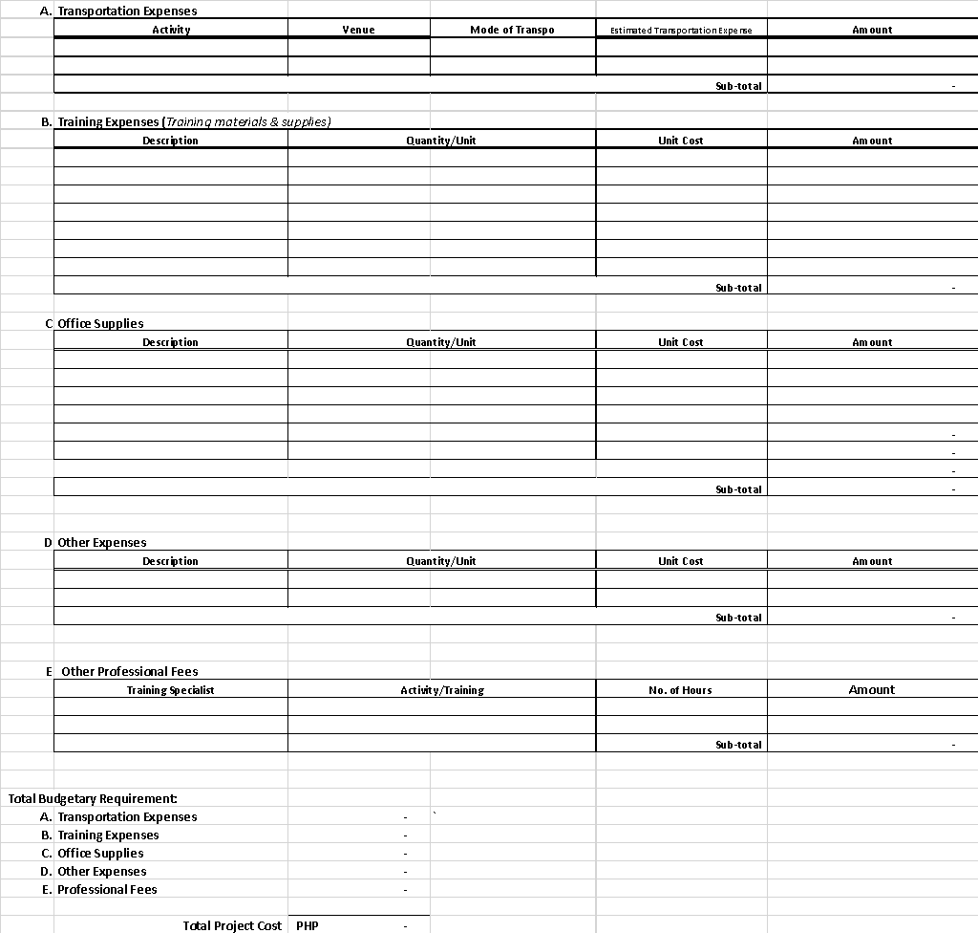

Prepared by:

_________________________

Note: All members of the team (except for your students should sign here, to indicate their commitment to perform the roles assigned to them.

Reviewed and Verified:

(Extension Chairperson/Director)

(College Dean for Main Campus only)

(Campus Director)

EXTENSION COUNCIL REMARKS: |  | ENDORSED FOR BOR APPROVAL:
 | Deferred | CHARMAINE LEE M. CABRERA, LPT
 | Deferred | OIC- UD for Extension Services
 | For Revision
 | Endorsed for BOR Approval | ROSEIN A. ANCHETA JR., ASEAN P.E, DM, Ph. D.
 | Endorsed for BOR Approval | Vice-President for Production, Extension, and
 |  | Resource Generation
 |  | JOSEPH C. PEPITO, Ph.D.
 |  | SUC President IV

Attachments:

- Research Basis
  - Technical Paper based on Community Needs Assessment (CNA);
  - Abstract and Chapter III or V (contains the Finding, Summary, and Recommendations) of the study if thesis or dissertation with Technical Paper based on CNA
  - Patents/ Utility Models Certificate with Technical Paper based on CNA

- Terminal Report for Phase II and Above project proposals

Note: Only complete project proposals will be accepted.

TRAINING DESIGN

Project Title:

COMPETENCIES/TOPICS | NUMBER OF HOURS | RESOURCE PERSON

