Output:
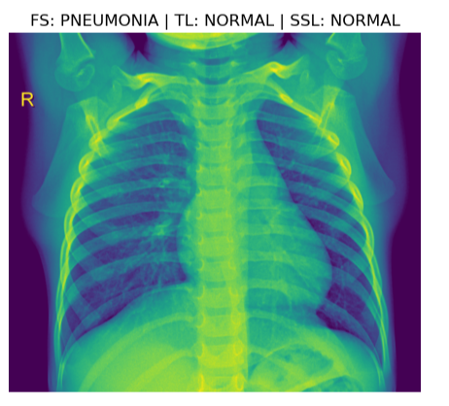
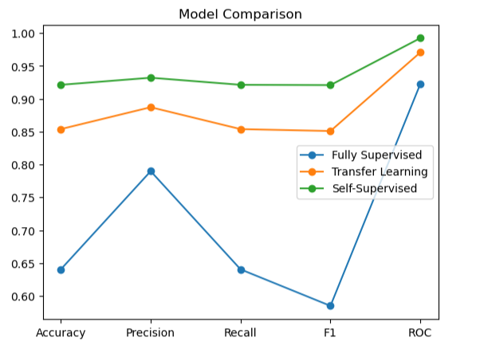
Final conclusion:
Self-Supervised Learning ≥ Transfer Learning > Fully Supervised Learning

