localhost:8080/eWallet/jcs/v2/rs/gt/register?email=Jaya10@mediaconcepts.com

{
"balance": 10000,
"success": true
}

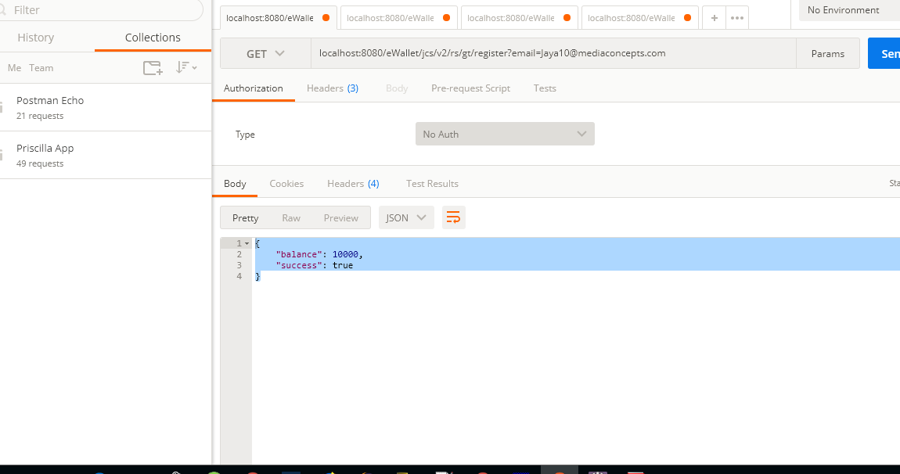

localhost:8080/eWallet/jcs/v2/rs/gt/latestBalance?email=test@test.com

{
"balance": 10000,
"success": true
}

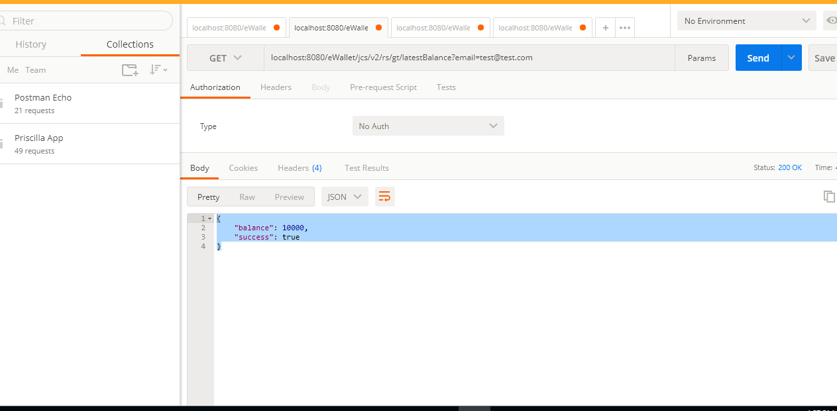

localhost:8080/eWallet/jcs/v2/rs/gt/transfer?email=Jaya@mediaconcepts.com&transferee=Mathangi@mediaconcepts.com&amount=200
{
"success": true
}

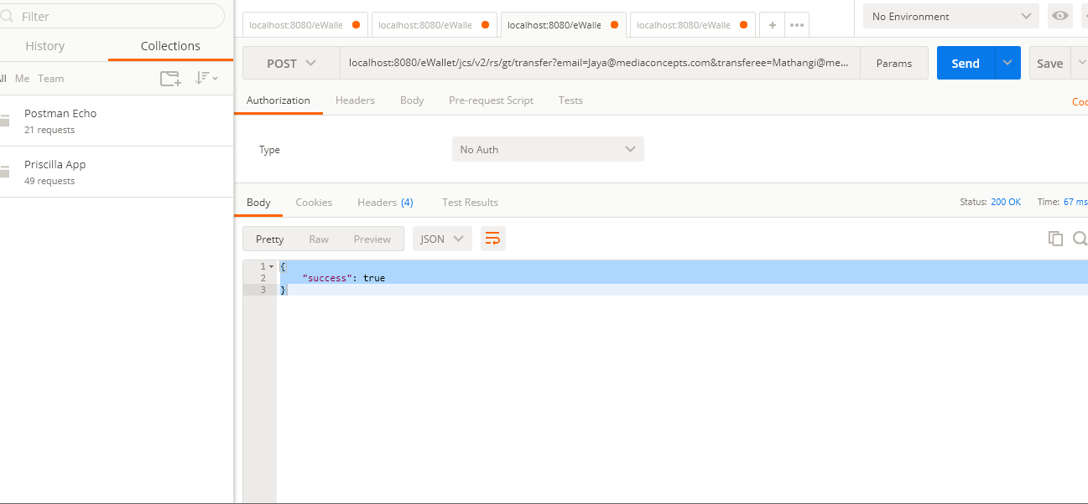

localhost:8080/eWallet/jcs/v2/rs/gt/retrieveLatestTransaction?email=Jaya@Mediaconcepts.com

{
"success": true,
"transactions": [
{
"id": "12",
"from": "Jaya@mediaconcepts.com",
"to": "Mathangi@mediaconcepts.com",
"type": "transfer",
"amount": "200.00",
"datetime": "2018-05-11 18:03:06.0"
},
{
"id": "13",
"from": "Jaya@mediaconcepts.com",
"to": "Mathangi@mediaconcepts.com",
"type": "transfer",
"amount": "200.00",
"datetime": "2018-05-12 16:50:01.0"
}
]
}

