**Potential question raised for Confusion matrix – evaluation metric or validating parameters**

* Algorithm ran using Decision Tree

1. What is the problem statement?

It is a classification problem and it has 2 class under one input column “Male” or “Female”.

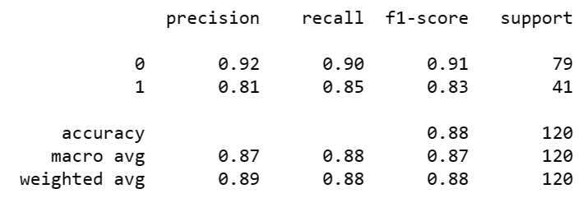

1. What is the overall accuracy or output?

Overall refers to the accuracy, hence in this algorithm it is 88% (0.88)

1. What the percentage of correctly classified as ‘Purchased’ and ‘Not purchased’?

It refers to Recall, hence for ‘Purchased’ 85% (0.85) and ‘Not purchased’ 90% (0.90)

1. What is the percentage of correctly and wrongly classified ‘Purchased’?

It refers to Precision, hence for purchased it is 92% (0.92)

1. What is the percentage of correctly and wrongly classified ‘Not Purchased’?

It refers to Precision, hence for Not purchased it is 81% (0.81)

1. What is the overall performance of ‘Purchased’ and ‘Not purchased’?

It refers to Macro avg

It refers to F1 measure, hence for Purchased’ 83% (0.83) and ‘Not purchased’ 91% (0.91)

1. What is the Average performance? Or what is the average performance of Precision, Recall, F1 measure?

|  |  |  |
| --- | --- | --- |
| **Precision** | **Recall** | **F1 Measure** |
| 87% | 88% | 87% |

1. What is the proportionate of each class or what is the Weight Average of each class?

|  |  |  |
| --- | --- | --- |
| **Precision** | **Recall** | **F1 Measure** |
| 89% | 88% | 88% |

* Algorithm ran using Random Forest

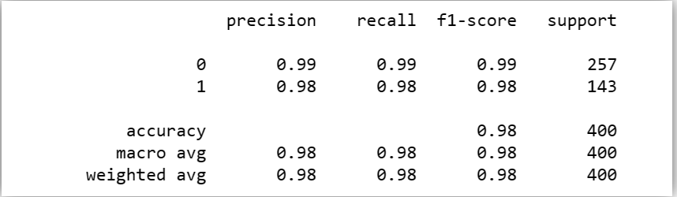

1. What is the overall accuracy or output?

Overall refers to the accuracy, hence in this algorithm it is 98% (0.98)

1. What the percentage of correctly classified as ‘Purchased’ and ‘Not purchased’?

It refers to Recall, hence for ‘Purchased’ 99% (0.99) and ‘Not purchased’ 99%

(0.99)

1. What is the percentage of correctly and wrongly classified ‘Purchased’?

It refers to Precision, hence for purchased it is 98% (0.98)

1. What is the percentage of correctly and wrongly classified ‘Not Purchased’?

It refers to Precision, hence for Not purchased it is 99% (0.99)

1. What is the overall performance of ‘Purchased’ and ‘Not purchased’?

It refers to F1 measure, hence for Purchased’ 98% (0.98) and ‘Not purchased’

99% (0.99)

1. What is the Average performance? Or what is the average performance of Precision, Recall, F1 measure?

It refers to Macro avg

|  |  |  |
| --- | --- | --- |
| **Precision** | **Recall** | **F1 Measure** |
| 98% | 98% | 98% |

1. What is the proportionate of each class or what is the Weight Average of each class?

|  |  |  |
| --- | --- | --- |
| **Precision** | **Recall** | **F1 Measure** |
| 98% | 98% | 98% |

**Conclusion:**

Since Random forest gives better result confusion matrix: overall 98%, hence will deploy this model in the production environment. However, determining result through SVMC is running indefinite, hence couldn’t verify the result for the same.