LABORATORY PROJECT REPORT

Cloud Computing | IIT Pune | 2025
An Enhanced Implementation of

Symmetric Searchable Encryption

with End-to-End Verifiability, Distributed Search Authority,
and Automated Storage Auditing

Based on the Research Paper:

"A Verifiable and Efficient Symmetric Searchable Encryption Scheme
for Dynamic Dataset With Forward and Backward Privacy"

Zhu et al. — IEEE Transactions on Dependable and Secure Computing, Vol. 22, No. 3, 2025

Submitted by

. Kotha Venkata Jayadeep (112315088)
· Dhanush Sai Reddy (112315048)
· K Sai Trinesh (112315085)

Github Link : https://github.com/Dhanush-sai-reddy/Secure-Cloud_storage/

Department of Computer Science and Engineering
Indian Institute of Information Technology Pune

Abstract

This project presents the design and implementation of a Secure Cloud Search System (SCS) that allows users to store encrypted documents in the cloud and perform keyword searches over ciphertext without revealing any information to the cloud provider. The system is built on two cryptographic schemes — Hexie and Jianding — which together provide dynamic dataset support, forward and backward privacy, and integrity verification of search results.

Beyond the core scheme, the project introduces three technical contributions:
- End-to-End Verifiability (Jianding-Plus): extends the Jianding MAC verification to include an SHA-256 content fingerprint, binding index integrity to storage integrity in a single cryptographic tag.
- Distributed Search Authority (HTV-DSSE): implements Hierarchical Threshold Secret Sharing, distributing the master key so a configurable quorum must cooperate before any search can be initiated.
- Automated Storage Audit: integrates real-time S3 integrity checking into the search pipeline, classifying every file in a search result and producing a structured JIANDING SUMMARY report.

1. Introduction

Organisations increasingly rely on cloud storage for managing large volumes of sensitive data. However, encrypting data before upload — which is necessary for security — makes the data unsearchable by conventional means. This creates a fundamental conflict: strong encryption prevents not only unauthorised access but also legitimate keyword search.

Symmetric Searchable Encryption (SSE) resolves this by allowing keyword searches to be performed directly over encrypted data without exposing the keyword, the query, or any document content to the cloud provider.

This project builds a demo Secure Cloud Search System implementing the Hexie and Jianding SSE schemes:

- Hexie provides core encrypted search functionality with dynamic insert/delete, forward privacy, backward privacy, and a light client model.
- Jianding extends Hexie with a chained MAC verification structure that detects incomplete, tampered, or missing results — including the malicious empty result attack.

While these schemes offer strong theoretical guarantees, a practical cloud deployment faces additional challenges: a cloud provider could silently replace file contents without touching the index, delete files causing system crashes, or a single insider with the master key could search all documents without authorisation. This project addresses all three gaps through original technical innovations detailed in Section 4.

The system is implemented in Python using the AWS ecosystem — Amazon S3 for encrypted file storage and an EC2 server for the encrypted index.

2. System Overview

2.1 Hexie — Dynamic Encrypted Search

Hexie builds a searchable encrypted index using an n-out-of-n XOR secret sharing construction. Each keyword is assigned a fixed secret value (1^λ). This secret is split into XOR shares — one per document associated with the keyword, plus one retained by the client. The shares are embedded into a linked chain of encrypted entries stored on the server.

During search, the server follows the chain, recovering one share per step. When all shares XOR back to 1^λ, the search terminates and the collected encrypted document identifiers are returned to the client.

Key Properties of Hexie
- O(1) client storage — stores only a single share per keyword
- Non-interactive — no counters or round-trip communication during search
- Fast symmetric operations only — HMAC-SHA256 and AES-128
- Dual index — inverted index (keyword → document list) + forward index (document → keyword list)

2.2 Jianding — Verifiable Search Results

Jianding extends Hexie by adding a chained Message Authentication Code (MAC) to each encrypted index entry. Each ciphertext includes the MAC of the previous entry, forming a tamper-evident chain. The client stores only the MAC of the last entry. During verification, the chain is traversed backwards — any broken link immediately indicates tampered or incomplete results.

Jianding also handles the malicious empty result attack: if the cloud returns an empty set but the client's local index state is non-empty, this contradiction is detected and flagged. Both index integrity and chain completeness are guaranteed.

2.3 System Modules

Module | Function
scs_client.py | Encrypts documents and uploads them to Amazon S3. Updates the encrypted index on EC2 with file addresses and security tags.
scs_search.py | Generates search trapdoors, queries the encrypted index, verifies search results, audits S3 file integrity, and produces the JIANDING SUMMARY report.
hexie_chain_visualiser.py | Diagnostic tool that renders the internal state of the Hexie XOR chain and validates MAC tags in the client's local index.
hierarchical_secret_sharing.py | Implements Shamir's Secret Sharing over GF(2^521 − 1) for cryptographic key distribution across departments and users.
htv_dsse.py | Manages two-level hierarchical key distribution and quorum-based search authority enforcement.

3. Identified Gaps in Existing SSE Systems

During design and testing, three practical security gaps were identified that are not addressed by the core Hexie and Jianding schemes. These exist between the theoretical model assumed by the schemes and the reality of a cloud deployment with untrusted infrastructure and multiple users.

Gap | Description | Security Impact
G1 — Storage Blindness | Jianding MAC chain verifies index pointers but not file contents in S3. A cloud provider could replace file bytes while keeping the index intact — the MAC verification would still pass. | File content can be silently substituted without detection. The user receives a verified but attacker-controlled document.
G2 — Missing File Crash | If a file is deleted from S3 — by the cloud provider or storage failure — the download operation raises an unhandled exception and crashes entirely. | One deleted file crashes retrieval of all other valid results in the same query.
G3 — Single Master Key | The entire system depends on one master key held by a single entity. No role separation or access policy is enforced at the cryptographic layer. | A single compromised or malicious insider can perform unrestricted searches over all encrypted documents with no accountability.

4. Technical Innovations

Three original innovations were developed and integrated to address gaps G1, G2, and G3 respectively. Each adds a new security property without weakening any existing guarantee of Hexie or Jianding.

4.1 End-to-End Verifiability — Jianding-Plus

Addresses | Gap G1 — Storage Blindness: MAC chain verifies index integrity but not the content of stored files.

Technical Design
The solution binds the encrypted file content into the same MAC tag that Jianding already verifies. At upload time, an SHA-256 hash of the encrypted file bytes — called f_hash — is computed and appended to the MAC tag content before the HMAC is calculated. This hash is also stored as a field in the encrypted index entry on the EC2 server.

This creates a two-layer verification structure during search:

Layer 1 — Index Integrity: Jianding MAC chain verified as before, confirming the correct and complete set of file pointers was returned. Unchanged from the original scheme.

Layer 2 — Storage Integrity: For each verified pointer, the corresponding file is fetched from S3, its SHA-256 hash is computed, and compared against the stored f_hash. A mismatch means the file content has been altered.

Post-Transfer Check: After full download, the hash is recomputed one final time to detect any corruption that occurred during network transfer.

Security Property Added
The system now guarantees end-to-end integrity: not only are correct file pointers returned (Jianding), but the content of each file is verified to be unmodified (Jianding-Plus). File content substitution by the cloud provider is detected before any decryption takes place.

4.2 Distributed Search Authority — HTV-DSSE

Addresses | Gap G3 — Single Master Key: any compromise of one entity gives complete, unauditable access to all encrypted documents.

Technical Design
The solution applies Hierarchical Threshold Secret Sharing at two levels using Shamir's scheme over the Mersenne prime field GF(2^521 − 1):

- Level 1 — Department Shares: master key k split into d department shares using a (t_d, d) threshold scheme. Any t_d shares are sufficient to reconstruct k; fewer than t_d shares reveal nothing.
- Level 2 — User Shares: each department share is split into u user shares using a (t_u, u) scheme. Any t_u users within that department can reconstruct the department share.

A configurable quorum policy is enforced — e.g. '3 of 5 Engineers AND 1 of 2 Admins must provide their shares before a search can begin.' The master key is reconstructed in memory only for the duration of trapdoor generation, then immediately zeroed.

Security Property Added
Search authority becomes a distributed cryptographic privilege. The security of Shamir's scheme over a large prime field is information-theoretic: any set of fewer than t shares is statistically independent of the secret, regardless of the adversary's computational power.

4.3 Automated Storage Audit

Addresses | Gap G2 — Missing File Crash: unhandled exceptions prevent retrieval of all other valid results.

Technical Design
The search pipeline is restructured around an audit-first approach. Before any file is downloaded, each file pointer is checked and classified into one of four categories:

Classification | Condition | System Action
VERIFIED | File exists in S3, Layer 1 MAC passes, SHA-256 hash matches stored f_hash. | Proceed to download and decrypt.
MISSING | S3 returns NoSuchKey or 404. | Log as MISSING, skip download, continue to next file.
TAMPERED | File exists but SHA-256 hash does not match stored f_hash. | Log as TAMPERED with expected and actual hash values. Skip decryption.
HASH_MISMATCH | File downloads successfully but post-transfer hash differs from pre-transfer. | Discard downloaded file. Log as network corruption event.

At the end of each search operation, a structured JIANDING SUMMARY report is printed, showing the total count and details for each category. Only VERIFIED files are decrypted and delivered to the user.

5. System Architecture

The complete system operates across two trust boundaries: the Client Trust Zone, where all key material and verification logic reside, and the Cloud Zone, which is treated as entirely untrusted.

Component | Trust Zone | Role
htv_dsse.py | Client | Enforces quorum policy. Reconstructs master key only when sufficient shares are provided.
hierarchical_secret_sharing.py | Client | Shamir Secret Sharing primitives over GF(2^521 − 1).
scs_client.py | Client | File encryption, SHA-256 fingerprinting, S3 upload, index update with f_hash.
scs_search.py | Client | Trapdoor generation, dual-layer verification, S3 audit, JIANDING SUMMARY.
hexie_chain_visualiser.py | Client | Validates XOR chain state and V2 MAC tags.
EC2 Index Server | Cloud (Untrusted) | Stores encrypted inverted and forward indexes. Returns entries on query.
Amazon S3 | Cloud (Untrusted) | Stores encrypted file ciphertext. Audited before and after each download.

Search Operation Flow

Step | Name | Description
1 | Quorum Assembly | Required users submit key shares. Department shares are reconstructed, then the master key k is reconstructed in memory.
2 | Trapdoor Generation | The search trapdoor is generated using k. The master key is immediately zeroed from memory.
3 | Index Query | The trapdoor is sent to the EC2 index server. The server walks the Hexie XOR chain and returns encrypted ciphertext entries.
4 | Layer 1 Verification | The Jianding MAC chain is verified from the last entry to the first. Any broken link causes immediate TAMPERED classification.
5 | Storage Audit | Each file pointer is checked against S3. Files are classified as VERIFIED, MISSING, or TAMPERED based on existence and hash comparison.
6 | Decryption | Only VERIFIED files are downloaded, post-transfer hash-checked, and decrypted.
7 | JIANDING SUMMARY | A structured audit report is printed showing the classification of every file in the result set.

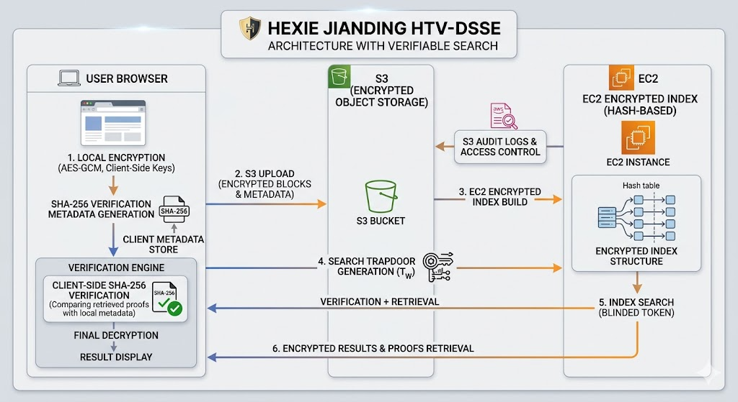

Figure 1 :shows System Architecture

6. Security Analysis

6.1 Core Scheme Security

The Hexie scheme achieves L-adaptive security with backward privacy Type-II, proven via a hybrid argument in the random oracle model. The proof replaces each cryptographic primitive — the pseudorandom function F, the symmetric encryption Enc2, the pseudorandom permutation PRP, and the hash function H — with ideal random functions one by one, showing that no probabilistic polynomial-time adversary can distinguish the real scheme from the ideal.

- Forward privacy: each update operation produces output statistically independent of all previous operations.
- Backward privacy Type-II: deleted document identifiers are never revealed during future searches.

6.2 Security Properties of the Innovations

Threat | Without Innovations | With Innovations
File content substitution | Undetected. MAC covers index address only. | Detected. SHA-256 fingerprint of content is bound into the MAC tag.
File deletion by cloud provider | System crash. All other results lost. | MISSING classification. Remaining VERIFIED files still retrieved and decrypted.
Network corruption | Undetected. Corrupted file delivered. | Detected by post-transfer hash recomputation. Corrupted file discarded.
Single insider key compromise | Full, unrestricted access to all documents. | Useless. One share has zero information about the master key (information-theoretic).
Unauthorised unilateral search | No cryptographic prevention. | Impossible without a valid quorum. Enforced at the cryptographic layer.
Malicious empty result attack | Detected by Jianding. | Preserved and included in JIANDING SUMMARY report.

6.3 Information-Theoretic Security of Key Sharing

The hierarchical key sharing uses Shamir's scheme over GF(2^521 − 1). The security is information-theoretic rather than computational: any coalition of fewer than t shares is perfectly independent of the master key. No amount of computation can extract the master key from an insufficient number of shares. The Mersenne prime 2^521 − 1 was chosen for its large field size — providing 521 bits of security — and the efficiency of modular arithmetic in its field.

7. Results and Comparison

Property | Base System (Hexie + Jianding) | Enhanced System (This Project)
Forward Privacy | Yes | Yes — Preserved
Backward Privacy Type-II | Yes | Yes — Preserved
Index Integrity Verification | Yes — Jianding MAC chain | Yes — Preserved and strengthened
Storage Content Verification | No | Yes — SHA-256 fingerprint in MAC tag
Missing File Handling | System crash | Yes — MISSING classification, graceful continuation
Network Corruption Detection | No | Yes — Post-transfer hash recomputation
Insider Threat Protection | No | Yes — Quorum-based key distribution
Role-Based Search Authority | No | Yes — Two-level hierarchical sharing
Per-Search Audit Report | No | Yes — JIANDING SUMMARY with full classification
Diagnostic Tool Consistency | Basic MAC validation | Updated for f_hash tag format

Performance Note: The three innovations add no overhead to the core search or update operations of Hexie. The SHA-256 fingerprint computation is a single symmetric hash per file — negligible compared to file encryption. The quorum key reconstruction adds latency only at search initiation. The S3 audit adds one API call per file pointer before download. All asymptotic performance properties of the base scheme are fully preserved.

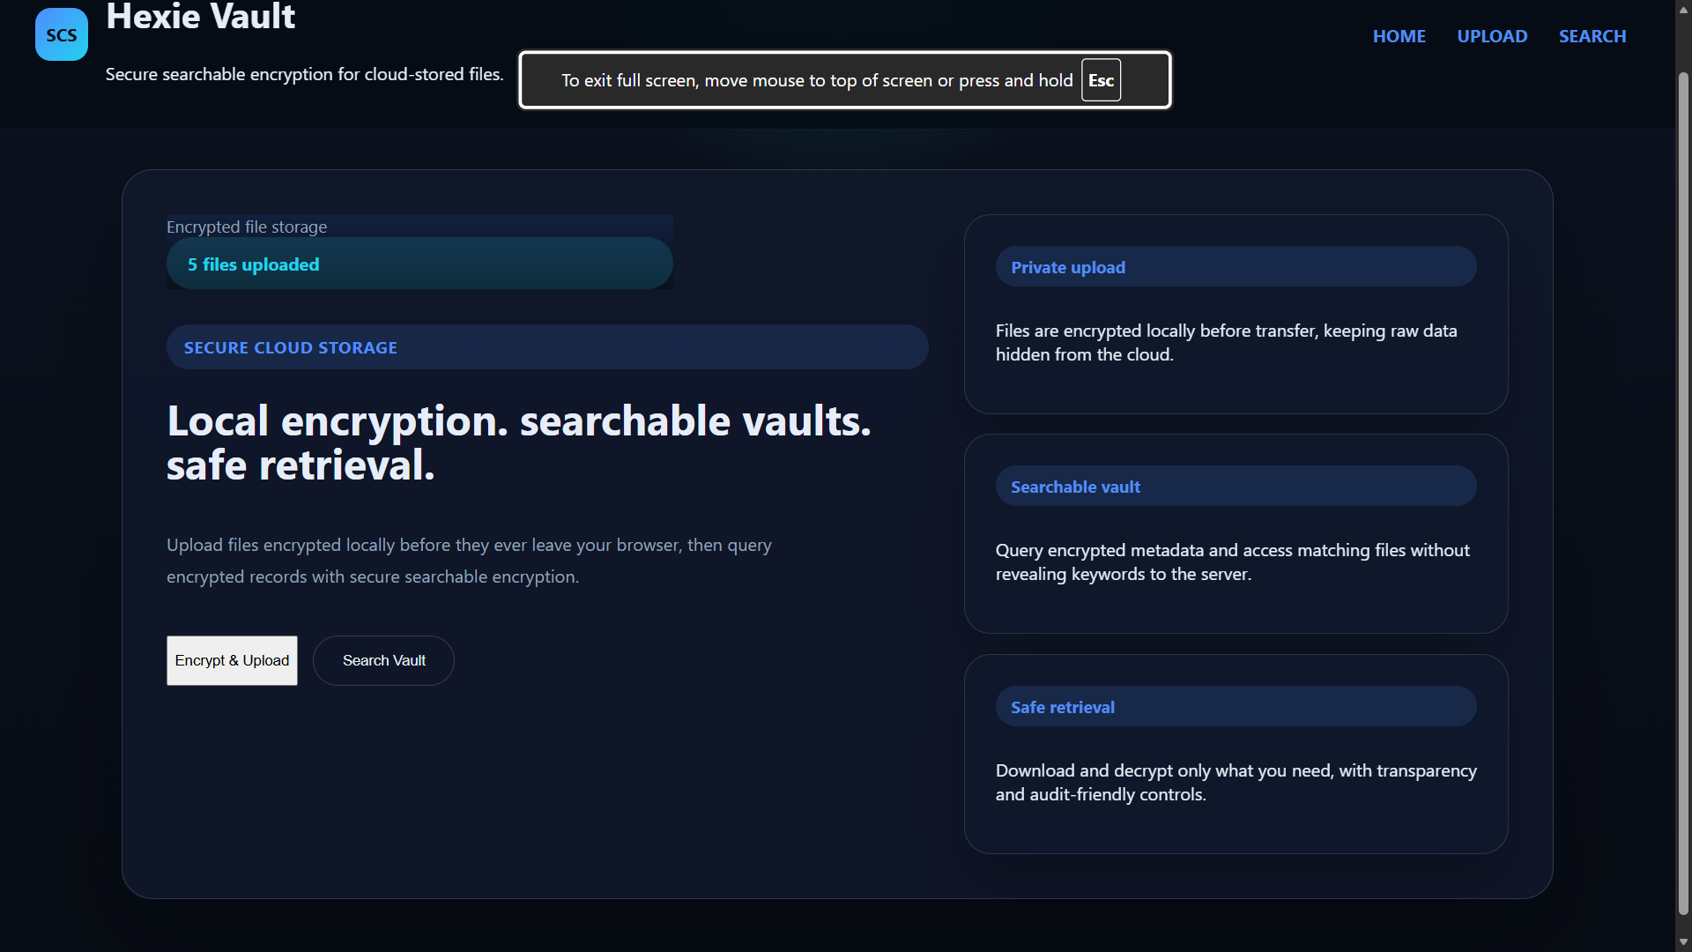

Figure 2 : Home page of web application

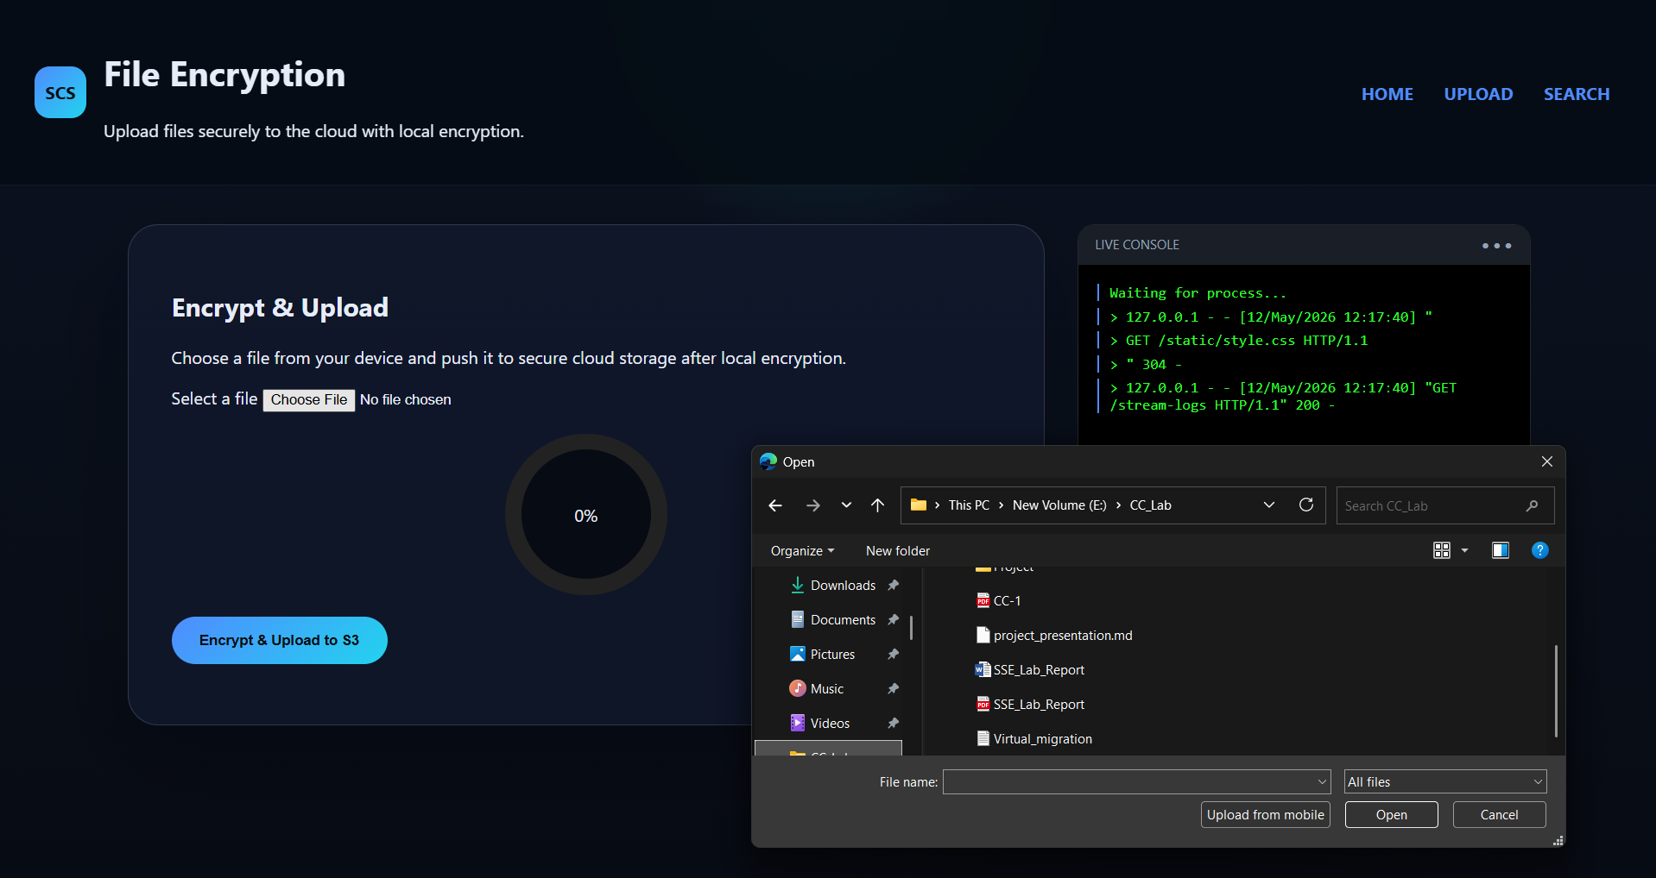

Figure 3 : Select the file to upload

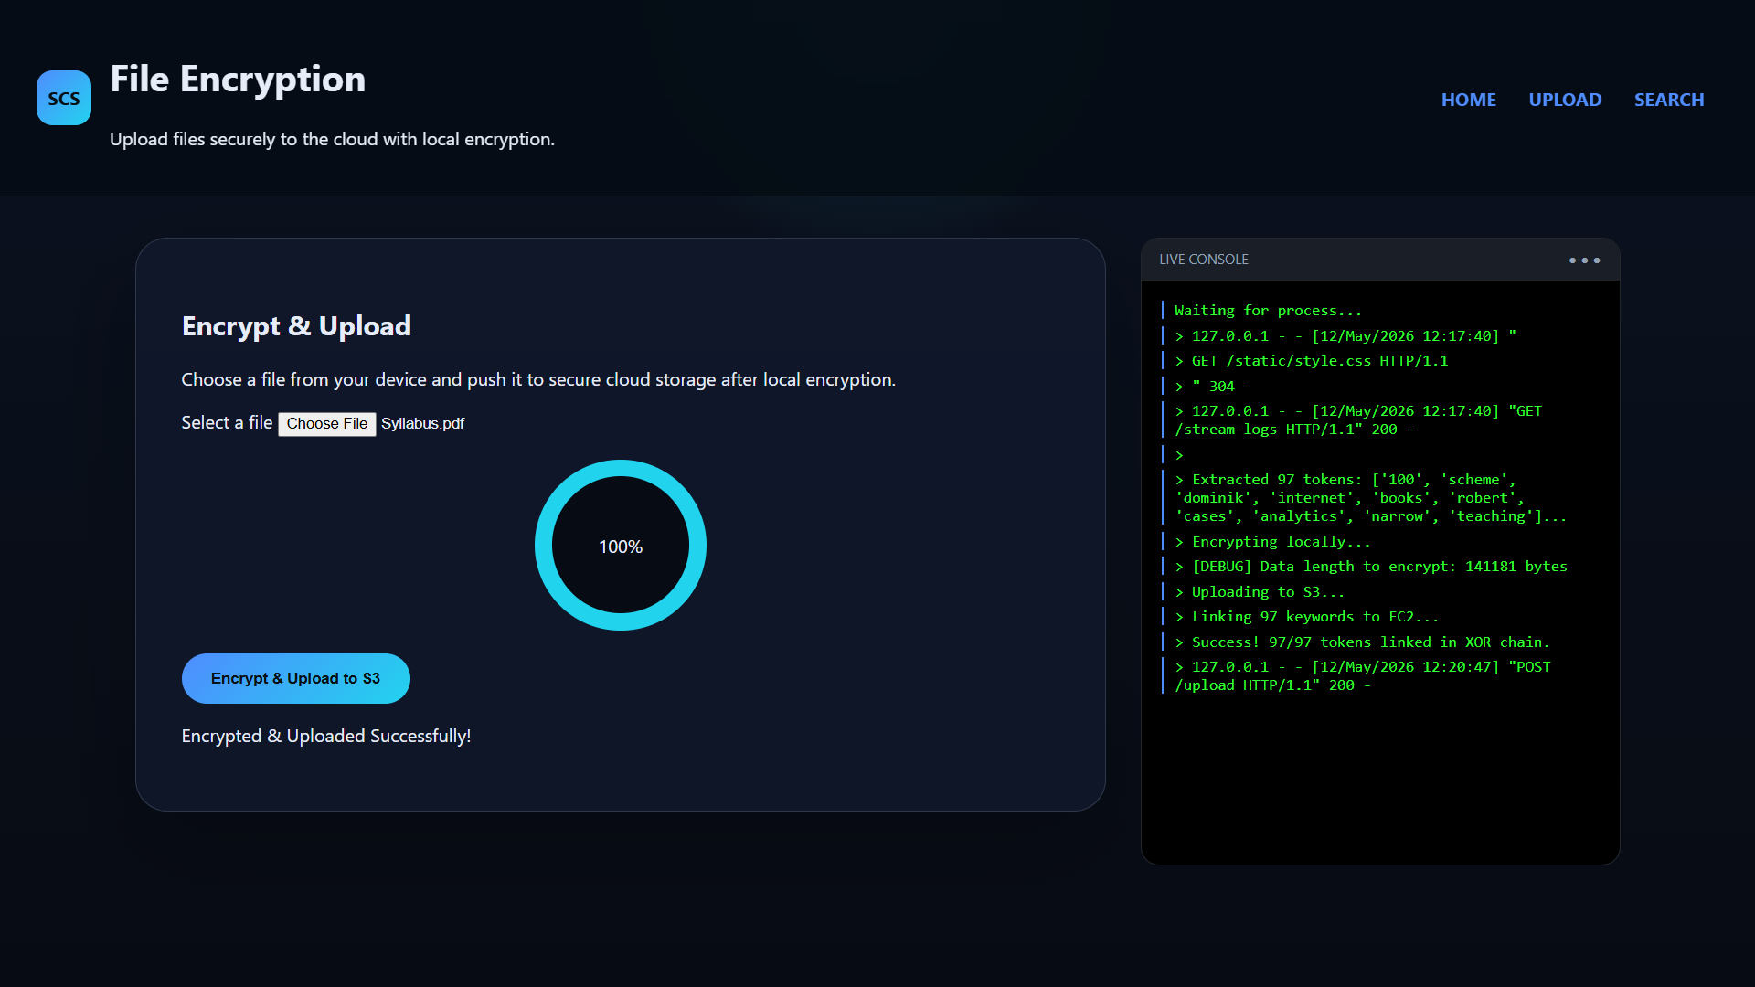

Figure 4 : Succesfull encryption and upload to cloud

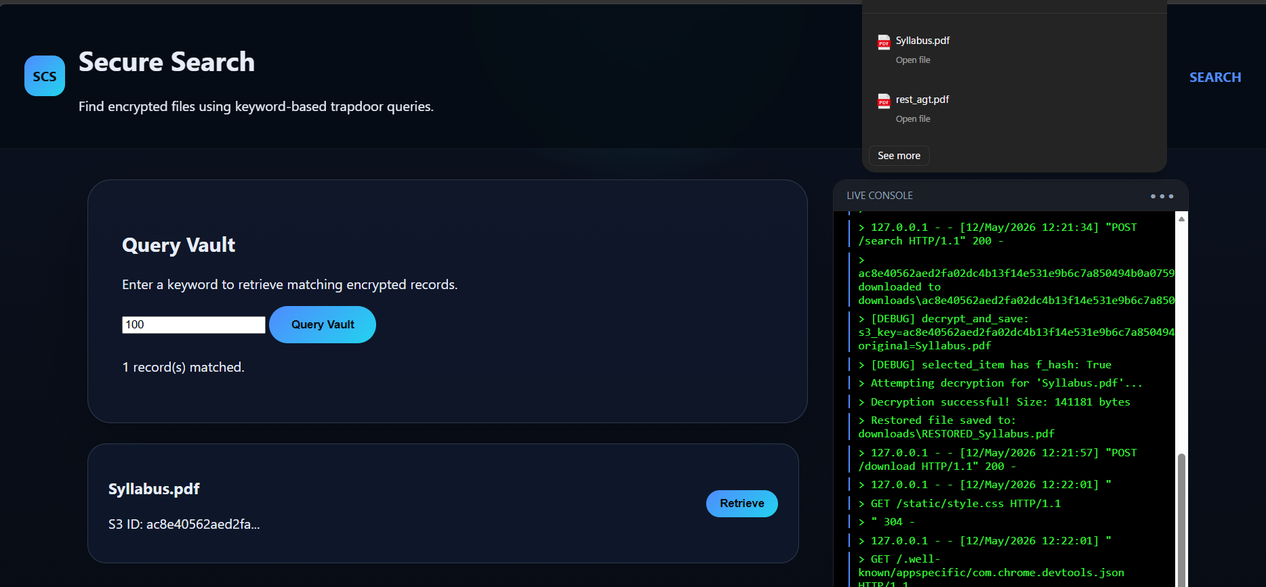

Figure 5 : Succesfully search working

8. Conclusion and Future Work

8.1 Conclusion

This project presents the design and implementation of a Secure Cloud Search System built on the Hexie and Jianding Symmetric Searchable Encryption schemes. The system enables users to store encrypted documents in the cloud and perform keyword searches over ciphertext, with the cloud provider learning nothing about the keyword, the query, or any document content.

Three original technical contributions extend the system beyond the core scheme:

- Jianding-Plus binds an SHA-256 content fingerprint into the Jianding verification tag, providing true end-to-end integrity from the index down to the stored file bytes.
- HTV-DSSE distributes the master search key across a two-level hierarchy, enforcing quorum-based search authority at the cryptographic layer and eliminating the single-point-of-failure key model.
- The Automated Storage Audit restructures the retrieval pipeline around an audit-first approach, classifying every file in every search result and producing a transparent JIANDING SUMMARY report.

All forward and backward privacy guarantees of the base scheme are fully preserved. The enhanced system is more robust, more accountable, and more suitable for real-world deployment than the base scheme alone.

8.2 Future Work

- Multi-keyword conjunctive search: Extend the trapdoor to support AND queries across multiple keywords in a single non-interactive round.
- Attribute-based access control: Replace the threshold quorum policy with expressive attribute-based policies.
- Formal proof extension: Extend the hybrid argument security proof to formally cover the SHA-256 fingerprint extension and hierarchical key sharing layer.
- Performance benchmarking: Quantify the overhead of each innovation against the base scheme on large-scale document collections.

References

[1] X. Zhu, J. Zhou, Y. Dai, P. Shen, S. K. Kermanshahi, and J. Hu, "A Verifiable and Efficient Symmetric Searchable Encryption Scheme for Dynamic Dataset With Forward and Backward Privacy," IEEE Trans. Dependable Secure Comput., vol. 22, no. 3, pp. 2741–2755, May/June 2025.
[2] A. Shamir, "How to share a secret," Commun. ACM, vol. 22, no. 11, pp. 612–613, 1979.
[3] R. Bost, "Forward secure searchable encryption," in Proc. ACM SIGSAC CCS, 2016, pp. 1143–1154.
[4] R. Bost, B. Minaud, and O. Ohrimenko, "Forward and backward private searchable encryption from constrained cryptographic primitives," in Proc. ACM SIGSAC CCS, 2017, pp. 1465–1482.
[5] E. Stefanov, C. Papamanthou, and E. Shi, "Practical dynamic searchable encryption with small leakage," in Proc. NDSS, 2014.
[6] D. Yuan, S. Cui, and G. Russello, "We can make mistakes: Fault-tolerant forward private verifiable dynamic SSE," in Proc. IEEE EuroS&P, 2022, pp. 587–605.
[7] Amazon Web Services, "Amazon S3 Documentation," 2024. [Online]. Available: https://docs.aws.amazon.com/s3/
[8] Python Software Foundation, "hashlib — Secure hashes and message digests," Python 3 Docs, 2024. [Online]. Available: https://docs.python.org/3/library/hashlib.html

