1️⃣ APACHE — Manual Installation (Deep Internal Understanding)
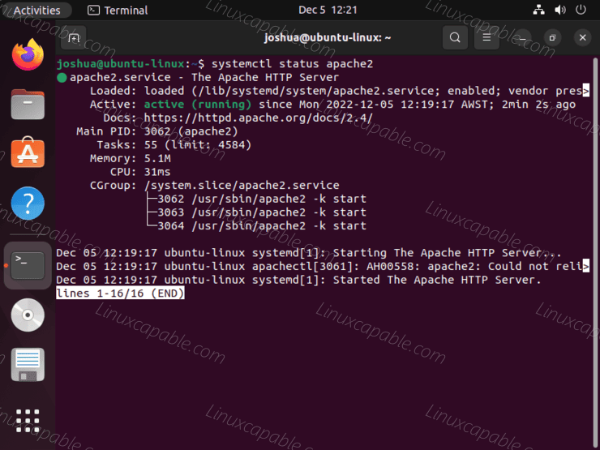
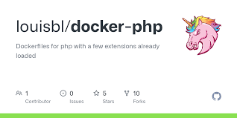
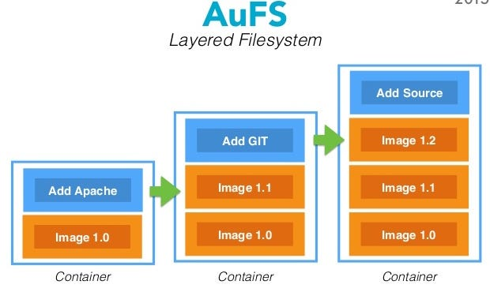
4

🔹 Base Image: ubuntu:22.04
When you write:
FROM ubuntu:22.04
Docker pulls:
- Minimal Ubuntu root filesystem
- No kernel (important!)
- Uses host machine kernel
👉 Container does NOT contain its own kernel.
It shares host kernel via namespaces + cgroups.

🔹 RUN apt install apache2
During build:
- Docker creates temporary container
- Runs:
apt update
apt install apache2
- Files installed:
  - /usr/sbin/apache2
  - /etc/apache2
  - /var/www/html
- That container is committed as a new image layer
- Temporary container destroyed
🔥 Important
Each RUN = new immutable layer.
Even if you later delete files, previous layer size remains.
That’s why we combine:
RUN apt update && \
apt install -y apache2 && \
rm -rf /var/lib/apt/lists/*
To reduce layer size.

🔹 WORKDIR /var/www/html
This instruction:
- Creates directory if not exists
- Sets default working directory
- Affects future COPY and CMD
Better than:
RUN cd /var/www/html
Because RUN executes in isolated shell per layer.

🔹 CMD ["apache2ctl","-D","FOREGROUND"]
💡 Why FOREGROUND?
Normally Apache daemonizes:
- Starts
- Forks
- Runs in background
- Parent exits
If parent exits → container stops.
Container lifecycle = lifecycle of PID 1.
So we force Apache to run in foreground.

🔹 Runtime Internals
When you run:
docker run -p 8080:80 apache-demo
Docker:
- Creates container namespace
- Adds writable layer
- Assigns container IP
- Creates virtual network interface
- Maps host port 8080 → container port 80
- Starts process:
PID 1 → apache2ctl -D FOREGROUND
If PID 1 dies → container exits.

🟢 2️⃣ NGINX — Using Official Base Image
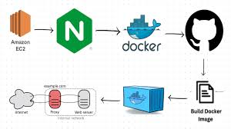
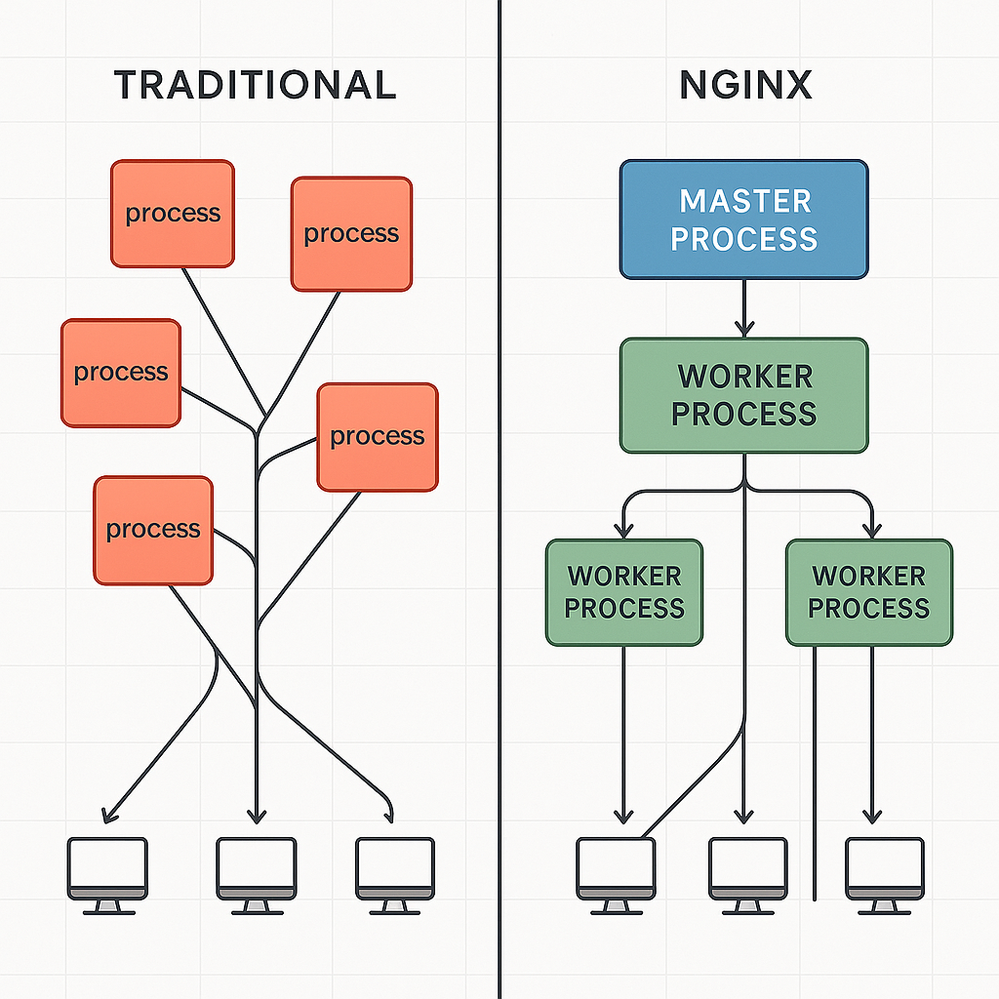
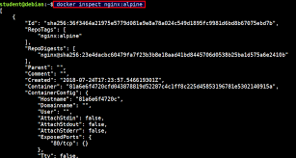
4

🔹 Base Image: nginx:1.25-alpine
This already contains:
- Alpine Linux (tiny OS)
- nginx installed
- Default CMD
- Default ENTRYPOINT
Run this:
docker inspect nginx:1.25-alpine
You’ll see:
"Cmd": ["nginx", "-g", "daemon off;"]
That’s why we don’t define CMD.

🔹 What Happens in Build?
Only this layer added:
COPY index.html .
Very lightweight image change.

🔹 Runtime Internals
When container starts:
PID 1 → nginx (master process)
Worker processes forked
Nginx master:
- Manages workers
- Handles signals
- Keeps running in foreground
daemon off; ensures no backgrounding.

🔹 Alpine vs Ubuntu
Alpine:
- ~5MB
- Uses musl libc
- Smaller attack surface
Ubuntu:
- Larger
- glibc based
- More compatibility
As a trainer — explain this tradeoff clearly.

🟢 3️⃣ FLASK — Python Web App (Deep Dive)
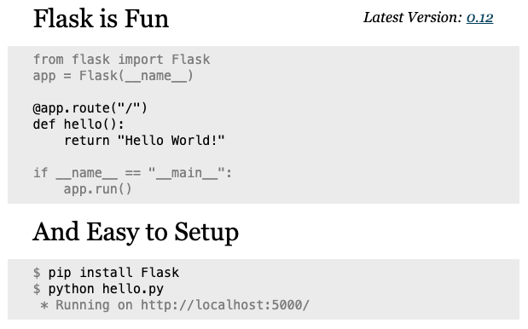
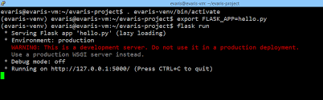
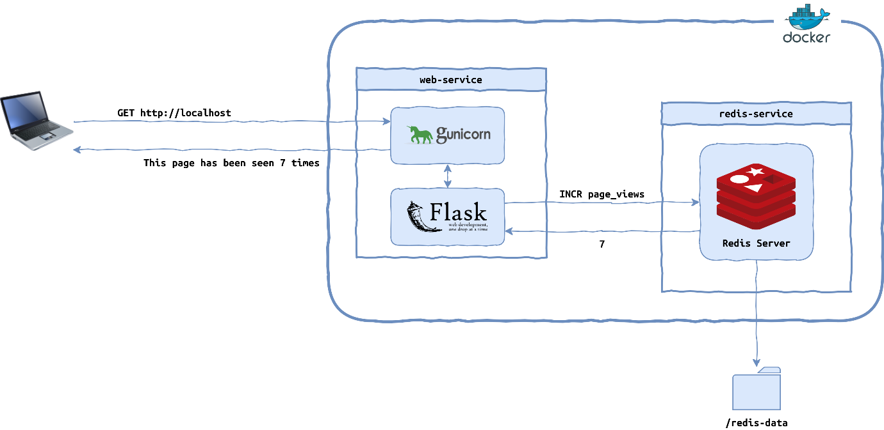
4

🔹 Base Image: python:3.9-slim
Contains:
- Debian slim
- Python interpreter
- pip

🔹 Layer Breakdown
- Base layer → python OS
- WORKDIR layer
- COPY requirements.txt layer
- RUN pip install layer
- COPY app layer
Why copy requirements separately?
So Docker can cache pip install if code changes but dependencies don’t.
This is optimization thinking.

🔹 Runtime Phase
When you run:
docker run -p 5000:5000 flask-demo
Container starts:
PID 1 → python app.py
Flask starts development server:
app.run(host="0.0.0.0", port=5000)
Why 0.0.0.0?
Because container has its own network namespace.
If you bind to 127.0.0.1, it binds inside container only.
External access requires 0.0.0.0.

🔥 Production Note
Flask dev server is single-threaded.
In real production:
Use:
- gunicorn
- uWSGI

🟢 4️⃣ SPRING BOOT — Java Deep Internal View
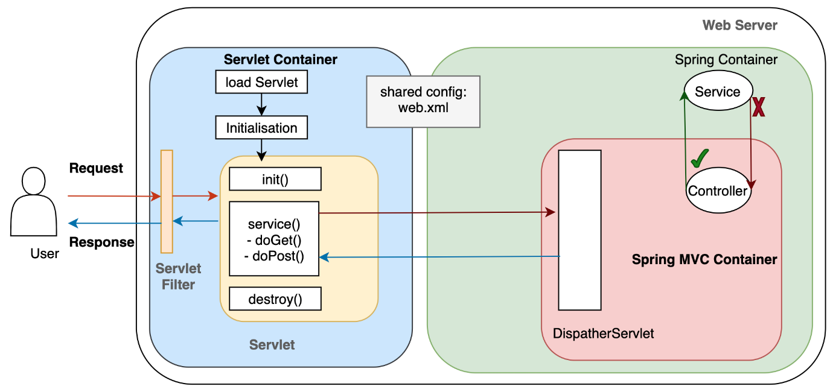
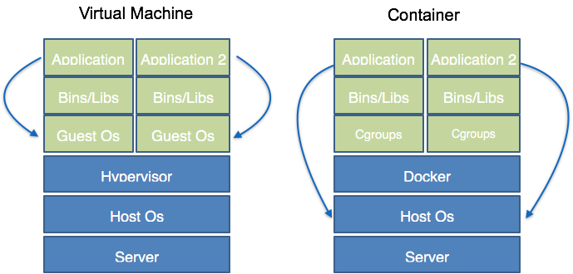
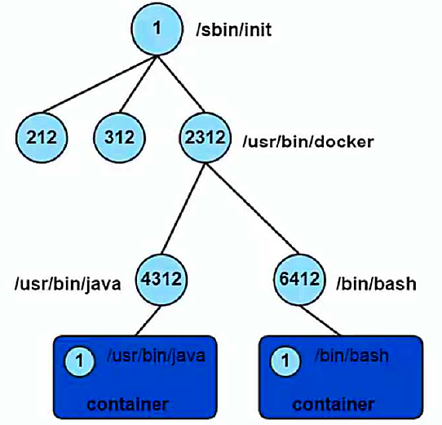
4

🔹 Base Image: eclipse-temurin:17-jre
From:
Eclipse Foundation
Contains:
- OpenJDK runtime
- Minimal OS
- No compiler (JRE only)

🔹 Why Copy JAR?
Spring Boot:
- Builds fat jar
- Includes embedded Tomcat
When running:
java -jar app.jar
Internally:
- JVM starts
- Loads classes
- Starts embedded Tomcat
- Binds to port 8080

🔹 Runtime Internals
PID 1 = java process.
Inside JVM:
- Heap allocated
- Threads created
- GC runs
- Embedded server listens
Container memory limit affects JVM heap.
If not configured properly:
Java may try to use more memory → OOMKilled.
Better practice:
ENV JAVA_OPTS="-Xms256m -Xmx512m"

🔥 Ultra Important: Container Process Model
Container is NOT a VM.
It is:
Host Kernel
├─ Namespace (isolated view)
├─ cgroups (resource limits)
└─ overlay filesystem
Each container:
- Has its own PID namespace
- Own network namespace
- Own mount namespace
But shares host kernel.

🧠 Deep Comparison
App | PID 1 | Foreground Required? | Who listens? | Complexity
Apache | apache2ctl | Yes | Apache | Medium
Nginx | nginx | Already handled | Nginx | Low
Flask | python | Yes | Dev server | Low
Spring | java | Yes | Embedded Tomcat | High

