Supplementary Material for “Is Your Wind Forecast Climate-Proof? Daily Wind Generation Forecasting for Tamil Nadu under Weather Error, Ramp Events and CMIP6 Climate Shift”
Pavan Kumar Kora, Student Member, IEEE [confirm membership or delete], Jayadharshini R., and [Supervisor name]
This file accompanies the paper of the same title submitted to the Journal of Modern Power Systems and Clean Energy. It holds the material that did not fit the page limit: the positioning table, data details, database design, validation folds and the extended and robustness results. Tables and figures are numbered with the prefix S; references to “the main paper” use its numbering, and reference numbers in square brackets are those of its reference list.

S1. Positioning Against Related Work
Table S-I positions this work against representative studies. Within the literature reviewed, we found limited evidence on whether a state-level operational wind generation forecast for India stays valid under CMIP6 projections, and no study that keeps the forecasting and climate pipelines in one reproducible database. The review was not systematic, so the gap is stated with that caution.
TABLE S-I
Positioning against representative studies. Region and focus are taken from each study’s title and abstract; “—” means not part of that study’s scope.
Study | Region | Climate information | Quantity analysed | Operational forecast tested under shift
Reyers et al. [17] | Europe | CMIP5 multi-model ensemble | Wind energy potential | No
Tobin et al. [20] | Europe | Climate projections | Generation potential of a wind-farm scenario | No
Carvalho et al. [18] | Europe | CMIP6 vs CMIP5 | Wind energy resource | No
Martinez and Iglesias [19] | North America | CMIP6 | Wind energy resources | No
Sherman et al. [22] | China, India | High-resolution climate models | Wind power potential | No
Lahouar and Ben Hadj Slama [10] | — | — | Hour-ahead wind power (Random Forest) | No climate shift
Demolli et al. [11] | — | — | Wind power from daily wind speed (ML) | No climate shift
Bossavy et al. [36] | — | — | Wind power ramps from NWP ensembles | No climate shift
This study | Tamil Nadu, India | 10 NEX-GDDP-CMIP6 models, 2 SSPs, 2 windows | Daily grid generation forecast, its ramps and its change | Yes, with shift diagnostic, ramp and extreme-day analysis, and database

S2. Data and Quality Control
The target is Tamil Nadu’s daily wind generation as reported by the Central Electricity Authority (CEA) [38]. Weather is taken from ERA5 [30] through the Open-Meteo archive [39] at three wind-belt locations: Muppandal–Kayathar (requested 8.25° N, 77.55° E; nearest grid cell 8.25° N, 77.50° E), Palghat–Udumalpet (10.6° N, 77.25° E; grid 10.5° N, 77.25° E) and Theni–Cumbum (9.75° N, 77.3° E; grid 9.75° N, 77.25° E). Climate projections come from NEX-GDDP-CMIP6 [26] for ten models: ACCESS-CM2, CanESM5, CMCC-ESM2, EC-Earth3, GFDL-ESM4, IPSL-CM6A-LR, MIROC6, MPI-ESM1-2-HR, MRI-ESM2-0 and NorESM2-MM. Table S-II summarises the data.
TABLE S-II
Data sources and stored rows.
Source and variables | Coverage | Rows
CEA daily renewable generation; Tamil Nadu wind (MU d⁻¹) | 2020-05-28 to 2025-04-27 | 1,796
ERA5 via Open-Meteo; daily mean wind speed, temperature, relative humidity | 2020-05-01 to 2025-04-30; 3 points | 5,478
NEX-GDDP-CMIP6; sfcWind, tas, hurs; 10 models | 1995–2014, 2021–2040, 2041–2060 | 1,950
The CEA file contains 1,776 of the 1,796 days in its span; 20 days are absent (1 in 2020, 15 in 2021 and 4 in 2022), and two days that reported zero for every state were set to missing. The 22 missing days remain NULL and are never imputed, leaving 1,774 valid days with a mean of 32.69 MU d⁻¹. The unit is million units (MU, GWh) per day, net generation, as stated in the dataset metadata. The file is the State Control Area table, which covers wind plants scheduled by the state load despatch centre and therefore is a subset of all wind generation in Tamil Nadu (plants dispatched under inter-state or central arrangements are not included); this is a limitation of the target and is discussed in Section V-E of the main paper. All ERA5 days have 24 hourly values; mean 10 m wind speed is 3.44, 2.44 and 1.59 m s⁻¹ at the three locations, and the state-level predictor is their equal-weight mean. Daily generation and this mean wind speed are strongly correlated (Pearson r = 0.891). Surface pressure is stored but excluded from modelling because the projections do not provide it. For the projections, the mean of each variable was extracted for every model, window, location and month (10 × 5 × 3 × 12 = 1,800 rows) plus 150 annual rows; all 50 model–window blocks were complete.
Fig. S1 shows the seasonal cycle: June–September carries the highest generation and the strongest winds, and November the lowest.
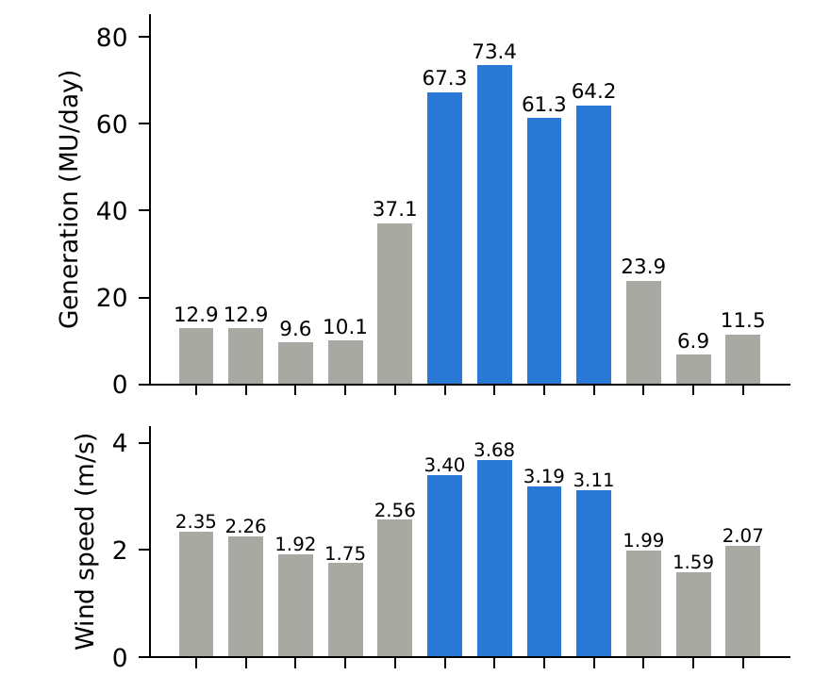
Fig. S1. Mean daily wind generation (top) and state-mean 10 m wind speed (bottom) by calendar month over the 1,774 valid days. Blue marks the June–September southwest monsoon.

S3. Database Design
Fig. 1 of the main paper shows the framework. All data flow into one PostgreSQL 16.6 database with TimescaleDB 2.17.2 [34]; models read only from views and write results back to tables, and the dashboard reads everything through SQL. Units are fixed throughout: wind speed in m s⁻¹ at 10 m, temperature in °C, relative humidity in % and generation in million units (GWh) per day.
The schema (Table S-III) was frozen before modelling. The two daily time-series tables are hypertables partitioned in one-year chunks, with the time column in their primary keys. CHECK constraints enforce physical ranges (wind speed 0–60 m s⁻¹, temperature −20 to 55 °C, humidity 0–100%, non-negative generation), valid scenario names, a forecast horizon of 1–3 days and ordered prediction bounds. Foreign keys tie readings, predictions and scenarios to stations, and deleting a forecast run cascades to its predictions.
TABLE S-III
Database tables and row counts after a full rebuild.
Table | Key and content | Rows
stations | station_id; state aggregate and 3 weather points | 4
raw_weather_readings (hypertable) | (station_id, ts); wind, temperature, humidity, pressure, hours behind mean | 5,478
power_output (hypertable) | (station_id, ts); generation (NULL = missing), capacity fields | 1,796
climate_scenarios | unique (name, target_year, month, climate_model, station_id) | 1,950
forecast_runs | run_id; model, horizon 1–3 days, parameters (JSONB) | 12
model_predictions | unique (run_id, station_id, forecast_date); value, lower, upper | 5,796
climate_impact | unique (region, scenario, target_year, climate_model, metric); value, p10, p90 | 268
Models never read raw tables. The materialized view mv_daily_features holds one row per day with the mean of the three locations left-joined to generation: 1,826 rows, of which 1,774 have generation (the remaining 52 are the 22 missing CEA days and 30 weather-only days outside the CEA span). Two views derive the climate change factors directly from the stored projections (Section III-D of the main paper). One command (python -m etl.run all) rebuilds all tables and results from committed seed files and checks them against golden files; a flag retrains the models, which reproduces the committed results to within rounding. Thirty-six automated tests cover the data, stored results and dashboard queries, and a further twenty-one cover the ramp, extreme-day, robustness, capacity and daily-output code (Sections III-F–III-H of the main paper); dependencies are pinned and the random seed is 42. [update the totals after the extremes branch is merged]

S4. Validation Folds
Table S-IV lists the walk-forward folds used in Section III-C of the main paper.
TABLE S-IV
Walk-forward folds. Every training window starts on 2020-05-28.
Fold | Training end / test period | Test days (h = 0 / h ≥ 1)
2022 | 2021-12-31 / 2022 | 360 / 345
2023 | 2022-12-31 / 2023 | 365 / 365
Holdout | 2023-12-31 / 2024-01-01 to 2025-04-27 | 483 / 483

S5. Extended Accuracy Results
Fig. S3 shows the observed and predicted daily generation on the holdout.
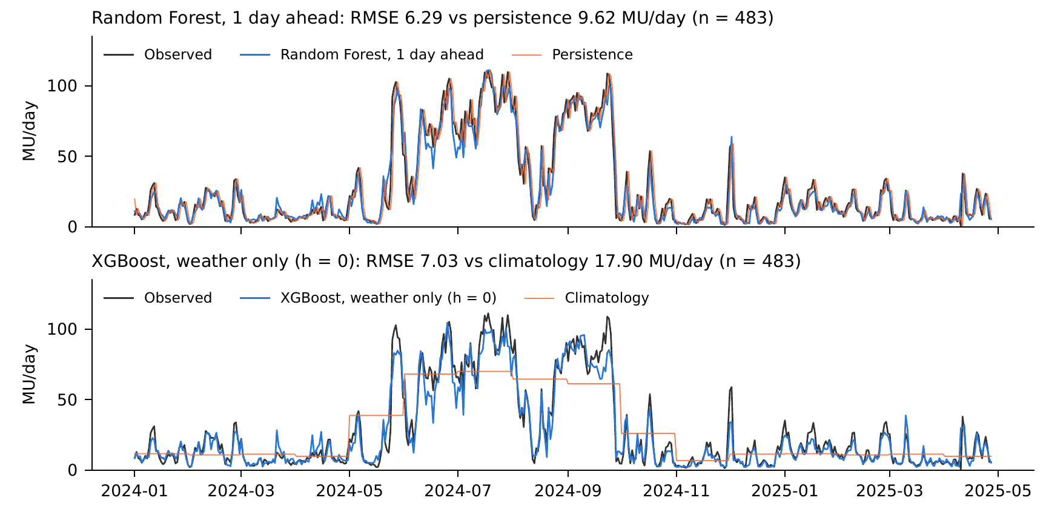
Fig. S3. Observed and predicted daily generation on the holdout. Top: one-day-ahead Random Forest and persistence. Bottom: weather-only XGBoost (used in the climate analysis) and monthly climatology.
Between the learning models, the evidence is weaker (Table S-V). Random Forest and XGBoost do not differ significantly at any horizon (p ≥ 0.48). The tree models beat the linear model at the 5% level in six of eight comparisons, but after a Holm correction for the twelve pairwise tests only XGBoost versus linear at h = 0 remains significant (adjusted p = 0.005). The fold results tell the same story: in 2022 the linear model had the lowest one-day RMSE (8.59, against 9.19 for Random Forest and 12.39 for persistence), while in 2023 XGBoost did (8.74, against 10.56 for persistence). The weather-only XGBoost RMSE was 10.25, 10.56 and 7.03 MU d⁻¹ in the 2022, 2023 and holdout folds.
TABLE S-V
Pairwise tests on the holdout (n = 483; squared-error loss; Harvey-corrected DM with Newey–West variance, 5 lags). Negative DM favours the first model. Holm-adjusted over the 12 tests.
h | Comparison | DM | p | Holm p
0 | XGBoost vs linear | −3.55 | 0.0004 | 0.005
0 | RF vs linear | −2.85 | 0.005 | 0.051
0 | RF vs XGBoost | 0.71 | 0.48 | 1.00
1 | RF vs linear | −2.03 | 0.043 | 0.35
1 | XGBoost vs linear | −1.84 | 0.066 | 0.40
1 | RF vs XGBoost | −0.50 | 0.61 | 1.00
2 | XGBoost vs linear | −1.98 | 0.048 | 0.35
2 | RF vs linear | −1.63 | 0.10 | 0.52
2 | RF vs XGBoost | 0.59 | 0.55 | 1.00
3 | RF vs linear | −2.50 | 0.013 | 0.13
3 | XGBoost vs linear | −2.22 | 0.027 | 0.24
3 | RF vs XGBoost | −0.39 | 0.70 | 1.00

S6. Climate-Model Results
The ensemble-mean change in mean generation is small in every case, from −1.7% (SSP2-4.5, 2050) to +2.7% (SSP5-8.5, 2050), and the climate models disagree on its direction: 3 to 6 of the 10 project an increase (Fig. 2 of the main paper). The spread widens with time and emissions; under SSP5-8.5 in 2050 the 10th–90th percentile range is −6.7% to +11.8%, and individual models range from −7.9% (CMCC-ESM2) to +18.8% (MIROC6). GFDL-ESM4 and MIROC6 project increases in all four cases, whereas ACCESS-CM2, CanESM5, EC-Earth3 and MRI-ESM2-0 project decreases in all four (Table S-VI). For June–September alone the ensemble means are −1.7% and −3.8% under SSP2-4.5 (2030, 2050) and +0.7% and −0.2% under SSP5-8.5, again with ranges that include zero.
TABLE S-VI
Change in mean daily generation (%) by climate model, weather-only XGBoost.
Climate model | SSP2-4.5 2030 | SSP2-4.5 2050 | SSP5-8.5 2030 | SSP5-8.5 2050
ACCESS-CM2 | −0.4 | −4.8 | −2.2 | −6.5
CanESM5 | −3.7 | −7.4 | −2.0 | −1.0
CMCC-ESM2 | −3.8 | −7.6 | 2.6 | −7.9
EC-Earth3 | −3.4 | −6.5 | −4.2 | −6.6
GFDL-ESM4 | 7.5 | 5.3 | 9.7 | 5.7
IPSL-CM6A-LR | −0.5 | −5.5 | 0.3 | 4.6
MIROC6 | 2.7 | 1.8 | 12.3 | 18.8
MPI-ESM1-2-HR | 1.4 | 4.8 | 3.4 | 11.1
MRI-ESM2-0 | −2.6 | −0.4 | −2.0 | −1.2
NorESM2-MM | 0.0 | 2.8 | 4.7 | 10.3
Ensemble mean | −0.3 | −1.7 | 2.3 | 2.7
Fig. S2 shows the monthly wind-speed change factors used by the delta-change method.
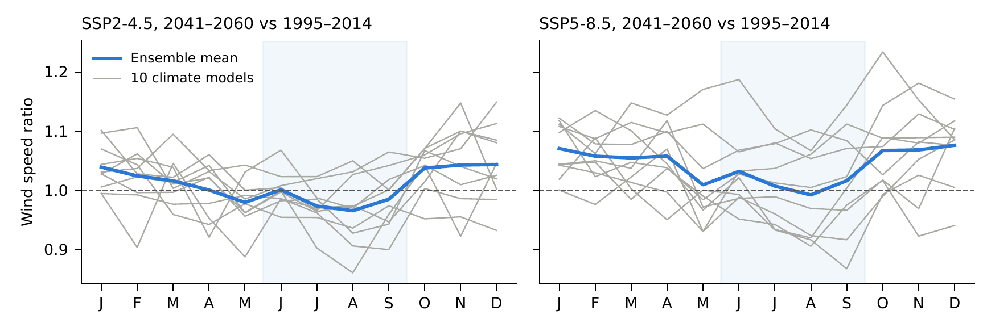
Fig. S2. Monthly wind speed change factors (2041–2060 relative to 1995–2014) at state level. Grey: ten climate models; blue: their mean; shaded: June–September. Values above 1 indicate stronger wind than in the baseline.
The linear model projects larger and more positive changes than XGBoost in every case, by 2.0 to 4.4 percentage points (Table S-VII), and reverses the sign of the temperature effect. The two models agree on present-day mean generation (32.64 and 32.90 MU d⁻¹, against an observed 32.69).
TABLE S-VII
Ensemble change in mean generation (%) for the primary (XGBoost) and sensitivity (linear) models; brackets: 10th and 90th percentiles across climate models.
Case | XGBoost | Linear | Linear, temperature only
SSP2-4.5 2030 | −0.3 [−3.7, 3.1] | 1.7 [−1.7, 4.4] | 0.54
SSP2-4.5 2050 | −1.7 [−7.4, 4.9] | 1.2 [−4.6, 7.5] | 1.12
SSP5-8.5 2030 | 2.3 [−2.4, 9.9] | 4.8 [−0.2, 14.2] | 0.58
SSP5-8.5 2050 | 2.7 [−6.7, 11.8] | 7.1 [−3.8, 16.5] | 1.54

S7. Ramps and Extreme Days
On the holdout there are 23 real one-day ramps (11 up-ramps and 12 down-ramps; median size 26 MU d⁻¹, largest 64 MU d⁻¹) and 26 real ramps over two and over three days. Ramps are a feature of the windy season. Over the whole record the share of days with a one-day ramp is zero in January and February, 1–3% in March, April, November and December, and 11–23% from May to October, with a peak of 22.6% in August (Table S-VIII).
Persistence, by construction, never flags a ramp, and its error on ramp days is 4.3 to 4.5 times that on other days (30.7 against 7.1 MU d⁻¹ at one day). The learning models do flag ramps (Table III of the main paper, Fig. S4), and they get the direction right: on every real ramp at one to three days the forecast change had the correct sign (96–100% for the same-day model). They detect only part of the events, however. At one day the hit rates are 17% (linear), 30% (Random Forest) and 22% (XGBoost), with false-alarm ratios of 33–53%; at three days they rise to 58–65% with false-alarm ratios of 21–29%. The weather-only models flag 39–43% of same-day ramps, at higher false-alarm ratios (58–65%). For every learning model the error on ramp days is 1.3 to 3.5 times the error on other days, so the headline RMSE understates the error on the days that matter most to an operator.
A plausible reading, consistent with the feature importance in Section IV-A of the main paper (the first lag carries 0.81 of the one-day forest), is that the one-day models lean on yesterday’s generation and so under-react to a jump in the same-day wind, whereas the larger two- and three-day changes are dominated by the weather term. We did not test this directly. With only 23–26 events per cell a hit rate carries an uncertainty of roughly ±18 percentage points (95% Wilson interval for 7 hits in 23 events), so the differences between the three learning models are not significant. The robust findings are that persistence is blind to ramps and that all learning models leave most one-day ramps unanticipated.
The same pattern holds for very low and very high days (Tables S-VIII and S-IX). The weather-driven models flag 50–79% of the 24 low days, with false-alarm ratios of 47–88% (the linear model is the worst), and 44–77% of the 43 high days with false-alarm ratios of 7–23%. Persistence flags 21–33% of low days and 56–72% of high days, with 28–44% false alarms on the high days.
TABLE S-VIII
Real one-day ramps by calendar month over the whole record (threshold 20.3 MU d⁻¹).
Month | Days | Up-ramps | Down-ramps | Share of days (%)
Jan | 155 | 0 | 0 | 0.0
Feb | 137 | 0 | 0 | 0.0
Mar | 145 | 2 | 0 | 1.4
Apr | 140 | 1 | 1 | 1.4
May | 122 | 10 | 10 | 16.4
Jun | 143 | 13 | 10 | 16.1
Jul | 153 | 11 | 7 | 11.8
Aug | 155 | 17 | 18 | 22.6
Sep | 148 | 14 | 11 | 16.9
Oct | 152 | 6 | 11 | 11.2
Nov | 150 | 2 | 1 | 2.0
Dec | 153 | 3 | 2 | 3.3
TABLE S-IX
Detection of low-generation days (below 3.1 MU d⁻¹, 24 real days) and high-generation days (above 85.2 MU d⁻¹, 43 real days) on the holdout. POD hit rate and FAR false-alarm ratio, both in %.
Horizon | Model | Low POD | Low FAR | High POD | High FAR
0 (weather only) | Climatology (ref.) | 0 | – | 0 | –
 | Linear | 54 | 88 | 44 | 10
 | Random Forest | 67 | 59 | 67 | 15
 | XGBoost | 79 | 54 | 60 | 10
1 day | Persistence (ref.) | 33 | 67 | 72 | 28
 | Linear | 54 | 82 | 67 | 12
 | Random Forest | 71 | 54 | 74 | 16
 | XGBoost | 67 | 60 | 77 | 13
2 days | Persistence (ref.) | 29 | 71 | 67 | 33
 | Linear | 50 | 86 | 65 | 7
 | Random Forest | 67 | 59 | 74 | 11
 | XGBoost | 54 | 68 | 72 | 14
3 days | Persistence (ref.) | 21 | 79 | 56 | 44
 | Linear | 54 | 87 | 49 | 13
 | Random Forest | 67 | 59 | 72 | 11
 | XGBoost | 71 | 47 | 63 | 23
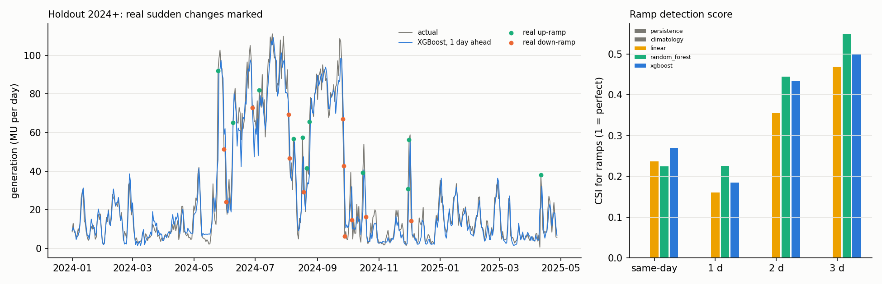
Fig. S4. Sudden changes on the holdout. Left: observed and one-day-ahead XGBoost generation, with the real up-ramps (green) and down-ramps (orange) marked; ramps occur almost only in the windy season. Right: critical success index for ramp detection by model and horizon (persistence and climatology score zero by construction).
Fig. S5 shows the extreme-day results for the ten climate models, and Table S-X repeats the main extreme-day analysis with the linear weather-to-power model.
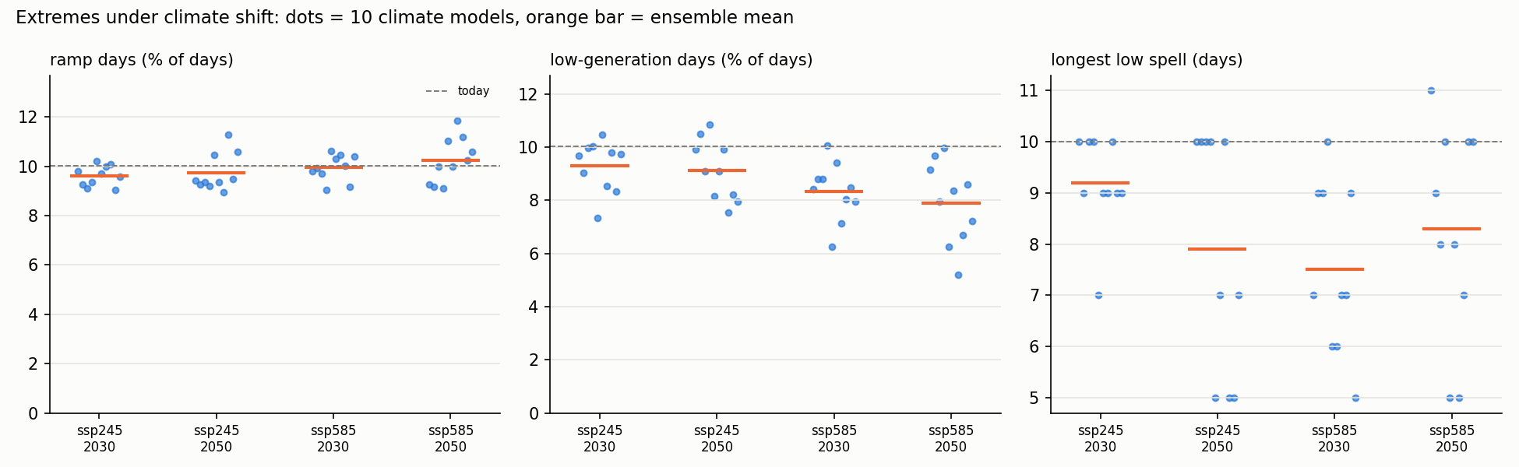
Fig. S5. Extremes under climate shift. Dots: ten climate models; orange bar: ensemble mean; dashed line: today’s value. Ramp days are essentially unchanged, while low-generation days and the longest low spell decline on average; the daily-output check (Section IV-H of the main paper) shows that the low-day result differs between models.
TABLE S-X
As Table IV of the main paper with the linear weather-to-power model.
Metric | SSP2-4.5, 2030 | SSP2-4.5, 2050 | SSP5-8.5, 2030 | SSP5-8.5, 2050
Ramp days (%) | 10.7 9.9, 11.1 | 10.4 9.5, 11.6 | 11.0 10.2, 12.1 | 11.4 9.5, 12.7
of which up (%) | 5.5 5.2, 5.9 | 5.5 5.0, 6.0 | 5.7 5.3, 6.2 | 5.9 5.2, 6.6
of which down (%) | 5.1 4.8, 5.4 | 4.9 4.4, 5.6 | 5.3 4.8, 5.9 | 5.4 4.4, 6.1
Low days (%) | 9.0 8.0, 9.9 | 8.7 7.9, 9.6 | 8.5 7.8, 9.3 | 7.6 6.6, 8.8
High days (%) | 10.1 8.3, 11.9 | 9.6 7.3, 12.1 | 11.2 8.8, 14.3 | 11.8 7.5, 16.3
Longest low spell (days) | 10.0 10.0, 10.0 | 10.0 10.0, 10.0 | 10.0 10.0, 10.0 | 10.0 10.0, 10.0
Low spells ≥ 5 days per year | 1.62 1.40, 1.82 | 1.64 1.38, 1.82 | 1.44 1.18, 1.62 | 1.30 0.98, 1.64

S8. Robustness Checks
Section III-H of the main paper trains the models on observed weather and tests them with the target-day weather degraded by random errors. The advantage over the reference shrinks quickly (Table S-XI, Fig. 3 of the main paper). The one-day models lose their advantage over persistence at a wind-speed error of about 16% (Random Forest) and 18% (XGBoost); at 20% error their RMSE is 10.1–10.9 MU d⁻¹ against 9.62 for persistence. The two- and three-day models and the weather-only model hold out longer, with crossovers at 23–25%, 30–31% and 31–32%. At 30% error the one- and two-day RMSE (12.3–13.4 and 15.8–17.1) are worse than their persistence references (9.62 and 14.09), and the three-day RMSE (17.1–17.5) equals persistence (17.33). The skill figures of Table I of the main paper therefore hold only for accurate weather input, which is the main caveat on the operational claims.
Noise-aware training largely removes this fragility. At 30% wind error the one-, two- and three-day XGBoost RMSE falls to 8.9, 12.3 and 13.9 MU d⁻¹, all below persistence, and the weather-only model reaches 14.7 against 17.9 for climatology; the one-day model stays ahead of persistence up to about 45% error. The price is a loss of accuracy when the weather is perfect (one-day RMSE 7.26 against 6.38; weather-only 9.27 against 7.03), so the choice of training depends on how good the weather forecast is expected to be.
TABLE S-XI
Holdout RMSE (MU d⁻¹) of XGBoost when the test weather is degraded by the stated wind-speed error (mean of 20 draws), for training on observed weather and for noise-aware training. Ref.: persistence (h ≥ 1) or climatology (h = 0), unaffected by weather error. Cross: wind error (%) at which the model’s RMSE reaches the reference.
Horizon | Training | 0% | 10% | 20% | 30% | 40% | 50% | Ref. | Cross
0 (weather only) | Observed-weather training | 7.03 | 9.12 | 13.23 | 17.24 | 20.36 | 22.76 | 17.90 | 32
 | Noise-aware training | 9.27 | 10.29 | 12.45 | 14.72 | 16.57 | 18.05 | 17.90 | 49
1 day | Observed-weather training | 6.38 | 7.62 | 10.10 | 12.25 | 13.87 | 15.12 | 9.62 | 18
 | Noise-aware training | 7.26 | 7.60 | 8.31 | 8.93 | 9.42 | 9.82 | 9.62 | 45
2 days | Observed-weather training | 6.92 | 8.75 | 12.41 | 15.85 | 18.53 | 20.62 | 14.09 | 25
 | Noise-aware training | 8.78 | 9.43 | 10.90 | 12.29 | 13.34 | 14.16 | 14.09 | 49
3 days | Observed-weather training | 7.11 | 9.09 | 13.17 | 17.08 | 20.15 | 22.51 | 17.33 | 31
 | Noise-aware training | 9.80 | 10.51 | 12.18 | 13.92 | 15.38 | 16.59 | 17.33 | > 50
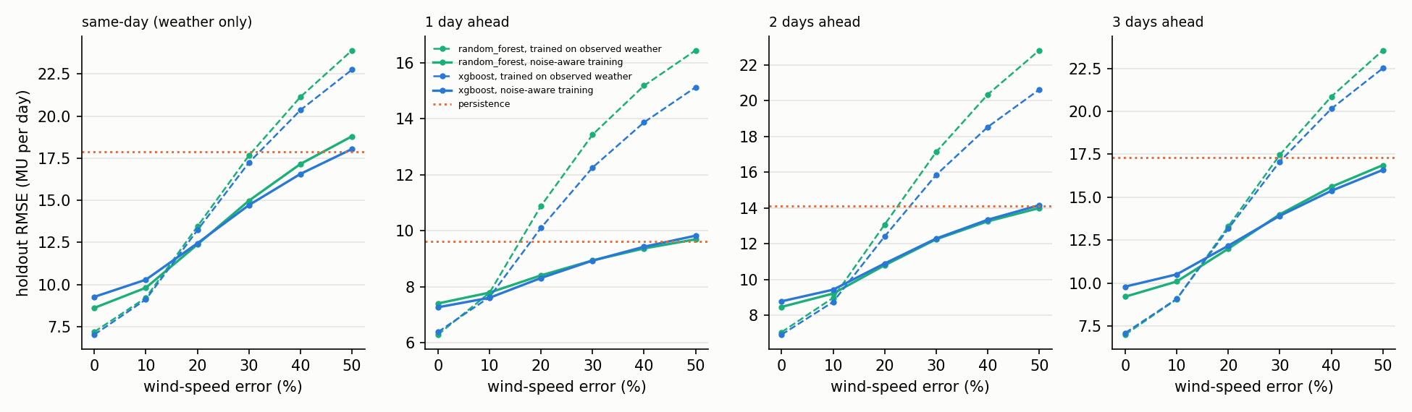
Fig. 3 of the main paper. Holdout RMSE against the error added to the test weather. Dashed: models trained on observed weather; solid: noise-aware training; dotted: reference. The dashed curves cross the reference at small errors; the solid curves stay below it.
Table S-XII compares XGBoost with the additional baselines. A power-curve model, which uses wind speed alone, is much worse (RMSE 12.65 against 7.03; DM p < 0.001), showing that temperature, humidity and season add real information. The additive spline model is no better than the cubic-in-wind linear model (8.39 against 8.36 at h = 0) and is significantly worse than XGBoost at every horizon (p = 0.003–0.03). SARIMAX with weather inputs reaches 6.80 at one day, close to the linear model and not significantly different from XGBoost (p = 0.31). The tree ensembles are therefore at least as good as every classical alternative tried and significantly better than the spline and power-curve models, but at one day the margin over SARIMAX is within noise, in line with the cautious reading of Section IV-A of the main paper.
TABLE S-XII
Holdout accuracy of additional baselines (n = 483). DM: Diebold–Mariano statistic against XGBoost with the Harvey correction; positive means the model is worse than XGBoost.
Horizon | Model | RMSE | MAE | DM vs XGBoost | p
0 (weather only) | Climatology (ref.) | 17.90 | 12.38 | 5.22 | <0.001
 | Power curve (isotonic) | 12.64 | 8.20 | 4.23 | <0.001
 | Additive splines (GAM-type) | 8.39 | 6.26 | 3.03 | 0.003
 | Linear | 8.36 | 6.31 | 3.55 | <0.001
 | Random Forest | 7.20 | 4.53 | 0.71 | 0.48
 | XGBoost | 7.03 | 4.58 | – | –
1 day | Persistence (ref.) | 9.62 | 6.33 | 6.01 | <0.001
 | SARIMAX + weather | 6.80 | 4.60 | 1.02 | 0.31
 | Additive splines (GAM-type) | 6.88 | 4.97 | 2.15 | 0.03
 | Linear | 6.80 | 5.00 | 1.84 | 0.07
 | Random Forest | 6.29 | 4.17 | −0.50 | 0.61
 | XGBoost | 6.38 | 4.23 | – | –
2 days | Persistence (ref.) | 14.09 | 9.06 | 5.25 | <0.001
 | Additive splines (GAM-type) | 7.84 | 5.80 | 2.36 | 0.02
 | Linear | 7.70 | 5.77 | 1.98 | 0.05
 | Random Forest | 7.06 | 4.55 | 0.59 | 0.55
 | XGBoost | 6.92 | 4.58 | – | –
3 days | Persistence (ref.) | 17.33 | 11.31 | 4.67 | <0.001
 | Additive splines (GAM-type) | 8.17 | 6.05 | 2.58 | 0.01
 | Linear | 8.03 | 6.05 | 2.22 | 0.03
 | Random Forest | 7.01 | 4.51 | −0.39 | 0.70
 | XGBoost | 7.11 | 4.62 | – | –
The ramp results do not depend on the 90th-percentile threshold (Table S-XIII). At the 80th percentile there are 49–64 real events per horizon, and the one-day hit rates are 45% [34–56] for Random Forest, 30% [19–40] for XGBoost and 30% [19–40] for the linear model, rising to 71–84% at three days; the three-day Random Forest reaches 84% [71–94]. At the 95th percentile only 10–14 events remain and the intervals run from zero to 0.5–0.9. In every setting persistence flags no ramp, the one-day hit rate stays at or below about 45%, and hit rates rise with horizon. What the data do not resolve is which learning model is best: the bootstrap intervals of the three overlap throughout.
TABLE S-XIII
Ramp detection by threshold percentile on the holdout: hit rate (POD, %) with 95% moving-block bootstrap interval, and critical success index (CSI). n: real ramps at the 80th/90th/95th percentile.
Horizon | Model | n | POD 80th | POD 90th | POD 95th | CSI 80th | CSI 90th | CSI 95th
0 (weather only) | Random Forest | 64/23/10 | 52 [40–64] | 39 [20–60] | 30 [0–57] | 0.37 | 0.23 | 0.17
 | XGBoost | 64/23/10 | 55 [43–66] | 43 [21–68] | 40 [13–67] | 0.41 | 0.27 | 0.25
1 day | Random Forest | 64/23/10 | 45 [34–56] | 30 [14–50] | 30 [0–58] | 0.35 | 0.23 | 0.21
 | XGBoost | 64/23/10 | 30 [19–40] | 22 [6–42] | 0 [0–0] | 0.28 | 0.19 | 0.00
2 days | Random Forest | 56/26/12 | 66 [53–78] | 62 [43–79] | 50 [17–80] | 0.54 | 0.44 | 0.38
 | XGBoost | 56/26/12 | 61 [48–73] | 50 [28–72] | 25 [0–57] | 0.55 | 0.43 | 0.23
3 days | Random Forest | 49/26/14 | 84 [71–94] | 65 [48–83] | 57 [25–86] | 0.68 | 0.55 | 0.44
 | XGBoost | 49/26/14 | 76 [62–88] | 58 [37–78] | 50 [20–83] | 0.65 | 0.50 | 0.41
Reported operational capacity rose from 9,304 MW on 31 March 2020 to 11,740 MW on 31 March 2025 (+26%) [48, 49]. On the holdout, every model under-forecasts in every half-year: the weather-only XGBoost by 4.0%, 7.4%, 10.1% of mean generation in 2024H1, 2024H2, 2025H1, and the one-day Random Forest by 1.8%, 4.3%, 4.1%. A persistent positive error is what a fleet larger than in the training years would produce, although other causes cannot be excluded. Rescaling generation to a fixed fleet (Section III-H of the main paper) lowers the holdout RMSE of the weather-only model from 7.03 to 6.35 (partly the rescaling itself) and moves every climate-shift estimate down by 1.1–2.4 percentage points (Table S-XIV): the ensemble means become −1.4%, −3.6%, +1.0% and +0.4%, no sign changes, the number of models projecting an increase stays at 30–50%, and every 10th–90th percentile range still spans zero. Fleet growth in the training record therefore inflates the projected changes by 1.1–2.4 points but does not alter the conclusion that their sign is unresolved.
TABLE S-XIV
Ensemble change in mean generation (%) with generation as recorded (primary) and rescaled to a fixed fleet; [10th, 90th percentile across 10 climate models. Capacity for March 2024 (10,603.52 MW) and March 2025 (11,739.89 MW) is taken from the MNRE reply to Lok Sabha Question 1630 (29 July 2026). ]
Case | Primary | Fleet-adjusted | Difference (points) | Models up, adjusted (%)
SSP2-4.5, 2030 | −0.3 [−3.7, 3.1] | −1.4 [−4.8, 2.3] | −1.1 | 30
SSP2-4.5, 2050 | −1.7 [−7.4, 4.9] | −3.6 [−9.7, 3.6] | −1.9 | 40
SSP5-8.5, 2030 | 2.3 [−2.4, 9.9] | 1.0 [−4.2, 9.0] | −1.2 | 50
SSP5-8.5, 2050 | 2.7 [−6.7, 11.8] | 0.4 [−9.3, 10.1] | −2.4 | 50

S9. Daily Climate-Model Output
Validation against ERA5. For the ten models we compared daily NEX-GDDP output under SSP2-4.5 for 2020–2025 (1,826 days, the period of the ERA5 record) with ERA5 at the same three points (Table S-XV). The seasonal cycle of wind is reproduced well (monthly-cycle correlation 0.86–0.93), but the level is not: the mean wind speed is 1.37–1.47 times the ERA5 value in every model, its day-to-day standard deviation 1.26–1.45 times, and the 90th percentile 1.34–1.47 times. Temperature is 1.3–2.1 °C colder and humidity 0.1–3.4 percentage points higher than ERA5. Feeding the raw NEX weather to the weather-only forecasting model would change the predicted generation by 56–65%, which is why the main analysis applies monthly change factors to the observed record and does not use the raw output. The offset is almost the same in all models, so it is a property of the product or of the reference more than of the individual models; the offset also depends on location: the model-to-ERA5 ratio of mean wind speed is about 1.34 at Muppandal–Kayathar, 1.07 at Palghat–Udumalpet and 2.16 at Theni–Cumbum (monthly state-mean ratios range from 1.07 to 1.74), and the ten models agree within about 0.1 of one another at each point, so the gap lies between the two products rather than among the models. We did not trace its origin (candidates are the height and processing of ERA5 wind and the bias-correction target of NEX-GDDP).
Daily output and variability. For all ten models and SSP5-8.5 for 2041–2060 we mapped the daily output onto the observed record by quantile delta mapping and ran it through the same weather-only model (Table S-XVI). The change in mean generation agrees with the monthly method within 1.1 percentage points in every model (for example −7.9% against −7.6% for CMCC-ESM2), so the main results are not an artefact of the monthly method. The share of ramp days stays between 9.5% and 10.9% against 10.0% today, which supports the finding that ramp frequency does not change detectably. The other extremes are less uniform. The share of low-generation days falls in nine of ten models (to between 6.4% and 11.6% across the ensemble) and rises only in EC-Earth3 (11.6%); high-generation days range from 7.4% to 18.0%, above 10% in five models and below it in five; the longest low spell lengthens in eight models and shortens in two; and spells of five or more low days per year fall in eight models and rise in two (ACCESS-CM2 and EC-Earth3). The direction of the low-generation result is therefore shared by most models, but its size and the behaviour of spells differ widely. With one scenario and one 20-year window these are indications of spread and not estimates, and the claim that low days become rarer should be read as a tendency of the ensemble, not a result for each model.
TABLE S-XV
NEX-GDDP-CMIP6 (SSP2-4.5) against ERA5 at the three wind-belt points, 2020–2025 (1,826 days), state mean. Ratios are model over ERA5; biases are model minus ERA5; cycle corr.: correlation of the twelve monthly means of wind speed; last column: difference in mean predicted generation when raw NEX weather replaces ERA5 weather in the weather-only XGBoost model.
Climate model | Wind mean ratio | Wind SD ratio | Cycle corr. | Wind P90 ratio | Temp. bias (°C) | Humidity bias (pts) | Predicted gen. diff. (%)
ACCESS-CM2 | 1.42 | 1.38 | 0.90 | 1.40 | −1.55 | 2.13 | 61.8
CMCC-ESM2 | 1.45 | 1.31 | 0.90 | 1.38 | −1.67 | 0.11 | 64.7
CanESM5 | 1.41 | 1.26 | 0.93 | 1.34 | −1.26 | 1.51 | 58.4
EC-Earth3 | 1.40 | 1.41 | 0.93 | 1.38 | −1.76 | 3.40 | 57.1
GFDL-ESM4 | 1.43 | 1.43 | 0.87 | 1.43 | −1.81 | 1.96 | 59.5
IPSL-CM6A-LR | 1.42 | 1.42 | 0.86 | 1.40 | −1.42 | 2.11 | 58.6
MIROC6 | 1.47 | 1.45 | 0.88 | 1.47 | −2.01 | 2.02 | 64.2
MPI-ESM1-2-HR | 1.45 | 1.44 | 0.88 | 1.43 | −1.63 | 2.04 | 64.1
MRI-ESM2-0 | 1.37 | 1.30 | 0.93 | 1.34 | −2.09 | 3.05 | 56.0
NorESM2-MM | 1.41 | 1.36 | 0.88 | 1.38 | −1.74 | 3.15 | 57.7
TABLE S-XVI
Daily output (quantile delta mapping) against the monthly delta-change method for ten models, SSP5-8.5, 2041–2060. Change in mean generation (%), then historical → future values of the extreme-day metrics (weather-only XGBoost; thresholds fixed on the observed baseline; historical share is 10.0% by construction).
Climate model | Mean change: delta / daily (%) | Ramp days (%) | Low days (%) | High days (%) | Longest low spell (days) | Spells ≥ 5 days per year
ACCESS-CM2 | −6.5 / −5.8 | 10.0 → 10.0 | 10.0 → 9.6 | 10.0 → 8.2 | 12.0 → 13.0 | 1.65 → 2.00
CMCC-ESM2 | −7.9 / −7.6 | 10.0 → 10.0 | 10.0 → 9.7 | 10.0 → 7.4 | 10.0 → 16.0 | 2.05 → 1.55
CanESM5 | −1.0 / −0.5 | 10.0 → 10.9 | 10.0 → 7.8 | 10.0 → 9.0 | 15.0 → 17.0 | 1.90 → 1.75
EC-Earth3 | −6.6 / −6.2 | 10.0 → 9.5 | 10.0 → 11.6 | 10.0 → 8.2 | 21.0 → 34.0 | 1.60 → 2.30
GFDL-ESM4 | 5.7 / 4.9 | 10.0 → 10.4 | 10.0 → 6.4 | 10.0 → 12.2 | 16.0 → 9.0 | 1.95 → 0.90
IPSL-CM6A-LR | 4.6 / 4.7 | 10.0 → 9.7 | 10.0 → 9.0 | 10.0 → 12.8 | 16.0 → 14.0 | 2.15 → 1.75
MIROC6 | 18.8 / 19.9 | 10.0 → 9.9 | 10.0 → 6.4 | 10.0 → 18.0 | 15.0 → 16.0 | 1.90 → 1.15
MPI-ESM1-2-HR | 11.1 / 11.4 | 10.0 → 10.9 | 10.0 → 7.5 | 10.0 → 15.2 | 20.0 → 24.0 | 2.30 → 1.75
MRI-ESM2-0 | −1.2 / −1.3 | 10.0 → 10.3 | 10.0 → 8.4 | 10.0 → 8.0 | 31.0 → 33.0 | 1.65 → 1.60
NorESM2-MM | 10.3 / 10.7 | 10.0 → 9.7 | 10.0 → 8.5 | 10.0 → 15.2 | 14.0 → 24.0 | 2.25 → 1.60

S10. Real Forecast Weather
Table S-XVII gives the error of the ECMWF forecast weather against ERA5 and Table V of the main paper the holdout RMSE (MU d−1) of the forecasting models fed that forecast. The reference is persistence at h ≥ 1 and climatology at h = 0. “Observed weather” and “raw forecast” are scored on all holdout days with a complete forecast (420–423 days); “recalibrated” applies a wind multiplier and temperature and humidity shifts fitted on 1 January–30 June 2024 and is scored on the 301 later days, for which the reference RMSE is given in the reference row. p is the Diebold–Mariano test against the reference.
TABLE S-XVII
ECMWF IFS forecast weather against ERA5 at the three wind-belt points, holdout days with a complete forecast. Wind ratio is forecast over ERA5; biases are forecast minus ERA5; wind RMSE (%) is relative to the mean observed wind.
Lead (days) | n | Wind ratio | Wind RMSE (m/s) | Wind RMSE (%) | Wind corr. | Temp. bias (°C) | Hum. bias (pts)
1 | 426 | 1.21 | 0.66 | 28.6 | 0.94 | −1.14 | −0.53
2 | 425 | 1.21 | 0.68 | 29.1 | 0.94 | −1.08 | −0.74
3 | 423 | 1.23 | 0.78 | 33.6 | 0.91 | −1.11 | −0.48

S11. Database Performance
Every dashboard query has a median latency under 17 ms (Table S-XVIII; 30 timed runs after 3 warm-ups, PostgreSQL 16.6 and TimescaleDB 2.17.2 on an Apple-silicon laptop). The materialized feature view is 1.54 ms faster than the equivalent live join (5.39 against 6.93 ms). The slowest query (16.25 ms) derives monthly change factors through a self-join at query time. At five years of daily data the benefit of hypertable partitioning cannot be demonstrated; the benchmark shows only that the design supports interactive use at this scale.
TABLE S-XVIII
Query latency (ms).
Query | Median | p95
Daily features, materialized view (1,826 rows) | 5.39 | 7.66
Same table computed live from raw tables | 6.93 | 8.83
One-year slice of the view | 2.48 | 3.07
Weekly features (materialized view) | 1.39 | 1.99
Monthly climatology | 1.53 | 1.93
Raw weather, one station, one year (hypertable) | 1.46 | 2.17
Change factors: monthly, all models, one case | 16.25 | 18.85
Change factors: annual, all cases | 5.84 | 6.78
Table row counts | 1.13 | 1.72

S12. Decision-Support Dashboard
The Streamlit dashboard (Fig. S6) reads all results from the database and serves three audiences. An overview gives the three headline answers with a confidence rating. The public view offers a month picker and the 2030 and 2050 outlook, including what the results cannot show. The researcher view gives per-model results, driver splits, monthly factors, forecast skill and CSV downloads. The planner view shows forecasts against observed generation with an empirical 80% error band, a monthly planning calendar and scenario risk, and states that its forecasts are back-tests using observed weather. The researcher view also has a section on sudden changes and extreme days: the share of real ramps each model flags by horizon, the calendar of ramps, and the change in the frequency of ramp, low and high days under each case with the ten individual climate models shown, a switch between the XGBoost and linear weather-to-power models, and the ten-model check with daily climate-model output. Unlike the other pages, this section reads the committed result files of Sections IV-D, IV-E and IV-H of the main paper and not the database, and its text is generated from those numbers.
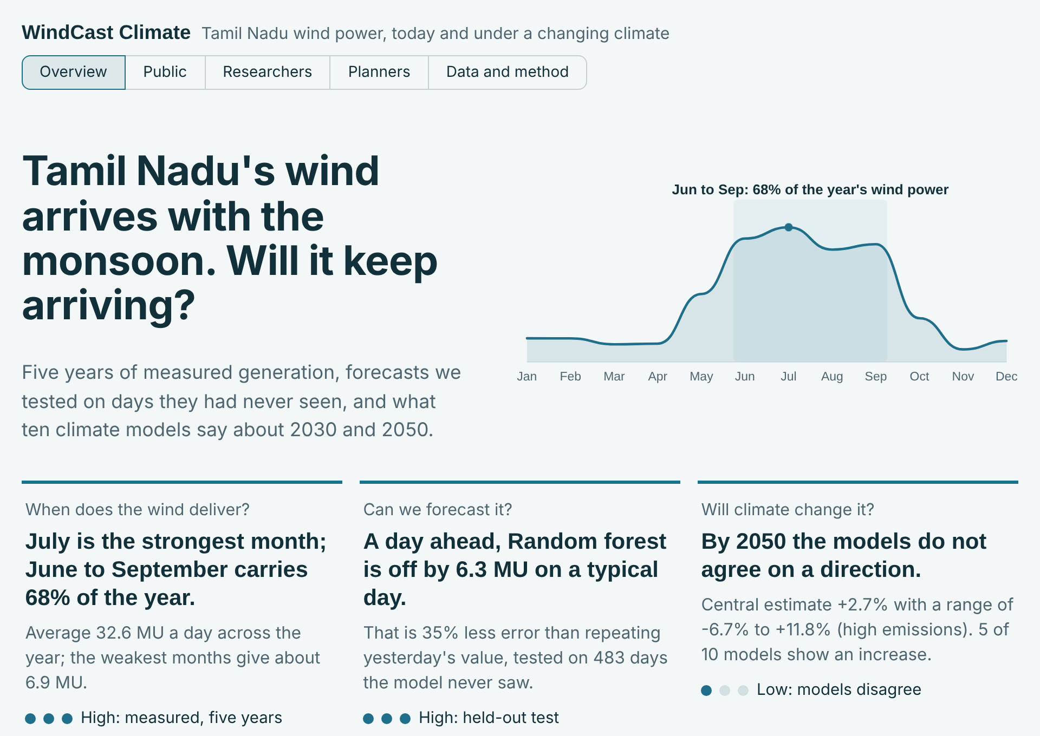
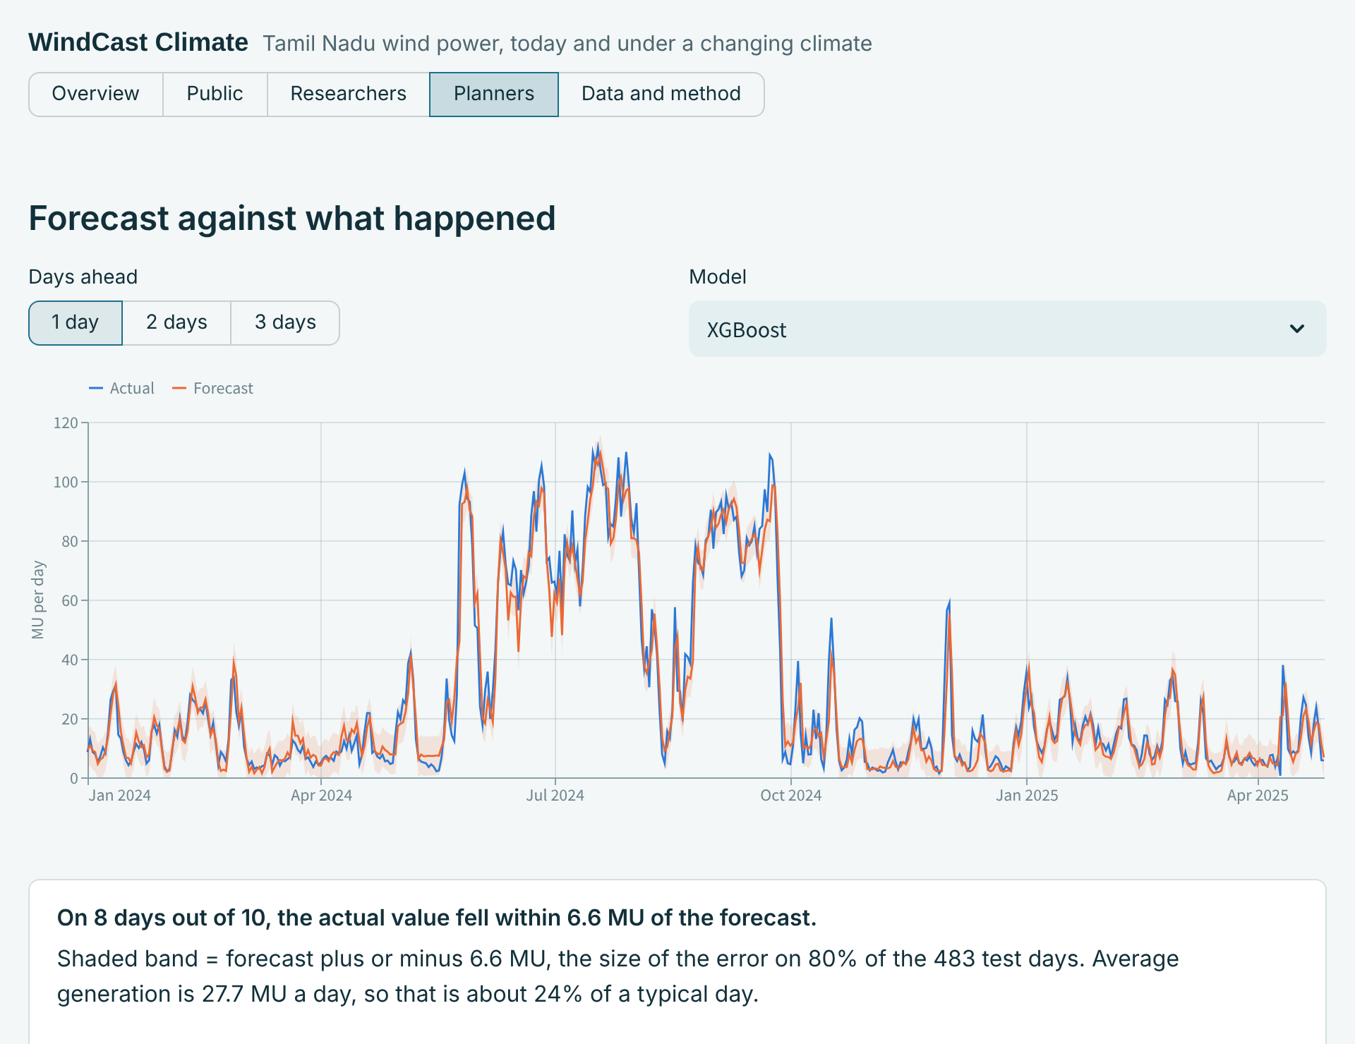
Fig. S6. Dashboard reading live from the database. Top: overview with headline answers and confidence. Bottom: planner view with one-day-ahead forecasts against observed generation and the empirical 80% error band.

