Var Hoisting & Functional scope:  
if the variable is declared with multiple places using VAR it is moved to top and removed duplicate declarations and we can use var before it’s declaration like consider it is like functional scope.

Const: Variable can be declared at the time of it’s declaration and can not be changed however properties inside the objects can be changed.

Arrow Function:  
Arrow Functions provide a short and concise syntax for writing function, they also simplify the behavior of this keyword in javascript.

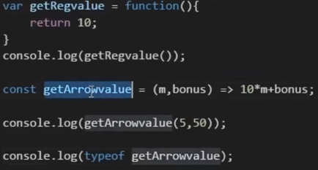 //function

Default function parameters:  
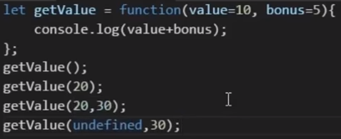

Rest Operator:  
Rest parameter represents indefinite number of arguments as an array.

Spread Operator:  
~Rest Operator. Takes array of object and splits into array elements   
Rest operator is specified at function declaration where as Spread Operator is specified during function calling.   
 //Rest  
 //Spread

Object Literals:  
ES5 ES6  
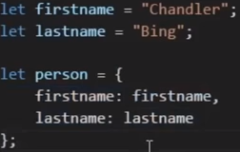=>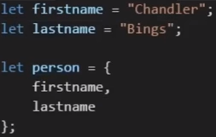

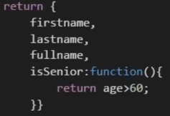=>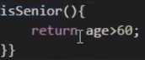

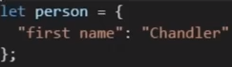 Property names can have spaces.  
we can use variable names to substituting property names.  
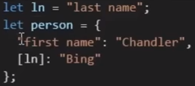

Destructuring:

Array:  
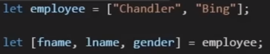 1:1 mapping, gender is undefined.

  
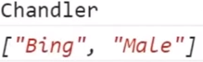

Objects:  
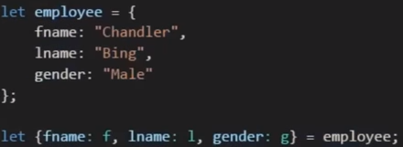

**String Templates:**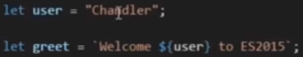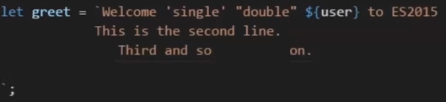

**For Loops:**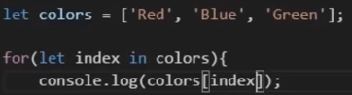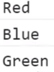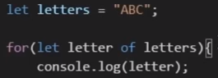=>A B C

**Class:**Class is a special function, classes unlike functions not hoisted.  
 //error  
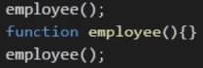 //no errorclass Person{}  
let p=new Person();  
console.log(typeof Person); //function  
Adding a method to class is same as adding method to prototype.  
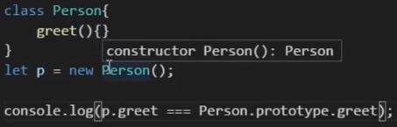  
**Class Body and Methods:**  
A class body can contains methods and not properties.  
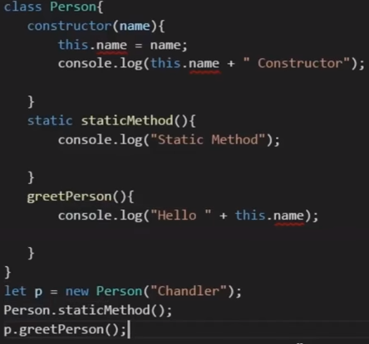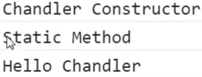

**Class Inheritance:**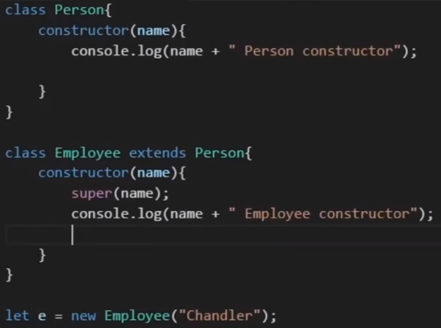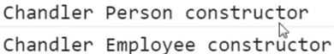

super(name):- it invokes parent constructor first followed by child constructor.  
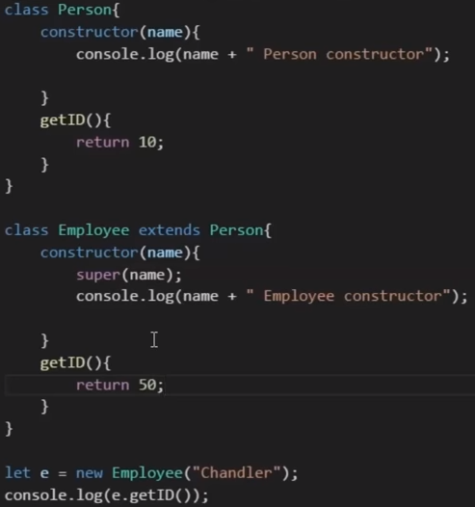 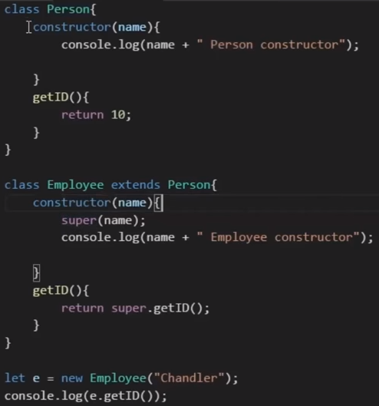  
//50 //10  
if child class doesn’t contain method then it will call parent class’s method otherwise it will call child class method only.  
By using super keyword, we can call parent class method using child class instance.

**Modules:**Keeping related pieces of code together and have separation of concerns.  
By using import/export, we can use Modules in entire application.  
**Named Exports:**  
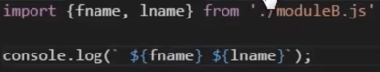  
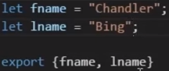  
import is readonly and cannot be changed however object properties can be changed.

**Default export: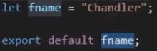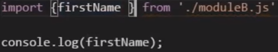 or** 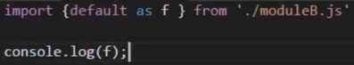

**Set:**Set helps us to manage list of values (Key-value). Set ignores duplicate values.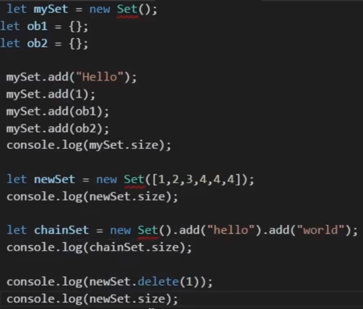 **output:**4  
4  
2  
true  
3  
console.log(newSet.has(5)); //false

**Maps:**When we need some sort of association between information and values, we need Maps.  
Map is an ordered list of key value pairs  
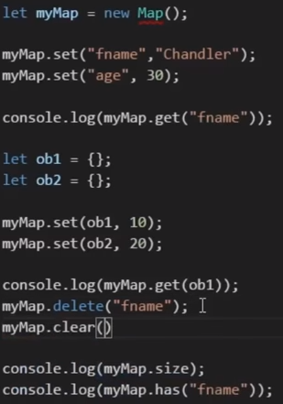  
output:  
Chandler  
10  
3  
false  
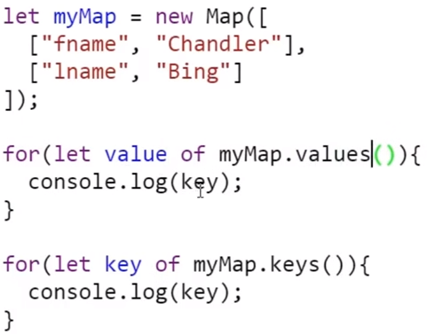  
output:

Chandler  
Bing  
fname  
lname

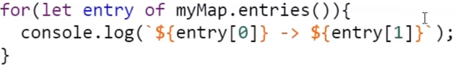  
output:  
fname - > Chandler  
lname - > Bing  
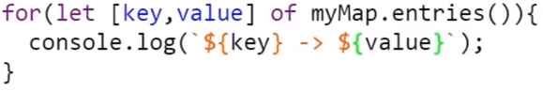  
output:  
fname - > Chandler  
lname - > Bing

**Generator:**Generator is a special function, capable of pausing and resuming execution with the help of yield keyword.  
  
