### **Get Started - Onboard With Calimatic Coach**

Get Started with your Account setup and one-on-one training from Calimatic Coach.



Written By Ivan Karmer

Updated 2 years ago

Calimatic provides the following services to get started with the platform:

* **Free Calimatic Coach Program -** An online meeting with your personal Calimatic Coach to determine your needs.
* **Platform Configuration -** Web-session with your Coach to get step by step walkthrough of the Platform and configuration to get you started with a customized platform.
* **Billing & ePayments Configuration -** Setting up Billing & ePayments and configuring the payment system to your requirements.
* **Free Training to Franchise/Center Admin -** Free of charge 1-hour training to the Franchise/Center Admin on the management, tools, and frameworks of the platform.
* **Ongoing support -** Customer Support team to provide any type of assistance about the platform.

At Calimatic, we ensure that you will:

1. Get a customized platform for your needs
2. Use the platform effectively
3. Have innovative tools on-hand
4. Get assistance from the Support Team

Book your one-on-one session [here](https://calendly.com/calimatic/60min).

Contact us at hello@calimaticedtech.com for any questions.

### **Quick Start For Admins**

First steps after you subscribe to Calimatic EdTech (Jump Start)



Written By Ivan Karmer

Updated one year ago

This article covers the steps to quickly get started with the Platform.

The user with which you subscribe to Calimatic (Free or Paid) will be the Master Admin.

Once you login as Master Admin, you will be landed in the Dashboard/Home Page (after you activate your account and accept the End User License Agreement).

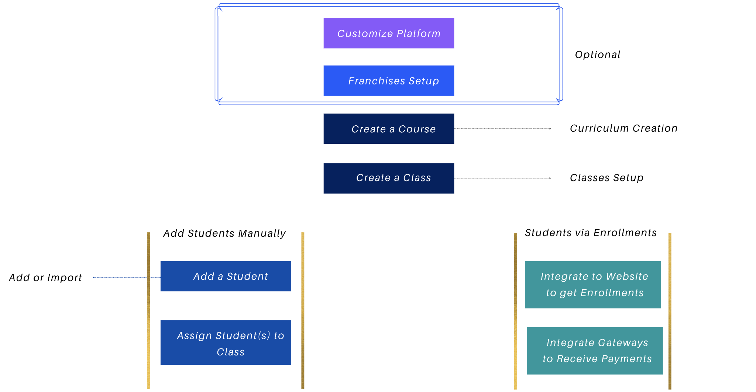

***Customization - If you want to Customize the Platform to meet your branding & institute needs*,** the high level Platform customizations are listed here - [Customizing the Platform](https://help-lcm.calimatic.com/article?categoryId=52&solutionId=149)

***Franchise or Center Management***

***If you want to use the Platform for multiple Centers or Franchises separately*,** you have the ability to create separate accounts for each Center or Franchise.

* The Platform accounts structure are explained here - [Platform Accounts Structure](https://help-lcm.calimatic.com/article?categoryId=3&solutionId=159)
* Follow these steps to create a new Center or Franchise account - [Franchise or Center Creation](https://help-lcm.calimatic.com/article?categoryId=6&solutionId=102)
* Follow below steps for each Franchise or Center as needed. If you have Franchises or Centers in multiple countries, please contact us to discuss the Payment Gateways & other details regarding the setup.

***Curriculum Creation***

**Create a Course:**

Click on the Courses menu. You have the ability to create and manage Courses and Curriculum or learning content in 2 different views -

1. Clicking on Course Player submenu will navigate to the Course Player page (OR)
2. Clicking on Central submenu will navigate to the Central page  
     
   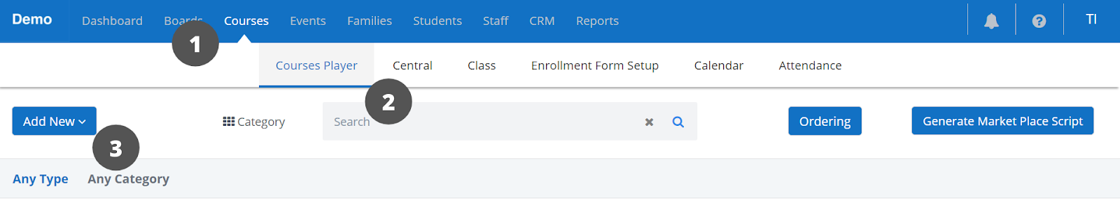

You can choose any one of these ways based on your convenience.

Clicking on the "Add New" button and selecting the "Course" option will open the Course popup.

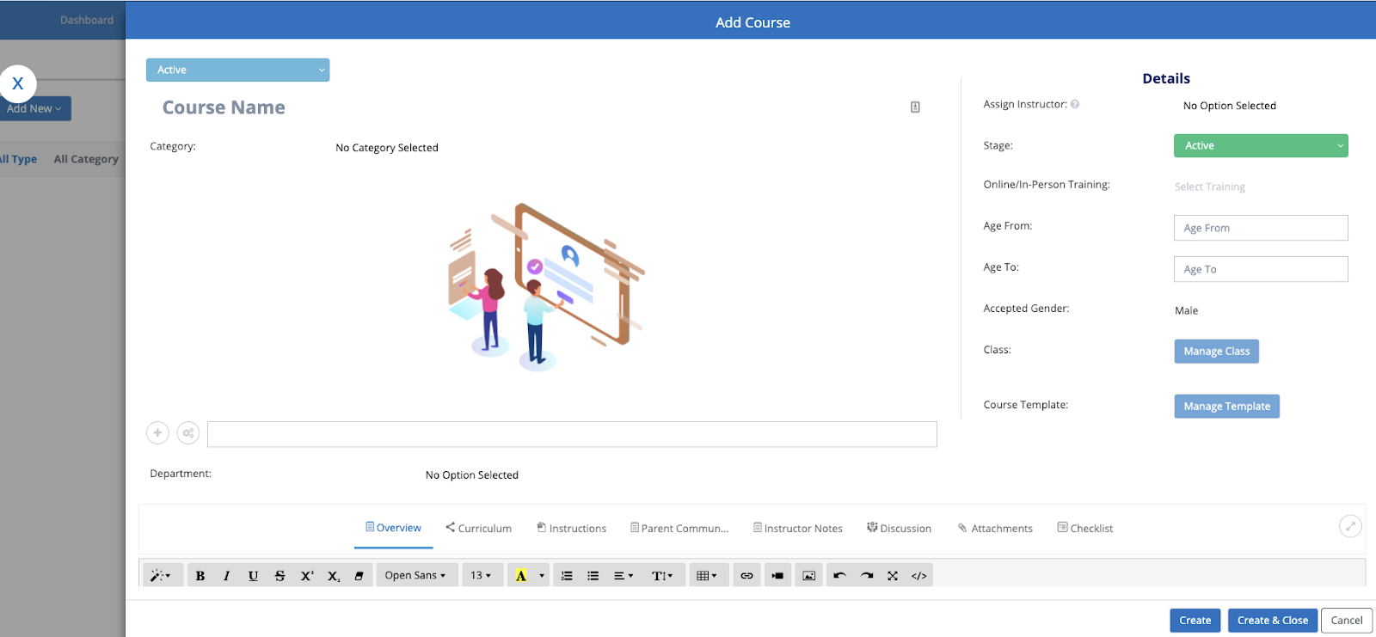

Enter the required information for the Course as needed.

Click on the Create button and this will create the Course and keep the popup open.

***Class Creation***

You have the ability to create classes for a Course or its Level in the Course popup or in "Classes Overview" page. Refer here for managing Classes in ["Classes Overview"](https://help-lcm.calimatic.com/article?categoryId=10&solutionId=177)

**Create a Class within a Course:**

Click on the "Manage Class" popup. In the popup, click on the "Add New" button to create a new Class.

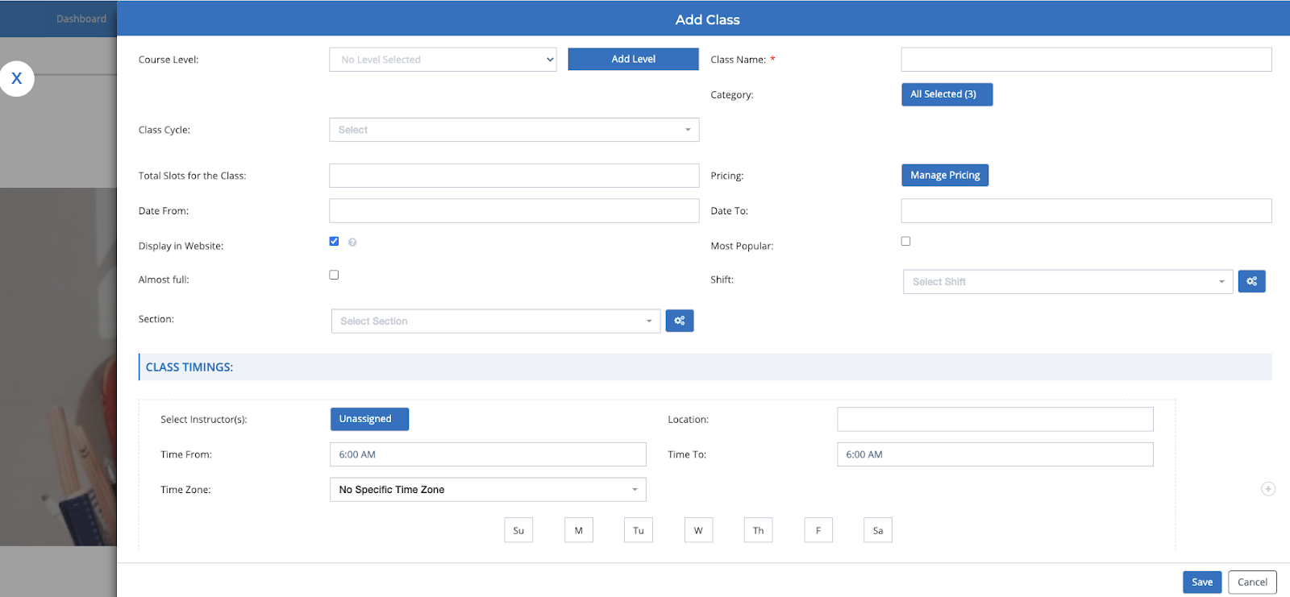

Enter required information for Class and click on Manage Pricing to enter Pricing information.

Click on the Save buttons for Pricing and Class popups to save the info.

***Setup Payment Gateway to receive Payments for the enrollments***

Refer here to setup Stripe to receive Payments for US & International Clients - [Stripe Payment Setup](https://help-lcm.calimatic.com/article?categoryId=3&solutionId=158)

Refer here to setup RazorPay to receive Payments for India Clients - [Razor Payment Setup](https://help-lcm.calimatic.com/article?categoryId=3&solutionId=163)

Refer here to setup Plaid to receive Bank Account Payments for US Clients - [Plaid Payment Setup](https://help-lcm.calimatic.com/article?categoryId=3&solutionId=162)

***Integrate the enrollment page to your website or directly use the enrollment page***

Click on the Courses menu and click on the Class submenu. Click on the "Class Setup" menu on the left side section.

Click on the "Generate Embedded Script" to integrate to your website. Copy the code from the popup and add in your website code.

Add a Student and assign him to a Class (if not Enrolled via enrollment page)?

Click on the Students menu and click on "Student Info" submenu.

Click on the “Add Student" button to add a new Student. In the Overview tab, you have the ability to add Student's Information, add one or more Contacts of a Student.

Click on Create button to create the Student. In the Student popup, click on the Class tab and click on "Add to a Class" button.

Click on "Add to Class" button for the Class you need to add the Student.

**To Add Bulk Students**, refer here - [Import Students & Parents/Contacts](https://help-lcm.calimatic.com/article?categoryId=3&solutionId=181)

***Add a Instructor or Staff***

Click on the Staff menu and click on the Staff Info submenu.

Click on Add Staff and fill the required information in the Staff Info popup. Click on the "Create & Close" button.

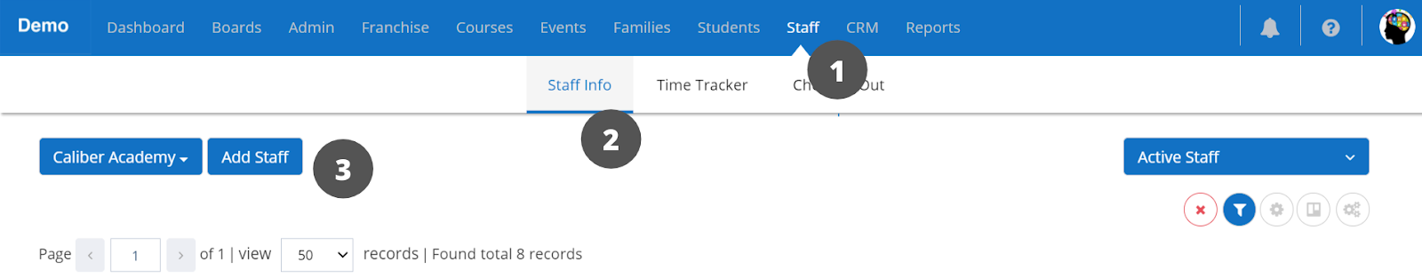

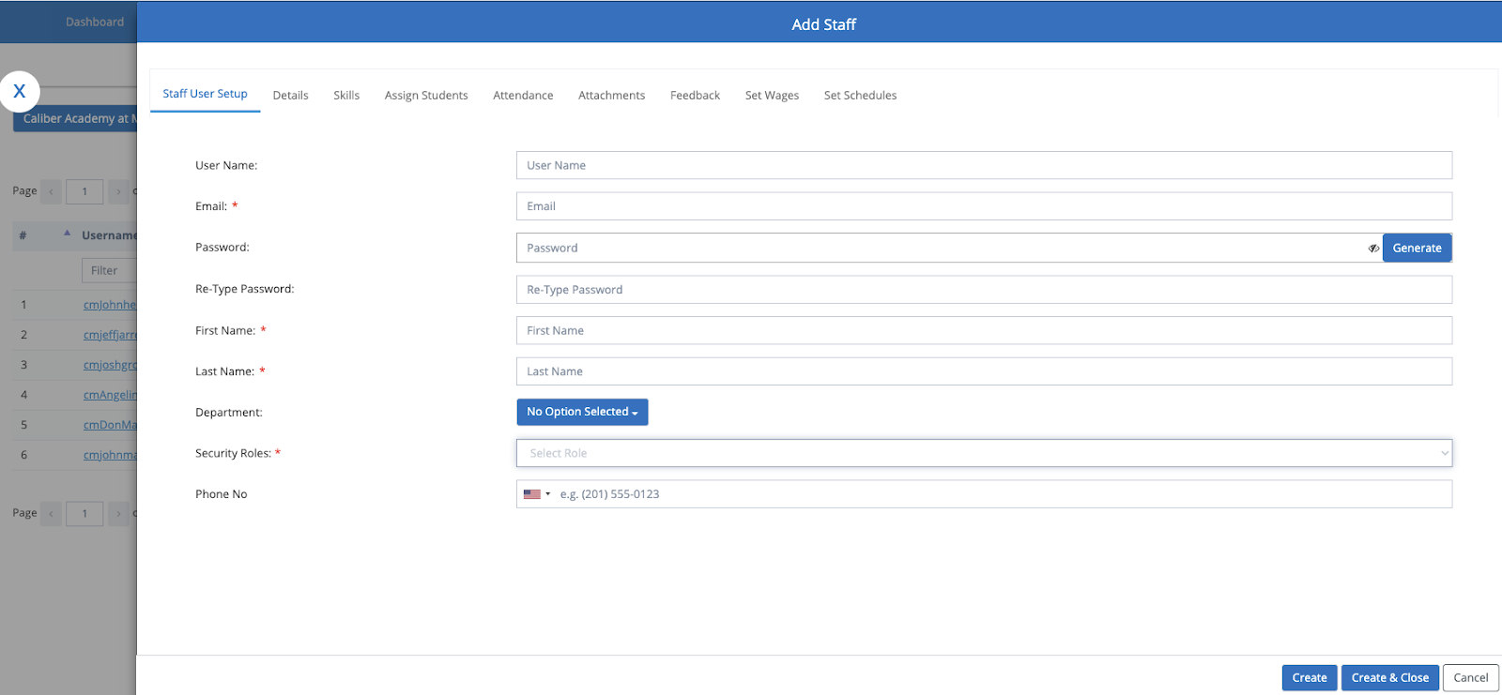

**To Add Bulk Staff**, refer here - [Import Staff](https://help-lcm.calimatic.com/article?categoryId=3&solutionId=182)