**TITLE**: **Develop a fully responsive online education platform**

**My online Edu-Platform Name is – JOURNIFY_ED**

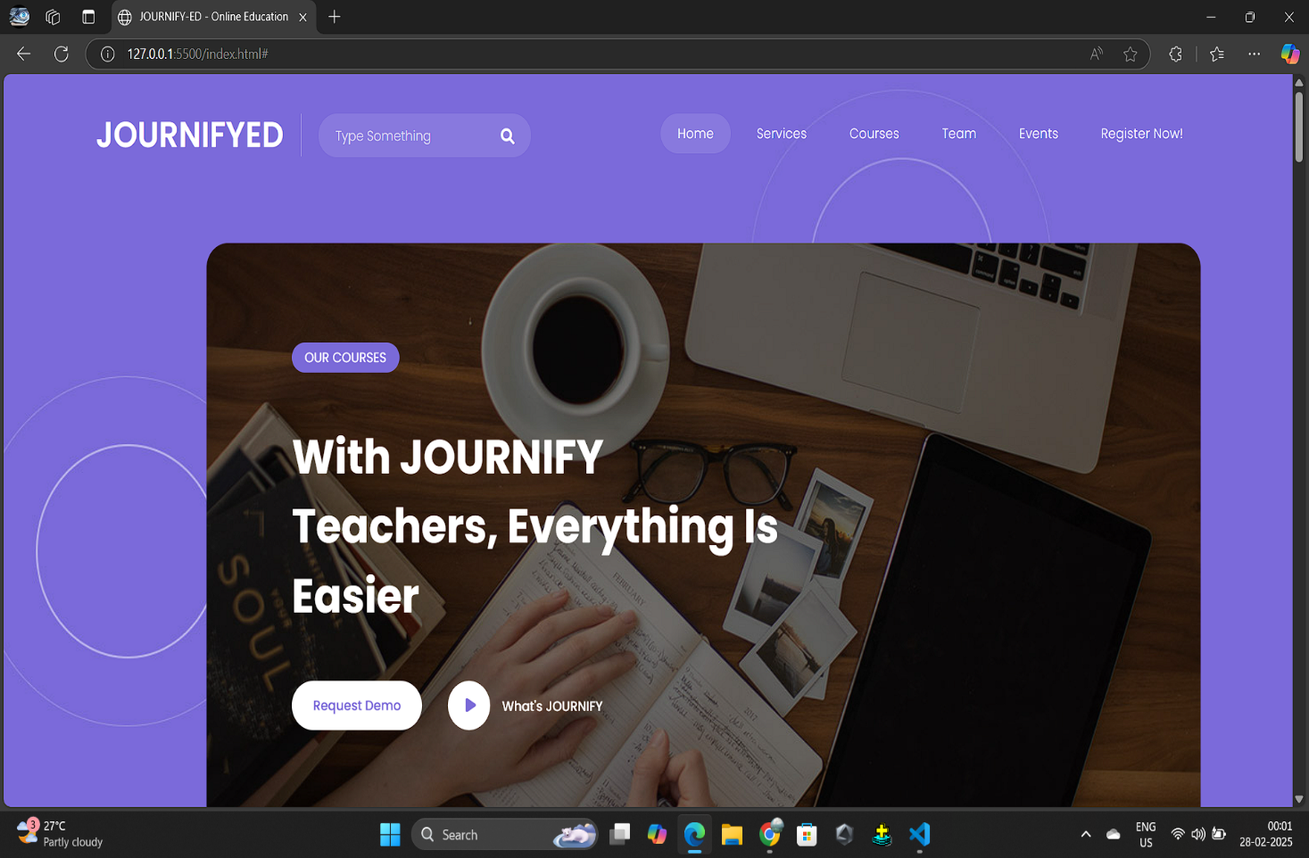

**HOME PAGE**

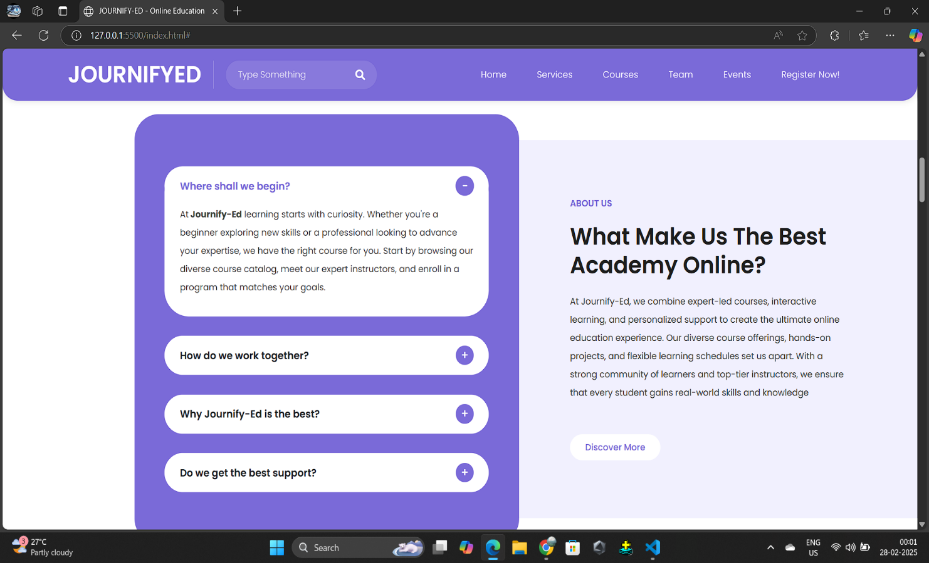

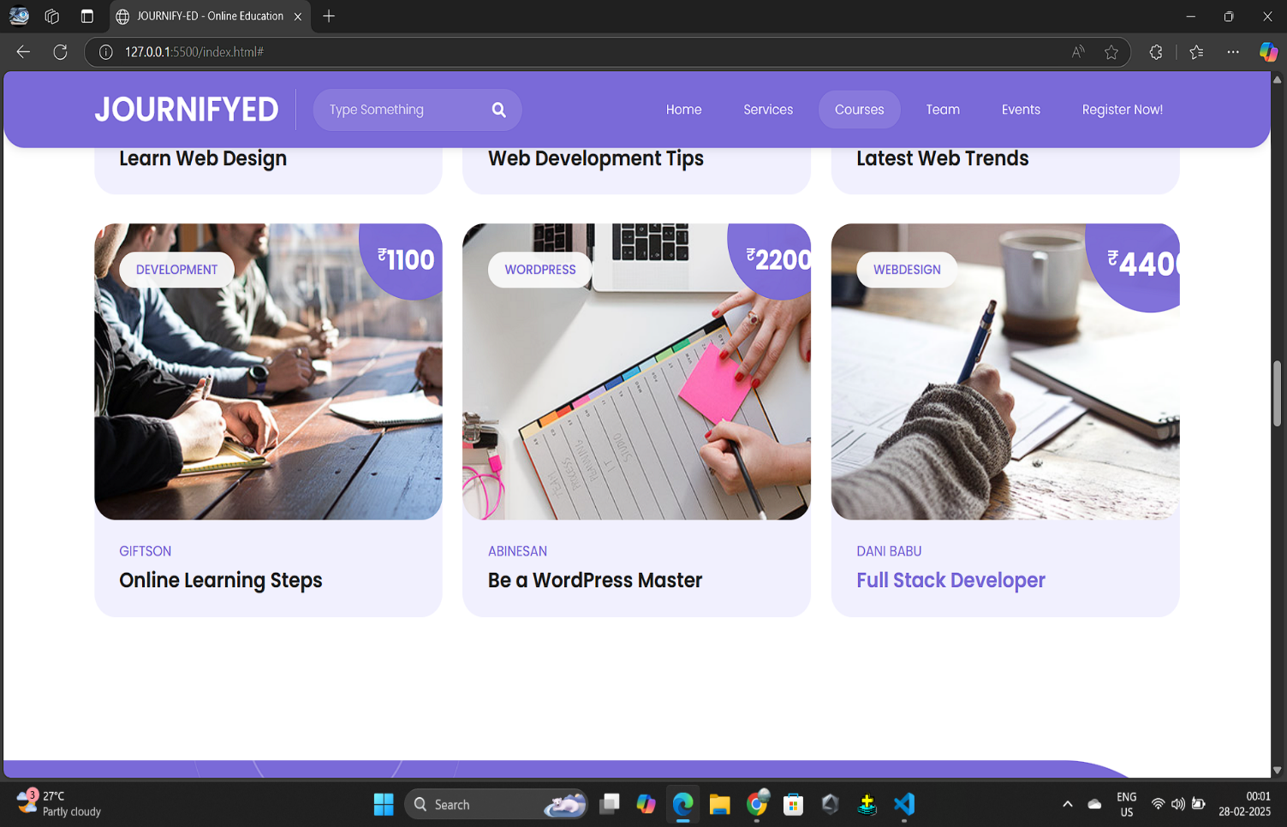

**OUR COURSES**

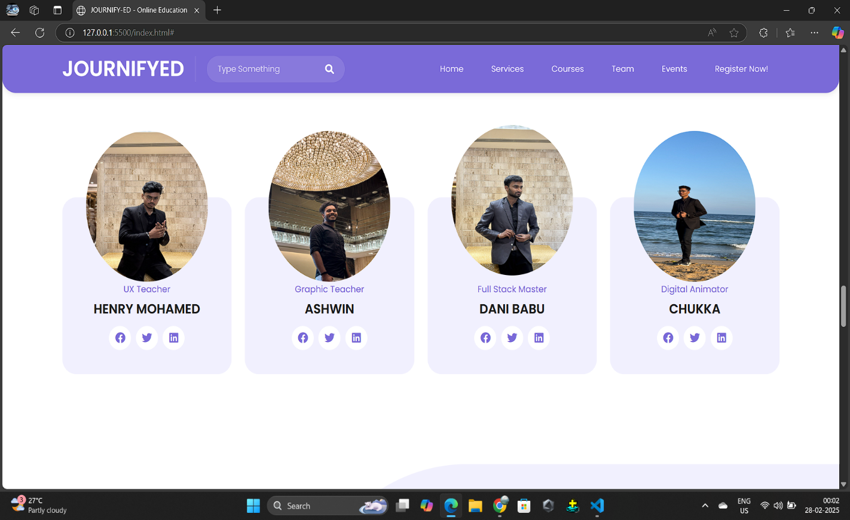

**OUR BEST STAFFS AT JOURNIFY-ED**