**Exercise 1: 1. ReactJS-HOL**

import React from 'react';

function App() {

return (

<div className="min-h-screen flex items-center justify-center bg-gray-100">

<h1 className="text-4xl font-bold text-blue-600 text-center p-4 rounded-lg">

Welcome to the first session of React

</h1>

</div>

);

}

export default App;

**Exercise 2: 2. ReactJS-HOL**

**//Home.js**

import React from 'react';

function Home() {

return (

<div className="p-8 text-center bg-blue-100 rounded-lg shadow-md mb-4">

<h2 className="text-3xl font-bold text-blue-800">Welcome to the Home Page!</h2>

<p className="mt-2 text-lg text-blue-700">This is the main section of our StudentApp.</p>

</div>

);

}

export default Home;

**//About.js**

import React from 'react';

function About() {

return (

<div className="p-8 text-center bg-green-100 rounded-lg shadow-md mb-4">

{/* The h2 tag displays the main content of the About component. */}

<h2 className="text-3xl font-bold text-green-800">About Our StudentApp</h2>

<p className="mt-2 text-lg text-green-700">

This application helps manage student information and activities.

</p>

</div>

);

}

export default About;

**//App.js**

import React from 'react';

import Home from './Components/Home';

import About from './Components/About';

import Contact from './Components/Contact';

function App() {

return (

<div className="min-h-screen bg-gray-50 flex flex-col items-center p-8 font-sans">

<h1 className="text-5xl font-extrabold text-gray-900 mb-10 text-center">

StudentApp Dashboard

</h1>

<div className="w-full max-w-4xl space-y-6">

<Home />

<About />

<Contact />

</div>

</div>

);

}

export default App;

**//Contact.js**

import React from 'react';

function Contact() {

return (

<div className="p-8 text-center bg-yellow-100 rounded-lg shadow-md mb-4">

<h2 className="text-3xl font-bold text-yellow-800">Contact Us</h2>

<p className="mt-2 text-lg text-yellow-700">

You can reach us at support@studentapp.com or call us at 123-456-7890.

</p>

</div>

);

}

export default Contact;

**Exercise 3:3. ReactJS-HOL**

**//CalculateScore.js**

import React from 'react';

const percentToDecimal = (value) => {

const num = typeof value === 'number' && !isNaN(value) ? value : 0;

return num.toFixed(2) + '%'; // Removed * 100 to correctly display average as percentage

};

const calcScore = (total, goal) => {

if (goal === 0) {

return "N/A"; // Or handle as an error/specific message

}

return percentToDecimal(total / goal);

};

function CalculateScore({ Name, School, total, goal }) {

return (

<div className="p-8 bg-white rounded-xl shadow-2xl max-w-md mx-auto my-10 border border-gray-200 text-gray-800 formatstyle">

<h1 className="text-3xl font-bold mb-6 text-center">Student Details</h1>

<div className="mb-4 Name">

<b className="text-lg font-semibold">Name: </b>

<span className="text-lg">{Name}</span>

</div>

<div className="mb-4 School">

<b className="text-lg font-semibold">School: </b>

<span className="text-lg">{School}</span>

</div>

<div className="mb-4 Total">

<b className="text-lg font-semibold">Total Marks: </b>

<span className="text-lg">{total}</span>

</div>

<div className="mb-6">

<b className="text-lg font-semibold">Goal: </b>

<span className="text-lg text-blue-700">{goal}</span>

</div>

<div className="mt-8 p-6 bg-blue-50 rounded-lg shadow-inner w-full text-center Score">

<h3 className="text-2xl font-semibold text-gray-700 mb-2">Score Percentage:</h3>

<p className="text-5xl font-extrabold">{calcScore(total, goal)}</p>

</div>

</div>

);

}

export default CalculateScore;

**//mystyle.css**

html {

scroll-behavior: smooth;

}

body {

margin: 0;

font-family: 'Inter', sans-serif;

-webkit-font-smoothing: antialiased;

-moz-osx-font-smoothing: grayscale;

background-color: #f0f2f5;

min-height: 100vh;

display: flex;

flex-direction: column;

justify-content: center;

align-items: center;

}

code {

font-family: source-code-pro, Menlo, Monaco, Consolas, 'Courier New', monospace;

}

.Name {

font-weight: 300;

color: blue;

}

.School {

color: crimson;

}

.Total {

color: darkmagenta;

}

.formatstyle {

text-align: center;

font-size: large;

}

.Score {

color: forestgreen;

}

**//App.js**

import React from 'react';

import './StyleSheets/mystyle.css';

function App() {

return (

<div className="min-h-screen flex items-center justify-center bg-gray-100 p-4">

<CalculateScore

Name={"Steeve"}

School={"DNV Public School"}

total={284} // This 'total' prop is a fixed value passed from App.js

goal={3}

/>

</div>

);

}

export default App;

**Exercise 5:** **5. ReactJS-HOL**

.box {

width: 300px;

display: inline-block;

overflow: hidden;

margin: 10px;

padding: 10px;

padding-left: 20px;

padding-right: 20px;

border: 1px solid black;

border-radius: 10px;

box-shadow: 0 4px 8px rgba(0, 0, 0, 0.1);

background-color: #f9f9f9;

vertical-align: top;

}

h1 {

font-weight: 800;

color: #333;

text-align: center;

margin-bottom: 15px;

}

**//CohortDetails.js**

import React from 'react';

import styles from '../CohortDetails.module.css';

function CohortDetails({ cohortId, startedOn, endedOn, currentStatus, coach, trainees }) {

const statusColor = currentStatus === 'Ongoing' ? 'green' : 'blue';

return (

<div className={`${styles.box} p-4 rounded-lg shadow-md`}>

<h1>{cohortId}</h1>

<p className="mb-2"><strong>Started On:</strong> {startedOn}</p>

<p className="mb-2"><strong>Ended On:</strong> {endedOn}</p>

<p className="mb-2"><strong>Current Status:</strong> <span style={{ color: statusColor, fontWeight: 'bold' }}>{currentStatus}</span></p>

<p className="mb-2"><strong>Coach:</strong> {coach}</p>

<p><strong>Trainees:</strong> {trainees.join(', ')}</p>

</div>

);

}

export default CohortDetails;

**//App.js**

import React from 'react';

import CohortDetails from './Components/CohortDetails';

function App() {

const cohorts = [

{

id: 'INTADM2019-JMT FSD',

startedOn: '10 Dec 2021',

endedOn: '10 Jun 2022',

currentStatus: 'Ongoing',

coach: 'Asthma',

trainees: ['John Doe', 'Jane Smith']

},

{

id: 'ADM21F214-Java FSD',

startedOn: '10 Dec 2021',

endedOn: '10 Jun 2022',

currentStatus: 'Completed', // Example of a completed status

coach: 'Appon',

trainees: ['Bob Johnson', 'Alice Brown']

},

{

id: 'CDB121025-Java FSD',

startedOn: '10 Dec 2021',

endedOn: '10 Jun 2022',

currentStatus: 'Ongoing',

coach: 'Asthma',

trainees: ['David Lee', 'Emily White']

}

];

return (

<div className="min-h-screen bg-gray-100 flex flex-col items-center p-8 font-sans">

<h1 className="text-5xl font-extrabold text-gray-900 mb-10 text-center">

Cohorts Details

</h1>

<div className="flex flex-wrap justify-center gap-6">

{cohorts.map(cohort => (

<CohortDetails

key={cohort.id}

cohortId={cohort.id}

startedOn={cohort.startedOn}

endedOn={cohort.endedOn}

currentStatus={cohort.currentStatus}

coach={cohort.coach}

trainees={cohort.trainees}

/>

))}

</div>

</div>

);

}

export default App;

**Exercise 4: 4. ReactJS-HOL**

**//App.js**

import React from 'react';

import Posts from './Posts';

function App() {

return (

<div className="min-h-screen bg-gray-100 flex flex-col items-center justify-center p-4 font-sans">

<Posts />

</div>

);

}

export default App;

**//Posts.js**

import React from 'react';

class Posts extends React.Component {

constructor(props) {

super(props);

this.state = {

posts: [],

loading: true,

error: null,

hasError: false,

errorInfo: null,

};

}

componentDidMount() {

this.setState({ loading: true, error: null, hasError: false }); // Reset error state on mount

fetch("https://jsonplaceholder.typicode.com/posts")

.then(response => {

if (!response.ok) {

throw new Error(`HTTP error! status: ${response.status}`);

}

return response.json();

})

.then(data => {

this.setState({

posts: data,

loading: false,

});

})

.catch(error => {

console.error("Error fetching posts:", error);

this.setState({

error: error,

loading: false,

hasError: true,

errorInfo: error,

});

});

}

componentDidCatch(error, errorInfo) {

console.error("Caught an error in a child component:", error, errorInfo);

this.setState({

hasError: true,

errorInfo: errorInfo,

error: error,

});

}

render() {

const { posts, loading, error, hasError } = this.state;

if (hasError) {

return (

<div className="text-center text-xl font-semibold text-red-600 mt-10 p-4 border border-red-300 rounded-lg bg-red-50">

<p>Something went wrong.</p>

<p className="text-sm mt-2">{error ? error.message : 'An unknown error occurred.'}</p>

</div>

);

}

if (loading) {

return (

<div className="text-center text-xl font-semibold text-gray-600 mt-10">

Loading posts...

</div>

);

}

return (

<div className="container mx-auto p-4">

<h1 className="text-4xl font-bold text-gray-900 mb-8 text-center">Blog Posts</h1>

{posts.map(post => (

<Posts key={post.id} title={post.title} body={post.body} />

))}

{posts.length === 0 && !loading && !error && (

<p className="text-center text-gray-500 mt-10">No posts found.</p>

)}

</div>

);

}

}

export default Posts;

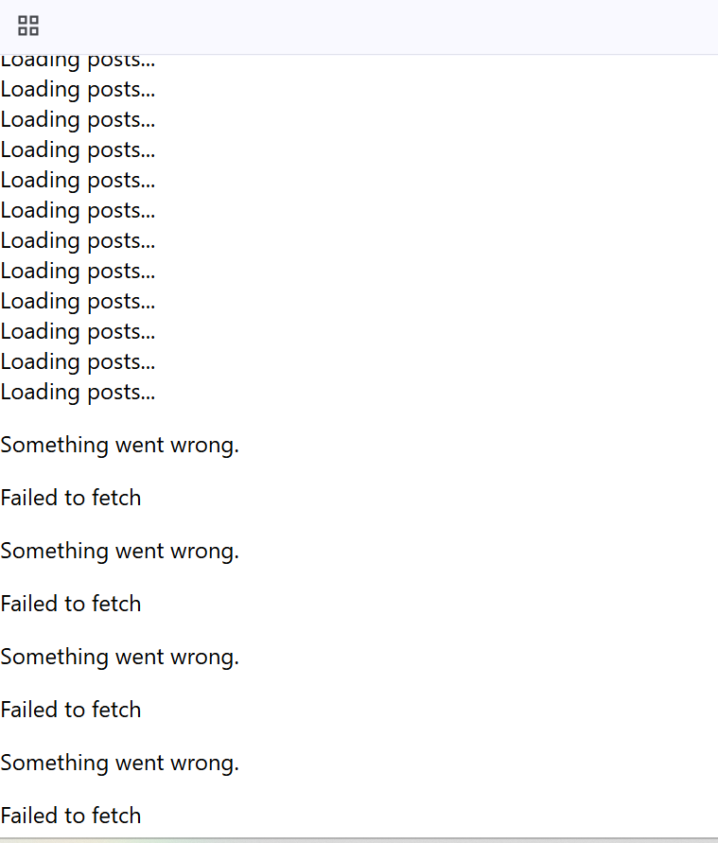

I couldn’t fetch the posts from the json file link provided in the handbook.