Online Bus Ticket Booking System
1. Aim
To design and develop a simple Online Bus Ticket Booking System using HTML that allows users to register, log in, search for buses, view available seats, book and cancel tickets, and post comments. It also provides an admin section to manage bus categories, bus details, registered users, news, and reports.
2. Source Code
<!DOCTYPE html>
<html>
<head>
<title>Online Bus Ticket Booking System</title>
<meta name="viewport" content="width=device-width, initial-scale=1.0">
<style>
body {
font-family: Arial, sans-serif;
background-color: #f2f6fc;
text-align: center;
margin: 0;
padding: 20px;
}
.container {
max-width: 850px;
margin: auto;
background: white;
padding: 25px;
border-radius: 12px;
}
input, select, textarea, button {
padding: 9px;
margin: 5px;
max-width: 95%;
box-sizing: border-box;
}
button, input[type="submit"], input[type="button"] {
cursor: pointer;
background: #155eef;
color: white;
border: 0;
border-radius: 5px;
}
table {
margin: 12px auto;
border-collapse: collapse;
width: 95%;
}
th, td { border: 1px solid #999; padding: 9px; }
section { padding: 12px 0; border-bottom: 1px solid #ddd; }
.message { color: #087443; font-weight: bold; }
@media (max-width: 600px) {
body { padding: 8px; }
.container { padding: 12px; }
table { font-size: 13px; }
th, td { padding: 5px; }
}
</style>
</head>
<body>
<div class="container">
<h1>Online Bus Ticket Booking System</h1>
<p>Search buses, select your journey and book your ticket.</p>
<p id="message" class="message">Welcome! Choose an action below.</p>

<section>
<h2>User Registration</h2>
<form id="registerForm">
<input id="regName" type="text" placeholder="Full name" required><br>
<input id="regEmail" type="email" placeholder="Email address" required><br>
<input id="regPassword" type="password" placeholder="Password" required><br>
<button type="submit">Register</button>
</form>
</section>

<section>
<h2>Login</h2>
<form id="loginForm">
<input id="loginEmail" type="email" placeholder="Email address" required><br>
<input id="loginPassword" type="password" placeholder="Password" required><br>
<button type="submit">Login</button>
<button type="button" id="forgotBtn">Forgot Password</button>
<button type="button" id="changeBtn">Change Password</button>
</form>
</section>

<section>
<h2>Search Buses</h2>
<form id="searchForm">
<input id="from" type="text" placeholder="From" required>
<input id="to" type="text" placeholder="To" required><br>
<label>Journey date: <input id="journeyDate" type="date" required></label><br>
<button type="submit">Search Buses</button>
</form>
<table>
<tr><th>Bus</th><th>Category</th><th>Time</th><th>Fare</th><th>Seats</th><th>Action</th></tr>
<tr>
<td>Chennai Express</td><td>Volvo AC</td><td>09:00 AM</td>
<td>₹750</td><td id="seats1">12</td>
<td><button type="button" onclick="selectBus('Chennai Express', 750, 'seats1')">Select</button></td>
</tr>
<tr>
<td>Southern Travels</td><td>Sleeper Coach</td><td>10:30 PM</td>
<td>₹950</td><td id="seats2">8</td>
<td><button type="button" onclick="selectBus('Southern Travels', 950, 'seats2')">Select</button></td>
</tr>
</table>
<p id="selectedBus">Selected bus: None</p>
</section>

<section>
<h2>Book Ticket</h2>
<form id="bookingForm">
<input id="passenger" type="text" placeholder="Passenger name" required><br>
<input id="age" type="number" min="1" placeholder="Passenger age" required><br>
<label>Seat:
<select id="seat">
<option value="1">Seat 1</option><option value="2">Seat 2</option>
<option value="3">Seat 3</option><option value="4">Seat 4</option>
</select>
</label><br>
<button type="submit">Book Ticket</button>
</form>
<h3>My Booking History</h3>
<table id="history">
<tr><th>Passenger</th><th>Bus</th><th>Seat</th><th>Fare</th><th>Status</th></tr>
</table>
<button type="button" id="cancelBtn">Cancel Latest Ticket</button>
</section>

<section>
<h2>Comments</h2>
<form id="commentForm">
<textarea id="comment" rows="3" cols="35" placeholder="Write a comment about a bus" required></textarea><br>
<button type="submit">Post Comment</button>
</form>
<ul id="comments"></ul>
</section>

<section>
<h2>Admin Panel (Demo)</h2>
<h3>Add or Update Bus Information</h3>
<form id="busForm">
<input id="busName" type="text" placeholder="Bus name" required><br>
<select id="busCategory">
<option>Volvo</option><option>Sleeper Coach</option><option>AC Coach</option><option>Non-AC Coach</option>
</select><br>
<input id="busRoute" type="text" placeholder="Route / location" required><br>
<input id="busTime" type="time" required><br>
<input id="busSeats" type="number" min="1" placeholder="Available seats" required><br>
<input id="busFare" type="number" min="1" placeholder="Ticket price (₹)" required><br>
<button type="submit">Save Bus</button>
</form>
<h3>Registered Users</h3>
<ul id="users"><li>No users registered yet.</li></ul>
<h3>Manage News</h3>
<form id="newsForm">
<input id="newsText" type="text" placeholder="Enter news or announcement" required>
<button type="submit">Publish News</button>
</form>
<ul id="news"></ul>
<h3>Reports</h3>
<button type="button" id="reportBtn">Generate Booking Report</button>
<p id="report"></p>
</section>

<section>
<h2>Contact Us</h2>
<p>Email: support@example.com | Phone: 9876543210</p>
</section>
<p>Online Bus Ticket Booking System</p>
</div>

<script>
const message = document.getElementById("message");
let currentBus = "";
let currentFare = 0;
let currentSeatCountId = "";
let bookings = [];
let users = [];

function showMessage(text) {
message.textContent = text;
}

document.getElementById("registerForm").addEventListener("submit", function(event) {
event.preventDefault();
const name = document.getElementById("regName").value.trim();
const email = document.getElementById("regEmail").value.trim();
if (users.some(user => user.email === email)) {
showMessage("This email is already registered.");
return;
}
users.push({name, email});
const list = document.getElementById("users");
if (users.length === 1) list.innerHTML = "";
const item = document.createElement("li");
item.textContent = name + " (" + email + ")";
list.appendChild(item);
showMessage("Registration successful (demo only).");
this.reset();
});

document.getElementById("loginForm").addEventListener("submit", function(event) {
event.preventDefault();
const email = document.getElementById("loginEmail").value.trim();
if (users.some(user => user.email === email)) {
showMessage("Login successful (demo only).");
} else {
showMessage("Please register first. This demo does not verify passwords.");
}
});

document.getElementById("forgotBtn").addEventListener("click", function() {
showMessage("Demo: password reset would be sent to your registered email.");
});
document.getElementById("changeBtn").addEventListener("click", function() {
showMessage("Demo: password change requires a real account system.");
});

document.getElementById("searchForm").addEventListener("submit", function(event) {
event.preventDefault();
showMessage("Showing sample buses for " + document.getElementById("from").value +
" to " + document.getElementById("to").value +
" on " + document.getElementById("journeyDate").value + ".");
});

function selectBus(name, fare, seatId) {
currentBus = name;
currentFare = fare;
currentSeatCountId = seatId;
document.getElementById("selectedBus").textContent =
"Selected bus: " + name + " | Fare: ₹" + fare;
showMessage(name + " selected. Enter passenger details to book.");
}

document.getElementById("bookingForm").addEventListener("submit", function(event) {
event.preventDefault();
if (!currentBus) {
showMessage("Please select a bus before booking.");
return;
}
const seatsCell = document.getElementById(currentSeatCountId);
let available = Number(seatsCell.textContent);
if (available <= 0) {
showMessage("Sorry, no seats are available on this bus.");
return;
}
available--;
seatsCell.textContent = available;
const booking = {
passenger: document.getElementById("passenger").value.trim(),
bus: currentBus,
seat: document.getElementById("seat").value,
fare: currentFare,
status: "Booked",
seatId: currentSeatCountId
};
bookings.push(booking);
addBookingRow(booking);
showMessage("Ticket booked successfully (demo only). No payment was taken.");
this.reset();
});

function addBookingRow(booking) {
const row = document.getElementById("history").insertRow();
[booking.passenger, booking.bus, booking.seat, "₹" + booking.fare, booking.status]
.forEach(value => {
const cell = row.insertCell();
cell.textContent = value;
});
}

document.getElementById("cancelBtn").addEventListener("click", function() {
const booking = bookings.find(item => item.status === "Booked");
if (!booking) {
showMessage("There are no active tickets to cancel.");
return;
}
booking.status = "Cancelled";
const rows = document.getElementById("history").rows;
for (let i = 1; i < rows.length; i++) {
if (rows[i].cells[0].textContent === booking.passenger &&
rows[i].cells[1].textContent === booking.bus &&
rows[i].cells[4].textContent === "Booked") {
rows[i].cells[4].textContent = "Cancelled";
break;
}
}
document.getElementById(booking.seatId).textContent =
Number(document.getElementById(booking.seatId).textContent) + 1;
showMessage("Latest active ticket cancelled (demo only).");
});

document.getElementById("commentForm").addEventListener("submit", function(event) {
event.preventDefault();
const item = document.createElement("li");
item.textContent = document.getElementById("comment").value;
document.getElementById("comments").appendChild(item);
this.reset();
showMessage("Comment posted.");
});

document.getElementById("busForm").addEventListener("submit", function(event) {
event.preventDefault();
const row = document.getElementById("history");
showMessage("Bus details saved for this demo: " +
document.getElementById("busName").value + " (" +
document.getElementById("busCategory").value + ").");
alert("Bus information saved in the current page demo. It is not stored permanently.");
this.reset();
});

document.getElementById("newsForm").addEventListener("submit", function(event) {
event.preventDefault();
const item = document.createElement("li");
item.textContent = document.getElementById("newsText").value;
document.getElementById("news").appendChild(item);
this.reset();
showMessage("News published on this page.");
});

document.getElementById("reportBtn").addEventListener("click", function() {
const active = bookings.filter(item => item.status === "Booked");
const total = active.reduce((sum, item) => sum + item.fare, 0);
document.getElementById("report").textContent =
"Total bookings: " + bookings.length +
" | Active bookings: " + active.length +
" | Cancelled: " + (bookings.length - active.length) +
" | Active booking value: ₹" + total;
showMessage("Booking report generated.");
});
</script>
</body>
</html>

Output
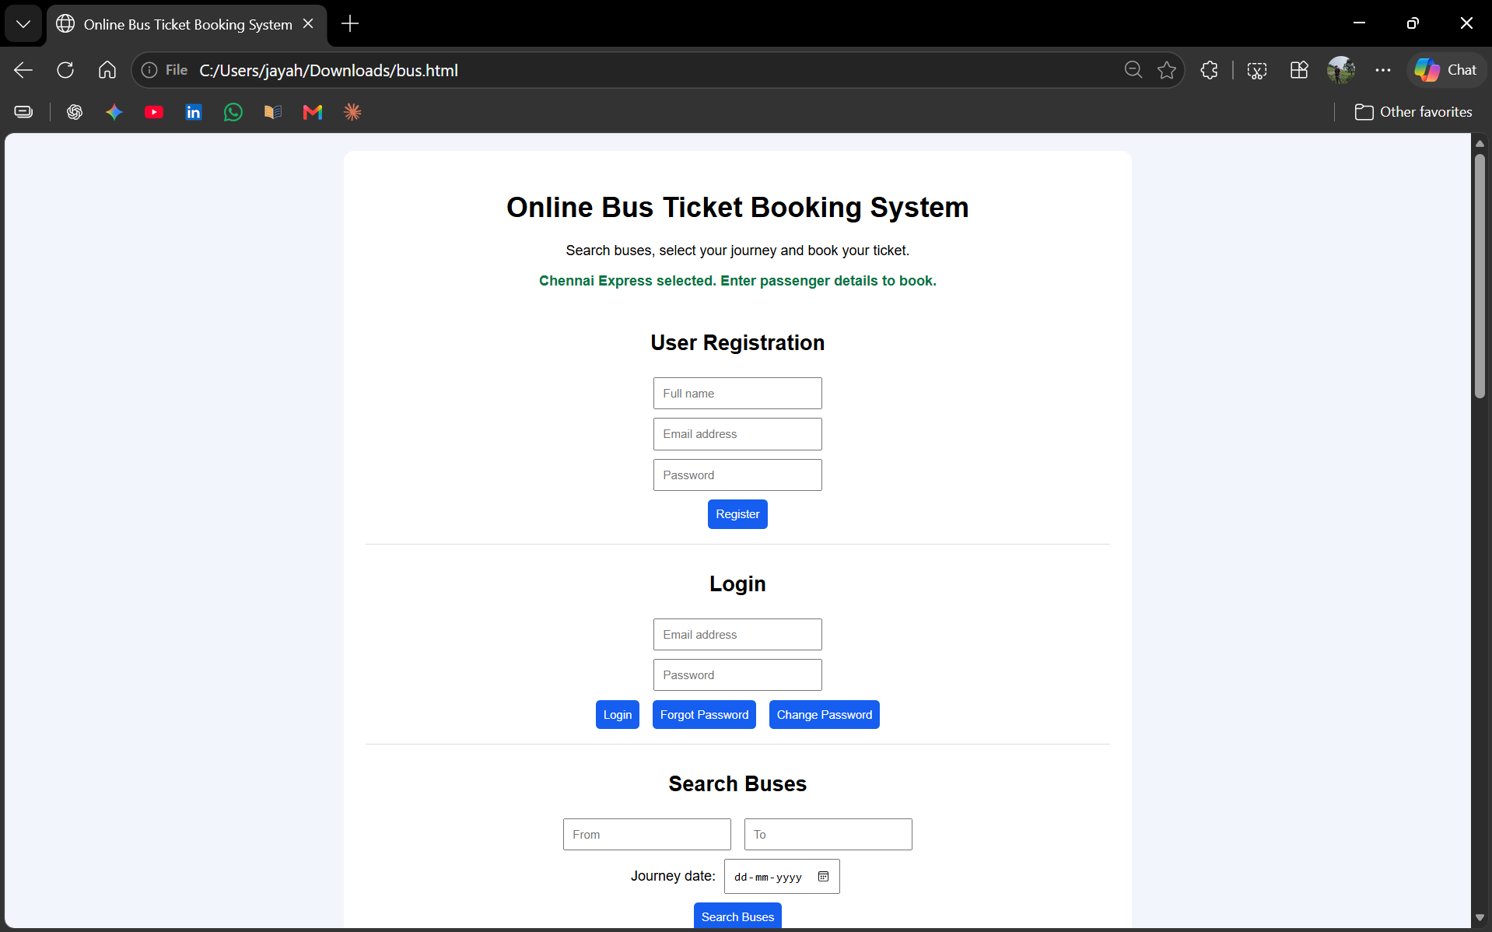
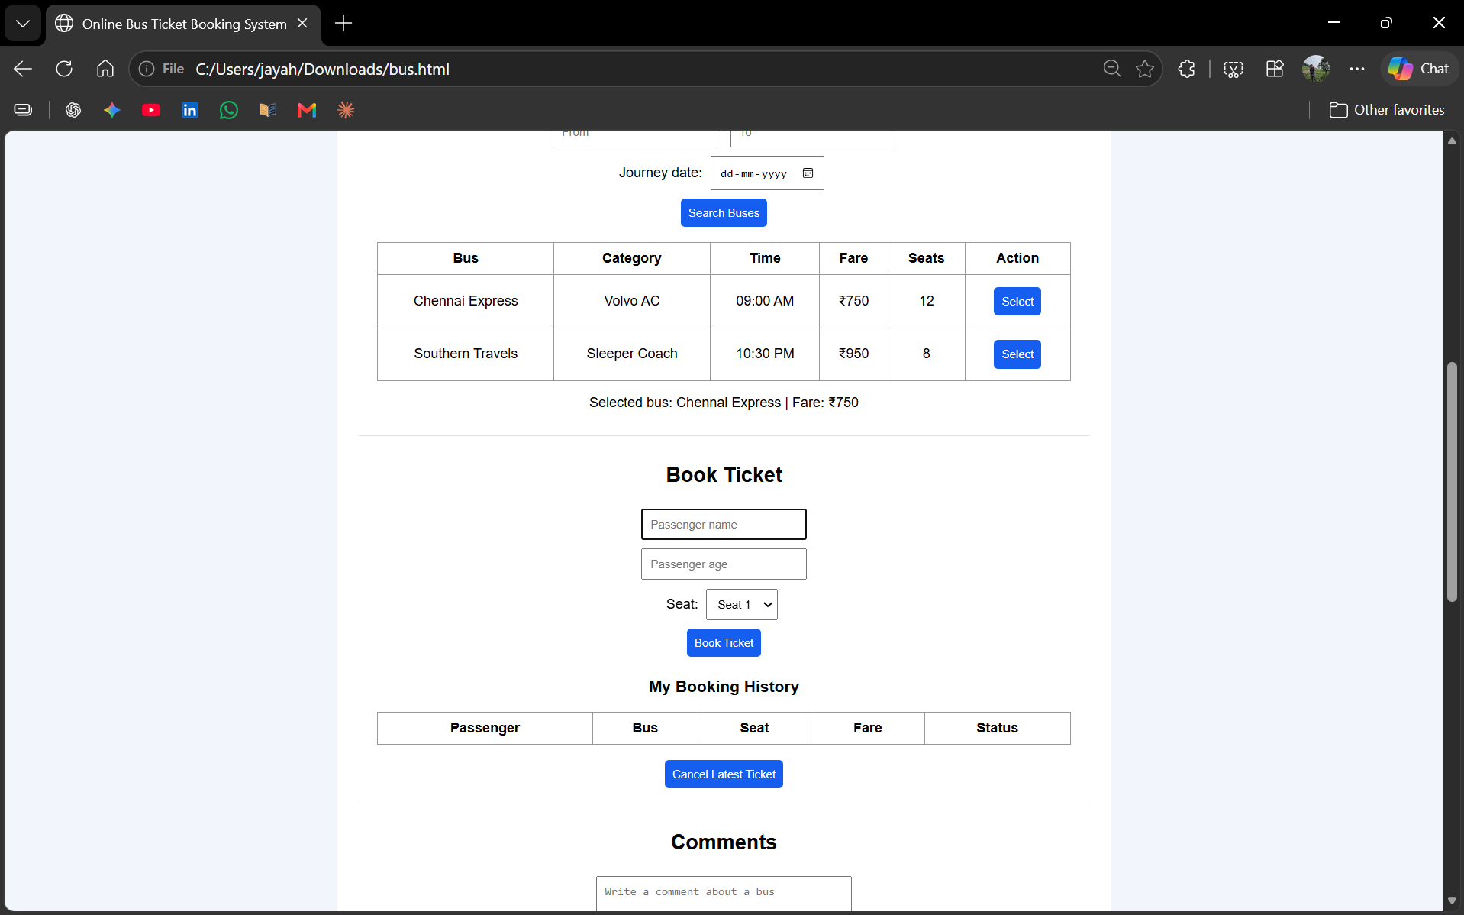
Result
Thus, an Online Bus Ticket Booking System webpage was created using HTML, CSS, and basic JavaScript.

