Online Electronics Shopping Platform

1. Aim
To design and develop a responsive Online Electronics Shopping Platform webpage ('TechSavvy') using HTML, CSS, and JavaScript that implements 13 essential e-commerce use cases including user registration, login/logout, product searching and category-wise filtering, stock availability verification, detailed specification modal display, cart management (add, edit quantities, remove, clear), secure checkout with address and payment mode collection, real-time order tracking, and order history browsing. It also equips administrators with permissions to add new products, update prices and descriptions, remove obsolete gadgets, and review customer checkout transactions.

2. Source Code
<!DOCTYPE html>
<html lang="en">
<head>
<meta charset="UTF-8">
<meta name="viewport" content="width=device-width, initial-scale=1.0">
<title>TechSavvy - Online Electronics Store</title>
<style>
body {
font-family: Arial, sans-serif;
background-color: #f5f7fb;
text-align: center;
margin: 0;
padding: 20px;
color: #1e293b;
}
.container {
max-width: 950px;
margin: auto;
background: #ffffff;
padding: 25px;
border-radius: 12px;
box-shadow: 0 4px 14px rgba(79, 70, 229, 0.1);
}
h1 { color: #3730a3; margin-bottom: 5px; }
h2 { color: #4f46e5; border-bottom: 2px solid #e0e7ff; padding-bottom: 6px; margin-top: 25px; font-size: 20px; }
h3 { color: #1e1b4b; font-size: 16px; margin-top: 15px; }
p { margin: 6px 0; }
input, select, textarea, button {
padding: 9px;
margin: 6px;
max-width: 95%;
border: 1px solid #cbd5e1;
border-radius: 5px;
box-sizing: border-box;
font-size: 14px;
}
button, input[type="submit"], input[type="button"] {
cursor: pointer;
background: #4f46e5;
color: white;
border: 0;
border-radius: 5px;
padding: 9px 18px;
font-weight: bold;
transition: background 0.2s;
}
button:hover, input[type="submit"]:hover {
background: #4338ca;
}
table {
margin: 15px auto;
border-collapse: collapse;
width: 98%;
background: #fff;
}
th, td {
border: 1px solid #e2e8f0;
padding: 10px;
text-align: center;
font-size: 14px;
}
th {
background-color: #eef2ff;
color: #3730a3;
}
tr:nth-child(even) { background-color: #f8fafc; }
section {
padding: 14px 0;
border-bottom: 1px solid #e2e8f0;
text-align: center;
}
.message {
background-color: #eef2ff;
color: #3730a3;
padding: 10px;
border-radius: 6px;
font-weight: bold;
margin: 12px 0;
display: inline-block;
min-width: 60%;
}
.badge {
display: inline-block;
padding: 4px 8px;
border-radius: 4px;
font-size: 12px;
font-weight: bold;
}
.badge-stock { background: #dcfce7; color: #166534; }
.badge-out { background: #fee2e2; color: #991b1b; }
.card-grid {
display: grid;
grid-template-columns: repeat(auto-fit, minmax(270px, 1fr));
gap: 15px;
margin: 15px 0;
}
.product-card {
border: 1px solid #e2e8f0;
border-radius: 8px;
padding: 15px;
background: #ffffff;
text-align: left;
box-shadow: 0 2px 6px rgba(0,0,0,0.03);
}
.product-card h4 { margin: 0 0 6px 0; color: #4338ca; }
.category-pill {
display: inline-block;
background: #e0e7ff;
color: #3730a3;
padding: 4px 10px;
border-radius: 12px;
font-size: 12px;
margin: 3px;
}
@media (max-width: 600px) {
body { padding: 8px; }
.container { padding: 12px; }
table { font-size: 12px; display: block; overflow-x: auto; }
th, td { padding: 6px; }
}
</style>
</head>
<body>
<div class="container" id="mainContainer">
<h1>TechSavvy Online Electronics Platform</h1>
<p>Explore Premium Smartphones, Laptops, Tablets, and Smart Gadgets</p>
<p id="message" class="message">Welcome to TechSavvy! High-tech electronics at unbeatable prices.</p>

<!-- Category & Subcategory Navigation -->
<section>
<h2>Popular Product Categories & Subcategories</h2>
<div style="margin: 10px 0;">
<span class="category-pill">ðŸ“± Smartphones: Flagship 5G | Budget Android | iOS Devices</span>
<span class="category-pill">ðŸ’» Laptops: Ultrabooks | Gaming Powerhouses | Business</span>
<span class="category-pill">ðŸ“Ÿ Tablets: iPad Series | Drawing Stylus Tabs</span>
<span class="category-pill">ðŸŽ§ Audio: ANC Headphones | True Wireless Earbuds</span>
<span class="category-pill">âš¡ Accessories: 65W GaN Chargers | 20000mAh Powerbanks</span>
</div>
</section>

<!-- Use Cases 1, 2, 12, 13: Visit, Login, Logout, Leave Site -->
<section>
<h2>User Authentication & Session Controls</h2>
<form id="userRegForm">
<input type="text" id="regName" placeholder="Full Name" required>
<input type="email" id="regEmail" placeholder="Email Address" required>
<input type="password" id="regPass" placeholder="Password" required><br>
<button type="submit">Register Customer Account</button>
</form>

<h3>Login / Logout / Exit</h3>
<form id="userLoginForm">
<input type="email" id="logEmail" placeholder="Customer Email" required>
<input type="password" id="logPass" placeholder="Password" required><br>
<button type="submit">Customer Login</button>
<button type="button" onclick="demoLogin()">Demo Login (Rohan)</button>
<button type="button" onclick="logoutUser()" style="background: #dc2626;">Logout</button>
<button type="button" onclick="leaveSite()" style="background: #64748b;">Leave Site</button>
</form>
<p id="sessionDisplay" style="font-weight: bold; color: #4f46e5; margin-top: 8px;">Active Session: Guest Visitor</p>
</section>

<!-- Use Cases 3, 4, 11: Search, Availability, Item Details -->
<section>
<h2>Search, Filter & Check Availability</h2>
<form id="searchProductForm">
<input type="text" id="kwSearch" placeholder="Search gadgets (e.g. iPhone, Dell, Sony)...">
<select id="catSelect">
<option value="All">All Categories</option>
<option value="Smartphones">Smartphones</option>
<option value="Laptops">Laptops</option>
<option value="Tablets">Tablets</option>
<option value="Audio">Audio & Wearables</option>
<option value="Accessories">Accessories</option>
</select>
<select id="priceFilter">
<option value="All">All Price Ranges</option>
<option value="under15k">Under â‚¹15,000</option>
<option value="15k-50k">â‚¹15,000 - â‚¹50,000</option>
<option value="above50k">Above â‚¹50,000</option>
</select><br>
<button type="button" onclick="applySearch()">Search Products</button>
<button type="button" onclick="resetSearch()" style="background: #64748b;">Reset Catalog</button>
</form>

<h3>Electronic Gadgets Catalogue</h3>
<div id="productGrid" class="card-grid"></div>
<div id="productDetailBox" style="display: none; background: #eef2ff; border: 1px solid #c7d2fe; padding: 15px; border-radius: 8px; margin-top: 15px; text-align: left;"></div>
</section>

<!-- Use Cases 5, 6, 7, 8: Shopping Cart & Checkout -->
<section>
<h2>Shopping Cart & Checkout Module</h2>
<table>
<thead>
<tr>
<th>Product</th>
<th>Category</th>
<th>Price</th>
<th>Qty</th>
<th>Subtotal</th>
<th>Actions</th>
</tr>
</thead>
<tbody id="cartTableBody">
<tr><td colspan="6">Your shopping cart is currently empty.</td></tr>
</tbody>
</table>
<p style="font-size: 16px; font-weight: bold; color: #3730a3;">Cart Total: â‚¹<span id="cartTotalText">0</span></p>
<button type="button" onclick="clearCart()" style="background: #64748b;">Clear Entire Cart</button>

<h3>Checkout Order</h3>
<form id="checkoutForm">
<input type="text" id="chkCustName" placeholder="Full Name" required>
<input type="tel" id="chkCustPhone" placeholder="Contact Mobile" required><br>
<textarea id="chkCustAddress" rows="2" cols="45" placeholder="Shipping Address..." required></textarea><br>
<label>Payment Method:
<select id="chkPayMethod">
<option value="Credit / Debit Card">Credit / Debit Card</option>
<option value="UPI (GPay / PhonePe / Paytm)">UPI Instant Payment</option>
<option value="Net Banking">Net Banking</option>
<option value="Cash on Delivery">Cash on Delivery</option>
</select>
</label><br>
<button type="submit" style="background: #16a34a; font-size: 16px;">Complete Secure Checkout</button>
</form>
</section>

<!-- Use Cases 9, 10: Check Order Status & Browse Order History -->
<section>
<h2>Order Status Enquiry & Customer History</h2>
<form id="trackOrderForm">
<input type="text" id="trackOrderId" placeholder="Enter Order ID (e.g. TS-1024)" required>
<button type="submit">Check Live Order Status</button>
</form>
<p id="trackStatusResult" style="font-weight: bold; margin-top: 10px;"></p>

<h3>Order History</h3>
<table>
<thead>
<tr>
<th>Order ID</th>
<th>Customer</th>
<th>Items Purchased</th>
<th>Total (â‚¹)</th>
<th>Payment</th>
<th>Status</th>
</tr>
</thead>
<tbody id="orderHistoryBody">
<tr><td colspan="6">No previous orders found.</td></tr>
</tbody>
</table>
</section>

<!-- Admin Panel -->
<section>
<h2>TechSavvy Administration Dashboard</h2>
<h3>Add New Electronic Product</h3>
<form id="adminAddProductForm">
<input type="text" id="admPName" placeholder="Product Name (e.g. Pixel 8 Pro)" required>
<select id="admPCat">
<option value="Smartphones">Smartphones</option>
<option value="Laptops">Laptops</option>
<option value="Tablets">Tablets</option>
<option value="Audio">Audio</option>
<option value="Accessories">Accessories</option>
</select>
<input type="text" id="admPSubCat" placeholder="Subcategory" required><br>
<input type="number" id="admPPrice" placeholder="Price (â‚¹)" required>
<input type="number" id="admPStock" placeholder="Stock Qty" required><br>
<textarea id="admPDesc" rows="2" cols="45" placeholder="Full Product Description & Specs..." required></textarea><br>
<button type="submit" style="background: #3730a3;">Add Product to Catalogue</button>
</form>

<h3>Modify Item Price / Description or Remove Item</h3>
<form id="adminModifyForm">
<select id="modProductSelect" onchange="populateModFields()"></select><br>
<input type="number" id="modPrice" placeholder="New Price (â‚¹)" required>
<input type="text" id="modDesc" placeholder="Updated Description" required style="width: 50%;"><br>
<button type="button" onclick="updateItemDetails()">Update Price & Description</button>
<button type="button" onclick="deleteCurrentItem()" style="background: #dc2626;">Remove Item from Store</button>
</form>

<h3>Customer Checkout Audit Log</h3>
<table id="adminAuditTable">
<thead>
<tr>
<th>Order ID</th>
<th>Customer Name</th>
<th>Phone</th>
<th>Items</th>
<th>Amount</th>
<th>Payment Mode</th>
</tr>
</thead>
<tbody id="adminAuditBody">
<tr><td colspan="6">No checkouts recorded yet.</td></tr>
</tbody>
</table>
</section>

<p style="color: #64748b; font-size: 13px; margin-top: 25px;">TechSavvy Electronics Retail Portal - Academic Year 2026</p>
</div>

<script>
const msg = document.getElementById("message");
let currentUser = null;
let cart = [];
let orders = [];

let products = [
{ id: 1, name: "Galaxy S24 Ultra 5G", category: "Smartphones", subcategory: "Flagship 5G", price: 124999, stock: 12, desc: "Snapdragon 8 Gen 3, 200MP Quad Camera, S-Pen included, 5000mAh battery." },
{ id: 2, name: "Apple iPhone 15 Pro", category: "Smartphones", subcategory: "iOS Devices", price: 129900, stock: 8, desc: "A17 Pro chip, Aerospace titanium design, Action button, 48MP Pro camera." },
{ id: 3, name: "Dell XPS 15 OLED", category: "Laptops", subcategory: "Ultrabooks", price: 168000, stock: 5, desc: "Intel Core i7 13th Gen, 32GB RAM, 1TB NVMe SSD, 3.5K OLED InfinityEdge display." },
{ id: 4, name: "Sony WH-1000XM5", category: "Audio", subcategory: "ANC Headphones", price: 29990, stock: 15, desc: "Industry leading noise cancellation, 30 hours battery, crystal clear hands-free call." },
{ id: 5, name: "Anker 65W GaN Charger", category: "Accessories", subcategory: "Fast Chargers", price: 3499, stock: 25, desc: "Ultra-compact 3-port fast wall charger compatible with laptops, phones, and tablets." }
];

function showMessage(text) {
msg.textContent = text;
}

function demoLogin() {
currentUser = { name: "Rohan Verma", email: "rohan@techsavvy.com" };
document.getElementById("sessionDisplay").textContent = "Active Session: " + currentUser.name + " (" + currentUser.email + ")";
document.getElementById("chkCustName").value = currentUser.name;
showMessage("Logged in as Rohan Verma.");
}

function logoutUser() {
currentUser = null;
document.getElementById("sessionDisplay").textContent = "Active Session: Guest Visitor (Logged Out)";
showMessage("Logged out successfully.");
}

function leaveSite() {
if (confirm("Are you sure you want to leave TechSavvy platform?")) {
document.getElementById("mainContainer").innerHTML = "<h2>Thank you for visiting TechSavvy! You may safely close this browser tab.</h2><button onclick='location.reload()'>Revisit Store</button>";
}
}

// Render Products
function renderProducts(list) {
const grid = document.getElementById("productGrid");
grid.innerHTML = "";
const modSel = document.getElementById("modProductSelect");
modSel.innerHTML = "";

if (list.length === 0) {
grid.innerHTML = "<p>No products found matching your search criteria.</p>";
return;
}

list.forEach(p => {
const card = document.createElement("div");
card.className = "product-card";
const inStock = p.stock > 0;
card.innerHTML = `
<h4>${p.name}</h4>
<p><strong>Category:</strong> ${p.category} > ${p.subcategory}</p>
<p><strong>Price:</strong> â‚¹${p.price.toLocaleString()}</p>
<p><strong>Availability:</strong> <span class="badge ${inStock ? 'badge-stock' : 'badge-out'}">${inStock ? 'In Stock (' + p.stock + ' units)' : 'Out of Stock'}</span></p>
<button type="button" onclick="displayItemDetails(${p.id})">Display Details</button>
<button type="button" onclick="checkItemAvailability(${p.id})">Check Stock</button>
<button type="button" onclick="addToCart(${p.id})" style="background: #16a34a;" ${!inStock ? 'disabled' : ''}>Add to Cart</button>
`;
grid.appendChild(card);

const opt = document.createElement("option");
opt.value = p.id;
opt.textContent = p.name + " (â‚¹" + p.price + ")";
modSel.appendChild(opt);
});
populateModFields();
}

renderProducts(products);

function displayItemDetails(id) {
const p = products.find(x => x.id === id);
const box = document.getElementById("productDetailBox");
box.style.display = "block";
box.innerHTML = `
<h3 style="color: #3730a3; margin-top: 0;">${p.name}</h3>
<p><strong>Category:</strong> ${p.category} | <strong>Subcategory:</strong> ${p.subcategory}</p>
<p><strong>Price:</strong> â‚¹${p.price.toLocaleString()} (Inclusive of all taxes)</p>
<p><strong>Specifications & Overview:</strong> ${p.desc}</p>
<p><strong>Inventory Level:</strong> ${p.stock} units ready for immediate courier dispatch.</p>
<button type="button" onclick="document.getElementById('productDetailBox').style.display='none'">Close Details</button>
`;
showMessage("Item details displayed for " + p.name);
}

function checkItemAvailability(id) {
const p = products.find(x => x.id === id);
alert("Live Stock Query for " + p.name + ": " + p.stock + " units available in central warehouse.");
showMessage("Availability checked for " + p.name + ": " + p.stock + " units.");
}

// Search and filter
function applySearch() {
const kw = document.getElementById("kwSearch").value.toLowerCase().trim();
const cat = document.getElementById("catSelect").value;
const pr = document.getElementById("priceFilter").value;

const filtered = products.filter(p => {
const matchKw = p.name.toLowerCase().includes(kw) || p.desc.toLowerCase().includes(kw);
const matchCat = cat === "All" || p.category === cat;
let matchPr = true;
if (pr === "under15k") matchPr = p.price < 15000;
else if (pr === "15k-50k") matchPr = p.price >= 15000 && p.price <= 50000;
else if (pr === "above50k") matchPr = p.price > 50000;
return matchKw && matchCat && matchPr;
});

renderProducts(filtered);
showMessage("Search returned " + filtered.length + " gadget(s).");
}

function resetSearch() {
document.getElementById("kwSearch").value = "";
document.getElementById("catSelect").value = "All";
document.getElementById("priceFilter").value = "All";
renderProducts(products);
showMessage("Catalog reset to display all products.");
}

// Cart operations
function addToCart(id) {
const p = products.find(x => x.id === id);
if (p.stock <= 0) {
showMessage("Item is out of stock!");
return;
}
const existing = cart.find(item => item.id === id);
if (existing) {
existing.qty++;
} else {
cart.push({ id: p.id, name: p.name, category: p.category, price: p.price, qty: 1 });
}
renderCart();
showMessage(p.name + " added to shopping cart.");
}

function renderCart() {
const tbody = document.getElementById("cartTableBody");
tbody.innerHTML = "";
if (cart.length === 0) {
tbody.innerHTML = "<tr><td colspan='6'>Your shopping cart is currently empty.</td></tr>";
document.getElementById("cartTotalText").textContent = "0";
return;
}

let total = 0;
cart.forEach((item, index) => {
const sub = item.price * item.qty;
total += sub;
const tr = document.createElement("tr");
tr.innerHTML = `
<td><strong>${item.name}</strong></td>
<td>${item.category}</td>
<td>â‚¹${item.price.toLocaleString()}</td>
<td>
<button type="button" onclick="changeCartQty(${index}, -1)" style="padding: 2px 7px;">-</button>
${item.qty}
<button type="button" onclick="changeCartQty(${index}, 1)" style="padding: 2px 7px;">+</button>
</td>
<td>â‚¹${sub.toLocaleString()}</td>
<td><button type="button" onclick="removeCartItem(${index})" style="background: #dc2626; padding: 4px 8px;">Remove</button></td>
`;
tbody.appendChild(tr);
});
document.getElementById("cartTotalText").textContent = total.toLocaleString();
}

function changeCartQty(index, delta) {
cart[index].qty += delta;
if (cart[index].qty <= 0) {
cart.splice(index, 1);
}
renderCart();
}

function removeCartItem(index) {
cart.splice(index, 1);
renderCart();
showMessage("Item removed from cart.");
}

function clearCart() {
cart = [];
renderCart();
showMessage("Cart emptied.");
}

// Checkout
document.getElementById("checkoutForm").addEventListener("submit", function(e) {
e.preventDefault();
if (cart.length === 0) {
showMessage("Your cart is empty! Add products before checkout.");
return;
}

const orderId = "TS-" + Math.floor(1000 + Math.random() * 9000);
const name = document.getElementById("chkCustName").value.trim();
const phone = document.getElementById("chkCustPhone").value.trim();
const addr = document.getElementById("chkCustAddress").value.trim();
const method = document.getElementById("chkPayMethod").value;
const total = cart.reduce((sum, item) => sum + (item.price * item.qty), 0);
const itemSummary = cart.map(i => i.name + " (x" + i.qty + ")").join(", ");

// Deduct stock
cart.forEach(c => {
const p = products.find(prod => prod.id === c.id);
if (p) p.stock = Math.max(0, p.stock - c.qty);
});

const newOrder = {
id: orderId,
customer: name,
phone,
address: addr,
items: itemSummary,
total,
method,
status: "Order Confirmed - Dispatch Ready"
};

orders.push(newOrder);
renderOrderHistory();
renderAuditLog();
renderProducts(products);

cart = [];
renderCart();

showMessage("Order " + orderId + " placed successfully! Email notification dispatched to " + name + ".");
this.reset();
});

// Order History & Status
function renderOrderHistory() {
const tbody = document.getElementById("orderHistoryBody");
tbody.innerHTML = "";
if (orders.length === 0) {
tbody.innerHTML = "<tr><td colspan='6'>No previous orders found.</td></tr>";
return;
}
orders.forEach(o => {
const tr = document.createElement("tr");
tr.innerHTML = `
<td><strong>${o.id}</strong></td>
<td>${o.customer}</td>
<td>${o.items}</td>
<td>â‚¹${o.total.toLocaleString()}</td>
<td>${o.method}</td>
<td><span class="badge badge-stock">${o.status}</span></td>
`;
tbody.appendChild(tr);
});
}

function renderAuditLog() {
const tbody = document.getElementById("adminAuditBody");
tbody.innerHTML = "";
if (orders.length === 0) {
tbody.innerHTML = "<tr><td colspan='6'>No checkouts recorded yet.</td></tr>";
return;
}
orders.forEach(o => {
const tr = document.createElement("tr");
tr.innerHTML = `
<td>${o.id}</td>
<td>${o.customer}</td>
<td>${o.phone}</td>
<td>${o.items}</td>
<td>â‚¹${o.total.toLocaleString()}</td>
<td>${o.method}</td>
`;
tbody.appendChild(tr);
});
}

document.getElementById("trackOrderForm").addEventListener("submit", function(e) {
e.preventDefault();
const oId = document.getElementById("trackOrderId").value.trim();
const o = orders.find(item => item.id === oId);
const res = document.getElementById("trackStatusResult");
if (o) {
res.style.color = "#15803d";
res.textContent = "Order " + oId + " is currently [" + o.status + "]. Items: " + o.items + ". Delivering to: " + o.address + ".";
} else {
res.style.color = "#dc2626";
res.textContent = "Order " + oId + " not found in store databases.";
}
});

// Admin Product Management
document.getElementById("adminAddProductForm").addEventListener("submit", function(e) {
e.preventDefault();
const name = document.getElementById("admPName").value.trim();
const cat = document.getElementById("admPCat").value;
const sub = document.getElementById("admPSubCat").value.trim();
const price = parseInt(document.getElementById("admPPrice").value);
const stock = parseInt(document.getElementById("admPStock").value);
const desc = document.getElementById("admPDesc").value.trim();

products.push({ id: products.length + 1, name, category: cat, subcategory: sub, price, stock, desc });
renderProducts(products);
showMessage("Admin: Product " + name + " added successfully.");
this.reset();
});

function populateModFields() {
const id = parseInt(document.getElementById("modProductSelect").value);
const p = products.find(x => x.id === id);
if (p) {
document.getElementById("modPrice").value = p.price;
document.getElementById("modDesc").value = p.desc;
}
}

function updateItemDetails() {
const id = parseInt(document.getElementById("modProductSelect").value);
const p = products.find(x => x.id === id);
if (p) {
p.price = parseInt(document.getElementById("modPrice").value);
p.desc = document.getElementById("modDesc").value.trim();
renderProducts(products);
showMessage("Admin: Updated price and description for " + p.name);
}
}

function deleteCurrentItem() {
const id = parseInt(document.getElementById("modProductSelect").value);
const idx = products.findIndex(x => x.id === id);
if (idx !== -1) {
const name = products[idx].name;
products.splice(idx, 1);
renderProducts(products);
showMessage("Admin: Removed " + name + " from product inventory.");
}
}
</script>
</body>
</html>

Output
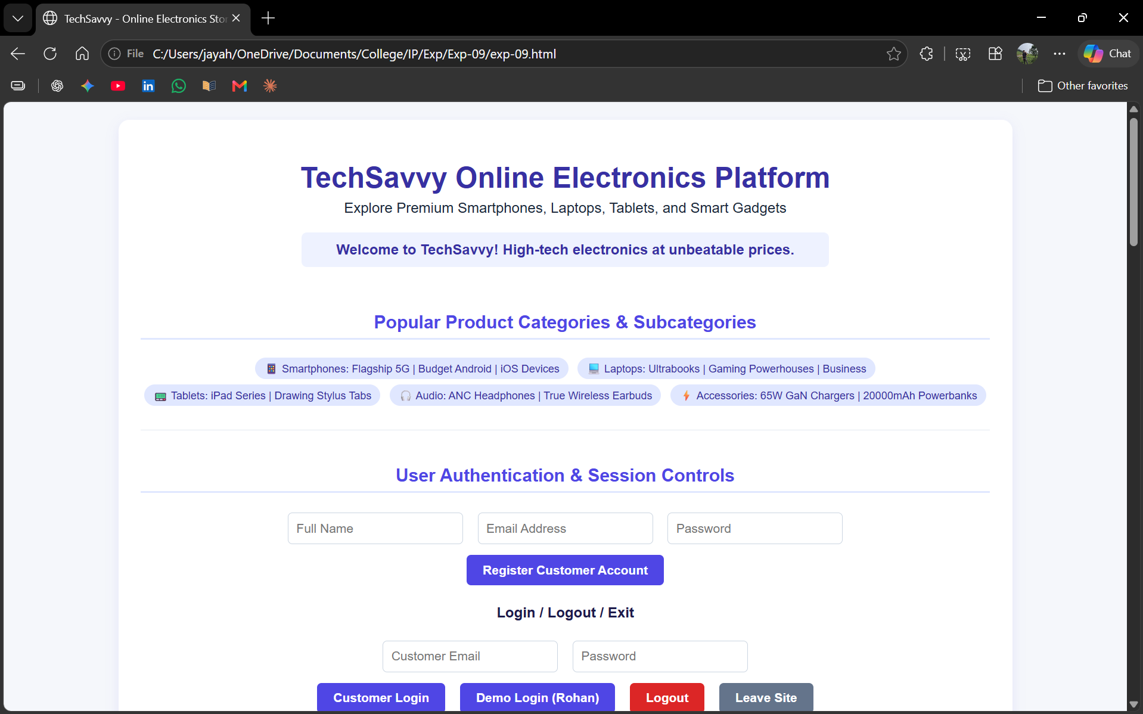
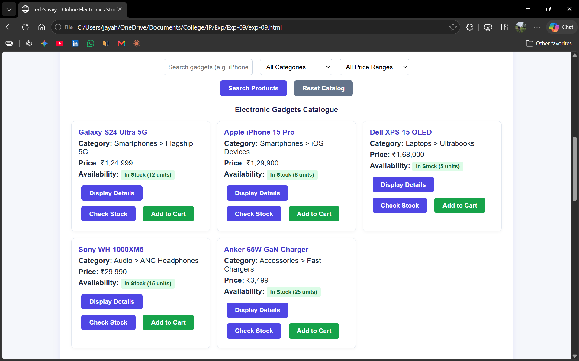
Result
Thus, an Online Electronics Shopping Platform webpage was created successfully using HTML, CSS, and JavaScript.

