Aim
To design and develop a simple Hotel Room Booking website using HTML that allows users to register, view room details, check availability, make bookings, view booking history, and manage their profiles. It also provides an administrator section to manage room types, prices, bookings, and hotel information.
Source Code
<!DOCTYPE html>
<html>
<head>
<title>Hotel Room Booking</title>
</head>
<body>
<h1>Welcome to Grand Hotel</h1>
<p>Book your comfortable stay with us!</p>
<hr>
<h2>User Registration</h2>
<form>
Name: <input type="text" placeholder="Enter name"><br><br>
Email: <input type="email" placeholder="Enter email"><br><br>
Password: <input type="password"><br><br>
<input type="submit" value="Register">
</form>
<h2>User Login</h2>
<form>
Email: <input type="email"><br><br>
Password: <input type="password"><br><br>
<input type="submit" value="Login">
</form>
<hr>

<h2>Search and Book Rooms</h2>
<form>
Destination: <input type="text" placeholder="Enter city"><br><br>
Check-in Date: <input type="date"><br><br>
Check-out Date: <input type="date"><br><br>
Number of Guests: <input type="number" min="1"><br><br>
Room Type:
<select>
<option>Single Room</option>
<option>Double Room</option>
<option>Deluxe Room</option>
<option>Suite Room</option>
</select>
<br><br>
<input type="submit" value="Check Availability">
<input type="submit" value="Book Room">
</form>
<h2>Room Details</h2>
<table border="1">
<tr>
<th>Room Type</th>
<th>Facilities</th>
<th>Price Per Night</th>
</tr>
<tr>
<td>Single Room</td>
<td>Bed, Wi-Fi, TV</td>
<td>Rs. 1500</td>
</tr>
<tr>
<td>Double Room</td>
<td>Double Bed, Wi-Fi, TV</td>
<td>Rs. 2500</td>
</tr>
<tr>
<td>Deluxe Room</td>
<td>AC, TV, Wi-Fi, Breakfast</td>
<td>Rs. 4000</td>
</tr>
<tr>
<td>Suite Room</td>
<td>Luxury Bed, AC, Wi-Fi, Mini Bar</td>
<td>Rs. 6000</td>
</tr>
</table>
<hr>
<h2>My Booking History</h2>
<table border="1">
<tr>
<th>Booking ID</th>
<th>Room Type</th>
<th>Check-in</th>
<th>Check-out</th>
<th>Status</th>
</tr>
<tr>
<td>101</td>
<td>Deluxe Room</td>
<td>10-11-2026</td>
<td>12-11-2026</td>
<td>Confirmed</td>
</tr>
</table>
<h3>Modify or Cancel Booking</h3>
<form>
Booking ID: <input type="text"><br><br>
New Check-in Date: <input type="date"><br><br>
New Check-out Date: <input type="date"><br><br>
<input type="submit" value="Modify Booking">
<input type="reset" value="Cancel Booking">
</form>
<p>Bookings can be modified or cancelled up to 3 days
before the arrival date, according to hotel policy.</p>
<hr>
<h2>Administrator Panel</h2>
<h3>Manage Rooms</h3>
<form>
Room Type:
<select>
<option>Single Room</option>
<option>Double Room</option>
<option>Deluxe Room</option>
<option>Suite Room</option>
</select><br><br>
Available Quantity: <input type="number"><br><br>
Price Per Night: <input type="number"><br><br>
<input type="submit" value="Update Room">
</form>
<h3>Manage Bookings</h3>
<form>
Booking ID: <input type="text"><br><br>
Customer Name: <input type="text"><br><br>
Booking Status:
<select>
<option>Confirmed</option>
<option>Cancelled</option>
<option>Completed</option>
</select><br><br>
<input type="submit" value="Update Booking">
</form>
<h3>Manage Hotel Information</h3>
<form>
Page Name:
<select>
<option>About Us</option>
<option>Contact Us</option>
<option>Room Information</option>
<option>Customer Service FAQ</option>
<option>Local Travel Guide</option>
<option>Privacy Policy</option>
</select><br><br>
Page Content:<br>
<textarea rows="5" cols="40"></textarea><br><br>
<input type="submit" value="Update Page">
</form>
<hr>
<h2>About Us</h2>
<p>Grand Hotel provides comfortable rooms and
quality service at affordable prices.</p>
<h2>Contact Us</h2>
<p>Address: Chennai, Tamil Nadu</p>
<p>Phone: 9876543210</p>
<p>Email: grandhotel@example.com</p>
<h2>Customer Service - FAQ</h2>
<p><b>Q: What time is check-in?</b></p>
<p>A: Check-in starts at 12 PM.</p>
<p><b>Q: Can I cancel my booking?</b></p>
<p>A: Yes, subject to the cancellation policy.</p>
<h2>Local Travel Guide</h2>
<p>Visit nearby beaches, temples, shopping centres,
and popular tourist attractions.</p>
<h2>Privacy Policy</h2>
<p>Customer information should be kept private
and used only for hotel services.</p>
<hr>
<p>Grand Hotel - 2026</p>
</body>
</html>
Output
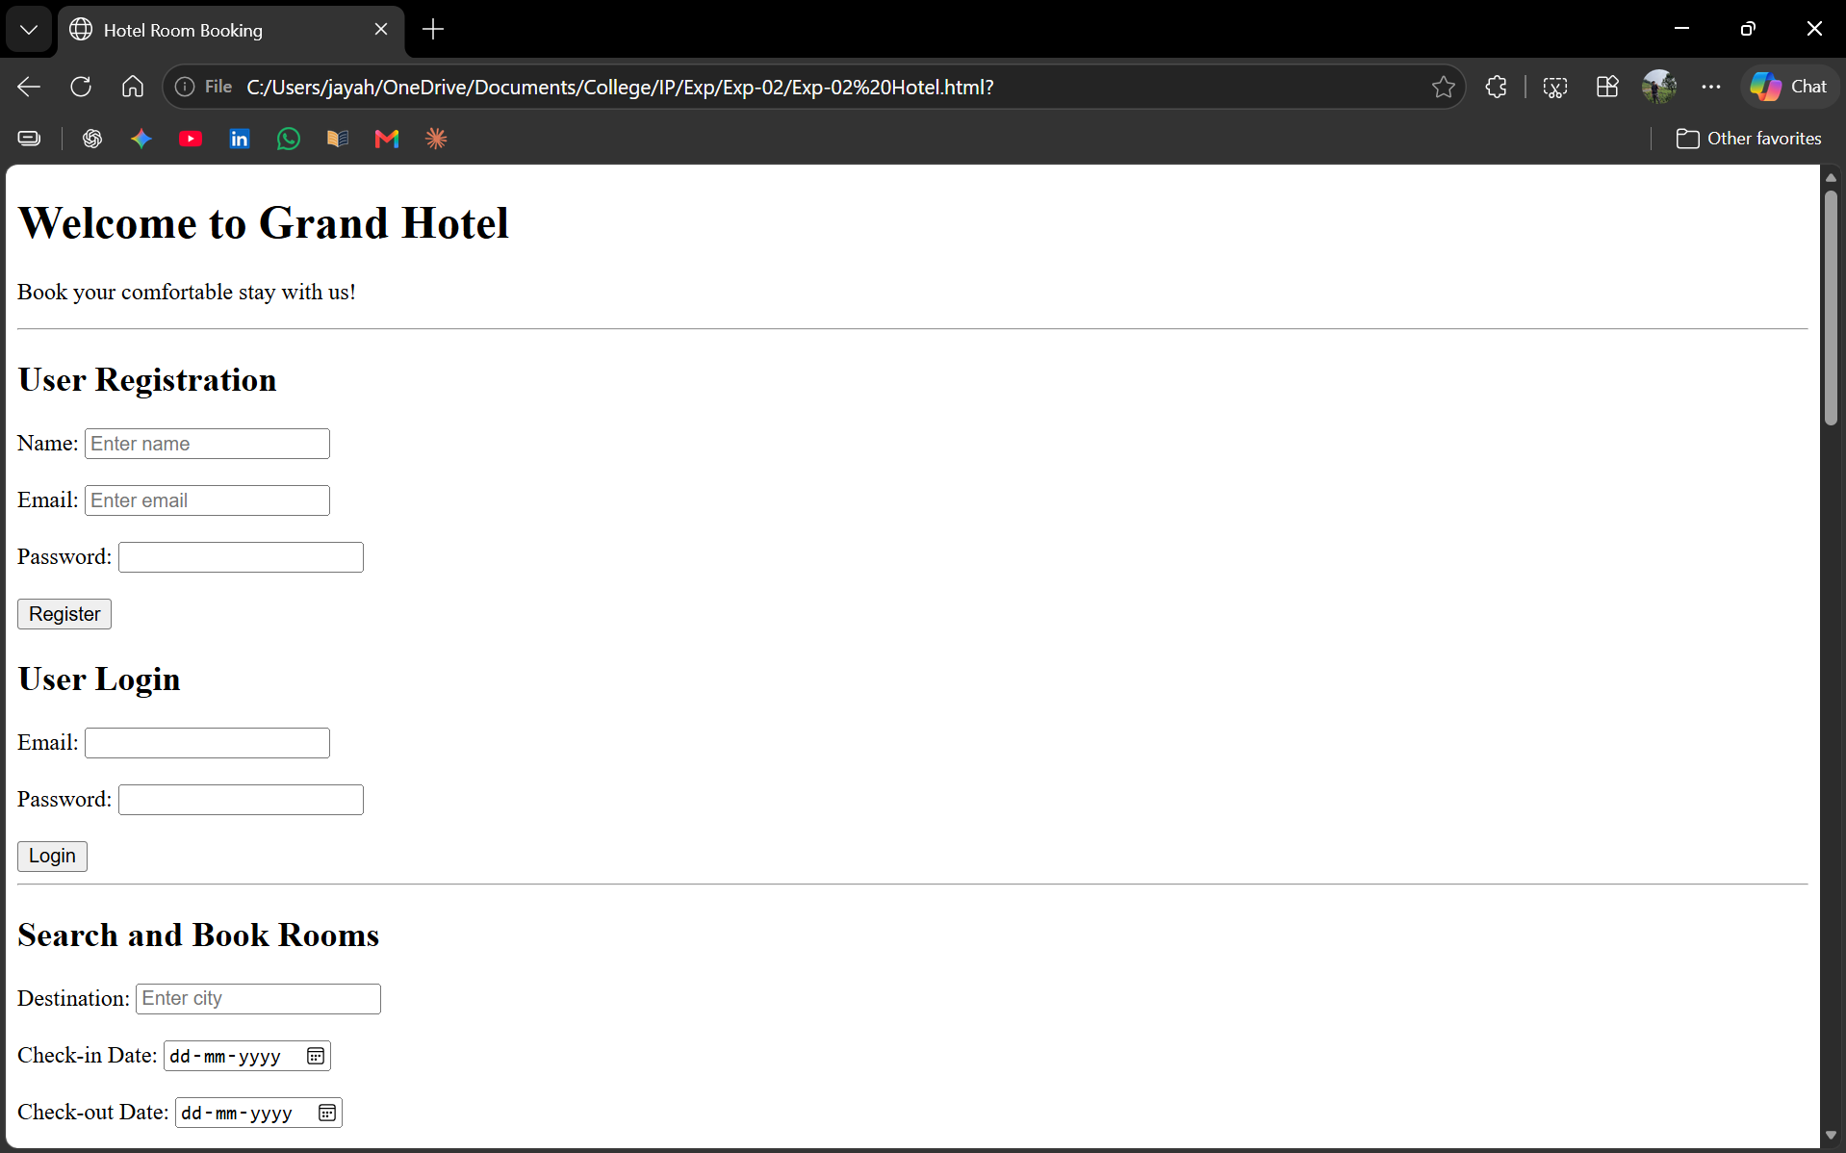

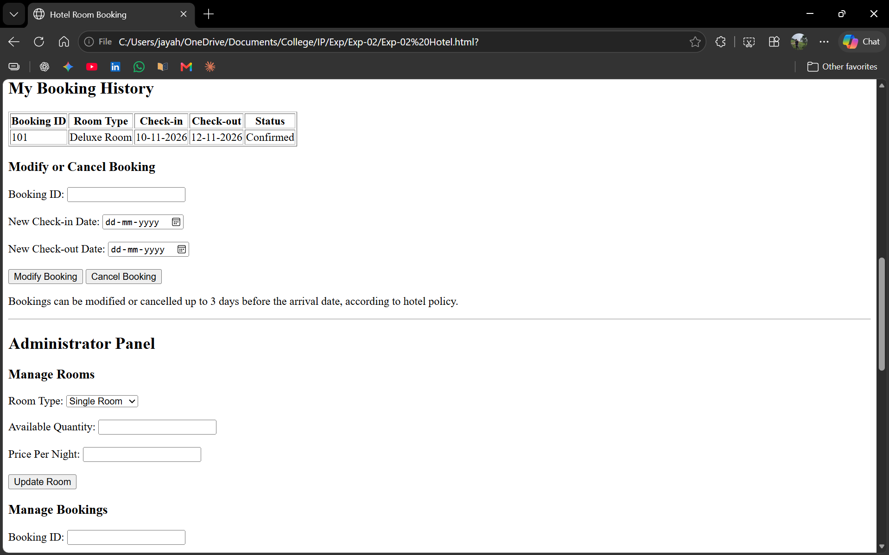
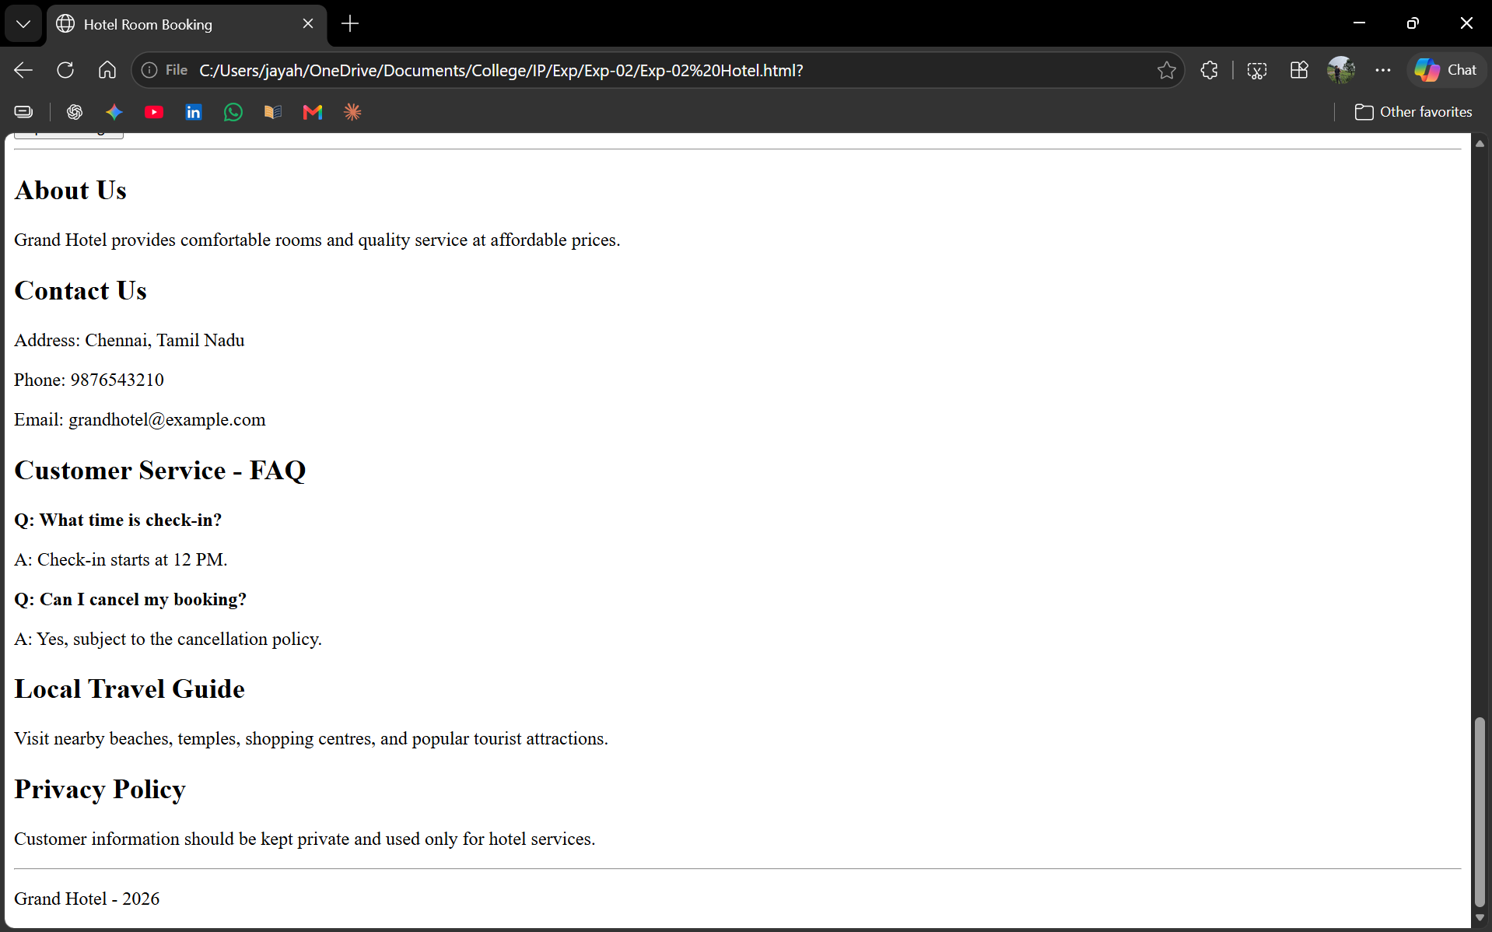

Result
Thus, a basic Hotel Room Booking website was created successfully using HTML.

