Name:Alluri Jaya Kalyan Varma
Mail:20pa1a0505@vishnu.edu.in
Date:10-09-2024

Task-1
To integrate Medusa on your local PC, follow these steps:

1. Install Node.js
- Download and install Node.js.

Installation Steps
- Download Node.js Installer:
  - Visit Node.js official website.
  - Click on the LTS (Long-Term Support) version to download the Windows Installer (.msi file).
- Run the Installer:
  - Double-click the downloaded .msi file to start the installation.
  - Follow the prompts in the setup wizard:
    - Click Next on the welcome screen.
    - Accept the license agreement and click Next.
    - Choose the default installation folder and click Next.
    - Ensure the options for "Node.js runtime" and "npm package manager" are selected, then click Next.
    - Click Install to begin the installation.
    - Click Finish when the installation is complete.
- Verify Installation:
  - Open Command Prompt (CMD) or PowerShell:
    - Press Win + R, type cmd or powershell, and press Enter.
- Check Node.js version:
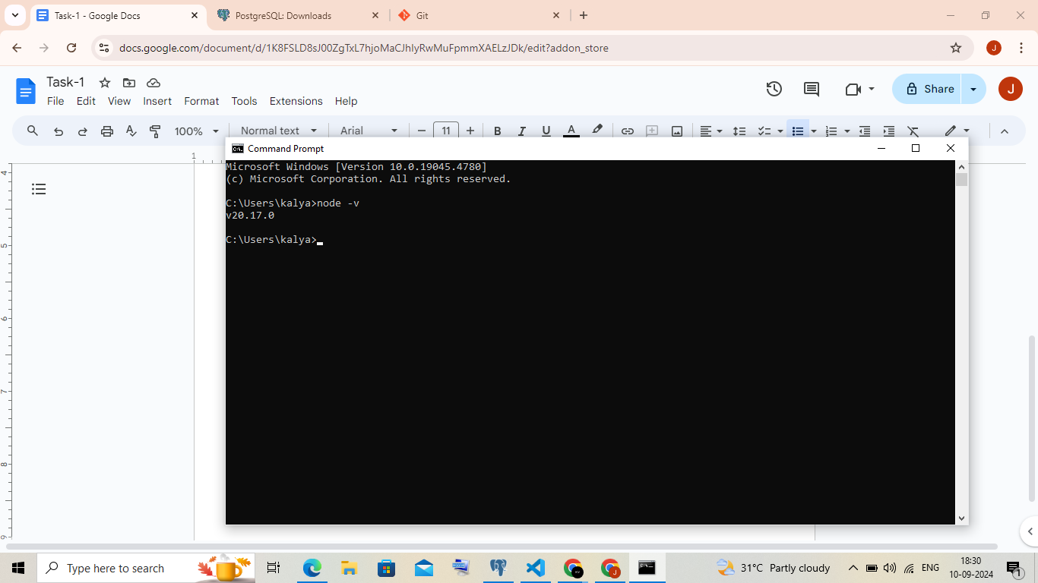
2. Install Git
Download the Git Installer:
- Go to the Git official website and click "Download" for Windows.
Run the Installer:
- Open the downloaded .exe file and follow the setup wizard. Click Next through the prompts, keeping the default settings.
Complete the Installation:
- Click Finish when the installation is done. Optionally, you can launch Git Bash right after installation.
Verify Installation:
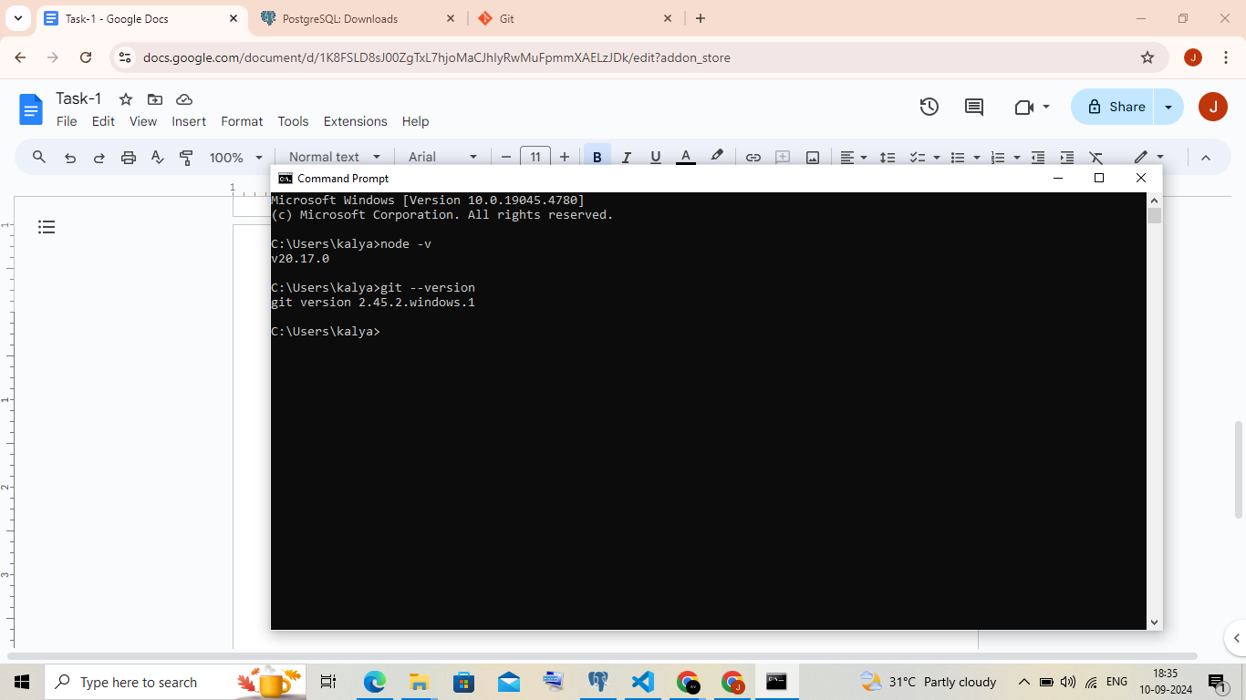

3. Install PostgreSQL
Download the Installer:
- Go to the PostgreSQL download page and select "Windows."
- Click on "Download the installer" to go to the EnterpriseDB site and download the .exe file.
- Run the Installer:
- Double-click the downloaded .exe file to start the installation.
- Follow the setup wizard and click Next through the prompts, using default settings or adjusting as needed.
Complete the Installation:
- Set the password for the PostgreSQL superuser (default user: postgres), choose the default port (5432), and click Finish when the installation is complete.
4. Create Medusa App
- Open your terminal and run:npx create-medusa-app@latest
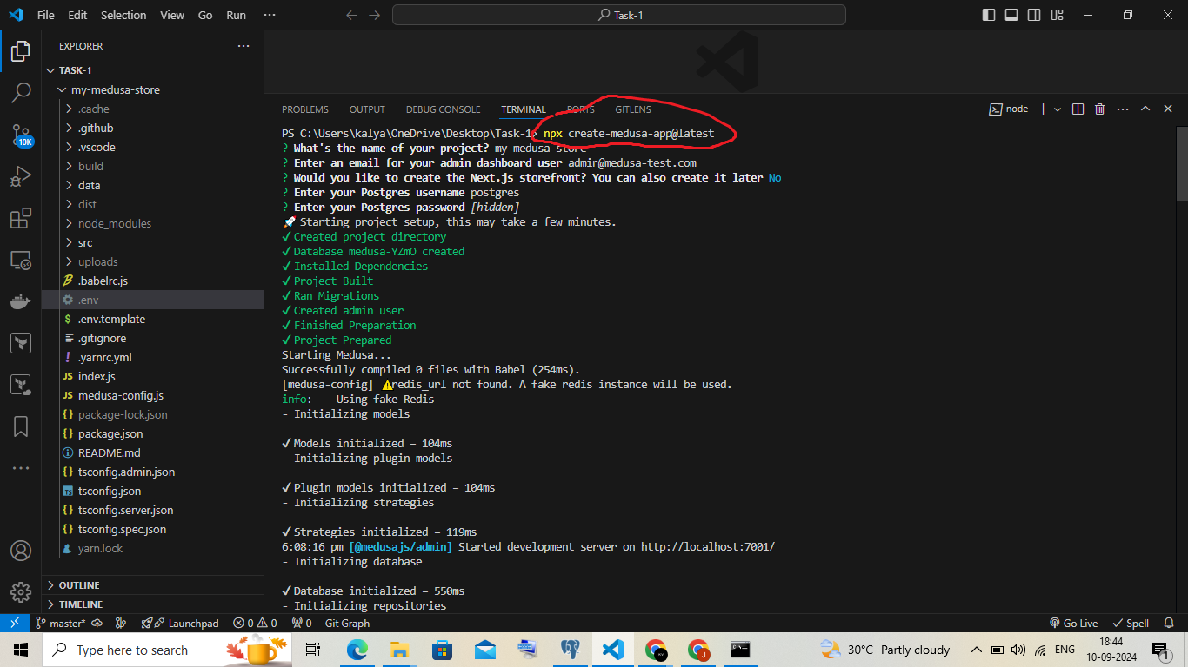
5.Specify a project name,Email
- Enter name of your project.
- Enter Email.

6. Configure PostgreSQL
- Set up a PostgreSQL database on your local PC. You'll need to configure the following environment variables in your .env file:
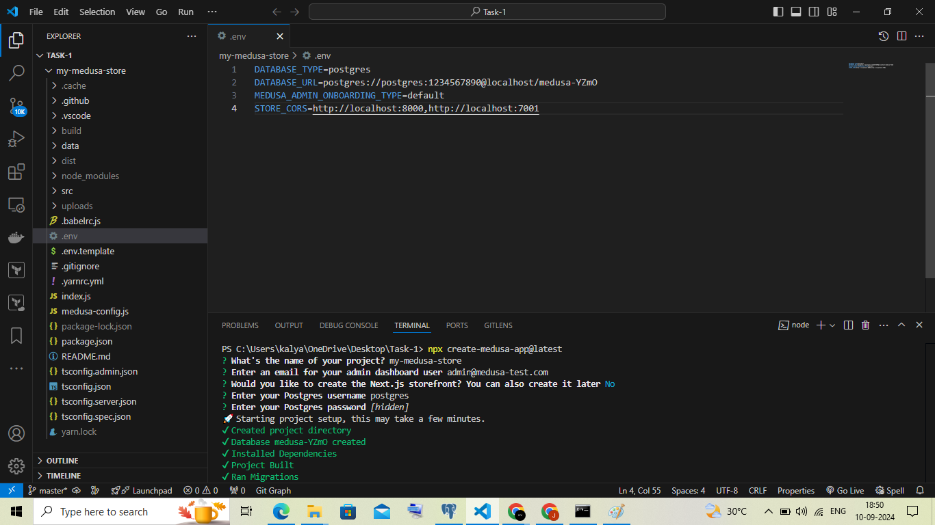

7. Install Dependencies
  - Navigate to your Medusa project folder and run these commands.
  - cd my-medusa-store
  - npm install
8.Finally run:npm run start
- Using npm run start will start the server locally, allowing you to interact with Medusa.
