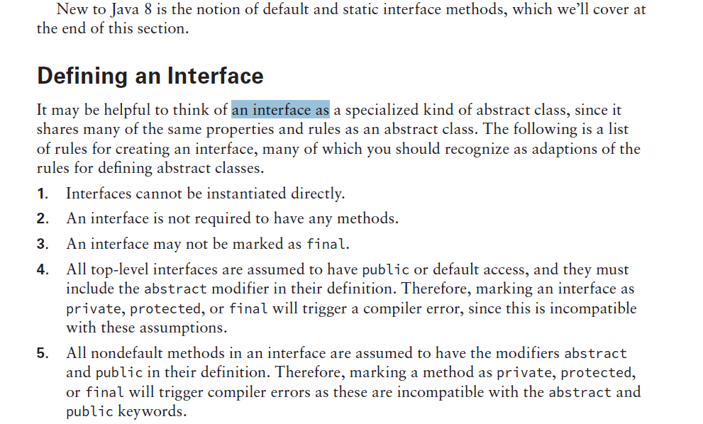

All interface fields are implicitly public, static and final

Interface methods :

Default : Contains method body

Static : Contains method body

Public abstract (implicit)