**Literals**

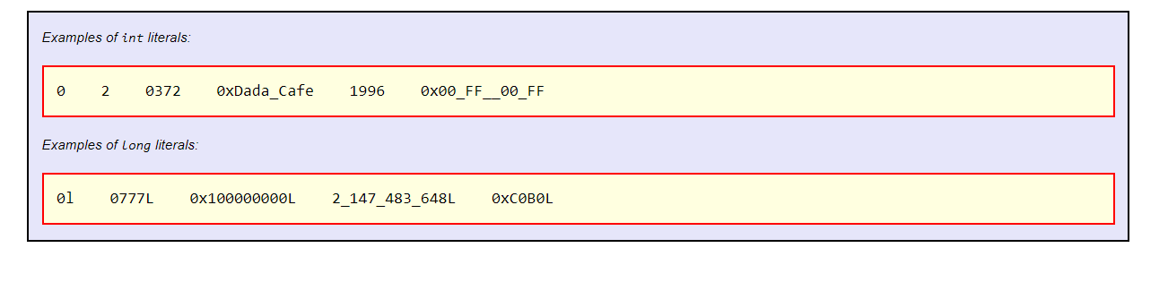

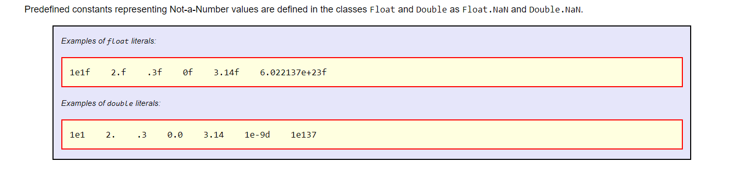

The largest positive hexadecimal, octal, and binary literals of type long - each of which represents the decimal value 9223372036854775807L (263-1) - are respectively:

* 0x7fff_ffff_ffff_ffffL,
* 07_7777_7777_7777_7777_7777L, and
* 0b0111_1111_1111_1111_1111_1111_1111_1111_1111_1111_1111_1111_1111_1111_1111_1111L

The most negative hexadecimal, octal, and binary literals of type long - each of which represents the decimal value -9223372036854775808L (-263) - are respectively:

* 0x8000_0000_0000_0000L, and
* 010_0000_0000_0000_0000_0000L, and
* 0b1000_0000_0000_0000_0000_0000_0000_0000_0000_0000_0000_0000_0000_0000_0000_0000L

The following hexadecimal, octal, and binary literals represent the decimal value -1L:

* 0xffff_ffff_ffff_ffffL,
* 017_7777_7777_7777_7777_7777L, and
* 0b1111_1111_1111_1111_1111_1111_1111_1111_1111_1111_1111_1111_1111_1111_1111_1111L