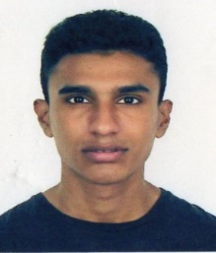

**Profile Summary:**

Jayakanth is an NUS graduate pursuing his career in software development. He is currently working in Capgemini Singapore Pte Ltd where he is being trained in software development.

**Education background:**  Aug 2011 – Dec 2015

**BEng (Mechanical Engineering) , National University Of Singapore**

* Graduated with Honours

**Technology Skill Set:**

* **Programming Languages:** Core Java, C, HTML/HTML5, CSS3, JavaScript
* **Tools:** SonarQube, Maven, Gradle
* **Databases:** MySQL, Oracle Database 11g
* **Web:** Servlets, JSP, Spring
* **ORM:** JPA, Hibernate
* **Frameworks:** Ember.js,
* **SCM:** Git

**Professional Experience:**

|  |  |
| --- | --- |
| **Capgemini Singapore Pte Ltd** | Jan 2018 – Current |

*Associate Consultant (Java Developer)*

* Underwent a 9-week long training program with exposure to Java, SQL, JavaScript, SPRING framework, Ember.js

**Equinix** Feb 2017– Nov 2017

*Software Programmer (Java Developer)*

* Worked in an agile team environment
* Developed APIs for new features that were implemented in portals
* Created Excel reports using Apache Poi API that involved data restructuring
* Created and ran selenium test cases during testing phase