Assignment 23

Select * from employees;

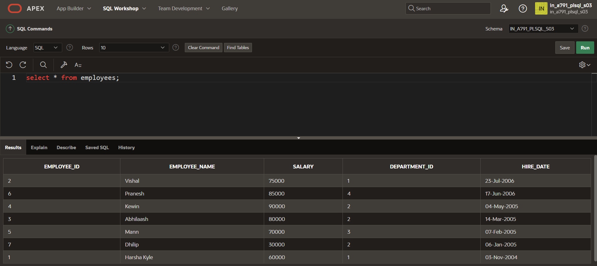

CREATE OR REPLACE PROCEDURE EMP_DET IS

v_emp_id EMPLOYEES.EMPLOYEE_ID%TYPE;

v_emp_name EMPLOYEES.EMPLOYEE_NAME%TYPE;

v_salary EMPLOYEES.salary%TYPE;

BEGIN

v_emp_id:=6;

v_emp_name:='Mohan';

v_salary:=47000;

INSERT INTO EMPLOYEES VALUES(v_emp_id,v_emp_name,v_salary);

END;

/

BEGIN EMP_DET;

END;

/

Select * from employees;

