Assignment 24

Select * from employees;

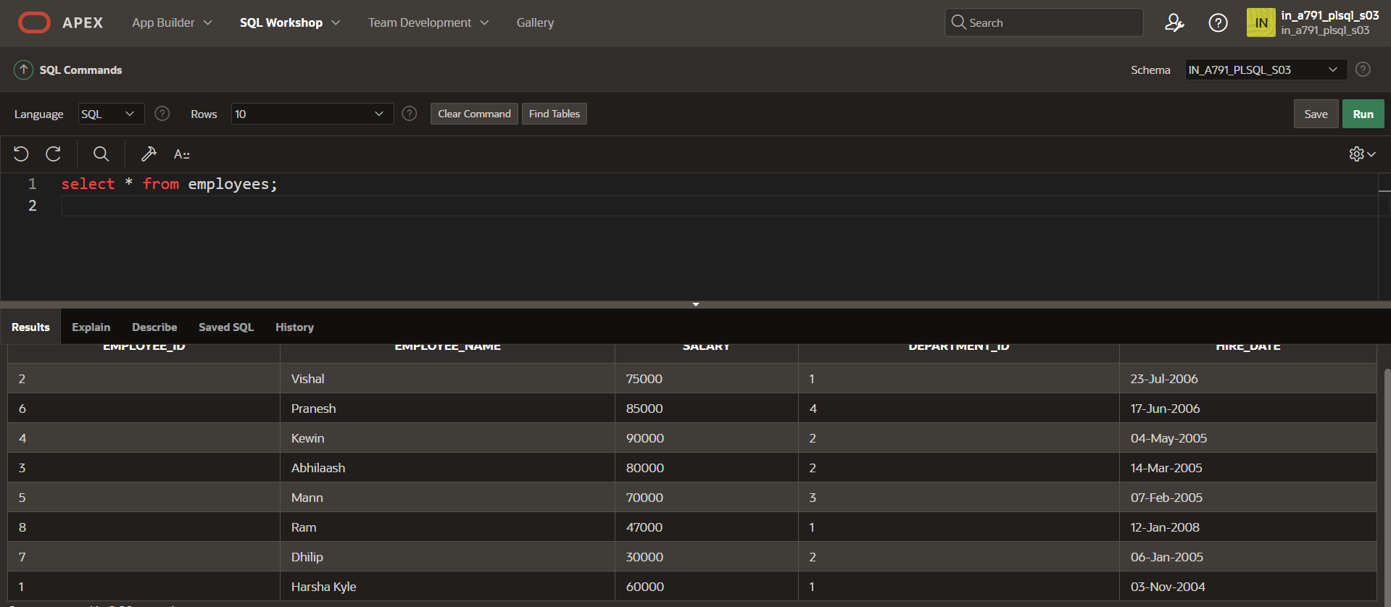

CREATE OR REPLACE PROCEDURE r_salary

(v_emp_id IN EMPLOYEES.EMPLOYEE_ID%TYPE,

v_raise_salary IN INT)

IS

BEGIN

UPDATE EMPLOYEES

SET SALARY=SALARY*(1+v_raise_salary/100)

WHERE EMPLOYEE_ID=v_emp_id;

END r_salary;

BEGIN r_salary(3,10);

END;

/

Select * from employees;

