Assignment 25

SELECT *FROM EMPLOYEES ORDER BY EMPLOYEE_ID;

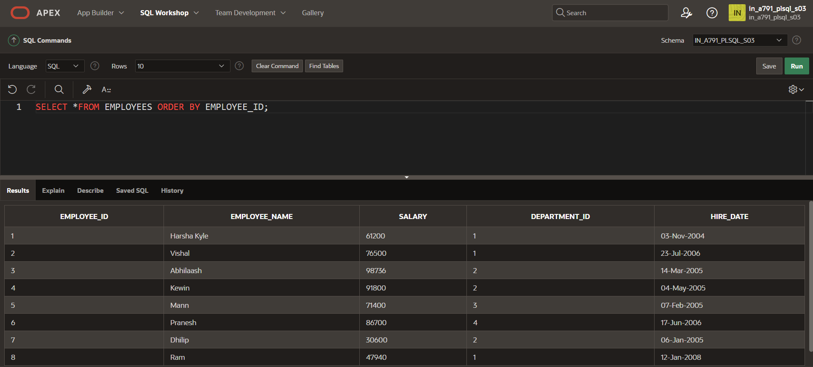

CREATE OR REPLACE PROCEDURE process_employees

IS

CURSOR emp_cursor IS

SELECT EMPLOYEE_ID

FROM EMPLOYEES;

BEGIN

FOR v_emp_rec IN emp_cursor

LOOP

r_salary(v_emp_rec.EMPLOYEE_id,2);

END LOOP;

END process_employees;

/

**BEGIN process_employees;**

**END;**

SELECT *FROM EMPLOYEES ORDER BY EMPLOYEE_ID;

