Assignment 26

OUT and IN OUT

**CREATE TABLE EMPLOYEE_DETAIL (EMP_ID INT PRIMARY KEY,EMP_NAME VARCHAR(20),SALARY INT);**

**INSERT INTO EMPLOYEE_DETAIL VALUES(1,'Harsha',30906);**

**INSERT INTO EMPLOYEE_DETAIL VALUES(2,'Vishal',31421);**

**INSERT INTO EMPLOYEE_DETAIL VALUES(3,'Abhilaash',16998);**

**OUT**

**CREATE OR REPLACE PROCEDURE q_emp**

**(p_id IN employee_detail.emp_id%TYPE,**

**p_name OUT employee_detail.emp_name%TYPE,**

**p_salary OUT employee_detail.salary%TYPE)**

**IS**

**BEGIN**

**SELECT emp_name,salary INTO p_name, p_salary**

**FROM employee_detail**

**WHERE emp_id = p_id;**

**END q_emp;**

**OUTPUT STATEMENT:**

**DECLARE**

**a_emp_name employee_detail.emp_name%TYPE;**

**a_emp_sal employee_detail.salary%TYPE;**

**BEGIN**

**q_emp(1, a_emp_name, a_emp_sal);**

**DBMS_OUTPUT.PUT_LINE('Name: ' || a_emp_name);**

**DBMS_OUTPUT.PUT_LINE('Salary: ' || a_emp_sal);**

**END;**

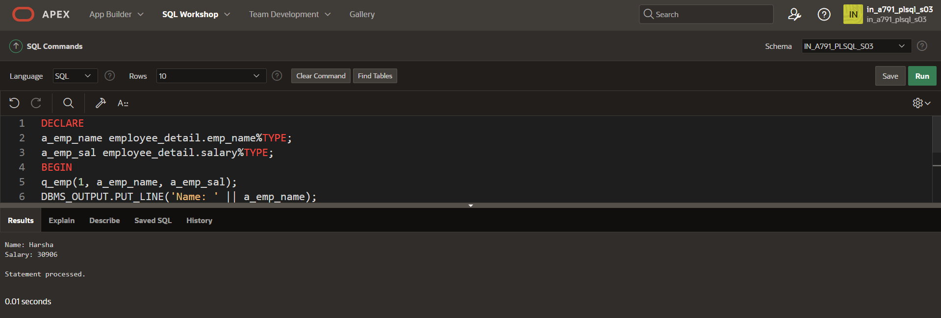

**IN OUT**

**CREATE OR REPLACE PROCEDURE update_employee_salary (**

**p_emp_id IN employee_detail.emp_id%TYPE,**

**p_new_salary IN OUT employee_detail.salary%TYPE**

**)**

**IS**

**BEGIN**

**UPDATE employee_detail**

**SET salary = p_new_salary**

**WHERE emp_id=p_emp_id;**

**SELECT salary INTO p_new_salary**

**FROM employee_detail**

**WHERE emp_id=p_emp_id;**

**COMMIT;**

**END update_employee_salary;**

**/**

**OUTPUT STATEMENT:**

**DECLARE**

**v_emp_id employee_detail.emp_id%TYPE := 1;**

**v_new_salary employee_detail.salary%TYPE := 50000;**

**BEGIN**

**update_employee_salary(v_emp_id, v_new_salary);**

**DBMS_OUTPUT.PUT_LINE('Updated Salary: ' || v_new_salary);**

**END;**

**/**

