**37.** **Using Native Dynamic SQL to Recompile PL/SQL Code**

**ALTER PROCEDURE d_any_table COMPILE;**

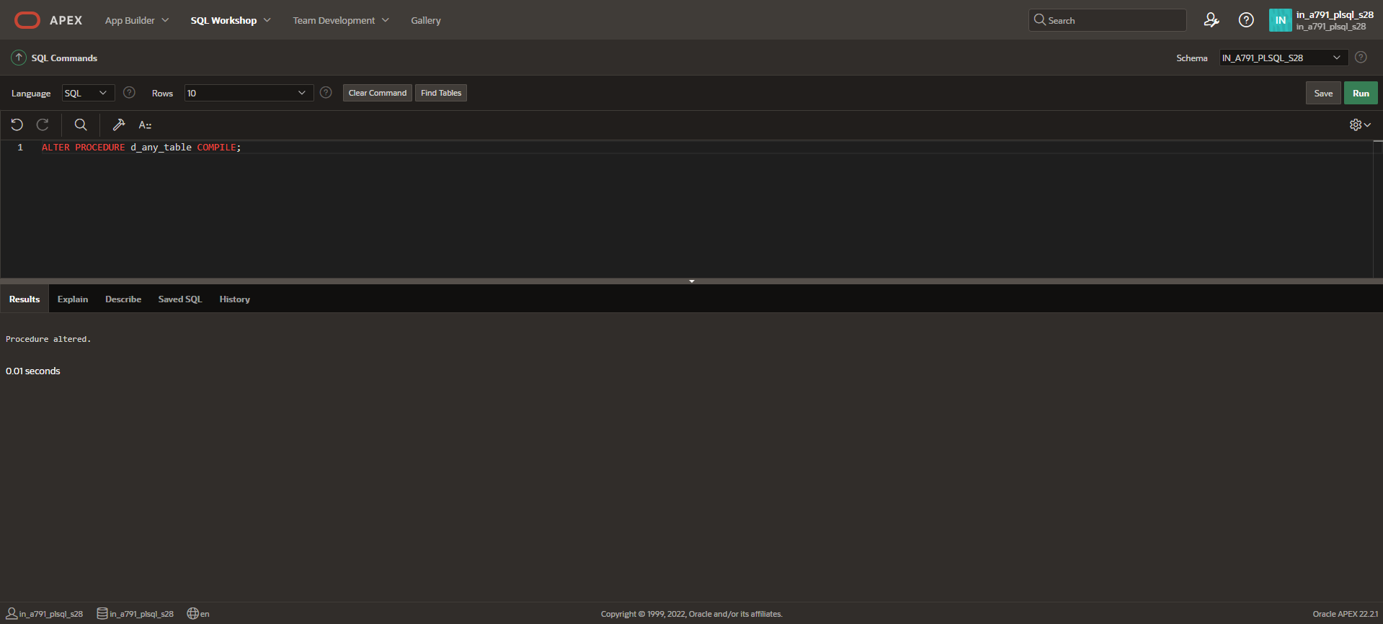

**ALTER FUNCTION d_rows COMPILE;**

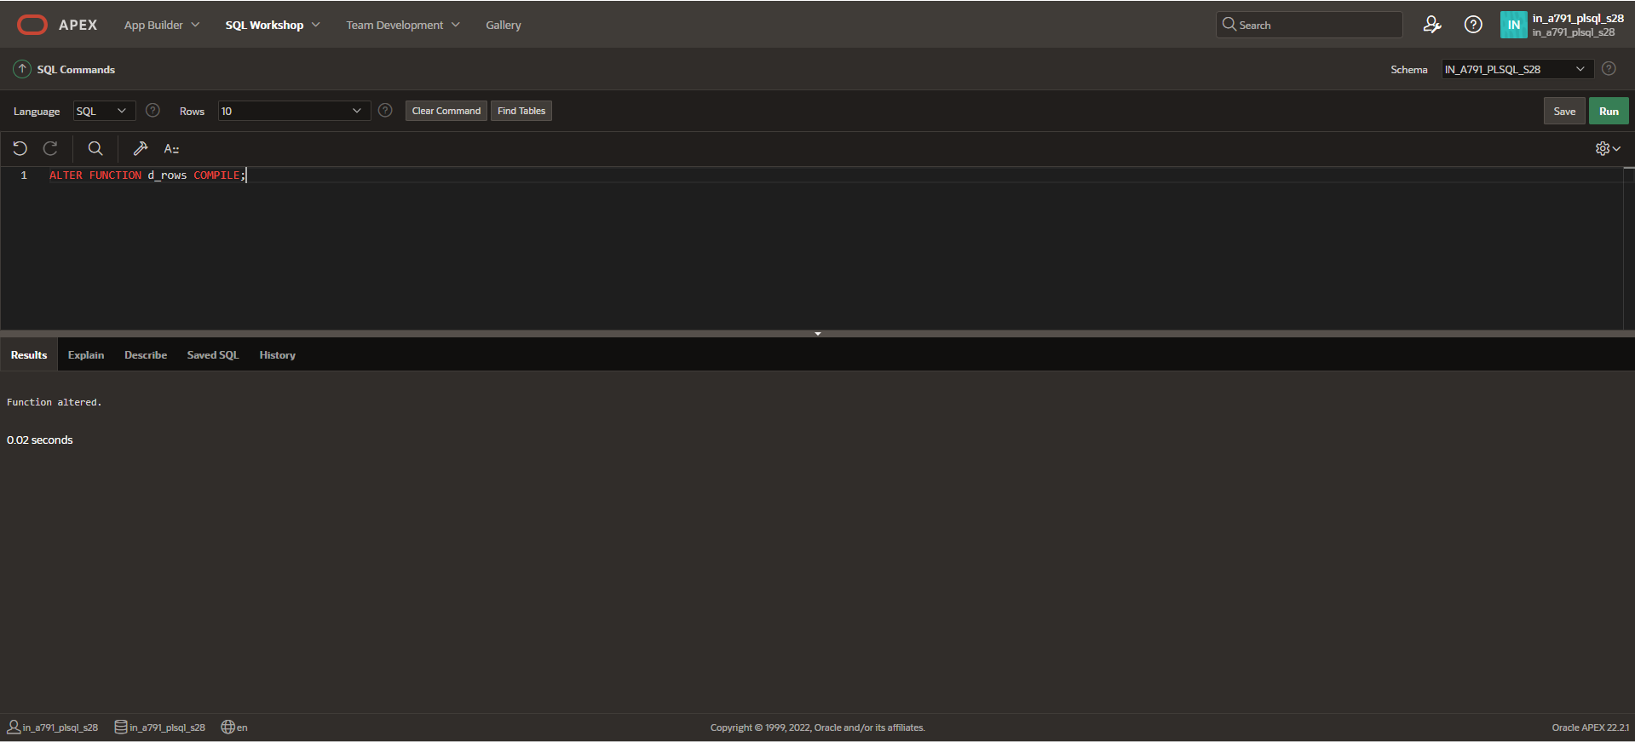

**ALTER PACKAGE dept_pkg COMPILE;**

