-- Query 1

-- find top top 10 highest revenue generating products

select product_id, round(cast(sum(sale_price) as numeric),2) as sales

from df_orders

group by product_id

order by sales desc

limit 10

– Data Output

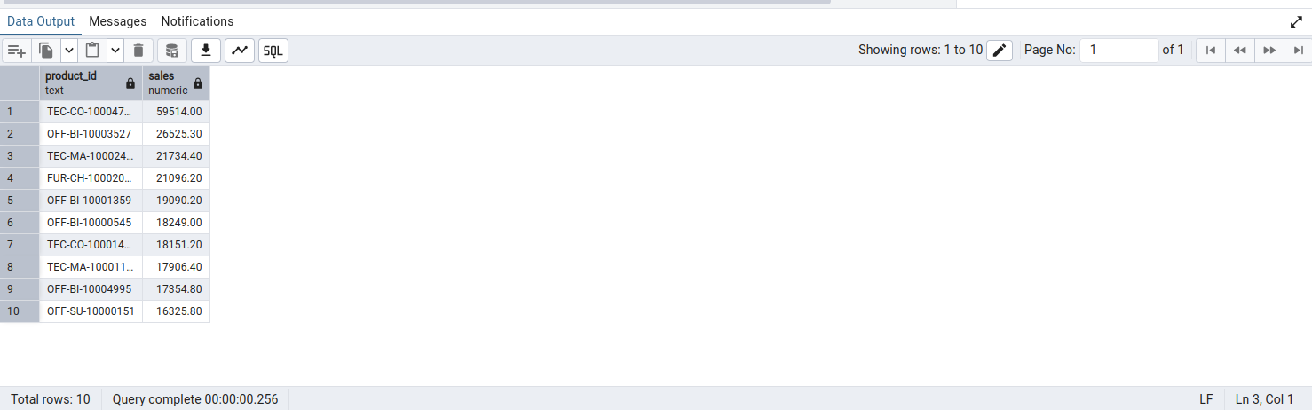

– Query 2

-- find top 5 highest selling products in each region

with cte as (select region, product_id, round(cast(sum(sale_price) as numeric),2) as sales

, row_number() over(partition by region order by sum(sale_price) desc)

from df_orders

group by region, product_id)

select * from cte

where row_number <= 5

– Data Output

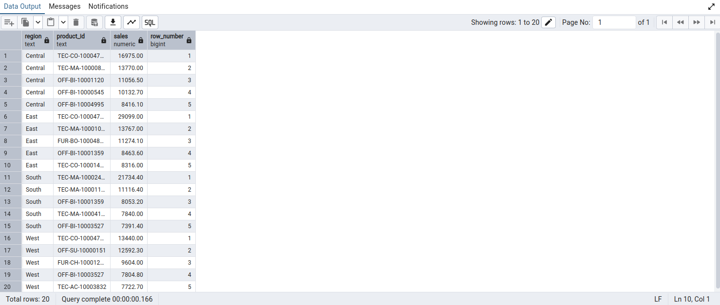

– Query 3

--find month over month growth comparison for 2022 and 2023 sales eg: jan 2022 vs jan 2023

with cte as (select date_part('year', cast(order_date as date)) as order_year

, date_part('month', cast(order_date as date)) as order_month, sum(sale_price) as sales

from df_orders

group by date_part('year', cast(order_date as date)), date_part('month', cast(order_date as date)))

select order_month

, round(cast(sum(case when order_year = 2022 then sales else 0 end) as numeric),2) as sales_2022

, round(cast(sum(case when order_year = 2023 then sales else 0 end) as numeric),2) as sales_2023

from cte

group by order_month

order by order_month

– Date Output

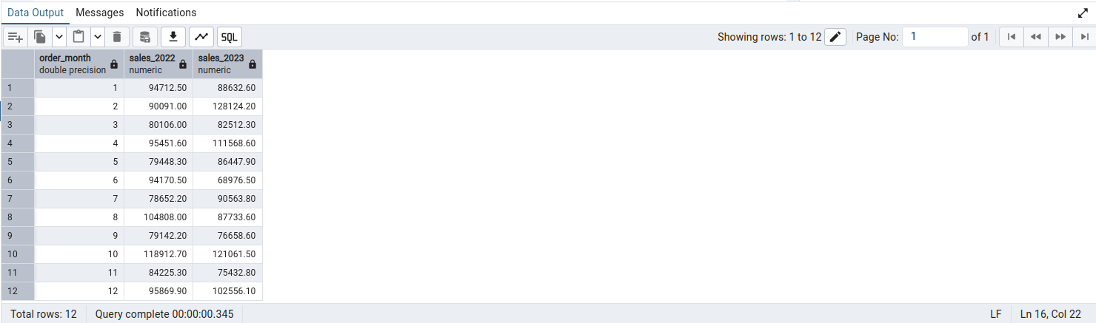

--Query 4

--for each category which month had highest sales

with cte as (select category, to_char(cast(order_date as date), 'yyyyMM') as order_year_month

, round(cast(sum(sale_price) as numeric),2) as sales

from df_orders

group by category, to_char(cast(order_date as date), 'yyyyMM')

order by category, to_char(cast(order_date as date), 'yyyyMM'))

select * from (

select *, row_number() over(partition by category order by sales desc) as rn

from cte)

where rn = 1

--Data Output

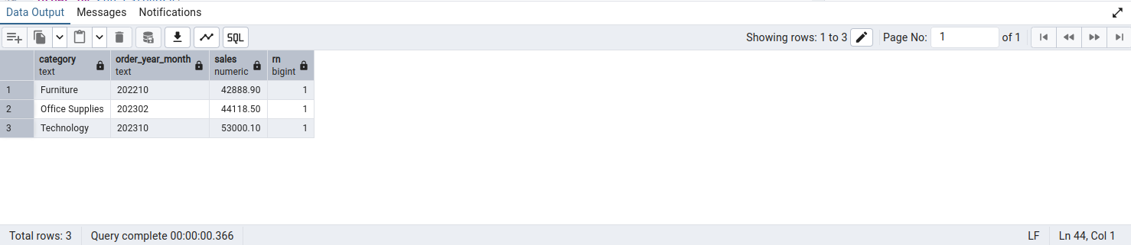

--Query 5

--which sub category had highest growth by profit in 2023 compare to 2022

with cte as (select sub_category, date_part('year', cast(order_date as date)) as order_year

, sum(sale_price) as sales

from df_orders

group by sub_category, date_part('year', cast(order_date as date))),

cte2 as(

select sub_category

, round(cast(sum(case when order_year = 2022 then sales else 0 end) as numeric),2) as sales_2022

, round(cast(sum(case when order_year = 2023 then sales else 0 end) as numeric),2) as sales_2023

from cte

group by sub_category

order by sub_category)

select *

, round((sales_2023-sales_2022) * 100 / sales_2022,2) as growth_perc

from cte2

order by (sales_2023-sales_2022) * 100 / sales_2022 desc

limit 1

-Data Output

