**Uploading a narrative**

1) Folder ----------- Where the output will be stored

2) Narrative ------ The narrative file

3) GPS ---- The GPS file

4) Offset --- offset time in hh:mm:ss

5) Sentence Time --- max interpolation time in seconds

6) Upload button ---- to upload

7) Narrative ---- Select the required narrative

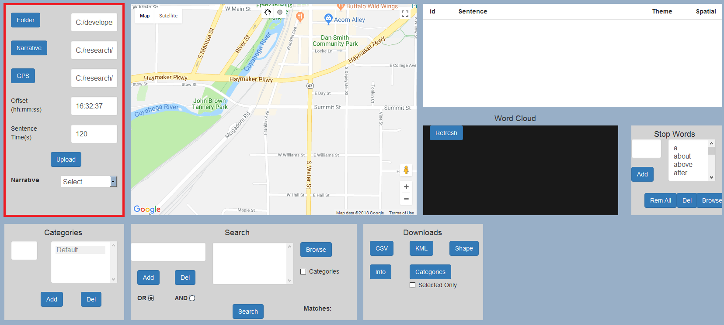

**Selecting a narrative**

1) Once selected, the narrative sentences will start to appear in the narrative table

2) The word cloud will appear.

3) Markers with sentences will appear.

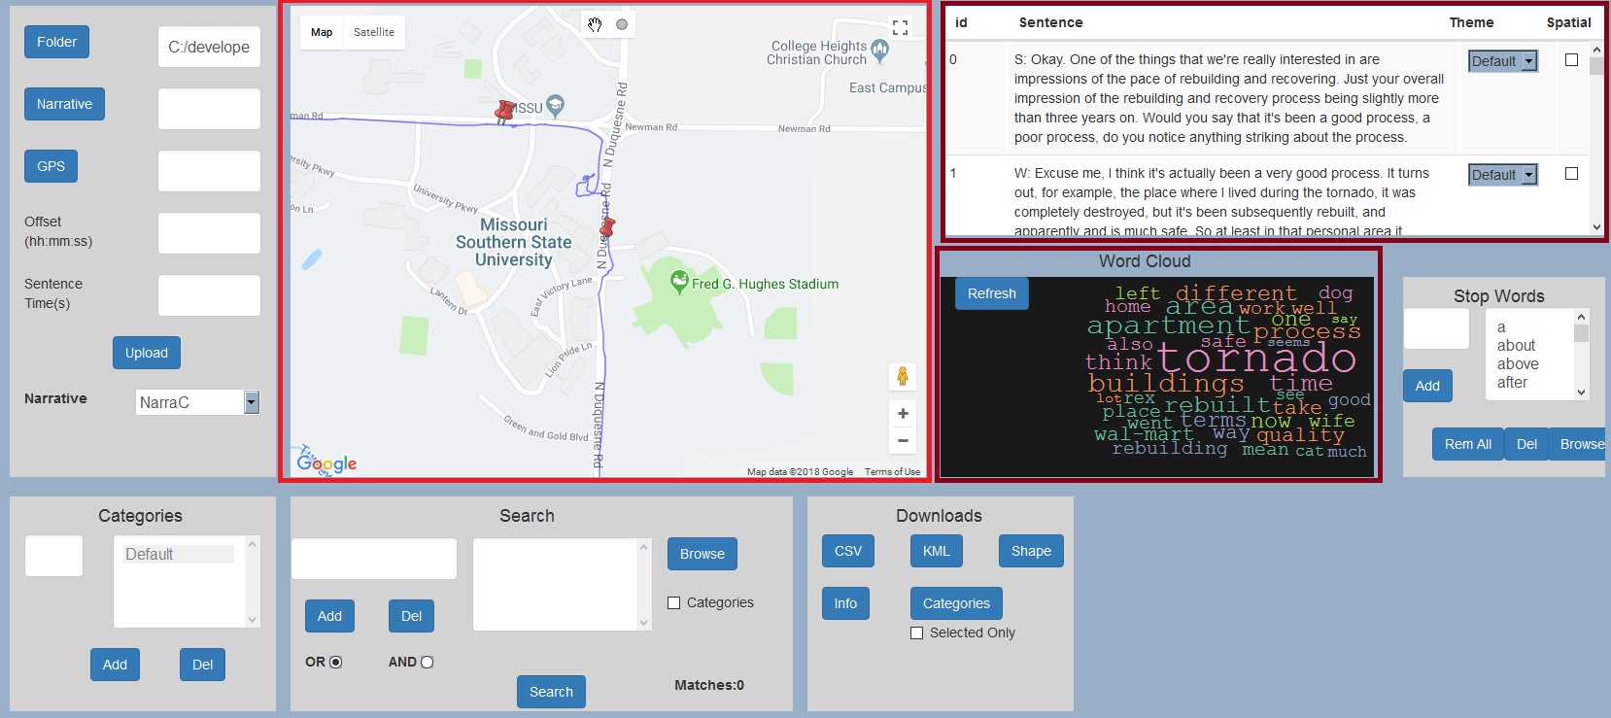

**Adding Categories**

1) Type categories to the category text box

2) Click add to add a category, and del to remove it (for removing the category must be selected by a click)

3) Corresponding Categories will start appearing in the narrative table theme column

4) For this example we have created three categories spatial, spatially inspired, and spatially fuzzy

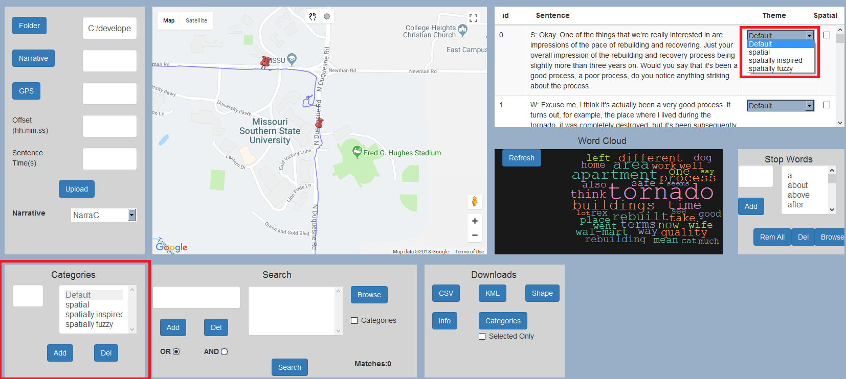

**Stopwords**

1) User can add stopwords using stopword box

2) User can remove all stopwords by clicking Rem All

3) User can upload a custom stopword file by clicking on the browse button. The stopword file should have words split by new lines , an eg

the

this

that

4) User can click the Refresh button on the word cloud to update the word cloud with respect to the stopwords

**Word Cloud**

1) Word cloud will be generated for each narrative and will get modified with respect to the searach changes and stopwords. User can modify stopwords and click refresh to view the changes in wordcloud

2) Word cloud could also be used to create consecutive searches. A click on any word would generate a new search query with that word

An example of clicking on the word tornado. A new search keyword tornado will be added to the search parameters.

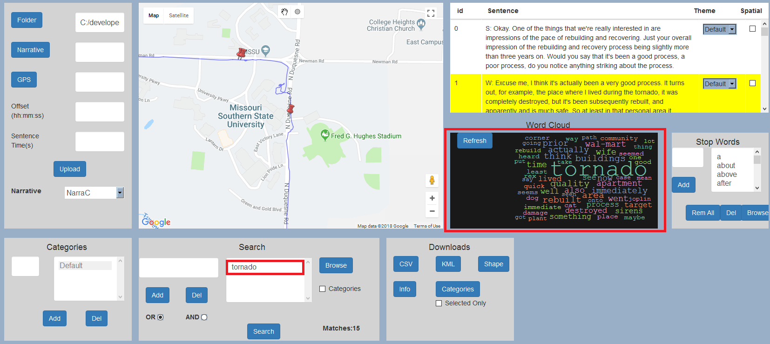

**Search**

1) Main feature of word mapper

2) User can type in the keyword, and add it, as well as remove it

3) Upload a search word file to populate the search word list

4) combine results with OR or AND , with OR looks for any matching, while AND looks for constrained matching

5) Matching results will be displayed on the Matches section.

6) Matching results will have a yellow marker and the corresponding sentences will be highlighted in yellow

A search for the word tornado

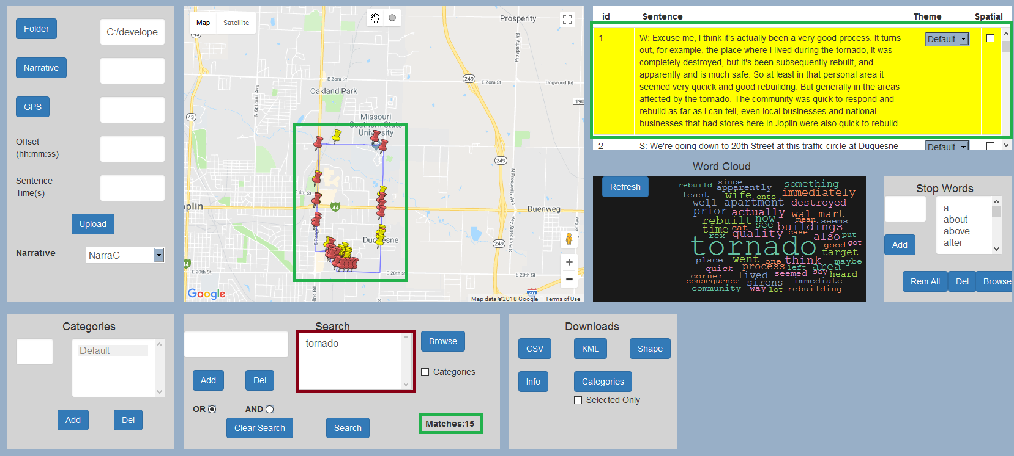

7) Categories could be included for searching by clicking on the check box categories and selecting the categories to search through by clicking in the category option

In this example we are searching only for tornadoes categorized under spatially fuzzy category.

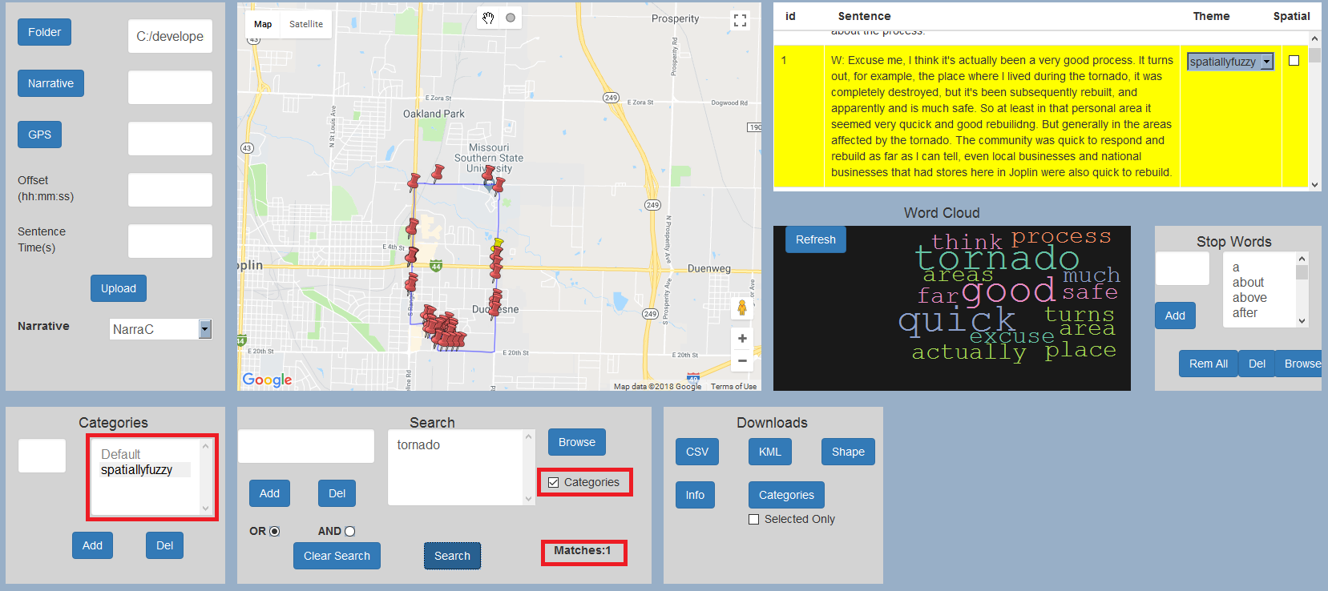

8) Clear search could be used to clear all matches and reload the narrative

9) If used without any keywords, a category based search will return all sentences that match a category

**Downloads**

1) CSV for downloading sentences and words

2) KML for kml sentence and word

3) Shape to download word and sentence shape file

4) Info to download current narrative details including search words stop words file name etc

5) Categories to download shapefile with sentence and category as attribute

6) if selected only is checked, only selected data based on search will be downloaded