ZUCI HACKFEST '26 · AGENTIC PRESCRIPTIVE ANALYTICS
From Prediction to Governed Action
Zuci Agent Services — Agentic Prescriptive Analytics Hackfest Showcase

Combined Executive Summary, Showcase, Architecture, Decision Trace, Demo Script, and Evidence Mapping.
Generated September 19, 2026

Zuci Agent Services — Agentic Prescriptive Analytics Hackfest Showcase

1. Executive Summary
The message: Prediction tells us what is likely to happen. Our solution focuses on what should happen next.
Zuci Agent Services processes insurance claim documents end-to-end — upload, AI-assisted extraction, source verification, policy-governed routing, and human-approved resolution — on a real Angular + FastAPI + Google Gemini stack, with zero external database (in-memory Python repositories).
The story, in one line: a computed signal (document relevance score + AI extraction confidence) is turned into a governed, explainable action through three configured policy thresholds and a repeated "AI drafts, deterministic code decides" pattern — proven four separate times in one working application, not once.
What is proven [IMPLEMENTED]:
- Real signal → policy → action pipeline (25% / 60% / 70% thresholds, core/config.py)
- Four bounded AI agents, each immediately checked by deterministic code (source-text grounding, whitelist filtering, confidence overrides)
- Live KPIs computed from the same claim data the pipeline just wrote — no batch delay (Governance, Managed Operations)
- Human-in-the-loop by construction — "Approve & Resolve" is the only path to a final decision
What is honestly not yet built [PROPOSED]:
- A trained prediction model (today's "signal" is computed per-document, not forecast from history)
- A true optimization step comparing alternative actions (ROI/Revenue tabs are fixed arithmetic, not a solver)
- A feedback/learning loop (corrections update only the current record)
- Multi-role RBAC and backend authentication (one mock role; the API is fully open today)
The closed loop, mapped honestly:
DATA[implemented] -> PREDICTION[partial] -> RULES & POLICY[implemented] -> OPTIMIZATION[partial]
-> AI AGENT[implemented] -> OUTCOME[implemented] -> KPI[implemented]
-> LEARNING[proposed] -> NEXT DECISION[partial]

2. Current Business Problem
Message: Manual claim intake is slow, inconsistent, and stops at "here's a number" — a human still has to decide, unaided, what to do about it.
Before (the actual manual workflow this application replaces):
DATA (faxed/scanned claim)
|
ANALYST reads the document manually
|
MANUAL REVIEW — retype up to 15 fields, cross-check by eye
|
BUSINESS RULE CHECK — inconsistent, judgment-based, not codified
|
DECISION — varies by reviewer, not recorded systematically
|
ACTION

Real pain points this application addresses:
- A human must retype up to 15 fields per document (patient, policy, hospital, financial amounts).
- Faxed/scanned documents often have no text layer — ad hoc OCR or manual reading.
- Cross-checking a value against the source document is tedious and skipped under time pressure.
- No systematic way to catch a document with two conflicting values for the same field.
- "Is this even a valid claim?" is a subjective, reviewer-dependent judgment.
- No consistent, auditable policy for "auto-process vs. escalate vs. reject."
SCREEN: Fax Intake (/queue/all) — PURPOSE: shows the exact document a reviewer would otherwise process by hand. DEMO ACTION: upload a real sample claim PDF. EXPECTED RESULT: real per-stage progress labels, not a spinner. BUSINESS MESSAGE: "Every stage you see here replaces a manual step a reviewer used to do by hand."

3. What Existing Solutions Do
Capability | What it provides | Remaining limitation
Descriptive analytics [IMPLEMENTED] | Live counts, status distribution, confidence buckets (Governance/Managed Operations) | Describes what happened — does not decide what to do next
Diagnostic analytics [IMPLEMENTED] | Per-field confidence, source-page citation, conflict flags | Explains why a value looks uncertain — still needs a policy to act on it
Predictive analytics [PARTIALLY IMPLEMENTED] | Document relevance score + AI extraction confidence, computed per document | Not a trained forecasting model over historical outcomes
Rule-based decision systems [IMPLEMENTED] | Three configured thresholds route every claim identically | Rules alone can't draft a narrative recommendation or reason over unstructured text
Workflow automation [IMPLEMENTED] | Async upload → extraction → routing pipeline | Automates the pipeline, not the judgment call within it
Generative AI [IMPLEMENTED] | Gemini drafts field values, chat answers, process assessments, simulated agent output | A draft is not a decision until deterministic code checks it
Agentic AI [PARTIALLY IMPLEMENTED] | Four bounded, code-governed AI touch points | No autonomous multi-step planning — a fixed, human-defined sequence only

This is not a criticism of any single capability — each does its job well. The gap is that none of them, alone, closes the loop from signal to governed action to measured outcome.

4. What Gap Remains
Prediction ≠ Decision.
Prediction / Signal
|
Business Decision <-- this step is where most systems leave a human unaided
|
Action
|
Outcome

Missing link | Present here?
Context (already-extracted claim fields) | [IMPLEMENTED]
Eligibility check | [PARTIALLY IMPLEMENTED] — deterministic lookup exists, backing data table is an empty placeholder
Rules / Policy | [IMPLEMENTED] — three configured thresholds
Constraints (whitelist, override rules) | [IMPLEMENTED]
Optimization (compare alternative actions) | [PROPOSED]
Explainability | [IMPLEMENTED] — source-text citation, named thresholds
Human approval | [IMPLEMENTED] — "Review Anyway", "Approve & Resolve"
Governance / audit | [IMPLEMENTED] — live Governance page, audit log
Outcome measurement (KPI) | [IMPLEMENTED]
Feedback / Learning | [PROPOSED]

The honest gap: Optimization and Learning. Everything else needed to turn a signal into a governed, explainable action already exists and is demonstrable live.

5. Our Solution — Agentic Prescriptive Analytics
Message: "The innovation is not simply adding AI. The innovation is connecting signal, policy, and AI into a governed decision loop."
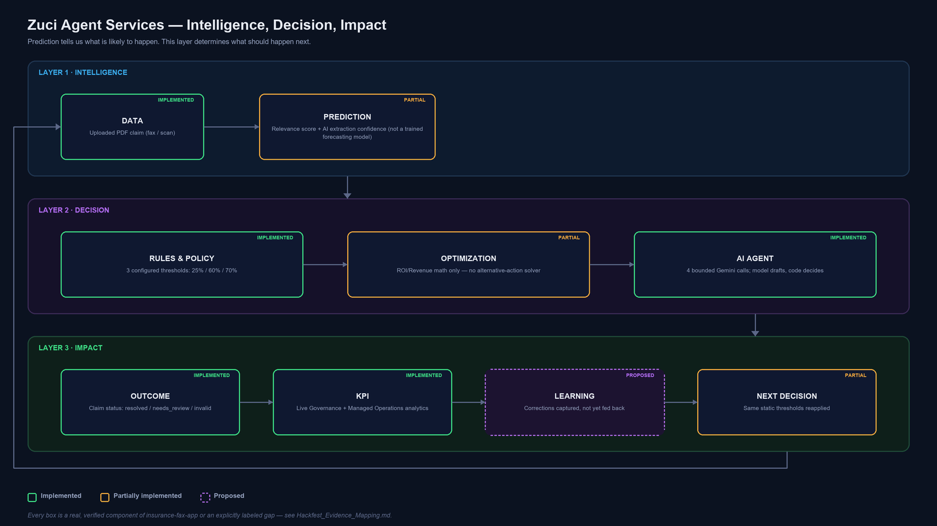
Intelligence, Decision, Impact — Master Infographic
Stage | Real component | Status
Data | PDF upload, orchestrator pipeline | [IMPLEMENTED]
Prediction | Relevance score + extraction confidence | [PARTIALLY IMPLEMENTED]
Rules & Policy | Three config thresholds, domain whitelist | [IMPLEMENTED]
Optimization | Fixed-formula ROI/Revenue calculators only | [PARTIALLY IMPLEMENTED] / true optimization [PROPOSED]
AI Agent | 4 bounded Gemini-backed agents | [IMPLEMENTED]
Outcome | Claim status transition, decision endpoint | [IMPLEMENTED]
KPI | Governance/Managed Operations analytics | [IMPLEMENTED]
Learning | — | [PROPOSED]
Next Decision | Same static thresholds re-applied to the next claim | [PARTIALLY IMPLEMENTED]

Key message: "AI provides contextual reasoning; deterministic controls provide governance." This is demonstrated four separate times in the codebase, not once.

6. End-to-End Architecture
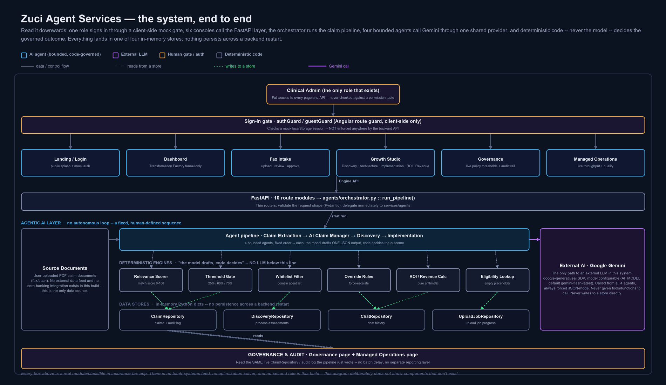
Technical Architecture
Verified technology stack — Angular 17.3 (TypeScript, standalone components) · FastAPI (Python) · Google Gemini via google-generativeai · Tesseract OCR · PyMuPDF/pdfplumber · in-memory Python dictionaries (no database). Not present, and not shown in any diagram: Node.js, PostgreSQL/any SQL database, Azure OpenAI, OpenAI (non-Google), Redis, any ML framework, any optimization solver.
Angular 17 Frontend (standalone components, lazy routes)
|
FastAPI Backend -- 10 route modules, consistent error contract
|
Orchestration -- agents/orchestrator.py :: run_pipeline()
|
Decision Layer
+-- Prediction/Signal: DocumentRelevanceService, ClaimExtractionService
+-- Rules: core/config.py thresholds (25 / 60 / 0.70)
+-- Policy: Discovery agent whitelist, Implementation override rules
+-- Optimization: ROI/Revenue calculators (fixed formula, not a solver) [PARTIAL]
+-- AI Agent: Gemini via one shared AIProvider abstraction, RuleBasedProvider fallback
|
Action Layer -- claim status transition, human Approve & Resolve
|
Outcome / KPI -- Governance + Managed Operations (live, real-data views)
|
Feedback / Learning -- [PROPOSED] -- not implemented today

The AI Provider Abstraction (the actual guardrail seam): services/ai/base.py defines an abstract AIProvider, with two implementations — GeminiProvider (real calls, forced JSON-mode) and RuleBasedProvider (zero-dependency deterministic fallback). Every one of the four AI touch points calls through this same abstraction — there is exactly one code path to an external LLM in the whole application.
AI touch point | File | Deterministic guardrail applied immediately after
Claim field extraction | claim_extraction_service.py | Source-text must literally appear in the document; cross-page conflict check
Grounded chat | chat_service.py | Cited source text must appear in the exact context sent, or the answer is discarded
Discovery assessment | discovery.py | Recommended agents filtered against a domain whitelist; rejects logged
Implementation simulation | implementation.py | Skip AI below 60% confidence; force-flag missing diagnosis; force review if no patient name

SCREEN: Governance (/governance) — PURPOSE: proves the architecture's governance claim with live numbers, not a diagram. DEMO ACTION: open Governance immediately after resolving a claim. EXPECTED RESULT: decision-authority split changes in real time. BUSINESS MESSAGE: "This isn't illustrative — these are the exact thresholds enforced on the document you just uploaded."

7. Data → Prediction → Rules → Optimization → AI Agent → Outcome
DATA [IMPLEMENTED]: User-uploaded PDF claim documents (fax/scan) — the only data source; no external feed exists. Ingested via POST /api/faxes/upload-async, parsed by PyMuPDF/pdfplumber with a per-page Tesseract OCR fallback.
PREDICTION [PARTIALLY IMPLEMENTED]: Not a trained ML model. Two real, computed signals stand in for it: (1) DocumentRelevanceService — deterministic keyword-signal match score, 0–100; (2) per-field AI extraction confidence (Gemini JSON-mode, or rule-based fallback). Both are point-in-time, document-specific — not a forecast from historical outcomes.
RULES & POLICY [IMPLEMENTED]: Three configured thresholds (core/config.py): match score < 25 → reject; < 60 → human required; ≥ 60 with every field ≥ 70% confidence → auto-process. Discovery's domain-specific AGENT_WHITELIST and Implementation's override rules (skip AI below 60% confidence; force-flag missing diagnosis; force review if no patient name) are additional, code-enforced policy layers.
OPTIMIZATION [PARTIALLY IMPLEMENTED / PROPOSED]: Growth Studio's ROI and Revenue calculators are real, fixed-formula arithmetic — genuinely implemented, but this is estimation, not optimization. No solver compares alternative actions anywhere in the codebase. How this can be extended: the claim-context data already assembled for the AI Agent stage is the natural input to a future constrained-optimization step (e.g., prioritizing which needs-review claims a limited reviewer pool should work first, weighted by value/risk).
AI AGENT [IMPLEMENTED]: Four bounded agents — Claim Extraction, AI Claim Manager (grounded chat), Discovery, Implementation — each a single Gemini call followed immediately by a deterministic check. No autonomous multi-step loop; not claimed as such.
OUTCOME [IMPLEMENTED]: Claim status set to auto_filled / needs_review / resolved / invalid; the only way to resolved is an explicit human "Approve & Resolve."
SCREEN: Fax Intake claim detail — DEMO ACTION: click "View Source" on a field, then "Approve & Resolve." EXPECTED RESULT: source snippet highlighted; claim status becomes Resolved. BUSINESS MESSAGE: "Every value is traceable, and the human — not the model — makes the final call."

8. KPI → Learning → Next Decision
KPI [IMPLEMENTED] — real fields computed by analytics_service.py, not illustrative numbers:
KPI | Source field | Business meaning
Total / Pending / Resolved / Invalid claims | summary.* | Volume and backlog at a glance
Total / Approved / Pending / Rejected claim value | financial.* (INR) | Financial exposure by state
Status distribution (%) | statusDistribution | Real, not hardcoded, percentage split
High / Medium / Low confidence fields | quality confidence buckets | Extraction reliability
Source-mapping success rate | quality success rate | % of fields with a verifiable citation
OCR required vs. completed | document analytics | Scan-quality operational load
Attention-required queue (HIGH/MEDIUM/LOW) | attentionRequired | Prioritized real work backlog

LEARNING [PROPOSED]: A manager's field correction updates only the current claim record. It is not fed back into the extraction model, the three thresholds, or the agent whitelist. No expected-vs-actual outcome tracking exists. This is the clearest, most valuable next build item.
NEXT DECISION [PARTIALLY IMPLEMENTED]: The loop restarts at Data for the next uploaded claim, using the same static thresholds every time — the pipeline closes structurally, but not yet adaptively (thresholds don't tune themselves from outcomes).
SCREEN: Governance (/governance) → "Recent Decision Audit Trail" — DEMO ACTION: refresh after approving a claim. EXPECTED RESULT: decision-authority split and audit trail update immediately. BUSINESS MESSAGE: "No reporting lag — Governance reads the same store the pipeline just wrote."

9. Decision Trace — A Representative Scenario
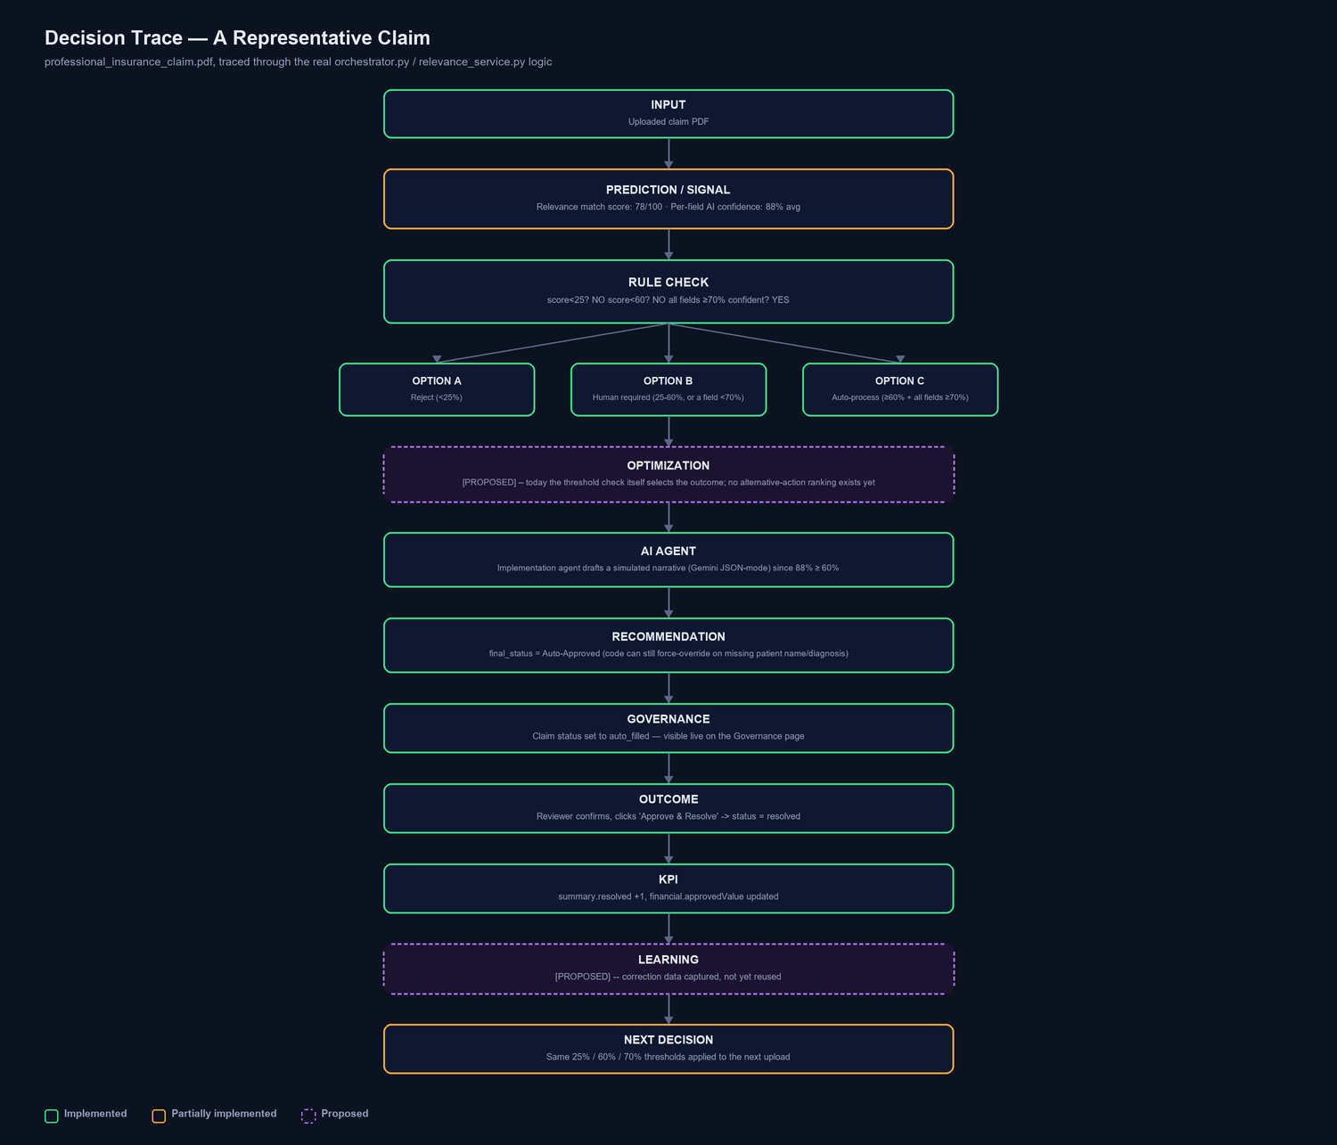
Decision Trace
This trace uses real configured values — a document with a 78/100 relevance score and 88% average field confidence clears both the invalid (25%) and review (60%) thresholds, so it auto-processes; the Implementation agent's AI call still runs (confidence ≥ 60%) to draft a simulated narrative, and code-level overrides remain active regardless (missing patient name/diagnosis would still force a review).

10. Before vs. After
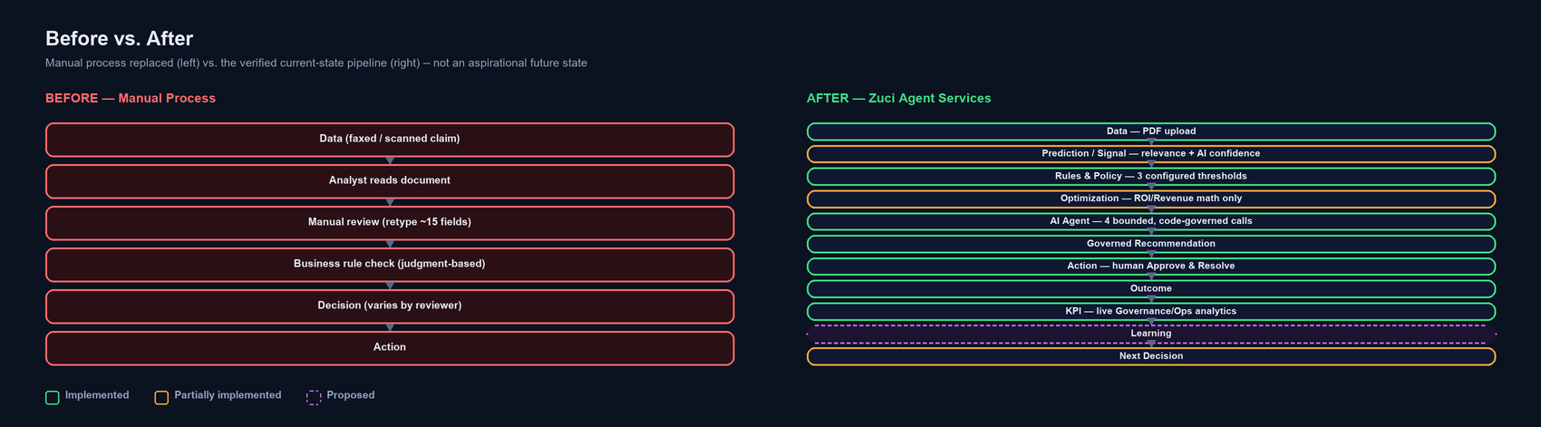
Before vs After
The transformation is not hypothetical — every box on the right side of this diagram is a verified, working stage in the current codebase, each labeled with its real implementation status.

11. Governance and Responsible AI
Implemented:
- PDF upload validation (extension, content-type, size)
- Consistent typed-error → JSON contract; a catch-all handler prevents stack traces reaching the client
- Logging excludes raw document text/field values — metadata only
- Frontend route guards (authGuard/guestGuard) — client-side only
- Four separate, real AI guardrails (source-text grounding, whitelist filtering, confidence-threshold overrides)
Not implemented — stated plainly:
- No backend authentication or authorization of any kind — every API endpoint is fully open
- No RBAC — one mock role, never checked against a permission table
- CORS wide open (allow_origins=["*"]), an explicit development convenience
- No rate limiting on any endpoint, including the AI-backed ones
- No tamper-evident audit log — it is a plain in-memory list
How this application prevents an AI model from making an uncontrolled decision:
AI Agent
|
Recommendation (drafted JSON, not yet trusted)
|
Rules / Policy Validation (source-text grounding / whitelist / confidence override)
|
Approval / Controlled Action (human "Approve & Resolve", or automatic if thresholds clear)
|
Audit Trail (in-memory log, visible on Governance)

The model never has a code path that writes to the claim record directly — it only ever populates a variable that governed code then validates, filters, or overrides before it is trusted.

12. Business Value + Innovation
- Faster, consistent decisions — one policy, applied identically, every time, not a judgment call that varies by reviewer.
- From signal to action — a confidence score doesn't just sit on a dashboard; it drives a real routing decision, in code.
- Explainable by construction — every value cites its source page; every routing decision names its threshold.
- Repeatable governance pattern — "model drafts, code decides" proven four times, not once, which is evidence it generalizes.
- Augments, doesn't replace — the architecture is designed to sit on top of existing predictive signals rather than requiring a rebuilt model.

13. Implemented vs. Proposed — Final Capability Matrix
Capability | Status
PDF upload + async pipeline | [IMPLEMENTED]
OCR fallback | [IMPLEMENTED]
AI field extraction + rule-based fallback | [IMPLEMENTED]
Source verification / conflict detection | [IMPLEMENTED]
Policy-threshold routing | [IMPLEMENTED]
Human approval gate | [IMPLEMENTED]
Grounded AI chat | [IMPLEMENTED]
Agent whitelist enforcement | [IMPLEMENTED]
Confidence-based override rules | [IMPLEMENTED]
Live KPI / audit trail | [IMPLEMENTED]
Eligibility lookup | [PARTIALLY IMPLEMENTED] — deterministic, but backing table is empty
ROI / Revenue estimation | [IMPLEMENTED] (arithmetic, not optimization)
True optimization (alternative-action comparison) | [PROPOSED]
Feedback / learning loop | [PROPOSED]
Multi-role RBAC | [PROPOSED]
Backend authentication | [PROPOSED]
Trained prediction model | [PROPOSED]

14. Hackfest Demo Script (10 minutes)
Narrative spine: Problem → Why existing approach is not enough → Gap → Our innovation → How it works → Live demo → Business value → Closed-loop learning.
Time | Segment | What to show | What to say | Key message
0:00–1:00 | Business Problem | — | "Every claims team still manually reads faxed documents, retypes fields, and decides case-by-case. That's slow, and inconsistent." | Prediction tells us what is likely; we show what should happen next
1:00–2:00 | Existing Solution | Governance page | "Descriptive analytics, confidence scoring, generative AI drafting already exist here and work well." | We augment, not replace
2:00–3:00 | The Gap | Architecture diagram | "A confidence score is not a decision — someone still has to decide, consistently, auditably." | Prediction ≠ Decision
3:00–4:00 | Our Solution | Dashboard funnel | "Every stage of the decision journey is a real click, not five separate slides." | Connecting signal, policy, and AI into a governed loop
4:00–6:00 | Live Demo | Fax Intake | Upload a real claim; narrate real per-stage progress; watch field-by-field auto-fill. | Every value is source-verified
6:00–7:30 | Rules + Optimization + AI Agent | AI Claim Manager, Growth Studio → Implementation | Ask a quick action (no AI call) and an open-ended question (real Gemini call); simulate a low-confidence claim (forced escalation). | AI provides reasoning; deterministic controls provide governance
7:30–8:30 | Recommendation + Governance | Governance page | "These are the exact thresholds — 25/60/70 — that just decided this claim." | Governance is a live read of enforcement code, not a slide
8:30–9:15 | Outcome + KPI | Claim detail → Approve & Resolve → Governance | Approve the claim; refresh Governance; KPIs update live. | No batch delay — no batch layer exists
9:15–10:00 | Learning + Next Decision | Closing remarks | "A correction today updates only that claim — closing the feedback loop is our clearest next build." | From isolated predictions to continuous decision intelligence

Presenter checklist: backend healthy (/api/health) · logged in · a clean sample PDF plus a low-confidence one ready · AI_API_KEY configured (know how to unset it live) · at least one claim already processed so Governance isn't all-zero · the three thresholds memorized (25% / 60% / 70%) · the honest-gaps list rehearsed.

15. Evidence Mapping (Selected)
Claim | Repository file | Status | Evidence
Three configured policy thresholds | config.py | [IMPLEMENTED] | Three named thresholds: 25 / 60 / 0.70
Agent whitelist enforcement | discovery.py | [IMPLEMENTED] | Domain agent whitelist; rejected agents logged, never shown
Confidence-based simulation override | implementation.py | [IMPLEMENTED] | AI call skipped entirely below 60% confidence
Live KPIs | analytics_service.py | [IMPLEMENTED] | Summary, financial, quality, and document analytics fields
Eligibility lookup | mock_db.py | [PARTIALLY IMPLEMENTED] | Logic real; the backing table is an empty dict, always "Not Found"
True optimization | no file found | [PROPOSED] | No solver dependency anywhere in the codebase
Feedback / learning loop | no file found | [PROPOSED] | Corrections persist to the claim record only; not consumed elsewhere
Multi-role RBAC | auth.service.ts | [PROPOSED] | Single hardcoded mock role, never checked against a permission table
Backend authentication | no auth route exists | [PROPOSED] | Every FastAPI endpoint is unauthenticated

Full evidence table (25 rows) available in `Hackfest_Evidence_Mapping.md`.

16. Final Takeaway

