**Project**: **ENVIRONMENT MONITORING IN PARK**

**Phase4**: In this part you will continue building your project.

* Continue building the project by developing the environmental monitoring platform.
* Use web development technologies (e.g., HTML, CSS, JavaScript) to create a platform that displays real-time environmental data.
* Design the platform to receive and display real-time temperature and humidity data from IoT devices.

**Environment monitoring in park:**

To monitor,

* Temperature
* Humidity

1. **Microcontroller Naming:**

**ESP32:**

You can keep the default naming, but it’s advisable to add a unique identifier for each ESP32 device if you have multiple.

**Connecting from MicroPython[​](https://docs.wokwi.com/guides/esp32-wifi" \l "connecting-from-micropython" \o "Direct link to heading)**

To connect from a [MicroPython project](https://wokwi.com/projects/new/micropython-esp32" \t "_blank), use the following code:Once connected, you can use the [urequests library](https://mpython.readthedocs.io/en/master/library/mPython/urequests.html" \t "_blank) to send HTTP and HTTPS requests, and the [umqtt library](https://mpython.readthedocs.io/en/master/library/mPython/umqtt.simple.html" \t "_blank) to establish MQTT connections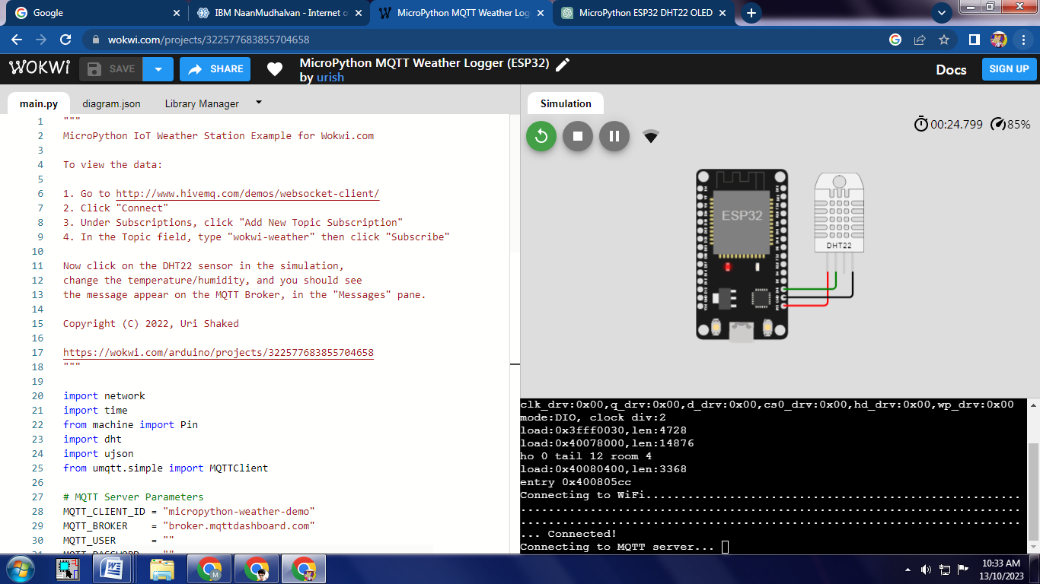

**1.Arduino UNO:**

Similar to the ESP32, consider using a default naming scheme with unique identifiers if you have multiple device

2**. Sensor Naming**:

**DHT22 Sensor:**

Use a naming convention like “DHT22\_Park\_Sensor1” to specify the type of sensor, location (Park), and a unique identifier if you have multiple sensors.

**3. Connectivity Naming**:

**BLE**

If you have multiple BLE devices, use clear and descriptive names, such **:**as “BLE\_Device\_1.”

**Wi-Fi**:

It’s advisable to name Wi-Fi access points or devices with descriptive names based on their location or function in the park.

Wokwi simulates a WiFi network with full internet access. You can use the [ESP32](https://docs.wokwi.com/guides/esp32) together with the virtual WiFi to prototype IoT projects. Common use cases include:

* Connect to MQTT servers to send sensor data
* Query web services over HTTP, HTTPS, and web sockets
* Run an HTTP server inside the ESP32 and connect to it from your browser (requires the [Wokwi IoT Gateway](https://docs.wokwi.com/guides/esp32-wifi" \l "the-private-gateway))

**Connecting to the Wi-Fi**[**​**](https://docs.wokwi.com/guides/esp32-wifi#connecting-to-the-wifi)

The simulator provides a virtual Wi-Fi access point called **Wokwi-GUEST**.

It is an open access point - no password is required.

**Zigbee:**

If you have multiple Zigbee devices, use clear and descriptive names, such as “Zigbee\_Node\_Park\_Area.”

**4. Cloud Naming:**

**Beeceptor:**

You can keep the name **“Beeceptor**” as-is for this development and testing tool.

5**. Protocol Naming**:

**MQTT:**

Use standard MQTT topics and naming conventions for publishing and subscribing to data.

**HTTP:**

Specify clear and consistent API endpoints and URL paths.

**AMQP:**

Use well-defined queues and exchanges with appropriate names for AMQP communication.

6. **Data Naming**:

For data collected, follow a standardized naming format, such as “Data\_Temperature\_Humidity\_Park\_Location” to ensure data consistency.

**PYTHON SUBSCRIPT:**

Import network

Import time

From machine import Pin

Import dht

Import ujson

From umqtt.simple import MQTTClient

# MQTT Server Parameters

MQTT\_CLIENT\_ID = “micropython-weather-demo”

MQTT\_BROKER = “broker.mqttdashboard.com”

MQTT\_USER = “amjath”

MQTT\_PASSWORD = “amjatj786”

MQTT\_TOPIC = “wokwi-weather”Sensor = dht.DHT22(Pin(15))

Print (“Connecting to Wi-Fi”, end=””)

Sta\_if = network.WLAN(network.STA\_IF)

Sta\_if.active(True)

Sta\_.connect(‘Wokwi-GUEST’, ‘’)

While not sta\_if.isconnected():

Print(“.”, end=””)

Time.sleep(0.1)

Print(“ Connected!”)

Print(“Connecting to MQTT server... “, end=””)

Client = MQTTClient (MQTT\_CLIENT\_ID, MQTT\_BROKER, user=MQTT\_USER, password=MQTT\_PASSWORD)

Client.connect()

Print (“Connected!”)Prev\_weather = “”

While True:

Print (“Measuring weather conditions... “, end=””)

Sensor.measure()

Message = ujson.dumps

(

{

“thaemp”: sensor. Temperature (),

“Humidity”: sensor. Humidity (),

})

If message != prevweather:

Print(“Updated!”)

Print(“Reporting to MQTT topic {}: {}”.format(MQTT\_TOPIC, message))

Client.publish(MQTT\_TOPIC, message)

Prev\_weather = message

Else:

Print(“No change”)

Timesleep(1)

Simulation output:

(POWERON\_RESET), boot: 0x13 (SPI\_FAST\_FLASH\_BOOT)

Configsip: 0, SPIWP:0xee

Clk\_drv:0x00,q\_drv:0x00,d\_drv:0x00,cs0\_drv:0x00,hd\_drv:0x00,wp\_drv:0x00

Mode:DIO, clock div:2

Load:0x3fff0030,len:4728

Load:0x40078000,len:14876

Ho 0 tail 12 room 4

Load:0x40080400,len:3368

Entry 0x400805cc

Connecting to WiFi...................................................................................................................................................................................................................................................................................................................................................................................................................................................................................... Connected!

Connecting to MQTT server... Connected!

Measuring weather conditions... Updated!

Reporting to MQTT topic wokwi-weather: {“humidity”: 40.0, “temp”: 24.0}

Measuring weather conditions... No change

Measuring weather conditions... No change

Measuring weather conditions... No change

Measuring weather conditions... No change

Measuring weather conditions... No change

Measuring weather conditions... Updated!

Reporting to MQTT topic wokwi-weather: {“humidity”: 80.5, “temp”: 48.8}

Measuring weather conditions... Updated!

Reporting to MQTT topic wokwi-weather: {“humidity”: 80.5, “temp”: -13.8}

Traceback (most recent call last):

File “main.py”, line 62, in <module>

File “umqtt/simple.py”, line 134, in publish

OSError: [Errno 104] ECONNRESET

MicroPython v1.21.0 on 2023-10-05; Generic ESP32 module with ESP32

Type “help ()” for more information