|  |  |
| --- | --- |
| Date | 11 October 2023 |
| Team ID | NM2023TM15559 |
| Team Name | .proj_227254_Team_2 |
| Project Name | Chatbot deployment with IBM cloud watson assistant |

­

**Innovation:**

innovations are new or improved methods, processes, products, or services that bring about significant advancements, solve problems, or create novel opportunities.

**#Innovation**

Deploying a chatbot using IBM Cloud Watson Assistant involves utilizing the Watson Assistant service provided by IBM Cloud to integrate a chatbot into your applications, websites, or other platforms. Watson Assistant is an AI-powered chatbot service that allows businesses to build interactive interfaces such as chatbots and virtual agents. here are some key innovations and best practices related to deploying chatbots with IBM Cloud Watson Assistant:

**1. Integration with Multiple Channels:**

Watson Assistant allows integration with various messaging platforms such as Facebook Messenger, Slack, and other popular messaging apps. This allows businesses to deploy chatbots on their preferred platforms where their customers are already active.

**2. Natural Language Understanding (NLU):**

Watson Assistant integrates with IBM Watson Natural Language Understanding, which enables the chatbot to comprehend the context of user queries better. By understanding the intent and sentiment of the user, the chatbot can provide more accurate and relevant responses.

**3. Contextual Conversations:**

Watson Assistant supports contextual conversations, which means it can remember past interactions within a session. This context-awareness enables more coherent and relevant responses during multi-turn conversations.

**4. Machine Learning-based Training:**

Watson Assistant employs machine learning algorithms to continuously improve its responses. It learns from user interactions over time and becomes more accurate in understanding user intents, leading to better responses.

**5. Dialog Skill Builder:**

IBM Watson Assistant provides a user-friendly interface called Dialog Skill Builder, which allows developers and non-technical users to create chatbot dialogs without extensive programming knowledge. This feature simplifies the process of designing and deploying complex conversational flows.

**6. Flexible Deployment Options:**

Watson Assistant offers flexibility in deployment. You can deploy chatbots on IBM Cloud, on-premises, or even on other cloud platforms, depending on your organization's specific requirements and constraints.

**7. Security and Compliance:**

IBM Cloud services, including Watson Assistant, adhere to high-security standards. They provide features such as data encryption, identity and access management, and compliance certifications, ensuring that sensitive data and conversations are secure and compliant with regulations.

**8. Analytics and Insights:**

Watson Assistant provides analytics tools that allow businesses to track the performance of their chatbots. These analytics offer insights into user interactions, frequently asked questions, and areas where the chatbot might need improvement. Data-driven insights help in refining the chatbot's responses over time.

**9. Multi-Language Support:**

Watson Assistant supports multiple languages, allowing businesses to create chatbots for a global audience. This feature is crucial for companies operating in diverse regions with customers who speak different languages.

**10. Voice Integration:**

Watson Assistant can be integrated with voice interfaces, enabling businesses to create voice-enabled chatbots and virtual agents. This functionality is particularly valuable for applications in customer service and accessibility.

Please note that these features and innovations were applicable as of my last update, and there might have been additional enhancements and developments in IBM Watson Assistant since then. For the most recent and detailed information, I recommend visiting the official IBM Watson Assistant documentation or contacting IBM directly.

**Architecture of chatbot deployment:**

With the IBM Watson Assistant service, you can create an application that understands natural-language input and uses machine learning to respond in a way that simulates a conversation between humans.

* Identify sources of information for training the AI system.
* Identify the split between evaluation, test, and training data.
* Define and model the intents, entities, and their relationship.
* Train the conversation service.
* Identify and model the test data maps.
* Identify documents and answers for improving the model.

**­­­­ ­­­­**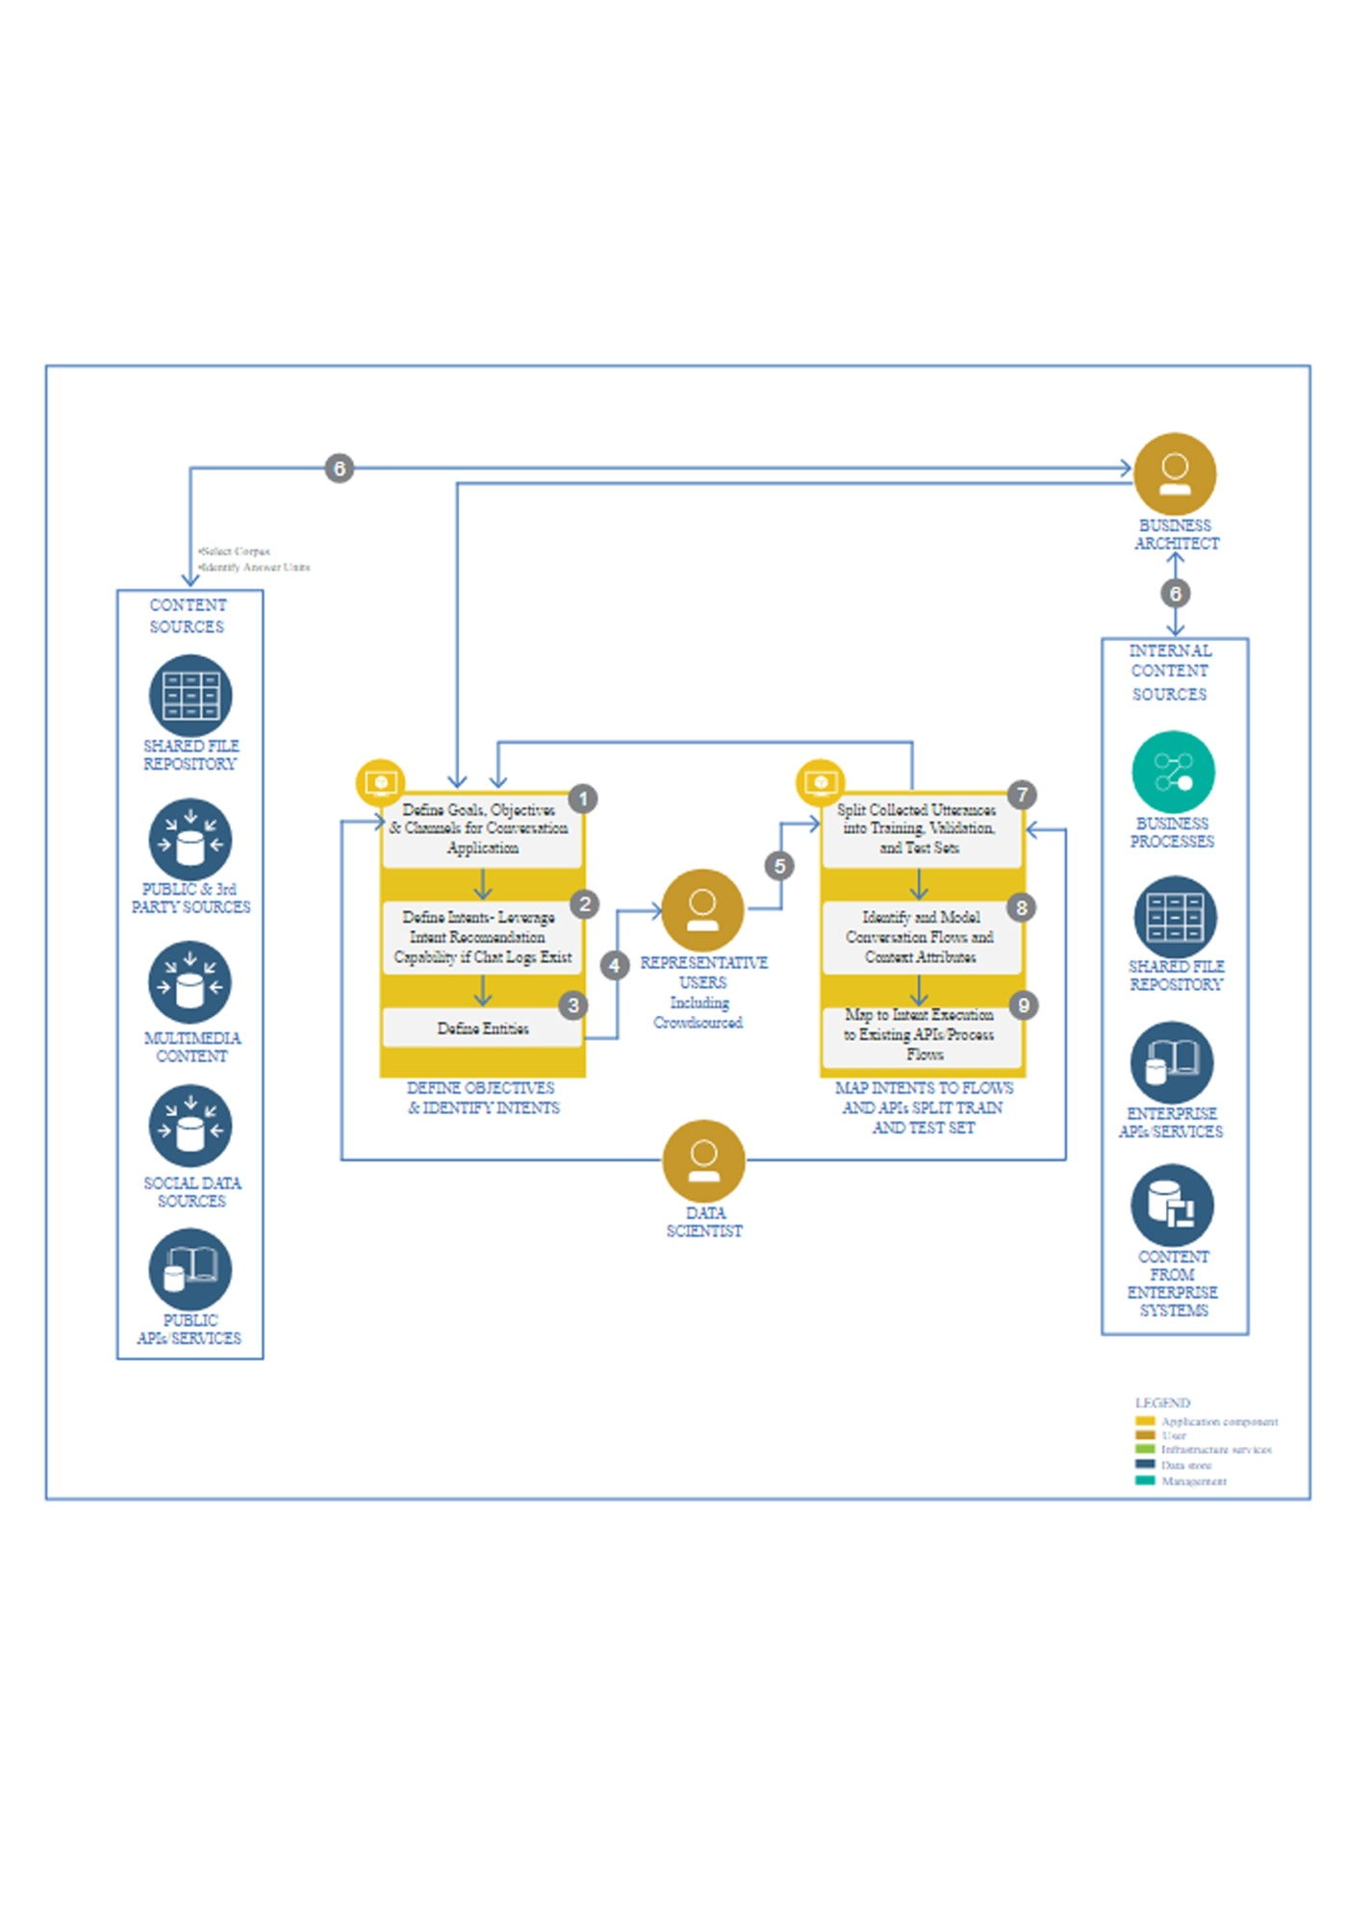

### Steps to Deploy Watson Assistant Chatbot on IBM Cloud:

#### Step 1: Create a Watson Assistant Service Instance

1. Log in to your IBM Cloud account.
2. Go to the IBM Cloud Catalog.
3. Select "AI" from the categories and choose "Watson Assistant."
4. Configure your Watson Assistant instance with necessary settings.

#### Step 2: Build Your Chatbot

1. Access your Watson Assistant instance.
2. Create Intents, Entities, and Dialog nodes to define the behavior of your chatbot.
3. Train your chatbot using example questions and answers.

#### Step 3: Connect External Services (Optional)

If your chatbot needs to interact with external services or APIs, set up the necessary integrations within Watson Assistant.

#### Step 4: Test Your Chatbot

1. Use the Watson Assistant tool to test your chatbot and ensure it responds correctly to user inputs.

#### Step 5: Deploy Your Chatbot

1. Once your chatbot is ready, go to the Watson Assistant tool.
2. Click on the "Deploy" tab.
3. Choose the integration options suitable for your application (e.g., web chat, messaging platforms, etc.).
4. Follow the configuration steps provided to integrate the chatbot into your application.

#### Step 6: Obtain Credentials

If your deployment requires authentication, make sure to obtain the necessary credentials and API keys for your deployed Watson Assistant service.

#### Step 7: Update Your Application Code

1. Integrate the obtained credentials into your application code.
2. Implement the logic to send user inputs to the Watson Assistant API endpoint and receive responses.
3. Handle the responses and display them to users through your application's user interface.

#### Step 8: Deploy Your Application on IBM Cloud

1. Deploy your application on IBM Cloud. You can use services like IBM Cloud Foundry or Kubernetes to host your application.

#### Step 9: Monitor and Improve

1. Monitor your deployed chatbot's performance using Watson Assistant analytics and user feedback.
2. Continuously improve your chatbot by analyzing user interactions and refining its responses and behavior.

Here's a basic example dataset that you can use to train a chatbot for deployment on IBM Cloud Watson Assistant.

**Intent:** Greetings

* **User Input:** Hello
  + **Chatbot Response:** Hi there! How can I assist you today?
* **User Input:** Hi
  + **Chatbot Response:** Hello! How can I help you?
* **User Input:** Good morning!
  + **Chatbot Response:** Good morning! What can I do for you?

**Intent:** Basic Information

* **User Input:** What services do you provide?
  + **Chatbot Response:** We provide a wide range of services including [list services]. Is there something specific you would like to know?
* **User Input:** Where are you located?
  + **Chatbot Response:** We are located at [address]. Feel free to visit us anytime!

**Intent:** FAQ

* **User Input:** What are your business hours?
  + **Chatbot Response:** We are open from Monday to Friday, 9 AM to 6 PM.
* **User Input:** How can I contact support?
  + **Chatbot Response:** You can contact our support team at [phone number] or email us at [email address].

**Intent:** Farewell

* **User Input:** Goodbye
  + **Chatbot Response:** Goodbye! Have a great day!
* **User Input:** See you later
  + **Chatbot Response:** See you! If you have any more questions, feel free to ask.

This dataset covers basic intents like greetings, asking for information about services and location, frequently asked questions, and farewell messages. You can expand this dataset by adding more intents and examples to make your chatbot more robust and capable of handling a variety of user queries.

Natural Language Understanding (NLU) techniques are essential for chatbots to understand and interpret user input accurately. Watson Assistant on IBM Cloud utilizes NLU capabilities to comprehend user intents, entities, and context. Here's an example of how you can leverage NLU techniques for chatbot deployment on IBM Cloud Watson Assistant:

### ****Intent Recognition with Example:****

#### ****Intent:**** Order Food

* **Example 1:**
  + **User Input:** "I want to order a pizza."
  + **Intent:** Order Food
  + **Entities:**
    - **Food Type:** Pizza

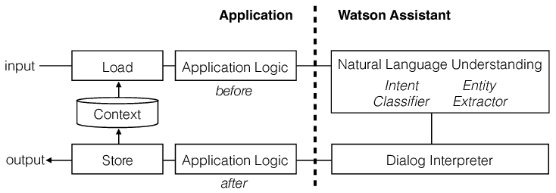Top of Form



**diagram for chatbot**

**conclusion:**

**IBM Cloud Watson Assistant offers a powerful platform for chatbot deployment. With its advanced features and capabilities, it enables businesses to create intelligent and interactive chatbots that can provide personalized and efficient customer support. By leveraging the innovative capabilities of IBM Cloud and Watson Assistant, businesses can enhance their customer experience and streamline their operations. It's an exciting project that brings together cutting-edge technology and the power of AI.**